**Exempt Research - eIRB System Enhancement to Show State of Completed Study**

For exempt research, the MUSC policy, Human Research Protection Program(HRPP 3.2) Exempt Research, stipulates that Exempt studies are expired by the IRB five years after the initial date of approval unless the study plan specifically describes the duration beyond the five-year expiration, in which case, that will be the end date for the project.

While researchers are responsible for tracking the study’s expiration date, the eIRB system has now been updated to *automatically* designate the completion of the study. Researchers will now see the below state in IRB once the study has reached the five-year expiration:

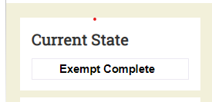

Reminder: Once the Exempt study expires, no further research can be performed on the project. If there is still a need to perform research past the expiration date, another Exempt study will have to be opened in order to continue.