**Study Conversion – ERMA to eIRB**

**This document outlines the process and information for converting a study from the ERMA system to the eIRB System.**

To enter the ERMA study in eIRB, proceed with the current process for creating an initial study in eIRB and the completion of all applicable smartforms. For documents, i.e., Informed Consent, HIPAA, Protocols, or Advertisements, please upload the latest clean, approved version to the appropriate sections in the eIRB application. The Informed Consent, HIPAA, and/or Advertisements must contain the eIRB watermark in the footer of those documents for stamping purposes.

Once the study is created in eIRB, there will be new smartforms titled: “Converted Study” and “Conversion Information.” See screen shots below:

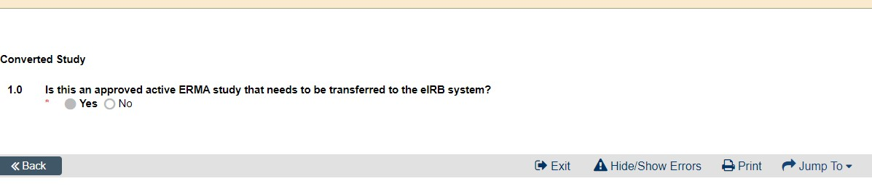

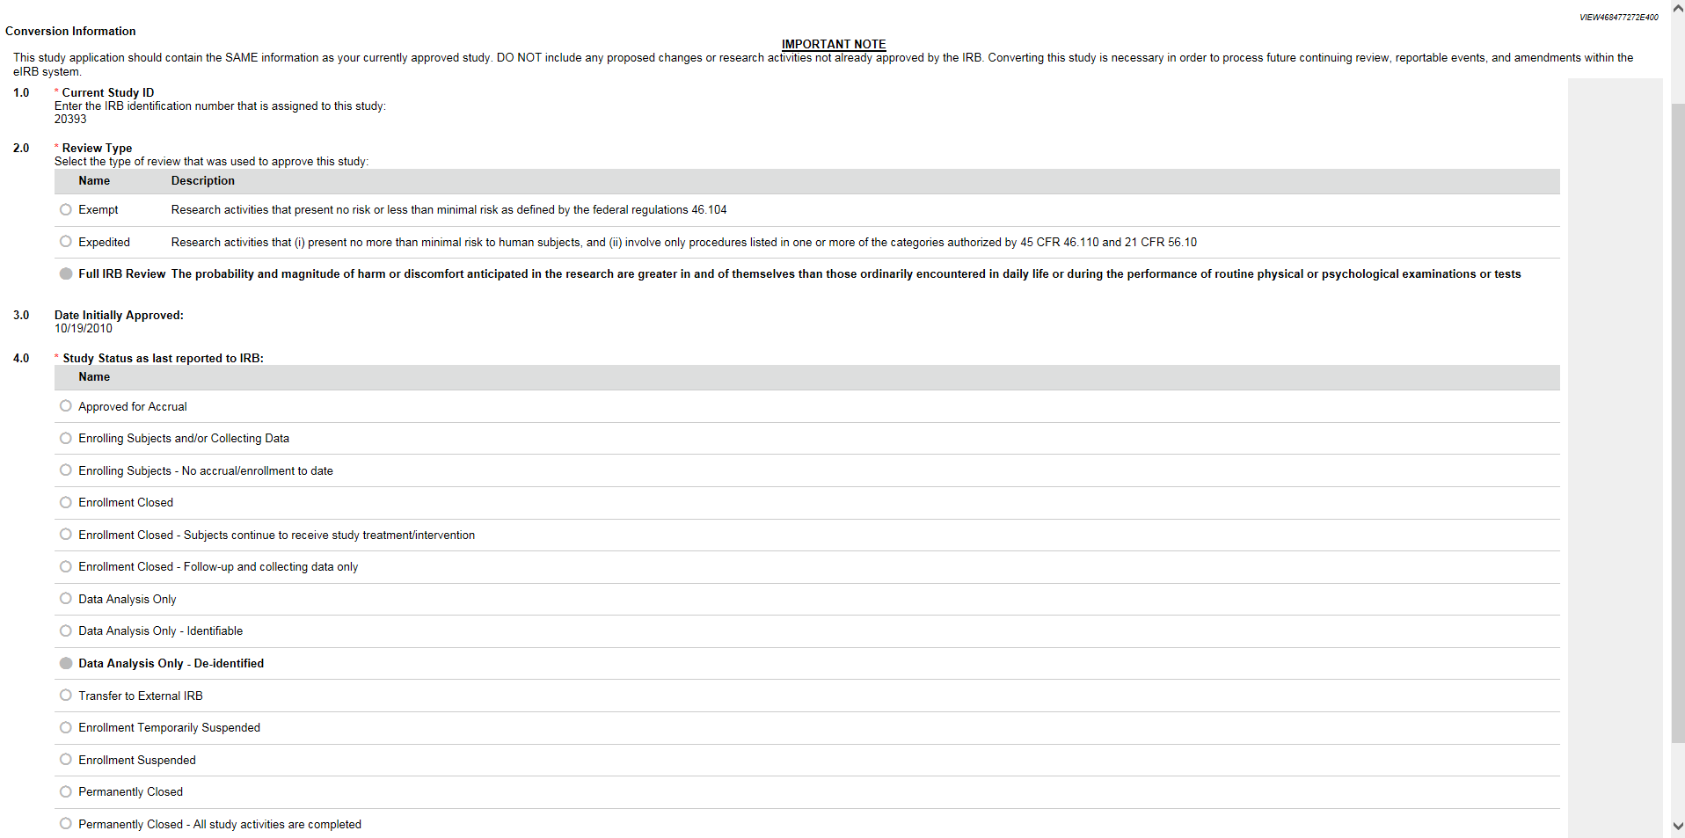

To convert the ERMA study to eIRB, select “Yes” on the Converted Study Smartform. The Conversion Information smartform will then auto-populate. Enter the information as follows:

1. Current Study ID: Enter the ERMA HR number (Example: 12345)
2. Review Type: Select the Review Type that was used to initially approve this study (Expedited or Full Board). This information can be found on the original approval letter issued by the IRB or in ERMA under “View/Print Forms”, then “Human Research Review Application”, and then scroll to “Section II. Type of Submission.”

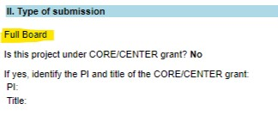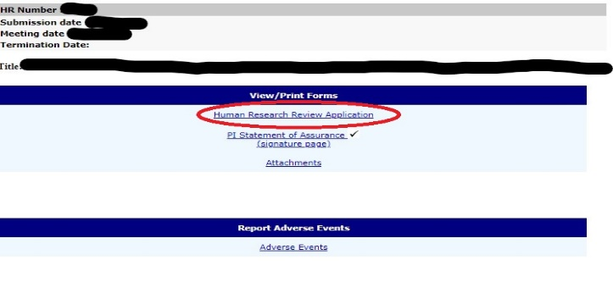

1. Date Initially Approved: Fill in the initial approval date of the study. In ERMA, this can be found on the ERMA study’s main page under “Approval Date” (upper right-hand corner).

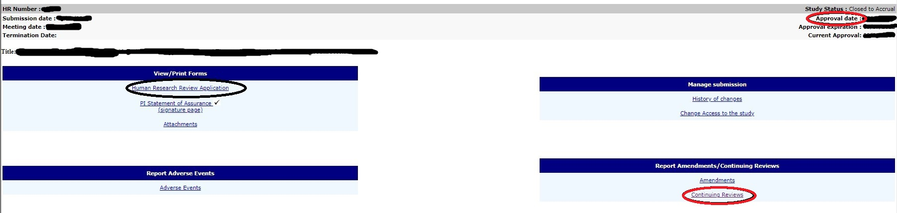

1. Study Status as last reported to IRB: Select the status that was approved on the last Continuing Review. In ERMA, this can be found on the ERMA study’s main page under “Continuing Review” (lower right-hand corner). Click on “Continuing Review” and click “View” on the last approved Continuing Review. Under 1.0 of the Continuing Review, you will see the last approved status.

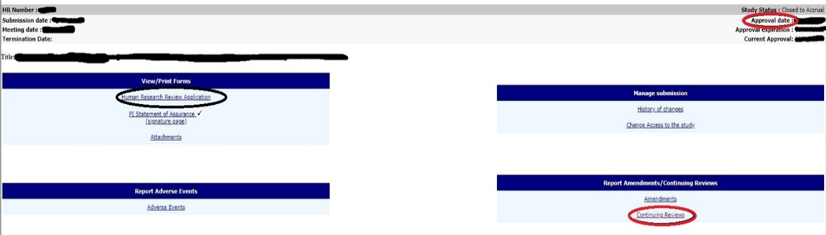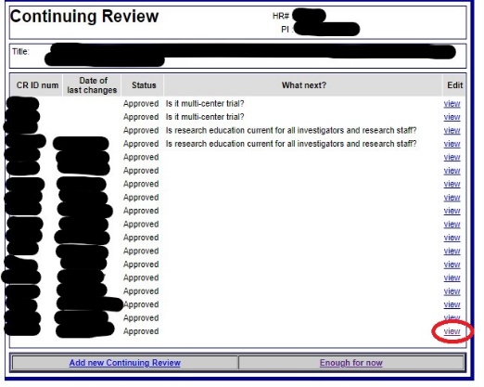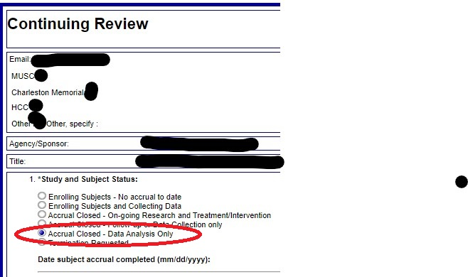

Click continue and fill out the eIRB application as applicable to the approved ERMA study file. Make sure that any documents that need to be stamped (Informed Consent, HIPAA, Advertisements) are uploaded with the eIRB watermark.

Once the PI clicks “Submit Converted Study,” the PI will need to select the checkbox and select “OK” as shown in the screen shot below:

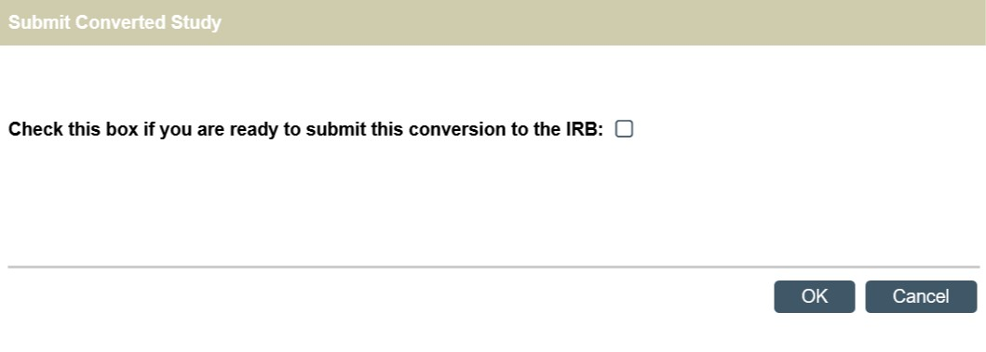

The study will route directly to the IRB staff and the state of the study will be “IRB Conversion Review.” See screen shot below. The study will not need to route through the department approval process.

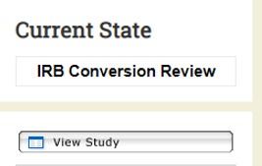

All smartforms must be completed correctly, just as with the normal submission of an initial study in eIRB.

The IRB administrator will review the study in eIRB by comparing it to the currently approved study in ERMA. The IRB administrator may request changes, clarifications, etc., using the same mechanism via eIRB that is used for initial studies.

The IRB will not need to “approve” the study again. The review is to make sure the study submitted in eIRB is the same approved study that is in ERMA and all study details match.

Once the IRB administrator completes the review, the study will move to the state of “approved” in eIRB. The stamped informed consent documents and any of the active ancillary documents that need to be stamped will be found in the same tabs and sections as normal in eIRB.