IACUC/DLAR/IBC Electronic registration system.
GENERAL REMARKS 2
NEW PROTOCOL – Initial Submission 2
Submitting an Amendment 7
Submitting a Continuing Review 8
Linking to your IBC protocol from the IACUC side 10
Flow Chart overview of eProtocol IBC sections 13

GENERAL REMARKS
- You must allow pop ups in your browser in order for eProtocol to work properly. Deactive any pop up blockers.
- Avoid running eProtocol in Internet Explorer since it has some compatibility issues. Chrome and Firefox are preferred.
- When flipping back and forth through eProtocol, do NOT use the back button in your browser, as you will get an error message! [1] Instead, use the menu bar [2] within eProtocol to go back/forth!
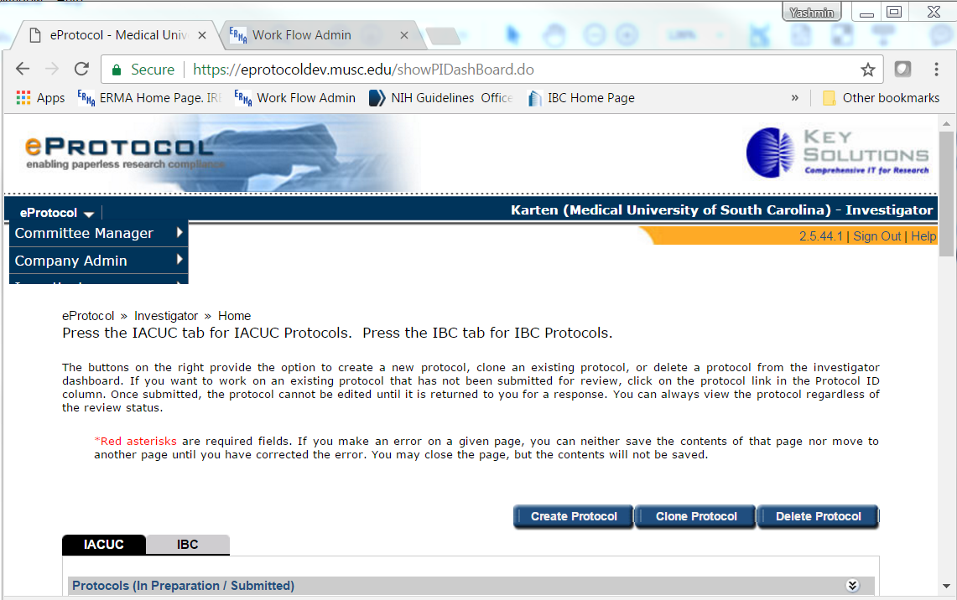
2
1

NEW PROTOCOL – Initial Submission
- Log in with your MUSC NetID to https://eprotocol.musc.edu
- Select your role [3] to be “Investigator”. Then click on IBC tab [4]
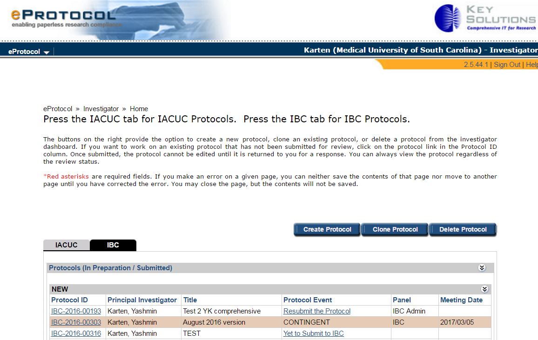
5
4
3
- Click “Create Protocol” [5], to start a new protocol. A new window will pop up. Provide a study title and make sure the IBC check box is clicked [6]. Click the radio button [7]. This starts the protocol to be formed.
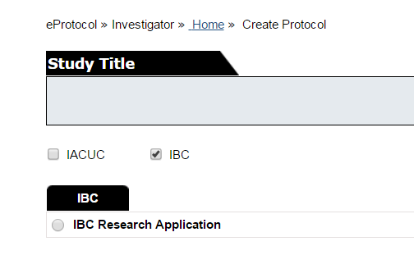
7
6
- Provide a project title [8]. If the PI also serves as Lab Safety Representative, you can leave this field blank [9]. To add a Lab Safety Representative, look up the name by clicking on the binoculars icon [10]. Then click “Create Protocol” [11].
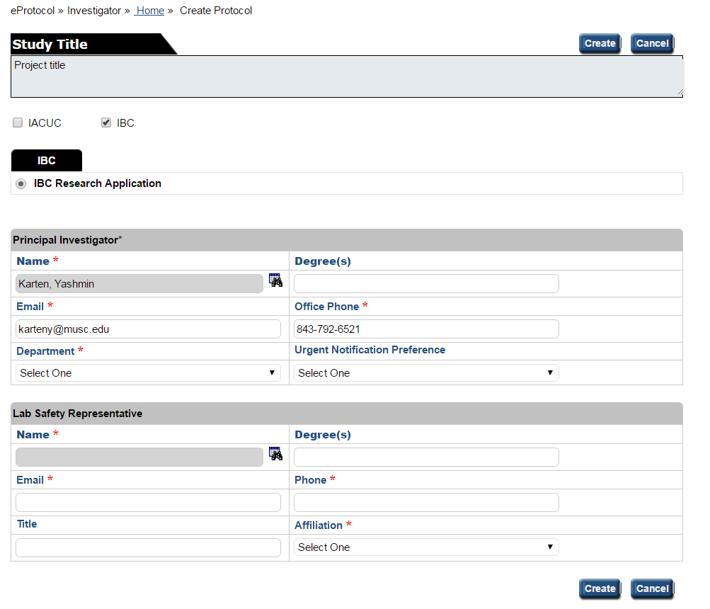
110
100
9
8
- A new window will be created. PI and personnel can be updated in this new window. Make sure that you, as the person filling out this form, are listed somewhere on the protocol, otherwise you will not have the correct privileges to be able to complete this form.
- To navigate this protocol, use the Previous and Next buttons on the top right [12]. Do NOT use your browser’s back/forward buttons as it will give an error message. 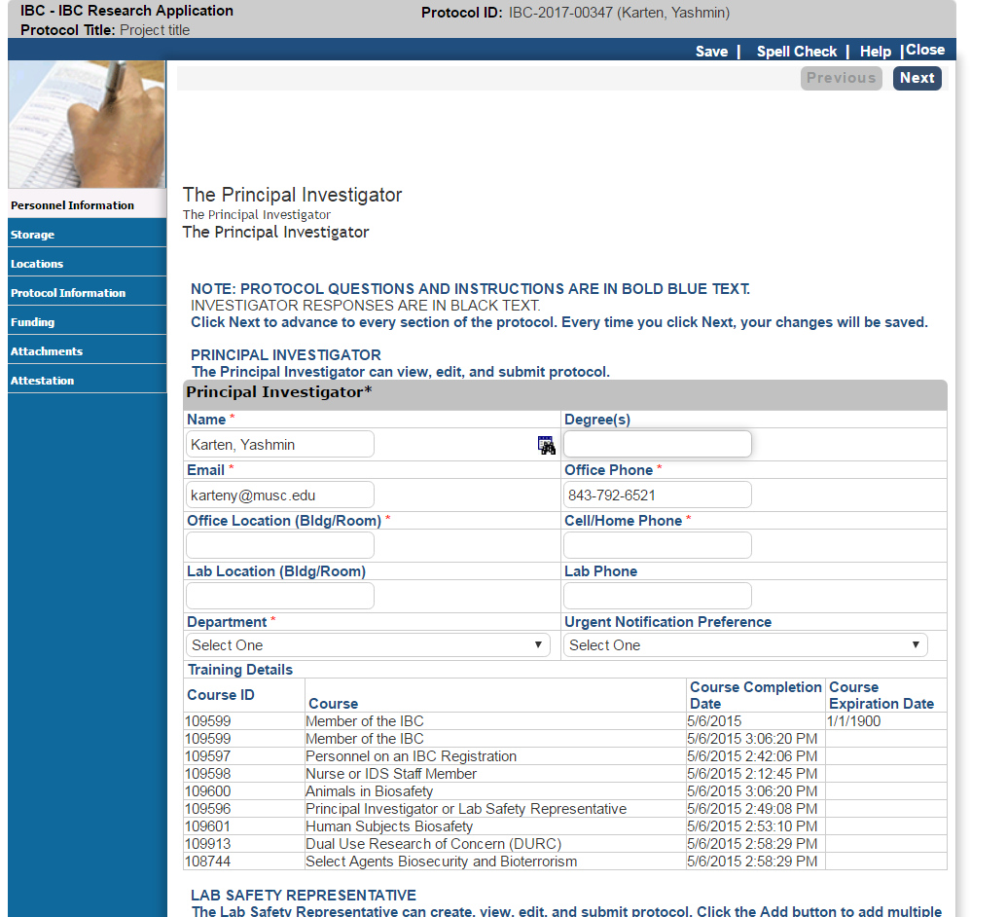
130
120
- You can also move around in the protocol by using the links in the blue left column. [13]
- Please read the help text on top carefully, as it will guide you through the questions [14 + 15] on that page. There is also ample help specific to the page you’re on by clicking on the Help button [16]:
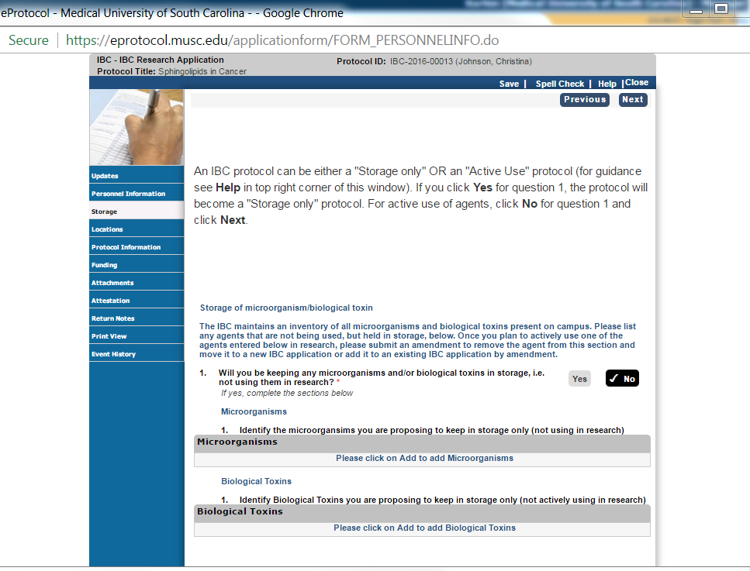
160
140
150

Submitting an Amendment
- Log in with your MUSC NetID to https://eprotocol.musc.edu
- Select your role to be “Investigator”. Then click on IBC tab
- Scroll down to “Approved Protocols” and click on the correct Protocol ID
- A popup window will open up: Select “Start Amendment”
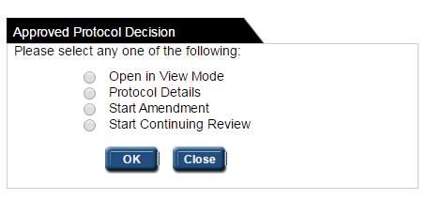
1
- If you don’t see “Start Amendment”, or “Start Continuing Review” it means you already have an amendment in the works. Only one amendment can be open/active. To start a new amendment, the outstanding amendment will have to complete the review cycle. To finish the amendment, click “Open in Edit Mode”
- Follow the instructions for the amendment as described in the new window.
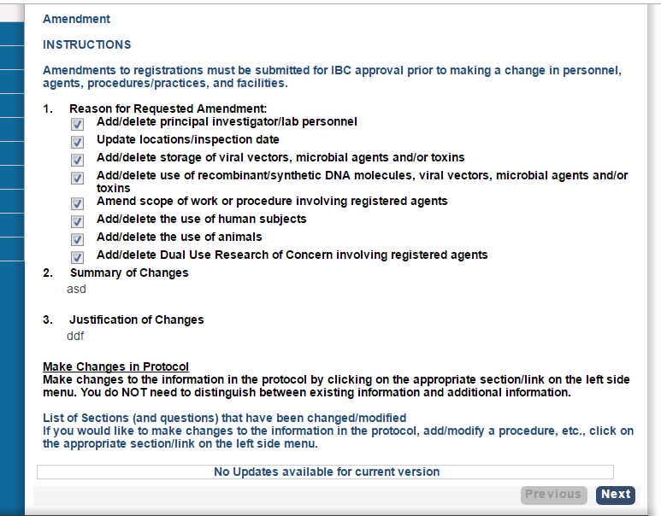
- For help with the form, go back to NEW PROTOCOL – Initial Submission

Submitting a Continuing Review
- Log in with your MUSC NetID to https://eprotocol.musc.edu
- Select your role to be “Investigator”. Then click on IBC tab
- Scroll down to “Approved Protocols” and click on the correct Protocol ID
- A popup window will open up: Select “Start Continuing Review” [1]
1
- If you don’t see “Start Amendment”, or “Start Continuing Review” it means you already have an amendment/continuing review in the works. Only one amendment/continuing review can be open/active. To start a new amendment/continuing review, the outstanding one will have to complete the review cycle. To finish the amendment/continuing review, click “Open in Edit Mode”
- Follow the instructions for the continuing review as described in the new window. For Annual Renewal click this box [2]
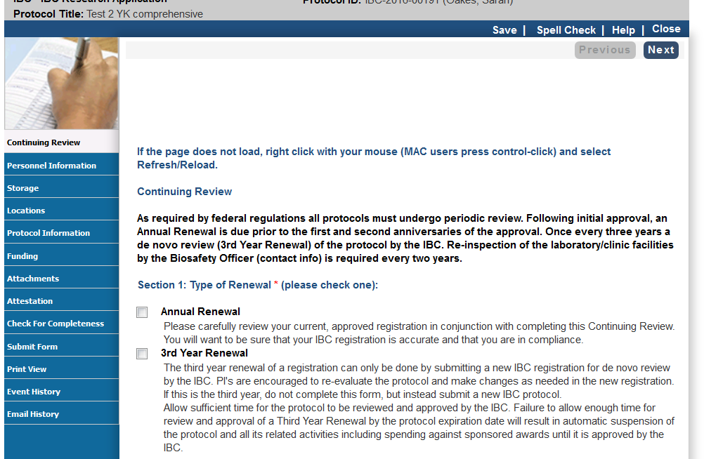
2
- Section 4: If you indicated No for ALL the items listed below, you can click Submit Form.
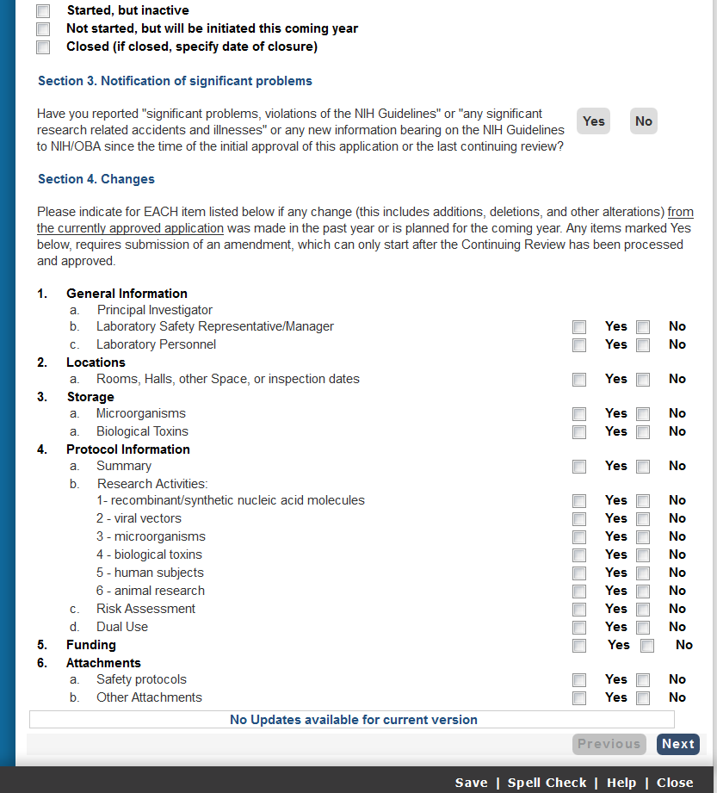
- Section 4: If you indicated Yes for any of items below, you will need to make corresponding changes in the form itself by submitting a new amendment (after the Continuing Review is approved by the IBC). Changes in rooms (pending satisfactory inspection) or personnel (pending completing of biosafety training) can be made in the Continuing Review itself. To do that, you click Next (bottom right) and select the appropriate section from the left hand column to update. When everything is updated, you click Submit Form.
- For help with the form, go back to NEW PROTOCOL – Initial Submission

Linking to your IBC protocol from the IACUC side
- In the IACUC protocol, go to “Special Considerations” [1]
1
- Scroll down to Question 3 and click Yes [2]. Then click Add [3].
3
2

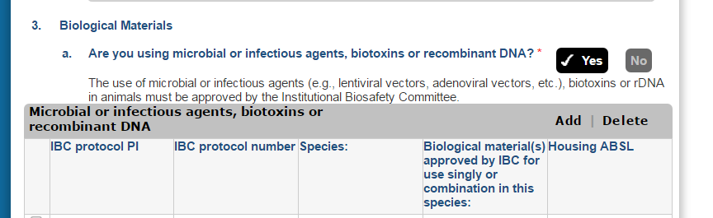

- A new popup window will open.
  - 3.a.1 – From the dropdown list, select the PI on the IBC protocol.
  - 3.a.ii – First select the relevant IBC protocol number from the dropdown list [4]. Second, click on the binoculars symbol [5]. This opens up a new window listing the procedures you created in the IBC protocol.
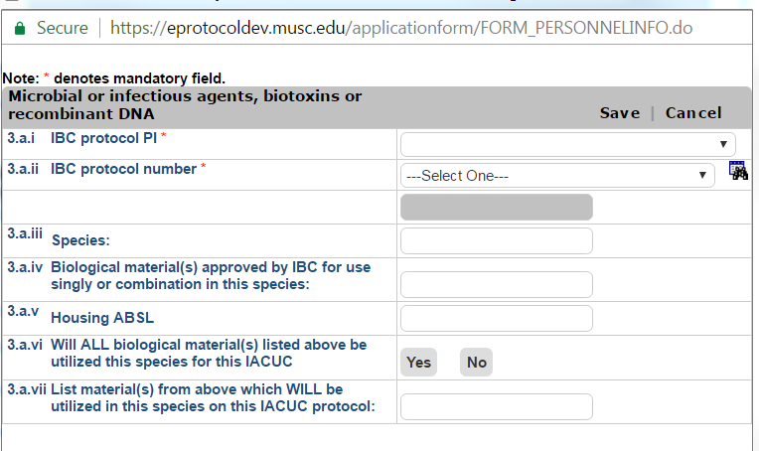
5
4

- From the popup below, select the relevant rows [6] that you want to include in your IACUC protocol. You can only click one row at a time. Then hit Save [7].
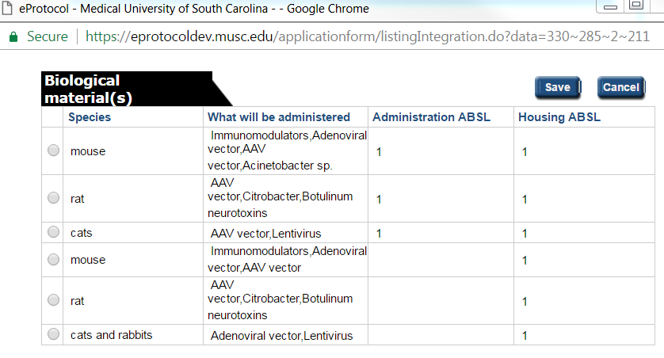
6
7
- Items 3.a.iii-v in the popup window below are now automatically filled out [8]. Answer 3.a.vi [9] and vii and hit Save [10].
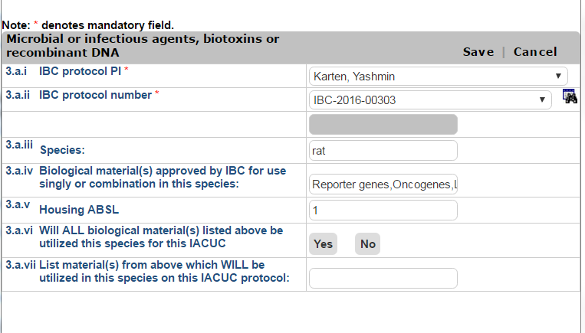
9
8
10
- To add additional procedures to the list “Special Considerations” Question 3, go back to step [3] above and repeat.
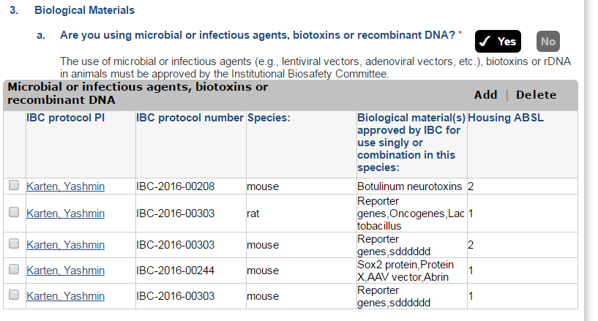

Flow Chart overview of eProtocol IBC sections
Some sections of the protocol will remain locked unless a particular question is answered in a way that requires that part of the form to be filled out. Then, the section will become unlocked :

New IBC application

Storage only?

YES
NO
“Storage Only”
protocol
Title
Yes : Section 10

Dual Use?

“Active Use”
protocol
Submit
List locations
List inventory
YES
List locations
NO
NO

Animals?

Section 8
YES
Section 7

Human subjects?

List ‘research activities’
Section 2
Viral vectors
Micro-organisms
Biological toxin
Section 3
Section 4
Section 5
Section 6
rDNA/RNA
Submit
Safety Protocols
Section 11
Title + Summary
Section 1
Community consideration: Section 9

