South Carolina Spinal Cord Injury Research Fund

Fiscal Year 2024 (FY24) Annual Report

# EXECUTIVE SUMMARY

Injury to the spinal cord can be irreversible and may cause permanent disability. The consequences of spinal cord injury (SCI) may include paralysis, loss of sensation, loss of control over movement and bodily functions, chronic pain, metabolic disorders, and complications such as uncontrolled blood pressure and infections. People with SCI may face extra demands due to the costs of medical care and rehabilitation and the absence of environmental support. Family members of people with SCI may also be affected.

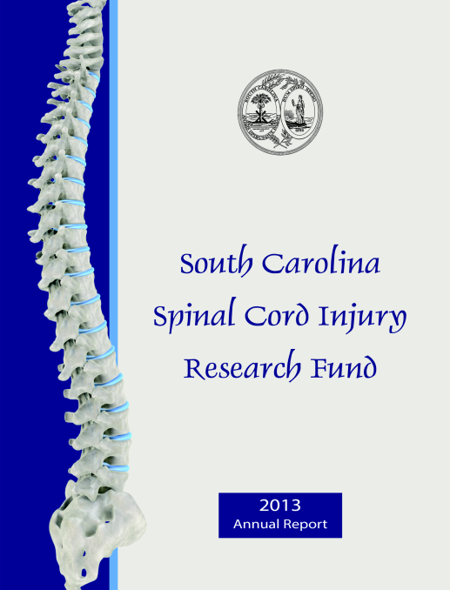The South Carolina Spinal Cord Injury Research Fund (SCIRF) was established by Amendment (Bill S54 44-38-510) of the SC Code ratified on July 20, 2000. The SCIRF is provided from a $100 surcharge on each Driving Under the Influence (DUI) conviction in the state. Surcharges are used to finance SCI research in South Carolina as well as cover the basic operation costs of the SCIRF. The SCIRF is governed by a seven member Board of Directors (BOD) appointed by the Governor upon recommendation of the President of the Medical University of South Carolina (MUSC) and is attached to MUSC for adminstrative purposes.

The long-term goal of the SCIRF is to interrupt or reverse the process of such injuries, and improve the health and quality of life for residents of South Carolina who have an SCI. This will reduce both the human and econmic cost of SCI for people in South Carolina.

The SCIRF BOD is charged with promoting research to develop better understanding of causes and effective treatment strategies for paralysis, sensory loss and other consequences of SCI and disease with a primary objective of advancing knowledge of SCI repair and regeneration within the South Carolina research community by encouraging physicians and scientists to apply expertise to the SCI field.

The BOD includes two medical doctors specializing or significantly engaged in the treatment of SCI, two people with an SCI or a family member with an SCI, two medical doctors from MUSC, and one medical doctor at large who is a member of the South Carolina Medical Association. The SCIRF has a full time Executive Director, part time Scientific Director and part time Associate Scientific Director. Board meetings are held two times per year in various locations throughout South Carolina.

The SCIRF BOD had seven open Requests for Proposals (RFPs) in order to solicit proposals from physicians, scientists and researchers throughout the state related to Primary Research, Pilot Research, Student Research Internship, Bridge Support, Recruitment/Seed Support, Postdoctoral Research, and Conference/Education/Training. All RFP details can be found on the [SCIRF Website](https://research.musc.edu/partnerships/scirf/rfp).

The SCIRF made five awards in FY24 and one no cost extension. Two of our grantees concluded their work in FY24 . As of the end of FY24 we had ten active grantees including our Administrative and Research Cores.

The SCIRF supports a variety of research activities that include basic science, clinical, epidemiologic, rehabilitative, and translational studies. Examples of the range of research include: 1) “bench science” to identify injury and recovery mechanisms 2) animal interventions that can be translated into 3) clinical trials in humans. Before clinical trials in humans 4) participant identification must occur as well as 5) a more complete understanding of health care access and health outcomes after SCI.

We support these multiple types of research to improve the lives of people with SCI, while concurrently creating opportunities for investigators within the state of South Carolina to successfully compete for larger federal grants that both bring new money into the state and advance knowledge used to help people with SCI.

The SCIRF income derived from the DUI surcharge is collected monthly. Collections for FY24 were $542,079.94 with an average monthly collection of $45,173.33.

We look forward to the upcoming year and are pleased to present this FY24 Annual Report.

*South Carolina Spinal Cord Injury Research Fund*

*Catherine Leigh Graham, MEBME – Executive Director*

*Phone: 843-614-1756*

*Email:* [*grahacat@musc.edu*](mailto:grahacat@musc.edu)

*Website:* *www.scscirf.org*

# **INDEX**

**Page**

Executive Summary 1

Index 3

Letter from Executive Director and Board Chair 4

Letter from Scientific Directors 5

**PART I: Overview 6**

**PART II: Requests for Proposals (RFP) 8**

**PART III: New Awards/Extensions 9**

**PART IV: Awards Closed 10**

**PART V: Active Awards 11**

**PART VI: Income 12**

**PART VII: Financial Overview 13**

**PART VIII: Directors 14**

**PART IX: Research Overview 17**

# LETTER FROM THE EXECUTIVE DIRECTOR AND BOARD CHAIR

Dear Friends and Supporters:

On behalf of the Board of Directors and the Executive Director, it is our pleasure to present the fiscal year 2024 (FY24) Report. This report highlights the progress and accomplishments in implementing the legislative mandate of promoting spinal cord injury (SCI) research throughout South Carolina from July 1, 2023-June 30, 2024.

The South Carolina Spinal Cord Injury Research Fund (SCIRF) received monthly DUI (Driving Under the Influence) collections. The monthly average and yearly collections for FY24 were $45,173.33 and $542,079.94, respectively, which were a slight increase over FY23 collections. We continue to judiciously award grants as funds allow, while working to promote high quality SCI research and its translation within the state of South Carolina.

The SCIRF continues to be a source of research funding for South Carolina entities that respond to the public requests for proposal (RFP) announcements. In the past year, the SCIRF promoted and supported SCI research through seven RFPs. Applications were reviewed for both scientific merit, often involving outside scientific reviewers knowledgeable with the topic, and for relevance to the mission of SCIRF. The SCIRF held our 6th Scientific Conference showcasing the impact that SCIRF funding has made in SC researchers garnering extramural funding to continue SCI research.

The SCIRF made five new awards in FY24 and one no cost extension. Two of our awardees concluded their research in FY24. As of the end of FY24, the SCIRF had 10 active grantees including our Administrative and Research Cores.

We are pleased to provide this annual report for FY24.

Respectfully submitted,

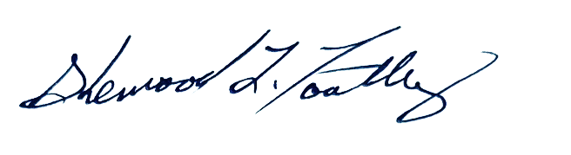

Sherwood L. Toatley Catherine Leigh Graham, MEBME

Board Chair Executive Director

# LETTER FROM THE SCIENTIFIC DIRECTORS

Spinal cord injury (SCI) continues to occur and result in severe disability, despite national and international efforts to improve function and outcomes. As scientific directors of the SCIRF, we have continued to support research conducted in South Carolina to improve outcomes for people with SCI, particularly those within the state. The SCIRF continues its dedication to advance knowledge through research and to use our funds to seed projects that may lead to further development and bring additional money and resources into the state of South Carolina.

We continue to support and fund research in the state of South Carolina and to emphasize those areas of research that are of national importance. This includes basic science research that directly attempts to find solutions to improve neurologic function and recovery; rehabilitative interventions that utilize state-of-the-art techniques to improve function using the individual’s abilities given their level of injury and state-of-the-art methods; and investigations of outcomes among those with SCI. These efforts require diverse methodologies and funding mechanisms.

We are proud of the accomplishments of investigators in the state of South Carolina. We are not large in number, but we are mighty. The research on SCI has visibility within the state and that visibility no doubt has helped to lead to more clinical options for people with SCI.

Both of us look forward to the upcoming year.

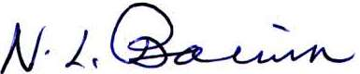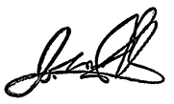

James S. Krause, PhD Naren L. Banik, PhD

Scientific Director Associate Scientific Director

# PART I: OVERVIEW

## PURPOSE/CHARGE

Promoting research to develop better understanding of causes and effective treatment strategies for paralysis, sensory loss, and other consequences of SCI and disease.

## NEED

Injury to the spinal cord can be irreversible and may cause permanent disability. The consequences of spinal cord injury (SCI) may include paralysis, loss of sensation, loss of control over movement and bodily functions, chronic pain, metabolic disorders, and complications such as uncontrolled blood pressure and infections. People with SCI may face extra demands due to the costs of medical care and rehabilitation and the absence of environmental support. Family members of people with SCI may also be affected. The long-term goal of the SCIRF is to minimize the risk and incidence of SCI, interrupt or reverse the process of such injuries, and improve the health and quality of life for residents of South Carolina who have an SCI.

## LEGISLATIVE BACKGROUND

The South Carolina SCIRF was established by the South Carolina General Assembly in 2000 by amendment (Bill S54 44-38-510) to Section 2, Chapter 38, Title 44 of the 1976 S.C. Code as signed by the Governor on July 20, 2000. The legislation calls for a $100 surcharge to be levied on every South Carolina “Driving Under the Influence” conviction. The proceeds from this surcharge go to the SCIRF and are used to finance SCI research in South Carolina as well as cover basic operation and administrative costs for the SCIRF.

## GOVERNANCE

The SCIRF is governed by a seven-member Board of Directors (BOD) appointed by the Governor upon the recommendation of the President of the Medical University of South Carolina (MUSC). It is comprised of two medical doctors specializing or significantly engaged in the treatment of people with SCI in South Carolina; two members who have an SCI or have a family member with an SCI; two medical doctors from MUSC, and one at large medical doctor who is a member of the South Carolina Medical Association.

## ADMINISTRATION/SCIENTIFIC DIRECTORS

The SCIRF is attached to MUSC for administrative purposes. The SCIRF has a full time Executive Director, Catherine Leigh Graham, MEBME, a part time Scientific Director, James S. Krause, PhD, and a part time Associate Scientific Director, Naren L. Banik, PhD. The Scientific Directors are involved in aspects of all research development and implementation including setting goals, developing project invitations to meet goals, and making recommendations based on their reviews to the SCIRF BOD of all such projects received.

## PRIMARY OBJECTIVES

Advance knowledge of SCI repair and regeneration within the South Carolina research community by encouraging physicians and scientists to apply expertise to the SCI field.

Foster collaborative interdisciplinary approaches to SCI research among South Carolina hospitals, rehabilitative centers, research universities, and interested organizations.

Nurture next generation of SCI researchers throughsupport of young scientists and post-doctoral fellows.

Improve the well-being and quality of life of individuals with SCI by research programs that prevent or treat the secondary conditions and consequences of SCI.

Set budgets and administer funds for SCI research as mandated by the South Carolina Legislative Act and assure highest quality of research and commitment by investigators.

# PART II: REQUESTS FOR PROPOSALS (RFP)

The SCIRF has maintained a focus on building research infrastructure, expertise and capacity throughout South Carolina. In order to accomplish this task, the SCIRF posted seven RFP’s throughout FY24 which can be found on the SCIRF website under [Request for Proposals](https://research.musc.edu/partnerships/scirf/rfp). We encourage any potential investigators to contact the Scientific Directors for additional information.

## RFP I (Investigator Initiated Research)

Investigator Initiated Research grants support clinicians, therapists, educators, and scientists in South Carolina researching aspects of spinal cord injury in an effort to develop a better understanding and ultimately treatment for paralysis and other consequences of spinal cord injury and spinal cord disease.

## RFP P (Pilot)

Pilot Research grants are to support investigators who need to collect pilot data to position themselves for extramural grants.

## RFP S (Student Research Internship)

Student Research Internship grants support the mentor of a student in medicine, nursing, health professions, epidemiology, neuroscience or other related fields that apply to basic, clinical or translational research with spinal cord injury or spinal cord disease.

## RFP PD (Postdoctoral Research)

Postdoctoral Research grants increase the number of individuals with doctorates who seek postdoctoral training in SCI, working with a mentor who has an independent program of research in SCI.

## RFP B (Bridge Funding)

Bridge Funding grants provide an investigator, with a research program in spinal cord injury with a research grant whose federal competing continuation application was not funded, an opportunity to obtain one year of bridge support.

## RFP R (Recruitment/Seed Funding)

Recruitment/Seed Funding grants promote the recruitment/seed funding for scientists and clinician scientists, who specialize in the area of spinal cord injury, to the state of South Carolina.

## RFP CET (Conference/Education/Training)

Conference/Education/Training grants support entities that will improve the knowledge of people with SCI in South Carolina and/or health care professionals that provide care for people with spinal cord injuries in South Carolina.

# PART III: NEW AWARDS/EXTENSIONS

## New Awards in FY24

**2022 SI-01 Basic Science Research Initiative**

Naren L. Banik, PhD, Professor, Dept of Neurosurgery – Medical University of South Carolina

Special Initiative Award

(7/1/2023–6/30/2028 for $693,980)

**2023 I-01 Evaluation of toxicity and therapeutic treatment window of rolipram-loaded PgP for SCI**

Jeoung Soo Lee, PhD, Associate Professor – Clemson University

Investigator Initiated Award

(7/1/2023-6/30/2025 for $150,000)

**2023 PD-01 Enhancing upper extremity motor function recovery through targeting corticospinal plasticity in people with chronic cervical SCI**

Aiko K. Thompson, PhD, Associate Professor, Dept of Health Sciences and Research – Medical University of South Carolina

Post Doc Award

(1/1/2024-12/31/2024 for $67,459)

**2023 P-01 Unbiased Computational Drug Discovery to Target Inflammatory Microglia**

Susana R. Cerqueira, PhD – Research Assistant Professor, Dept of Bioengineering – Clemson University

Pilot Research Award

(3/1/2024-2/28/2025 for $30,000)

**2024 S-01 Evaluation of toxicity and therapeutic treatment window of rolipram-loaded PgP for SCI**

Jeoung Soo Lee, PhD, Associate Professor – Clemson University

Student Award

(7/1/2023-6/30/2025 for $150,000)

## No Cost Extensions in FY24

**2017 SI-02 Measuring Outcomes after SCI throughout South Carolina: Statewide Outcomes Database**

James S. Krause, PhD, Professor and Associate Dean for Research, College of Health Professions – Medical University of South Carolina

Special Initiative Award

(1/1/2019-12/31/2023 for $799,127, *extension 12/31/2024)

# PART IV: AWARDS CLOSED in FY24

**2022 PD-01 Inducing corticospinal plasticity for improving upper extremity motor function recovery in people with chronic cervical spinal cord injury**

Aiko K. Thompson, PhD, Associate Professor, Dept of Health Sciences and Research – Medical University of South Carolina

Post Doc Award

(1/1/2023-12/31/2023 for $67,494)

**2022 CET-01 SC Spinal Cord Injury Research Fund 2023 Scientific Conference**

Catherine Leigh Graham, MEBME, Executive Director – SC Spinal Cord Injury Research Fund

Conference/Education/Training Award

(1/1/2023-12/31/2023 for $24,850)

# PART V: ACTIVE AWARDS (as of the end of FY24)

|  |  |  |  |
| --- | --- | --- | --- |
| **Grant #** | **Title** | **PI** | **Insti-tution** |
| Admin.  Core | SCIRF Administrative Core Services | Graham | N/A |
| Research  Core | SCIRF Research Core Services | Krause | N/A |
| 2017 SI-02 | Measuring Outcomes after SCI throughout South Carolina: Statewide Outcomes Database | Krause | MUSC |
| 2021 SI-01 | SC Traumatic SCI Surveillance & Registry | Selassie | MUSC |
| 2022 P-01 | Contrast Enhanced Ultrasound for the Evaluation of Intraoperative SCI following Surgical Decompression of a Chronically Compressed Spinal Cord | Saway | MUSC |
| 2022 SI-01 | Infrastructure Laboratory for SCI Research | Banik | MUSC |
| 2023 I-01 | Evaluation of toxicity and therapeutic treatment window of rolipram-loaded PgP for SCI | Lee | Clemson |
| 2023 PD-01 | Enhancing upper extremity motor function recovery through targeting corticospinal plasticity in people with chronic cervical SCI | Thompson | MUSC |
| 2023 P-01 | Unbiased Computational Drug Discovery to Target Inflammatory Microglia | Cerqueira | Clemson |
| 2024 S-01 | Evaluation of toxicity and therapeutic treatment window of rolipram-loaded PgP for SCI | Lee | Clemson |

# PART VI: INCOME

The income to the SCIRF comes exclusively from revenue attributed to a $100 fee levied on every “Driving Under the Influence” (DUI) conviction in South Carolina. MUSC is the legislated administrator of these collected funds and is the state agency responsible for their oversight.

The $100 per DUI surcharges are received monthly throughout each fiscal year. Below is the table of monthly collections for FY24. The total collected was $542,079.94 with a monthly average of $45,173.33.

|  |  |
| --- | --- |
| **Month** | **2023-2024** |
| Jul | $ 43,726.73 |
| Aug | $ 38,141.66 |
| Sep | $ 41,659.73 |
| Oct | $ 46,390.97 |
| Nov | $ 47,954.51 |
| Dec | $ 39,303.74 |
| Jan | $ 33,471.97 |
| Feb | $ 49,178.27 |
| Mar | $ 47,643.85 |
| Apr | $ 54,947.68 |
| May | $ 51,760.39 |
| Jun | $ 47,900.44 |
| **FY TOTAL** | **$542,079.94** |
| **Monthly Average** | **$ 45,173.33** |

# PART VII: FINANCIAL OVERVIEW (March 2001 - June 2024)

Income (DUI Surcharges) $ 16,167,334.01

Expenditures $ (13,353,375.39)

Committed Funds $ (1,545,502.40)

BALANCE $ 1,268,456.22

# PART VIII: DIRECTORS (as of end of FY24)

## Board of Directors

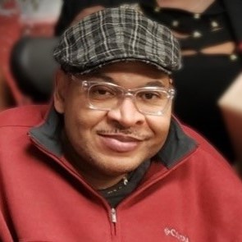**Sherwood L. Toatley - CHAIR**

Chapin, SC

(Category C) – Person with an SCI

Police Associate with the City of Columbia Police Department

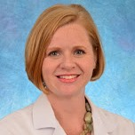**Heather W. Walker, MD**

Mount Pleasant, SC

(Category A) – Medical doctor from MUSC

PM&R, SCI Medicine, Medical Director

MUSC Rehabilitation Hospital/Encompass Health Affiliate

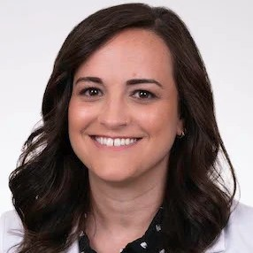

**Lindsay Mohney, DO**

Charleston, SC

(Category A) – Medical doctor from MUSC

Assistant Professor and Director of Inpatient Consultation at MUSC’s Department of Orthopedics and Physical Medicine

**Victoria L. Turgeon, PhD**

Greenville, SC

(Category C) – Family member of a person with an SCI

Professor, Furman University

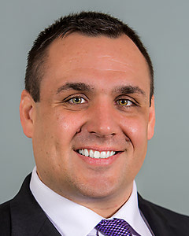

**David J. Powell, III, MD**

Mount Pleasant, SC

(Category B) – Medical doctor specializing in treatment of people with SCI

Medical Director, Center for Spinal Cord Injury at Roper Rehabilitation Hospital/St. Francis Health Care System

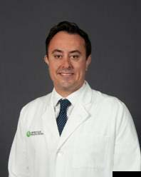**Jeffrey M. Derbas, MD**

Greenville, SC

(Category B) – Medical doctor specializing in treatment of people with SCI

Board Certified in Physical Medicine and Rehabilitation. SCI Medical Director at Prisma Health - Greenville

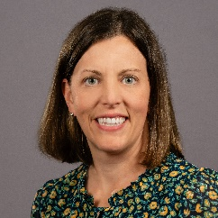**Jayne Donovan, MD**

Charleston, SC

(Category D) – At large medical doctor, member of the SC Medical Association

Physiatrist at Roper Rehabilitation Hospital

## Executive Director

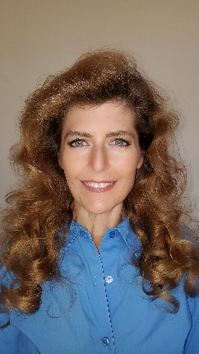

**Catherine Leigh Graham, MEBME**

***Executive Director***

W: 843-614-1756

Email: grahacat@musc.edu

## Scientific Directors

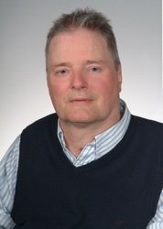

**James S. Krause, PhD**

***Scientific Director***

Associate Dean for Clinical Research College of Health Professions, MUSC

W: 843-792-1337

Email: krause@musc.edu

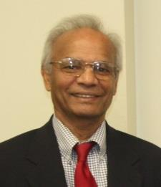**Naren L. Banik, PhD**

***Associate Scientific Director***

Professor, Department of Neurology and Neurosurgery, MUSC

W: 843-792-7594

Email: baniknl@musc.edu

## Terms

**Category A.** Two medical doctors from MUSC

**Heather W. Walker, MD** – (2026)

**Lindsay Mohney, DO** – (2027)

**Category B.** Two medical doctors at large specializing or significantly engaged in the treatment of people with an SCI

**Jeffrey M. Derbas, MD** – (2025)

**David J. Powell, III, MD** – (2026)

**Category C.** Two members who have an SCI or a family member with an SCI

**Victoria L. Turgeon, PhD** – (2026)

**Sherwood L. Toatley** – (2027)

**Category D.** One at large medical doctor who is a member of the SC Medical Association

**Jayne Donovan, MD** – (2028)

## Passing of the Gavel

The SCIRF Board of Directors elected Mr. Sherwood L. Toatley as the Board Chair at the fall Board meeting in 2023 and he began serving his first year as Chair in March of 2024.

## Meetings

The Board of Directors holds in-person meetings, usually two per year, to address the organization of the SCIRF as well as directional goals. Meeting dates and locations are listed below. The Board is responsible for approval of any proposals as well as budgets for Administrative and Research Core functions.

October 27, 2023 – Clemson University at Patewood in Greenville

March 29, 2024 - Virtual

# PART IX: RESEARCH OVERVIEW

During the past year, there have been multiple studies conducted in the areas of basic science and applied research, as well as a scientific conference that included both areas. The accomplishments over the past year have contributed to the overall state of the science within South Carolina. There were 8 funded projects at the end of 2024, exclusive of the administrative and scientific cores that relate to the overall functions of the SCIRF, with four projects each in basic and applied science. Additionally, the scientific conference was held in October.

Basic science.

Although Dr. Banik’s (MUSC) **Basic Science Research Initiative** ended, a great deal of data were generated from this earlier funding. Data were used by Dr. Haque, a previous SCIRF awarded investigator, to submit a grant to NIH to support the SCI research entitled “Enolase activation and neurodegeneration in SCI.” In addition, his letter of intent for submitting a proposal on SCI to the Department of Defense has been accepted, and the grant entitled “Enolase activation and neurodegeneration in SCI” has been submitted for the next DoD funding cycle.

Dr. Jeoung Soo Lee (Clemson) began her study “**Evaluation of toxicity and therapeutic treatment window of rolipram-loaded PgP (Rm-PgP) for SCI**.” Her study has shown promising results and is currently continuing its second year. Use of Rm-PgP in normal rats in single as well as repeated treatment is non-toxic. Testing the therapeutic efficacy indicated reduced inflammation in the rat SCI model and improved motor recovery with repeat treatment in the chronic SCI animals at 4 weeks post-injury. Dr. Lee also has a student grant (#2024 S-01) to expand this area of research.

Under Dr. Naren Banik’s (MUSC) **Infrastructure Laboratory for SCI Research**, work began to generate samples collected from the rat model of SCI at different levels of injury, including moderately severe (clinically relevant, 40gcf), severe (60gcf), and very severe (80gcf).

Applied science.

Dr. Aiko Thompson (MUSC) has continued her ongoing work on plasticity to improve function of those with SCI. Dr. Thompson’s Post Doc grant, mentoring fellow Allsion Foster Lewis, continues her work on “**Enhancing upper extremity motor function recovery through targeting corticospinal plasticity in people with chronic cervical SCI”** expanding to focus on upper extremity function, compared with lower extremity function used for gait. It is noteworthy that many people with SCI place a greater emphasis on being able to use their arms hands and fingers, compared with walking. Dr. Lewis has utilized data from the Statewide Outcomes Database (#2017 SI-02).

Dr. Brian Saway (MUSC) is making progress in a study entitled “**Contrast Enhances Ultrasound for The Evaluation of Intraoperative Spinal Cord Injury Following Surgical Decompression of a Chronically Compressed Spinal Cord**.” He will conclude his work in the latter half of 2024 and we look forward to presenting more results from his research in the FY25 Annual Report.

Dr. James Krause’s (MUSC) **Statewide Health Outcomes Database** has continued as a special initiative, collecting data on those newly injured with SCI and following them longitudinally over time. This study has been instrumental in tracking outcomes pre-and post-Covid. Although individuals often cite complications coming from Covid, as were reported last year in the annual report, inspection of actual pre-and post-pandemic changes suggests substantial resilience among those with SCI and stable outcomes over time. This initiative is now in a no cost extension where there will be considerable attention to the analysis, knowledge translation, and dissemination of the findings.

Lastly, the sixth **SCIRF Scientific Conference** was held at MUSC on November 3, 2023, under the leadership of Executive Director Catherine Leigh Graham and highlighted the work of multiple grantees in the areas of both basic and applied science and their acquisition of extramural funding. There were three guest keynote addresses: Elizabeth W. Regan, PhD, DPT (University of South Carolina), Dena P. Garner (PhD, Citadel), and Jon Roesler, MS (Minnesota Department of Health). Dr. Regan discussed the development of an adaptive rower for building aerobic capacity for people with SCI. Dr. Garner was trained in muscle atrophy in multiple sclerosis at Oregon Health Sciences University and later on the rat SCI model at MUSC. She discussed her work on muscle atrophy and the importance of creating a pipeline to train young scientists. Mr. Roesler drew attention to the connections between rehabilitation, which often ends formally when the individual leaves the rehabilitation hospital, and the extension into public health, which tracks the epidemiology of outcomes over time. This includes things such as emergency department visits and creates opportunities for linking individuals with services.

The excellent display of scientific work ranged from current and former grantees, including Dr. Susan Newman’s development of a community-based SCI peer navigator intervention as well as Dr. Aiko Thompson, who continues her work to improve gait and is working to expand this investigation to upper extremity function. Dr. Azizul Haque, a noted immunologist and well-known investigator on neurodegenerative diseases and SCI, stood in for Dr. Naren Banik to discuss the efficacy of estrogen therapy in acute and chronic SCI delivered at the injury site via fast and slow release nanoparticle gel patches. This treatment reduced inflammatory responses and muscle damage and improved bladder and locomotor function. Two SCIRF current Board members presented on exoskeletons for acute and chronic spinal cord injury.

Summary. This has been another successful year of research supported by the SCIRF, capped off by a scientific conference showcasing the work on SCI. We look forward to another year of continued success.

***South Carolina Spinal Cord Injury Research Fund***

***Executive Director: Catherine Leigh Graham, MEBME***

***Phone: 843-614-1756***

***Email:*** [***grahacat@musc.edu***](mailto:grahacat@musc.edu)

***Website:*** [***www.scscirf.org***](http://www.scscirf.org/)