South Carolina Spinal Cord Injury Research Fund
Fiscal Year 2018 (FY18) Annual Report
Executive Summary

Spinal cord injury (SCI) is a serious and usually irreversible cause of disability. The consequences of SCI are often severe and include paralysis, loss of sensation, loss of control over movement and bodily functions, chronic pain, metabolic disorders, and complications such as uncontrolled blood pressure and frequent infections. People with SCI may face extraordinary demands due to the costs of medical care and rehabilitation and the absence of environmental support. Family members of people with SCI are also affected.
The South Carolina Spinal Cord Injury Research Fund (SCIRF) was established by Amendment (Bill S54 44-38-510) of the SC Code ratified on July 20, 2000. The SCIRF is provided from a $100 surcharge on each Driving Under the Influence (DUI) conviction throughout the state. The monies
collected are used to finance SCI research in South Carolina as well as cover the basic operation costs. The SCIRF is governed by a seven member Board of Directors (BOD) appointed by the Governor upon recommendation of the President of the Medical University of South Carolina (MUSC) and is attached to MUSC for adminstrative purposes.
The long-term goal of the SCIRF is to minimize the risk and incidence of SCI, interrupt or reverse the process of such injuries, and improve the health and quality of life for residents of South Carolina who have an SCI.
The SCIRF BOD is charged with promoting research to develop better understanding of causes and effective treatment strategies for paralysis, sensory loss and other consequences of spinal cord injury and disease with the primary objective of advancing knowledge of SCI repair and regeneration within the South Carolina research community by encouraging physicians and scientists to apply expertise to the SCI field.
The BOD includes 2 medical doctors from MUSC, 2 medical doctors specializing or significantly engaged in the treatment of SCI, 2 people with an SCI or a family member with an SCI and 1 medical doctor at large who is a member of the South Carolina Medical Association. The SCIRF has a full time Executive Director, part time Scientific Director and part time Associate Scientific Director. Board meetings are held at least two times per year in various locations throughout South Carolina.
The SCIRF BOD had seven open Requests for Proposals (RFPs) in order to solicit proposals from physicians, scientists and researchers throughout the state related to Primary Research, Care/Access/Delivery, Career Development, Pilot Projects, Research Result Dissemination, Student Research Internship, Bridge Funding, Recruitment/Seed Funding, Postdoctoral Research, and Conference/Education/Training. All RFP details can be found on the website.
The SCIRF made one award in FY17 that started in FY18, six awards in FY18 with four awardees beginning work in FY18 and two starting in FY19. The SCIRF made 5 No Cost Extensions. Five of our grantees concluded their work in FY18. As of the end of FY18 we have 15 active grantees including our Administrative and Research Cores.
The SCIRF supports a variety of research activities that include basic science, clinical, epidemiologic, rehabilitative, and translational studies. Examples of the range of research include: 1) “bench science” to identify injury and recovery mechanisms 2) animal interventions that can be translated into 3) clinical trials in humans. Before clinical trials in humans 4) participant identification must occur as well as 5) a more complete understanding of health care access and health outcomes after SCI.
SCIRF supported activities have increased the number of clinicians and scientists in South Carolina that are focused on SCI research. Surveillance and outcome research projects are currently underway that enhance our understanding of the nature and scope of issues impacting the health of those with SCI. Key findings from studies have been presented at national and international conferences, and have been widely published in scientific journals where they may be used to promote better outcomes. SCIRF funded activities have also seeded federal research grants, bringing in millions of dollars to the state of South Carolina.
The SCIRF income derived from the DUI surcharge is collected on a monthly basis. The total collections for FY18 were $570,727.69 with an average monthly collection of $47,560.64 which is over a 13% decrease from the previous fiscal year.
We look forward to the upcoming year and are pleased to present this FY18 Annual Report.

South Carolina Spinal Cord Injury Research Fund
Catherine Leigh Graham, MEBME – Executive Director
Phone: 843-614-1756
Email: grahacat@musc.edu
Website: www.scscirf.org
INDEX

Page
Executive Summary 1
Index 3
Letter from Executive Director and Board Chair 4
Letter from Scientific Directors 5

PART I: Overview 7
PART II: New Awards/Extensions 9
PART III: Active Awards 11
PART IV: Requests for Proposals 13
PART V: Awards Closed 14
PART VI: Income 15
PART VII: Cash Analysis 16
PART VIII: Directors 17
PART IX: Research Overview 21

State of South Carolina
Spinal Cord Injury Research Fund Board

BOARD |  | STAFF
Kevin W. Kopera, MD |  | Catherine Leigh Graham, MEBME
Chair |  | Executive Director
M. Noreen Herring, MD  Sherron M. Jackson, MD  Stephen E. Rawe, MD  Victoria L. Turgeon, PhD  Abhay K. Varma, MD  Heather W. Walker, MD |  | James S. Krause, PhD
 |  | Scientific Director
 |  | Naren L. Banik, PhD
 |  | Associate Scientific Director

Dear Friends and Supporters:

On behalf of the Board of Directors, Scientific Directors and Executive Director, it is our pleasure to present the FY18 Report. This report highlights the progress and accomplishments in implementing the legislative mandate of promoting SCI research throughout South Carolina from July 1, 2017-June 30, 2018.

The SCIRF continued as a source of research funding for any South Carolina entity that responds to the public RFP announcements. In the past year, the SCIRF promoted and supported SCI research through seven RFPs. Applications were reviewed for both scientific merit, often involving outside scientific reviewers knowledgeable with the topic, and for relevance to the mission of SCIRF.

The SCIRF made six new grant awards as well as five no cost extensions. Four of these new awardees began their research in FY18 while two awardees will begin their research in FY19. Five awardees concluded their research in FY18. As of the end of FY18, the SCIRF had 15 active grantees including our Administrative and Research Cores. The ongoing technical progress reports and final reports for each grantee can be viewed on the SCIRF website.

The SCIRF continues to receive DUI collections on a monthly basis and saw a decrease over 13% from the previous year (FY17). The monthly average and yearly collection for FY18 are $47,560.64 and $570,727.69, respectively.

We are pleased to provide this annual report for FY18.

Respectfully submitted,
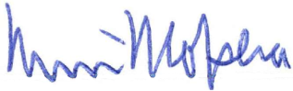
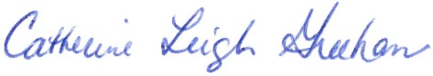

Kevin W. Kopera, MD Catherine Leigh Graham, MEBME
Board Chair Executive Director
State of South Carolina
Spinal Cord Injury Research Fund Board
BOARD |  | STAFF
Kevin W. Kopera, MD |  | Catherine Leigh Graham, MEBME
Chair |  | Executive Director
M. Noreen Herring, MD  Sherron M. Jackson, MD  Stephen E. Rawe, MD  Victoria L. Turgeon, PhD  Abhay K. Varma, MD  Heather W. Walker, MD |  | James S. Krause, PhD
 |  | Scientific Director
 |  | Naren L. Banik, PhD
 |  | Associate Scientific Director

Letter from the Scientific Directors

It is our distinct honor to provide scientific leadership for the South Carolina Spinal Cord Injury Research Fund (SCIRF) and its central mission to build research addressing the critical needs of people with spinal cord injury (SCI), emphasizing research of particular relevance in South Carolina. As we reflect upon the overall goal of enhancing the scope and diversity of research within the state, we see both the progress from where we have begun and the road ahead. We see an emerging and ever-changing field of SCI research and rehabilitation. As we progress towards the goal of improving function through basic science, discovery, translational, and rehabilitation research, we see new issues emerging for those with SCI.
Our ability to respond to all of the issues that impinge upon those with SCI is greatly determined by our capacity to identify these issues, facilitate the conduct of research, and ultimately develop intervention strategies to improve the lives of people with SCI. We maintain a broad perspective with regards to research, utilizing a number of funding mechanisms that match the potential for investigators within the state to address key issues. Our funding mechanisms are intended to promote investigator initiated research, those ideas brought forward by investigators, with several types of research mechanisms (e.g., basic science, rehabilitation). We have mechanisms for gathering pilot data that are essential to moving from ideas to concrete science and research plans. These mechanisms also account for the needs of those established investigators who wish to identify new areas of study or who may need a bridge from past research to new areas of research. We also promote multiple mechanisms for the training of students, postdoctoral fellows, and new investigators.
One of the important functions of the SCIRF is to develop the infrastructure for research so we may conduct the research, as well as the infrastructure needed for translating interventions from research. In the last couple of years, we have emphasized infrastructure with the basic sciences, ensuring that what has been established as a resource for research will continue into the future.
We continue to see the success of our research activities in many ways. As an example, one of our formerly funded investigators utilized her SCIRF funding to expand her study and obtain federal funding on a study of peer mentoring. This is a form of self-help which shows the translation of research into practical solutions for everyday life. Other research has received national recognition for drawing attention to the importance of pain medication misuse, helping us to understand the circumstances and individual behaviors that may lead to a risk of opioid misuse.
A review of the funded projects from the past year shows the strength and diversity of the projects, with particular strengths in basic science. Investigator initiated and pilot projects address multiple basic neurologic systems, with current awards focused on axonal stress, basic science infrastructure, the calpain system, nanotherapeutics, neuron-specific enolase, combination therapy, and cellular model systems. Applied research includes projects of ongoing support for the statewide SCI Association and SCI surveillance, with projects on ankle stretching, indirect costs of SCI due to lost employment/wages, and several projects wrapping up this year, which include tracking SCI outcomes, virtual reality exercise training, and modulation of stress reflexes. There is also a new project bridging the gap between basic and applied sciences focusing on microbial infections.
The work within our state lays the foundation for helping those with SCI well beyond our state borders, yet our work continues to be focused on improvement of function and the reduction of costly secondary health conditions which burden the healthcare system and may affect the quality of life and even longevity of those with SCI. Combining all types of research enables those with SCI in South Carolina to have access to interventions and services through research that might otherwise not be available. Research is essential for promoting the health, quality of life, and longevity of those with SCI.
There is no question that grants from the SCIRF have resulted in several accomplishments. Funding from federal agencies has grown in recent years. We continue to bring new research expertise into the state, which carries over to clinical service. The service, in turn, provides the opportunity to implement new interventions for people in South Carolina. Some funded activities identify individuals and their health challenges so that we may identify those who may benefit from interventions and offer them the opportunity to participate in these interventions.
As Scientific Directors, we continue our career long commitment to research with SCI. Each of us builds upon over 30 years of direct experience with SCI research, one of us focused in the basic sciences (Banik) and the other in applied sciences (Krause). We are grateful for the opportunity to provide leadership and vision to the SCIRF, and we look forward to another year of dedicated work to advance knowledge, service, and, ultimately, the health and quality of life of people with SCI.

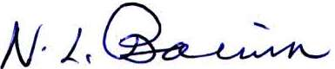

James S. Krause, PhD Naren L. Banik, PhD
Scientific Director Associate Scientific Director
PART I: OVERVIEW

PURPOSE/CHARGE
Promoting research to develop better understanding of causes and effective treatment strategies for paralysis, sensory loss, and other consequences of SCI and disease.

NEED
SCI is a serious and usually irreversible cause of disability. The consequences of SCI are often severe and include paralysis, loss of sensation, loss of control over movement and bodily functions, chronic pain, metabolic disorders, and complications such as uncontrolled blood pressure and frequent infections. People with SCI may face extraordinary demands due to the costs of medical care and rehabilitation and the absence of environmental support. Family members of people with SCI are also affected. The long-term goal of the SCIRF is to minimize the risk and incidence of SCI, interrupt or reverse the process of such injuries, and improve the health and quality of life for residents of South Carolina who have an SCI.

LEGISLATIVE BACKGROUND
The South Carolina SCIRF was established by the South Carolina General Assembly in 2000 by amendment (Bill S54 44-38-510) to Section 2, Chapter 38, Title 44 of the 1976 S.C. Code as signed by the Governor on July 20, 2000. The legislation calls for a $100 surcharge to be levied on every South Carolina “Driving Under the Influence” conviction. The proceeds from this surcharge go to the SCIRF and are used to finance SCI research in South Carolina as well as cover basic operation and administrative costs for the SCIRF.

GOVERNANCE
The SCIRF is governed by a seven member Board of Directors (BOD) appointed by the Governor upon the recommendation of the President of the Medical University of South Carolina (MUSC). It is comprised of two medical doctors from MUSC; two medical doctors specializing or significantly engaged in the treatment of people with SCI in South Carolina; two members who have an SCI or have a family member with an SCI; and one at large medical doctor who is a member of the South Carolina Medical Association.

ADMINISTRATION/SCIENTIFIC DIRECTORS
The SCIRF is attached to MUSC for administrative purposes. The SCIRF has a full time Executive Director, Catherine Leigh Graham, MEBME, a part time Scientific Director, James S. Krause, PhD, and a part time Associate Scientific Director, Naren L. Banik, PhD.
The Scientific Directors are involved in all aspects of all research development and implementation including setting goals, developing project invitations to meet goals, and making recommendations based on their reviews to the SCIRF BOD of all such projects received.

PRIMARY OBJECTIVES
Advance knowledge of SCI repair and regeneration within the South Carolina research community by encouraging physicians and scientists to apply expertise to the SCI field.
- Foster collaborative interdisciplinary approaches to SCI research among South Carolina hospitals, rehabilitative centers, research universities, and interested organizations.
- Nurture next generation of SCI researchers through support of young scientists and post-doctoral fellows.
- Improve the well-being and quality of life of individuals with SCI by research programs that prevent or treat the secondary conditions and consequences of SCI.
- Set budgets and administer funds for SCI research as mandated by the South Carolina Legislative Act, and assure highest quality of research and commitment by investigators.

PART II: NEW AWARDS/EXTENSIONS

New awards made in FY17 but started in FY18
- #2016 I-04 The Indirect costs of SCI in SC due to lost earnings: Relationships with secondary conditions and medical expenses
Yue Cao, PhD – Medical University of South Carolina
Investigator Initiated Research Award
(10/1/2017-9/30/2019 for $142,973)

New awards made in FY18 and started in FY18

- #2017 SI-01 SCIA Cooperative Agreement
Angela Rodriguez, MSW – Executive Director – South Carolina Spinal Cord Injury Association
Dissemination Award
(11/1/2017-10/30/2019 for $46,321)

- #2017 B-01 Multifunctional nanotherapeutics for Spinal Cord Injury Repair
Jeoung Soo Lee, PhD, Assistant Professor – Clemson University
Bridge Funding Award
(4/1/2018-3/31/2019 for $66,000)

- #2017 P-01 Establishment of a systematic protocol for assessment of microbial infections in people living with SCI
Pilot Grant Award
Anindya Chanda, PhD, Assistant Professor – University of South Carolina
(4/15/2018-4/14/209 for $29,595)

- #2017 I-01 Targeting neuronal NOS/peroxynitrite/calpain system as a therapeutic strategy for the treatment of spinal cord injury
Investigator Initiated Research Award
Mushfiquddin Khan, PhD, Associate Professor – Medical University of South Carolina
(7/1/2018-6/30/2020 for $150,000)

New awards made in FY18 but starting in FY19

- 2018 PD-01 Targeting axonal stress granules to improve axon regeneration
Postdoctoral Research Award
Jeffery L. Twiss, MD, PhD, Professor – University of South Carolina
(7/1/2018-6/30/2019 for $67,500)

- #2018 SpecReq-01 MUSC Research Laboratory
Special Request Award
Naren L. Banik, PhD, Professor – Medical University of South Carolina
(7/1/2018-6/30/2019)

No Cost Extensions in FY18

- #2016 I-01 Lower-Limb (Ankle) Stretching Device via the Vittori Device
Elizabeth DuBose, DPT, CBIS – Greenville Hospital System/Roger C. Peace Rehabilitation Hospital
Investigator Initiated Research Award
(10/1/2016-9/30/2018 for $150,000, No Cost Extension 9/30/2019)

- #2014 I-01 Community-based Virtual Reality Group Exercise Training in Persons with SCI
Jennifer Trilk, PhD – University of South Carolina School of Medicine Greenville
Investigator Initiated Research Award
(12/1/2014-11/30/2016 for $79,954, extension 11/30/2017, No Cost Extension 5/31/2018)

- #2015 I-01 Novel combination therapy for neuroprotection in spinal cord injury
Swapan K. Ray, PhD – University of South Carolina School of Medicine
Investigator Initiated Research Award
(7/1/2015-6/30/2017 for $80,000, No Cost Extension 6/30/2018, 6/30/2019)

- #2014 R-01 Modulation of Stretch Reflexes during Walking in People after SCI
Aiko K. Thompson, PhD, Associate Professor – Medical University of South Carolina
Recruitment/Seed Award
(3/1/2015-2/28/2018 for $117,599, No Cost Extension 2/28/2019)

- #2015 I-02 Establishment of cellular model systems to investigate and manipulate the hostile environment produced by thrombin following spinal cord injury
Victoria L. Turgeon, PhD, Associate Professor – Furman University
Investigator Initiated Award
(2/1/2016-1/30/2018 for $79,568, No Cost Extension 1/30/219)

PART III: ACTIVE AWARDS (as of the end of FY18)

All Technical Progress Report and Final Reports can be found on the website under each respective Grant #.
Grant # | Title | PI | Insti-tution
Admin.  Core | SCIRF Administrative Core Services | Graham | N/A
Research  Core | SCIRF Research Core Services | Krause | N/A
09-001 | Measuring Outcomes after SCI throughout SC: A System of Tracking, Research, & Referral | Krause | MUSC CHP
2014 I-01 | Community-based Virtual Reality Group Exercise Training in Persons with SCI | Trilk/Kopera | USCSOM Gvl, RCP
2014 R-01 | Modulation of Stretch Reflexes during Walking in People after SCI | Thompson | MUSC CHP
2015 I-01 | Novel combination therapy for neuroprotection in SCI | Ray | USCSOM
2015 I-02 | Establishment of cellular model systems to investigate & manipulate the hostile environment produced by thrombin following SCI | Turgeon | Furman
2016 SI-02 | SC Traumatic SCI Surveillance & Registry | Selassie | MUSC
2016 SI-03 | Basic Science Research Initiative | Banik | MUSC
2016 I-01 | Lower-Limb (Ankle) Stretching Device via the Vittori Device | DuBose | GHS
2016 I-04 | Indirect Costs of SCI in SC due to lost earnings | Cao | MUSC
2017 SI-01 | SCIA Cooperative Agreement | Rodriguez | SCIA
2017 B-01 | Multifunctional nanotherapeutics for Spinal Cord Injury Repair | Lee | Clemson
2017 P-01 | Establishment of a systematic protocol for assessment of microbial infections in people living with SCI | Chanda | USC
2017 I-01 | Targeting neuronal NOS/peroxynitrite/calpain system as a therapeutic strategy for the treatment of SCI | Khan | MUSC

PART IV: REQUESTS FOR PROPOSALS (RFP)

The SCIRF has maintained a focus on building research infrastructure, expertise and capacity throughout South Carolina. In order to accomplish this task, the SCIRF BOD posted throughout FY18 and can be found on the website under Request for Proposals. The name of each RFP includes the year that the RFP was last modified.

RFP 2017-P (Pilot)
Status: Open

RFP 2017-S (Student Research Internship)
Status: Open

RFP 2018-I (Investigator Initiated Research)
Status: Recurring Deadlines of January 15th and August 15th

RFP 2017-B (Bridge Funding)
Status: Open

RFP 2016-R (Recruitment/Seed Funding)
Status: Open

RFP 2017-CET (Conference/Education/Training)
Status: Open

RFP 2017 PD-Rev (Postdoctoral Research)
Status: Open

PART V: AWARDS CLOSED in FY18 (In Order of Date Awarded)

- #12-004 Cooperative Agreement between SCIRF and SCSCIA
Susan Newman, Board Member – SC Spinal Cord Injury Association
Dissemination
(11/1/2012-10/31/2017 for $193,397)

- #2015 I-03 Formoterol, an FDA-approved drug, stimulates mitochondrial biogenesis as a novel therapeutic strategy for spinal cord injury
Rick G. Schnellmann, PhD – Medical University of South Carolina; RHJ VAMC
Stephen Tomlinson, PhD – Medical University of South Carolina Department of Microbiology and Immunology
Investigator Initiated Research Award
(8/1/2015-7/31/2017 for $80,000)

- #2016 SI-01 Prospective Study Registry of Individuals in SC with SCI
Kevin K. Kopera, MD – Greenville Hospital System/Roger C. Peace Rehabilitation Hospital
Pilot Award
(6/1/2016-5/31/2017 for $33,389, extension 11/30/2017)

- #2016 I-03 Neuron-specific Enolase and SCI
Azizul Haque, PhD – Medical University of South Carolina
Investigator Initiated Research Award
(7/1/2016-6/30/2018 for $150,000)

- #2016 PD-01 State-of-the-Art Measurement in Monitoring Long-term Outcomes
Craig A. Velozo, PhD, OTR/L – Medical University of South Carolina
Postdoctoral Research Fellowship Award
(2/1/2017-1/30/2018 for $64,450)

PART VI: INCOME

The income to the SCIRF comes exclusively from revenue attributed to a $100 fee levied on every “Driving Under the Influence” (DUI) conviction in South Carolina. MUSC is the legislated administrator of these collected funds and is the state agency responsible for their oversight.

The $100 per DUI surcharges are received monthly throughout each fiscal year. Below is the table of monthly collections for FY18. The total collected was $570,727.69 with a monthly average of $47,560.64. This amount is a decrease of 13.1% from the previous fiscal year.

Month | 2017-2018
Jul | 53,409.98
Aug | 52,056.09
Sep | 49,393.35
Oct | 44,272.16
Nov | 53,088.30
Dec | 46,940.80
Jan | 35,581.23
Feb | 39,008.74
Mar | 51,449.69
Apr | 49,282.03
May | 49,918.91
Jun | 46,326.41
FY18 TOTAL | 570,727.69
Monthly Average | 47,560.64

PART VII: CASH ANALYSIS (Life to Date)
March 2001 - June 2018

Income (DUI Surcharge) |  |  |  | $ 13,336,095.54
Expenditures |  |  |  | $ (9,105,532.93)
Commitments |  |  |  | $ (2,139,865.80)
Proposals In Review
 | 2018 I-01 |  |  | $ (150,000.00)
 | 2017 SI-02 |  |  | $ (998,987.00)
 |  | BALANCE |  | $ 941,709.81

PART VIII: DIRECTORS (as of end of FY18)

Board of Directors

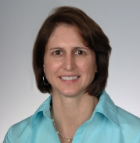
M. Noreen Herring, MD
Charleston, SC
(Category A) – Medical Doctor from MUSC
Specialist in Physical Medicine & Rehabilitation, Assistant Professor at MUSC Neuroscience Department
W: 843-792-3221

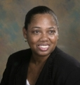
Sherron M. Jackson, MD
Charleston, SC
(Category C) – Family member with an SCI
Associate Professor of Pediatrics at MUSC
W: 843-792-2406

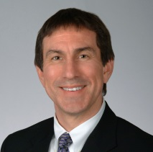
Kevin W. Kopera, MD, MPH - CHAIR
Greenville, SC
(Category B) – Medical Doctor specializing in treatment of people with SCI
Board Certified in Physical Medicine and Rehabilitation. Medical Director Roger C. Peace Rehabilitation Hospital
W: 864-455-3754

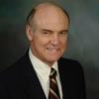
Stephen E. Rawe, MD
Charleston, SC
(Category D) – At large medical doctor, member of the SC Medical Association
Board Certified Neurosurgeon - Retired

Victoria L. Turgeon, PhD
Greenville, SC
(Category C) – Family member with an SCI
Professor, Furman University

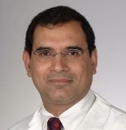
Abhay K. Varma, MD, MBBS
Mt. Pleasant, SC
(Category A) – Medical doctor from MUSC
Associate Professor of Neurosurgery at MUSC
W: 843-792-1308

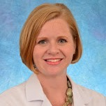
Heather W. Walker, MD
Mount Pleasant, SC
(Category B) – Medical Doctor specializing in treatment of people with SCI
PM& R, SCI Medicine, Program Director of Neuroscience Services
HealthSouth Rehabilitation Hospital
W: 843-820-7634

Executive Director

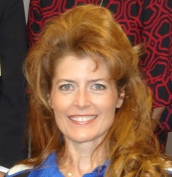
Catherine Leigh Graham, MEBME
Executive Director
W: 843-614-1756
Email: grahacat@musc.edu

Scientific Directors

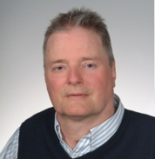
James S. Krause, PhD
Scientific Director
Associate Dean for Clinical Research College of Health Professions, MUSC
W: 843-792-1337
Email: krause@musc.edu

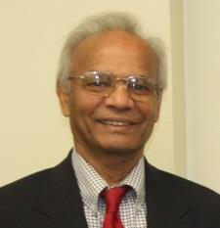
Naren L. Banik, PhD
Associate Scientific Director
Professor, Department of Neurology and Neuroscience, MUSC
W: 843-792-7594
Email: baniknl@musc.edu
Terms

The Board is comprised of the following Categories:

- Two medical doctors from MUSC;
- Two medical doctors at large specializing or significantly engaged in the treatment of people with an SCI;
- Two members who have an SCI or have a family member with an SCI; and,
- One at large medical doctor who is a member of the South Carolina Medical Association.

Category A. Two medical doctors from MUSC

M. Noreen Herring, MD – second term (2022)
Abhay K. Varma, MD – first term (2019)

Category B. Two medical doctors at large specializing or significantly engaged in the treatment of people with an SCI

Heather W. Walker, MD – first term (2021)
Kevin W. Kopera, MD, MPH – second term (2021)

Category C. Two members who have an SCI or a family member with an SCI

Victoria L. Turgeon, PhD – first term (2022)
Sherron M. Jackson, MD – first term (2019)

Category D. One at large medical doctor who is a member of the SC Medical Association

Stephen E. Rawe, MD – first term (2020)

Passing of the Gavel

The SCIRF BOD re-elected Dr. Kevin W. Kopera as the Board Chair at the fall Board meeting in 2017 and he began serving his fourth year as Chair in March of 2018.
Meetings
The BOD holds in-person meetings, usually 2-3 per year, to address the organization of the SCIRF as well as directional goals. Meeting dates, locations and select photos are included below. The BOD is responsible for approving all grants awarded as well as budgets for Administrative and Research Core functions.

November 3, 2017 – Patewood, Greenville

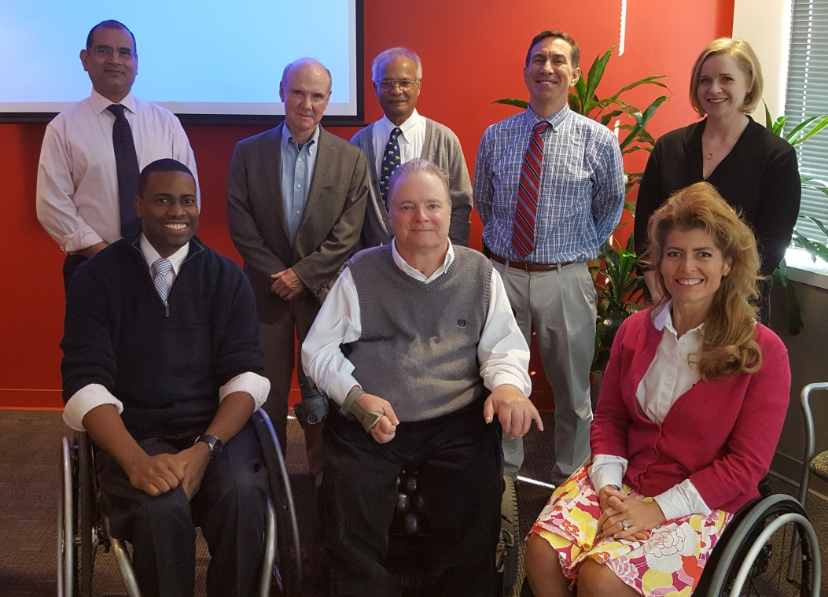
Back Row: Abhay K. Varma, Steve E. Rawe, Naren L. Banik,
Kevin W. Kopera, Heather W. Walker,
Front Row: Jeremy Chapman, James S. Krause, Catherine Leigh Graham

March 30, 2018 – MUSC, Charleston – No picture available

PART IX: RESEARCH OVERVIEW

During the past year, the SCIRF funded several types of activities that included: (1) basic science research, (2) epidemiologic research, (3) basic science infrastructure, (4) stakeholder involvement, and (5) training. These are essential areas to supporting the range of activities required to meet the SCIRF mission.
We are funding a new special initiative on infrastructure in basic science research under the leadership of Dr. Naren Banik. This initiative ensures key personnel will be available in the area of basic sciences. Other basic science studies a postdoctoral fellowship under the leadership of Dr. Jeffrey Twiss at the University of South Carolina. The focus of this project is on targeting axonal stress granules to improve axon regeneration. Another basic science proposal was funded as an investigator initiated study to Dr. Mushfiquddin Kahn at MUSC. This 2-year project is entitled, “Targeting neuronal NOS/peroxynitrite/calpain system as a therapeutic strategy for the treatment of spinal cord injury.” At Clemson University, Dr. Jeoung Soo Lee has been awarded bridge funding. This will help her maintain her laboratory, as she seeks federal funding. Her work relates to multifunctional nanotherapeutics for SCI repair. Another basic scientist at the University of South Carolina, Dr. Anindya Chanda, has a pilot project to collect preliminary data to bridge the gap between the basic and applied sciences related to microbial infections.
Another new award was made for a cooperative agreement between the SCIRF and the South Carolina SCI Association, a statewide stakeholder group, to disseminate research findings so they are more readily available for use by people with SCI.
We continue to support statewide surveillance under Dr. Anbesaw Selassie, which identifies all new instances of SCI treated acutely within the state of South Carolina. Dr. Yue Cao at MUSC also received an award in the previous year and has begun his project looking at indirect costs of SCI due to lost employment, as related to secondary health conditions.
In summary, this has been another strong year, particularly in the area of basic science research, with multiple opportunities created through SCIRF funding. We will continue to review and implement all possible means to promote the best possible outcomes for those with SCI in the state of South Carolina by supporting research, training, and knowledge translation.

South Carolina Spinal Cord Injury Research Fund
Executive Director: Catherine Leigh Graham, MEBME
Phone: 843-614-1756
Email: grahacat@musc.edu
Website: www.scscirf.org

