South Carolina Spinal Cord Injury Research Fund
FY 2016 Annual Report
Executive Summary

Spinal cord injury (SCI) is a serious and usually irreversible cause of disability. The consequences of SCI are often severe and include paralysis, loss of sensation, loss of control over movement and bodily functions, chronic pain, metabolic disorders, and complications such as uncontrolled blood pressure and frequent infections. People with SCI may face extraordinary demands due to the costs of medical care and rehabilitation and the absence of environmental support. Family members of people with SCI are also affected.
The South Carolina Spinal Cord Injury Research Fund (SCIRF) was established by Amendment (Bill S54 44-38-510) of the SC Code ratified on July 20, 2000. The SCIRF is provided from a $100 surcharge on each Driving Under the Influence (DUI) conviction throughout the state. The monies
collected are used to finance SCI research in South Carolina as well as cover the basic operation costs. The SCIRF is governed by a seven member Board of Directors (BOD) appointed by the Governor upon recommendation of the President of the Medical University of South Carolina (MUSC) and is attached to MUSC for adminstrative purposes.
The long-term goal of the SCIRF is to minimize the risk and incidence of SCI, interrupt or reverse the process of such injuries, and improve the health and quality of life for residents of South Carolina who have an SCI.
The SCIRF BOD is charged with promoting research to develop better understanding of causes and effective treatment strategies for paralysis, sensory loss and other consequences of spinal cord injury and disease with the primary objective of advancing knowledge of SCI repair and regeneration within the South Carolina research community by encouraging physicians and scientists to apply expertise to the SCI field.
The BOD includes 2 medical doctors from MUSC, 2 medical doctors specializing or significantly engaged in the treatment of SCI, 2 people with an SCI or a family member with an SCI and 1 medical doctor at large who is a member of the South Carolina Medical Association. The SCIRF has a full time Executive Director, part time Scientific Director and part time Associate Scientific Director. Board meetings are held at least two times per year in a variety of locations throughout South Carolina.
The SCIRF BOD posted seven updated and/or new Requests for Proposals (RFPs) in order to solicit proposals from physicians, scientists and researchers throughout the state related to Primary Research, Care/Access/Delivery, Career Development, Pilot Projects, Research Result Dissemination, Student Research Internship, Bridge Funding, Recruitment/Seed Funding, Postdoctoral Research, and Conference/Education/Training. All RFP details can be found on the website.
The SCIRF made nine awards in FY 2016 with six awardees beginning work in FY 2016 and three starting in FY 2017. Along with the new awards, we continue our support of our Administrative and Research Cores. Five of our grantees concluded their work in FY 2016. As of 6/30/2016 we have 13 active grantees in addition to our Administrative and Research Cores.
The SCIRF supports a variety of research activities that include basic science, clinical, epidemiologic, rehabilitative, and translational studies. Examples of the range of research include: 1) “bench science” to identify injury and recovery mechanisms 2) animal interventions that can be translated into 3) clinical trials in humans. Before clinical trials in humans 4) participant identification must occur as well as 5) a more complete understanding of health care access and health outcomes after SCI.
SCIRF supported activities have increased the number of clinicians and scientists in South Carolina that are focused on SCI research. Surveillance and outcome research projects are currently underway that enhance our understanding of the nature and scope of issues impacting the health of those with SCI. Key findings from studies have been presented at national and international conferences, and have been widely published in scientific journals where they may be used to promote better outcomes. SCIRF funded activities have also seeded federal research grants, bringing in millions of dollars to the state of South Carolina.
The SCIRF income derived from the DUI surcharge is collected on a monthly basis. The total collections for FY 2016 were $698,850.52 with an average monthly collection of $58,237.54. After accounting for committed funds on active grants, Adminstrative and Research Core support through the active grantee period, the balance remaining is $432,208.19.
We look forward to the upcoming year and are pleased to present this FY 2016 Annual Report.

South Carolina Spinal Cord Injury Research Fund
Catherine Leigh Graham, MEBME – Executive Director
Phone: 843-614-1756
Email: grahacat@musc.edu
Website: www.scscirf.org
INDEX

Page
Executive Summary 1
Index 3
Letter from Executive Director & Board Chair 4
Letter from Scientific Directors 5

PART I: Overview 7
PART II: New Awards/Extensions 9
PART III: Active Awards 11
PART IV: Requests for Proposals 13
PART V: Awards Closed 14
PART VI: Income 15
PART VII: Cash Analysis 16
PART VIII: Directors 17
PART IX: Research Overview 22

State of South Carolina
Spinal Cord Injury Research Fund Board

BOARD |  | STAFF
Kevin W. Kopera, MD |  | Catherine Leigh Graham, MEBME
Chair |  | Executive Director
Byron N. Bailey, MD  Jeremy S. Chapman  M. Noreen Herring, MD  Sherron M. Jackson, MD  Abhay K. Varma, MD  W. Daniel Westerkam, MD |  | James S. Krause, PhD
 |  | Scientific Director
 |  | Naren L. Banik, PhD
 |  | Associate Scientific Director

Dear Friends and Supporters:

On behalf of the Board of Directors, Scientific Directors and Executive Director, it is our pleasure to present the FY 2016 Report. This report highlights the progress and accomplishments in implementing the legislative mandate of promoting SCI research throughout South Carolina from July 1, 2015-June 30, 2016.

The SCIRF continued as a source of research funding for any South Carolina entity that responds to the public RFP announcements. In the past year, the SCIRF promoted and supported SCI research through seven RFPs including a new RFP for Postdoctoral Research. Applications were reviewed for both scientific merit, often involving outside scientific reviewers knowledgeable with the topic, and for relevance to the mission of SCIRF.

The SCIRF made nine new grant awards as well as two no cost extensions. Six of these new awardees began their research in FY 2016 while three will begin their research in FY 2017. Five awardees concluded their research in FY 2016. As of 6/30/2016 the SCIRF has 13 active grantees in addition to our Administrative and Research Cores. The ongoing technical progress reports and final reports for each grantee can be seen on the SCIRF website.

The SCIRF continues to receive DUI collections on a monthly basis. The monthly average and yearly collection for FY 2016 are $58,237.54 and $698,850.54, respectively.

We are pleased to provide this annual report for FY 2016.

Respectfully submitted,
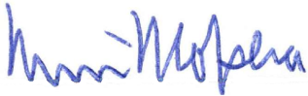

Kevin W. Kopera, MD Catherine Leigh Graham, MEBME
Board Chair Executive Director
State of South Carolina
Spinal Cord Injury Research Fund Board
BOARD |  | STAFF
Kevin W. Kopera, MD |  | Catherine Leigh Graham, MEBME
Chair |  | Executive Director
Byron N. Bailey, MD  Jeremy S. Chapman  M. Noreen Herring, MD  Sherron M. Jackson, MD  Abhay K. Varma, MD  W. Daniel Westerkam, MD |  | James S. Krause, PhD
 |  | Scientific Director
 |  | Naren L. Banik, PhD
 |  | Associate Scientific Director

Letter from the Scientific Directors

We are pleased to have concluded another year of outstanding work. The research activities over the past year continue to address the mission of the SCIRF through a number of grant mechanisms specifically designed to encourage a wide range of research and number of investigators. This includes both basic and applied sciences, as well as translational studies. Basic science studies typically focus on the mechanisms of SCI or its complications, whereas applied studies help us understand how these issues affect people in the real world. Translational studies take the information from research and apply it to the lives of people with SCI, including the development of treatments.

In developing the strategies for the SCIRF, we continue to emphasize the importance of the funded studies and other activities to have a particularly significant impact on people with SCI in South Carolina, while also being of national and international significance. There is no doubt that the state of South Carolina has seen a dramatic increase in SCI research and federal funding that have come from the foundation laid by the SCIRF.

Moving forward, it is important that we continue this essential work. We need to continue to look for discoveries in basic science that lay the foundation for future treatments. We also need to understand better the consequences of SCI on vital everyday outcomes that include health, quality-of-life, and longevity. This requires a number of funding mechanisms including core grants, pilot studies, funding for students and postdoctoral fellows, education and training, and special initiatives. We also must continue to support the recruitment of outstanding investigators and clinician scientists to the state of South Carolina, as well as provide opportunities for those already working in the state to develop a focus on SCI.

We maintain our firm and unrelenting commitment to improving the lives of people with SCI. In the upcoming year, we will continue to support research throughout the state of South Carolina with competitive grants providing opportunities for institutions of higher learning and specialty hospitals. We hope to continue to fund investigators throughout the state. We are truly grateful for the opportunity to provide leadership to the SCIRF so it can meet its critical mission within the state of South Carolina.

James S. Krause, PhD Naren L. Banik, PhD
Scientific Director Associate Scientific Director
PART I: OVERVIEW

PURPOSE/CHARGE
Promoting research to develop better understanding of causes and effective treatment strategies for paralysis, sensory loss, and other consequences of SCI and disease.

NEED
SCI is a serious and usually irreversible cause of disability. The consequences of SCI are often severe and include paralysis, loss of sensation, loss of control over movement and bodily functions, chronic pain, metabolic disorders, and complications such as uncontrolled blood pressure and frequent infections. People with SCI may face extraordinary demands due to the costs of medical care and rehabilitation and the absence of environmental support. Family members of people with SCI are also affected. The long-term goal of the SCIRF is to minimize the risk and incidence of SCI, interrupt or reverse the process of such injuries, and improve the health and quality of life for residents of South Carolina who have an SCI.

LEGISLATIVE BACKGROUND
The South Carolina SCIRF was established by the South Carolina General Assembly in 2000 by amendment (Bill S54 44-38-510) to Section 2, Chapter 38, Title 44 of the 1976 S.C. Code as signed by the Governor on July 20, 2000. The legislation calls for a $100 surcharge to be levied on every South Carolina “Driving Under the Influence” conviction. The proceeds from this surcharge go to the SCIRF and are used to finance SCI research in South Carolina as well as cover basic operation and administrative costs for the SCIRF.

GOVERNANCE
The SCIRF is governed by a seven member Board of Directors (BOD) appointed by the Governor upon the recommendation of the President of the Medical University of South Carolina (MUSC). It is comprised of two medical doctors from MUSC; two medical doctors specializing or significantly engaged in the treatment of people with SCI in South Carolina; two members who have an SCI or have a family member with an SCI; and one at large medical doctor who is a member of the South Carolina Medical Association.

ADMINISTRATION/SCIENTIFIC DIRECTORS
The SCIRF is attached to MUSC for administrative purposes. The SCIRF has a full time Executive Director, Catherine Leigh Graham, MEBME, a part time Scientific Director, James S. Krause, PhD, and a part time Associate Scientific Director, Naren L. Banik, PhD.
The Scientific Directors are involved in all aspects of all research development and implementation including setting goals, developing project invitations to meet goals, and making recommendations based on their reviews to the SCIRF BOD of all such projects received.

PRIMARY OBJECTIVES
Advance knowledge of SCI repair and regeneration within the South Carolina research community by encouraging physicians and scientists to apply expertise to the SCI field.
- Foster collaborative interdisciplinary approaches to SCI research among South Carolina hospitals, rehabilitative centers, research universities, and interested organizations.
- Nurture next generation of SCI researchers through support of young scientists and post-doctoral fellows.
- Improve the well-being and quality of life of individuals with SCI by research programs that prevent or treat the secondary conditions and consequences of SCI.
- Set budgets and administer funds for SCI research as mandated by the South Carolina Legislative Act, and assure highest quality of research and commitment by investigators.

PART II: NEW AWARDS/EXTENSIONS

New awards made in FY 2015 but started in FY 2016

- #2015 I-01 Novel combination therapy for neuroprotection in spinal cord injury
Swapan K. Ray, PhD – University of South Carolina School of Medicine Department of Pathology, Microbiology and Immunology
Investigator Initiated Research Award
(7/1/2015-6/30/2017 for $80,000)

- #2015 P-01 Targeting Enolase in spinal cord injury
Azizul Haque, PhD – Medical University of South Carolina Department of Microbiology and Immunology
Pilot Award
(7/1/2015-6/30/2016 for $30,000)

- #2015 I-03 Formoterol, an FDA-approved drug, stimulates mitochondrial biogenesis as a novel therapeutic strategy for spinal cord injury
Rick G. Schnellmann, PhD – Medical University of South Carolina; RHJ VAMC
Stephen Tomlinson, PhD – Medical University of South Carolina Department of Microbiology and Immunology
Investigator Initiated Research Award
(8/1/2015-7/31/2017 for $80,000)

New awards made in FY 2016 and started in FY 2016

- #2015 P-02 Development & Evaluation of Multimedia & Technology-enhanced Components of Telehealth SCI Self-management Intervention
Susan Newman, PhD – Medical University of South Carolina
Pilot Award
(10/1/2015-9/30/2016 for $28,029)

- #2015 P-04 DigiGait Analysis, a Valuable Correlate between Functional Recovery and Molecular Markers of Repair Following Experimental Spinal Cord Injury
Supriti Samantaray, PhD – Medical University of South Carolina
Pilot Award
(10/1/2015-9/30/2016 for $30,000)

- #2015 CET-02 2016 SCIRF Scientific Conference
Catherine Leigh Graham, MEBME – Executive Director, SCIRF
Conference/Education/Training Award
(1/1/2016-12/31/2016 for $15,957)

- #2015 I-02 Establishment of cellular model systems to investigate and manipulate the hostile environment produced by thrombin following spinal cord injury
Victoria L. Turgeon, PhD – Furman University
Investigator Initiated Research Award
(2/1/2016-1/30/2018 for $79,568)

- #2016 SI-01 Prospective Study Registry of Individuals in SC with SCI
Kevin K. Kopera, MD
Pilot Award
(6/1/2016-5/31/2017 for $33,389)

- #2016 S-01 Mechanisms of oligodendrobyte damage and survival in SCI
Naren Banik, PhD – Medical University of South Carolina
(Student: Jared Totaro – College of Charleston)
Student Award
(6/1/2016-8/10/2016 for $5,430)

New awards made in FY 2016 but starting in FY 2017

- #2016 SI-02 SC Traumatic SCI Surveillance & Registry
Anbesaw Selassie, Dr. PH – Medical University of South Carolina
Special Initiative Award
(7/1/2016-6/30/2021 for $249,125)

- #2016 I-03 Neuron-specific Enolase and SCI
Azizul Haque, PhD – Medical University of South Carolina
Investigator Initiated Research Award
(7/1/2016-6/30/2018 for $150,000)

- #2016 SI-03 Basic Science Research Initiative
Naren Banik, PhD – Medical University of South Carolina
Special Initiative Award
(7/1/2016-6/30/2021 for $723,310)

No Cost Extensions in FY 2016

- #2014 P-01 Geographic Disparities in Access to Outpatient Rehabilitation Services after Spinal Cord Injury
Nathaniel Bell, PhD – University of South Carolina College of Nursing
Pilot Award
(12/1/2014-11/30/2015 for $28,478; extension 11/30/2016)

- #2014 I-02 Neuron-specific Nanotherapeutics for Axonal Regeneration after Spinal Cord Injury
Jeoung Soo Lee, PhD – Clemson University Department of Bioengineering
Ken Webb, PhD – Clemson University Department of Bioengineering
Investigator Initiated Research Award
(1/1/2015-12/31/2015 for $39,500; extension 12/31/2016)

PART III: ACTIVE AWARDS (as of 6/30/2016)

All Technical Progress Report and Final Reports can be found on the website under each respective Grant #.
Grant # | Title | PI | Insti-tution
Admin.  Core | SCIRF Administrative Core Services | Graham | N/A
Research  Core | SCIRF Research Core Services | Krause | N/A
09-001 | Measuring Outcomes after SCI throughout SC: A System of Tracking, Research, & Referral | Saunders | MUSC CHP
12-004 | Cooperative Agreement between SCIRF and SCSCIA | Epperly | SCSCIA
2014 P-01 | Geographic Disparities in Access to Outpatient Rehab Services after SCI | Bell | USC Nursing
2014 I-01 | Community-based Virtual Reality Group Exercise Training in Persons with SCI | Trilk/Kopera | USCSOM Gvl, RCP
2014 I-02 | Neuron-specific Nanotherapeutics for Axonal Regeneration after SCI | Lee/Webb | Clemson
2014 R-01 | Modulation of Stretch Reflexes during Walking in People after SCI | Thompson | MUSC CHP
2015 I-01 | Novel combination therapy for neuroprotection in SCI | Ray | USCSOM
2015 I-03 | Formoterol, an FDA-approved drug, stimulates mitochondrial biogenesis as a novel therapeutic strategy for SCI | Schnellman/Tomlinson | MUSC
2015 P-02 | Development & eval of multimedia & technology-enhanced components of telehealth SCI self-management intervention | Newman/ Gregoski | MUSC
2015 CET-02 | 2016 SCIRF Scientific Conference | Graham | SCIRF

2015 I-02 | Establishment of cellular model systems to investigate and manipulate the hostile environment produced by thrombin following spinal cord injury | Turgeon | Furman
2016 SI-01 | SC Traumatic SCI Surveillance & Registry | Kopera | GHS/RCP
2016 S-01 | Mechanisms of oligodendrobyte damage and survival in SCI | Banik | MUSC

PART IV: REQUESTS FOR PROPOSALS

The SCIRF has maintained a focus on building research infrastructure, expertise and capacity throughout South Carolina. In order to accomplish this task, the SCIRF BOD has developed and distributed the following RFP’s and/or Requests for Contracts (RFCs) since its inception. The RFP’s listed below were posted throughout FY 2016 and can be found on the website under Request for Proposals.

RFP 2015-P (Pilot)
Status: Open

RFP 2016-S (Student Research Internship)
Status: Open

RFP 2016-I (Investigator Initiated Research)
Status: Recurring Deadlines of January 15th and August 15th

RFP 2015-B (Bridge Funding)
Status: Open

RFP 2016-R (Recruitment/Seed Funding)
Status: Open

RFP 2015-CET (Conference/Education/Training)
Status: Open

RFP 2015 PD (Postdoctoral Research)
Status: Open

PART V: AWARDS CLOSED (In Order of Date Awarded)
- #0908 SC Traumatic SCI Registry
Dr. Anbesaw Selassie – MUSC Division of Biostatistics and Epidemiology
Surveillance
(7/1/2011-6/30/2016 for $200,000)

- #11-006 The Application of Medical Sociology to the Study of Health and Mortality after SCI
Yue Cao, PhD, MSPH – Medical University of South Carolina Department of Health Sciences and Research
(11/1/2011-10/31/2014 for $124,875; extension 10/31/2015)

- #2015 S-01 Establishment of cellular model systems to investigate and manipulate the hostile environment produced by thrombin following spinal cord injury
Victoria L. Turgeon, PhD – Furman University Department of Biology
(Student: Maddison Lewis – Furman University)
Student Award
(6/1/2015-5/30/2016 for $5,000)

- #2015 P-01 Targeting Enolase in spinal cord injury
Azizul Haque, PhD – Medical University of South Carolina Department of Microbiology and Immunology
Pilot Award
(7/1/2015-6/30/2016 for $30,000)

- #2015 P-04 DigiGait Analysis, a Valuable Correlate between Functional Recovery and Molecular Markers of Repair following Experimental Spinal Cord Injury
Supriti Samantaray, PhD – Medical University of South Carolina
Pilot Award
(10/1/2015-9/30/2016 for $30,000; closed early 2/29/2016)

PART VI: INCOME

The income to the SCIRF comes exclusively from revenue attributed to a $100 fee levied on every “Driving Under the Influence” (DUI) conviction in South Carolina. MUSC is the legislated administrator of these collected funds and is the state agency responsible for their oversight.

The $100 per DUI surcharges are received monthly throughout each fiscal year. Below is the table of monthly collections for FY 2016. The total collected was $698,850.52 with a monthly average of $58,237.54.

Month | 2015-2016
Jul | $ 58,216.56
Aug | $ 46,779.41
Sep | $ 59,367.68
Oct | $ 59,480.74
Nov | $ 53,917.36
Dec | $ 51,237.13
Jan | $ 55,434.55
Feb | $ 52,919.70
Mar | $ 69,530.02
Apr | $ 71,099.37
May | $ 67,720.83
Jun | $ 53,147.17
FY 2016 TOTAL | $ 698,850.52
Monthly Average | $ 58,237.54

PART VII: CASH ANALYSIS
March 2001 - June 2016

 |  |  | LTD Running Balance
Income-DUI | 3/2001-6/2016 | $ 12,095,522.80 | $ 11,620,516.67
Expenditures | Active Accounts | $ (1,542,020.90) | $ 10,078,495.77
 | Inactive Accounts | $ (4,769,415.52) | $ 5,309,080.25
 | ADMIN Core | $ (849,051.98) | $ 4,460,028.27
 | RESEARCH Core | $ (574,671.14) | $ 3,885,357.13
Commitments | Active Grants | $ (1,885,009.16) | $ 2,000,347.97
 | ADMIN Core | $ (168,071.02) | $ 1,832,276.95
 | RESEARCH Core | $ (404,407.86) | $ 1,427,869.09
FY17 CORE's | ADMIN Core | $ (131,440.18) | $ 1,296,428.91
 | RESEARCH Core | $ (67,692.00) | $ 1,228,736.91
 |  | BALANCE | $ 1,228,736.91
Est. CORE | ADMIN Core | $ (525,760.72) | $ 702,976.19
Support | RESEARCH Core | $ (270,768.00) | $ 432,208.19
Through FY21
 |  | Projected Balance | $ 432,208.19

PART VIII: DIRECTORS (as of 6/30/2016)

Board of Directors

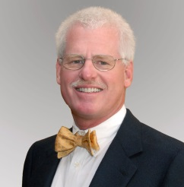
Byron N. Bailey, MD
Charleston, SC
(Category D)
Board Certified Neurosurgeon at Charleston Neurological Associates, L.L.C.
W: 843-723-8823

Jeremy S. Chapman
Pelzer, SC
(Category C)
Agent with New York Life Co.
Email: jroc153@msn.com

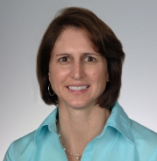
M. Noreen Herring, MD
Charleston, SC
(Category A)
Specialist in Physical Medicine & Rehabilitation, Assistant Professor at MUSC Neuroscience Department
W: 843-792-3221

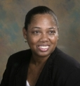
Sherron M. Jackson, MD
Charleston, SC
(Category C)
Associate Professor of Pediatrics at MUSC
W: 843-792-2406

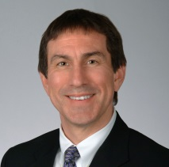
Kevin W. Kopera, MD, MPH - CHAIR
Greenville, SC
(Category B)
Board Certified in Physical Medicine and Rehabilitation. Medical Director Roger C. Peace Rehabilitation Hospital
W: 864-455-3754

Abhay K. Varma, MD, MBBS
Mt. Pleasant, SC
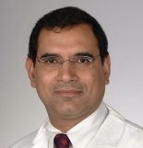
(Category A)
Associate Professor of Neurosurgery at MUSC
W: 843-792-1308

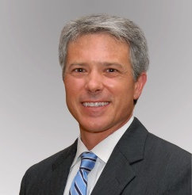
W. Daniel Westerkam, MD
Columbia, SC
(Category B)
Specialist in PM&R, Dir. of Rehab Services at Palmetto Richland Memorial Hosp. & Associate Med. Dir. at HealthSouth Rehabilitation Hospital
W: 803-401-1369/803-401-1404

Executive Director

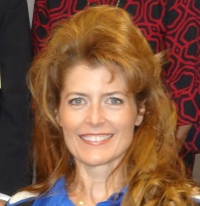
Catherine Leigh Graham, MEBME
Executive Director
W: 843-614-1756
Email: grahacat@musc.edu

Scientific Directors

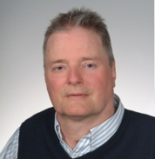
James S. Krause, PhD
Scientific Director
Associate Dean for Clinical Research College of Health Professions, MUSC
W: 843-792-1337
Email: krause@musc.edu

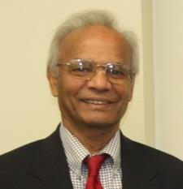
Naren L. Banik, PhD
Associate Scientific Director
Professor, Department of Neurology and Neuroscience, MUSC
W: 843-792-7594
Email: baniknl@musc.edu
Terms

The Board is comprised of the following Categories:

- Two medical doctors from MUSC;
- Two medical doctors at large specializing or significantly engaged in the treatment of people with an SCI;
- Two members who have an SCI or have a family member with an SCI; and,
- One at large medical doctor who is a member of the South Carolina Medical Association.

Category A. Two medical doctors from MUSC

M. Noreen Herring, MD – first term (2018)
Abhay K. Varma, MD – first term (2019)

Category B. Two medical doctors at large specializing or significantly engaged in the treatment of people with an SCI

W. Daniel Westerkam, MD – second term (2017)
Kevin W. Kopera, MD, MPH – first term (2017)

Category C. Two members who have an SCI or a family member with an SCI

Jeremy S. Chapman – first term (2018)
Sherron M. Jackson, MD – first term (2019)

Category D. One at large medical doctor who is a member of the SC Medical Association

Byron N. Bailey, MD – second term (2016)

Passing of the Gavel

The SCIRF BOD re-elected Dr. Kevin W. Kopera as the Board Chair at the fall Board meeting in 2015 and he began serving his second year as Chair in March of 2016.

Meetings
The BOD holds in-person meetings, usually 2-3 per year, to address the organization of the SCIRF as well as directional goals. Meeting dates, locations and select photos are included below. The BOD is responsible for approving all grants awarded as well as budgets for Administrative and Research Core functions.

November 13, 2015 – University of South Carolina School of Medicine, Columbia
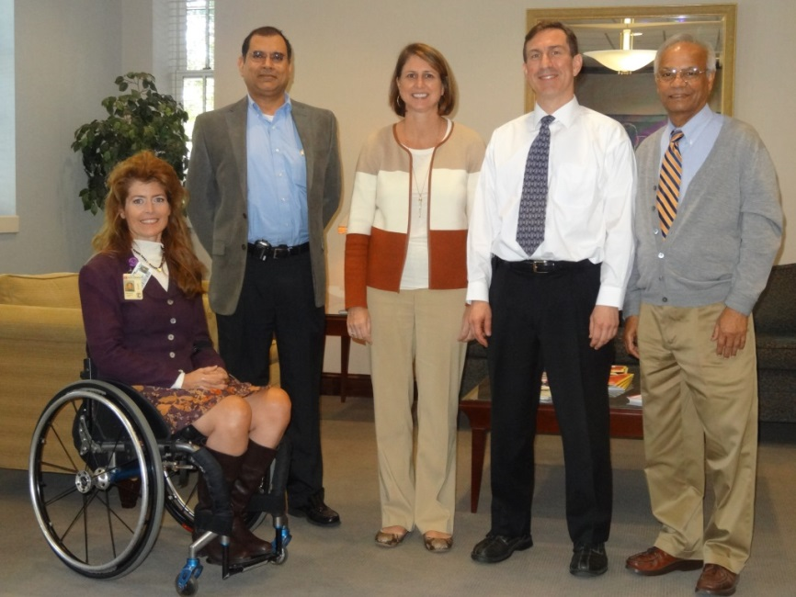
Catherine Leigh Graham (Executive Director), Abhay K. Varma, M. Noreen Herring,
Kevin W. Kopera (Chair), Naren L. Banik (Associate Scientific Director)
Via Phone: James S. Krause (Scientific Director), Sherron M. Jackson, Jeremy S. Chapman

1st Lunch and Learn Series: Three grantees presented their work. Details of each presentation can be found on the website under Awarded Grants.

April 8, 2016 – Roger C. Peace, Greenville
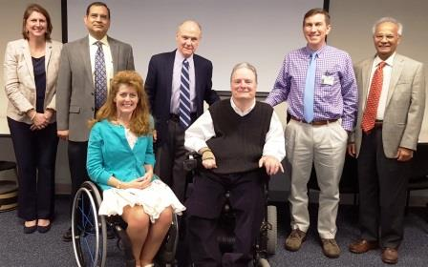
Back Row: M. Noreen Herring, Abhay K. Varma, Steve Rawe (guest),
Kevin W. Kopera (Chair), Naren L. Banik (Associate Scientific Director)
Front Row: Catherine Leigh Graham (Executive Director),
James S. Krause (Scientific Director)

2nd Lunch and Learn Series: Three grantees presented their work. Details of each presentation can be found on the website under Awarded Grants.

PART IX: RESEARCH OVERVIEW

The past year has seen enhanced research in terms of quality and diversity in projects and investigators. The research studies and activities supported by the SCIRF fall into four categories: (1) basic science, (2) applied rehabilitation or clinical studies, (3) epidemiologic or outcomes research, and (4) supported activities in infrastructure, stakeholder involvement, and training.

We are funding a new special initiative on basic science research under the leadership of the associate scientific director, Dr. Banik. This initiative ensures we will continue to focus on the most basic studies to help us understand SCI and develop interventions to minimize its consequences. In addition to this new five-year initiative, other important basic science studies include an investigation of the role of neuron-specific enolase (NSE) in the alterations of inflammatory processes following SCI in rats (Haque) and the effects of formoterol on inflammation and the role of complement in the inflammatory process (Tomlinson, Schnellman). These studies are important for future interventions targeting the inflammatory process. Other studies target the cellular model system to examine the effect of thrombin and in mixed glial cell cultures (Turgeon) and combination therapy using micro-RNAs miR-96 and bororetinoid BIT-5 to improve motor function following SCI (Ray). In a different type of project, Dr. Samantaray investigated the correlation between gait dynamics and molecular markers of repair and regeneration in rat SCI at different times to identify predictors of functional recovery. Dr. Lee from Clemson University is investigating the axonal regeneration in SCI using neuron-specific neurotherapeutics in a rat model. Lastly, funds also provided an opportunity for a College of Charleston student (Totaro) to work in Dr. Banik’s laboratory to investigate the mechanisms of oligodendrocyte damage and survival.

We continue to support studies that are highly innovative and utilize state-of-the-art rehabilitation techniques to improve function and clinical studies to help us better understand and improve health. Dr. Thompson continues her innovative research on the modulation of stretch reflexes during walking after SCI, utilizing these reflexes to improve gait and function. In a study at Roger C. Peace Rehabilitation Hospital of the Greenville Hospital System, virtual-reality exercise training is also being used to promote better outcomes. These studies complement those recently completed to promote gait and fitness (Bowden, Fritz, Gregory). Using a substantially different approach, telehealth is being investigated as an intervention to improve self-management and reduce the likelihood of secondary health conditions after SCI in a study from the MUSC College of Nursing (Newman). This complements another study just completed by Dr. Bell in the College of Nursing at USC investigating fundamental disparities in access to rehabilitation.

We have three important complementary projects to help us understand the epidemiology and the outcomes of SCI in South Carolina. Dr. Selassie continues to obtain surveillance data on all newly injured individuals who are treated in a non-military South Carolina hospital. This helps us understand the changing trends in the causes of injuries, their geographic distribution, and other essential information which allows for more detailed follow-up. The information that comes from the surveillance system is used for the much more detailed study of outcomes from the statewide outcomes database (under the direction of the scientific director, Dr. Krause). We attempt to contact all individuals identified by Dr. Selassie who have been injured in the state to identify critical health outcomes and the factors that lead to these outcomes. This includes linkages to administrative data to provide what is probably the most complete picture of outcomes of any state within the USA. The South Carolina SCI Association identifies individuals who are living in South Carolina with SCI, as well as those who were injured prior to the collection of identifying data. This allows a broader representation of people with SCI in South Carolina. Lastly, Dr. Kopera in the Greenville Hospital System will be collecting new data on newly injured individuals who are being treated as inpatients, which is of great clinical relevance. Collecting these data not only help us understand the issues pertinent to those with SCI in the state of South Carolina but provide the opportunity to make new treatments accessible to people with SCI in South Carolina.

Lastly, we support important other activities that promote research and education within the state of South Carolina. We work with the South Carolina SCI Association by providing funds for them to identify potential research participants, connect with stakeholders within the state, and as a means of disseminating the results of SCI research. We have also supported stakeholder conferences, which focus on issues identified as of greatest importance by those with SCI. We also hold scientific conferences, with one planned for fiscal year 2017, put together by the Executive Director, Ms. Graham. Other infrastructure sorts of activities have previously been funded to promote the widest range of research.

In summary, this has been an outstanding year with many diverse activities supported. We are confident that we have the appropriate balance of grant mechanisms and special initiatives to best utilize the funds to promote both short-term and long-term health, quality of life, and longevity among those with SCI in South Carolina.

South Carolina Spinal Cord Injury Research Fund
Executive Director: Catherine Leigh Graham, MEBME
Phone: 843-614-1756
Email: grahacat@musc.edu
Website: www.scscirf.org

