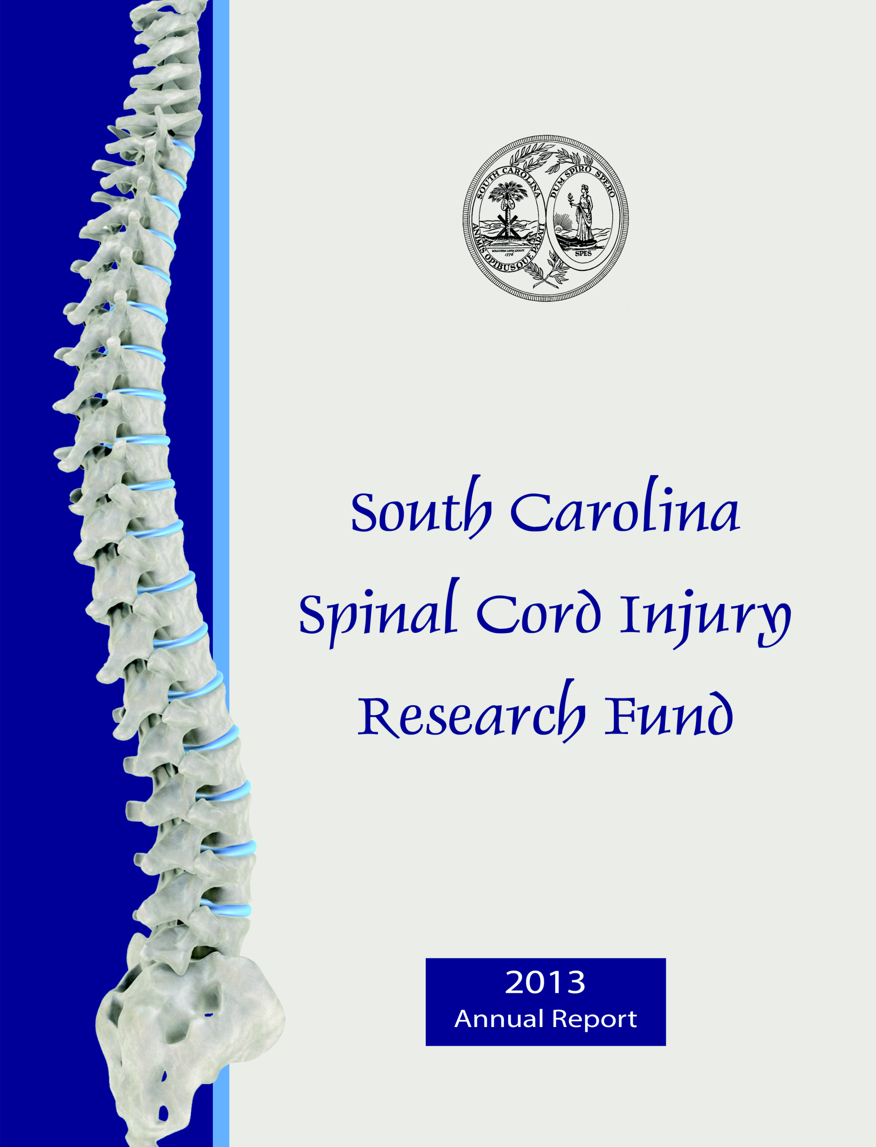

**FY 2015**

**Annual Report**

**South Carolina Spinal Cord Injury Research Fund**

**FY 2015 Report**

**Executive Summary**

Spinal cord injury (SCI) is a serious and usually irreversible cause of disability. The consequences of SCI are often severe and include paralysis, loss of sensation, loss of control over movement and bodily functions, chronic pain, metabolic disorders, and complications such as uncontrolled blood pressure and frequent infections. People with SCI may face extraordinary demands due to the costs of medical care and rehabilitation and the absence of environmental support. Family members of people with SCI are also affected.

The South Carolina Spinal Cord Injury Research Fund (SCIRF) was established by Amendment (Bill S54 44-38-510) of the SC Code ratified on July 20, 2000. The SCIRF is provided from a $100 surcharge on each Driving Under the Influence (DUI) conviction throughout the state. The monies

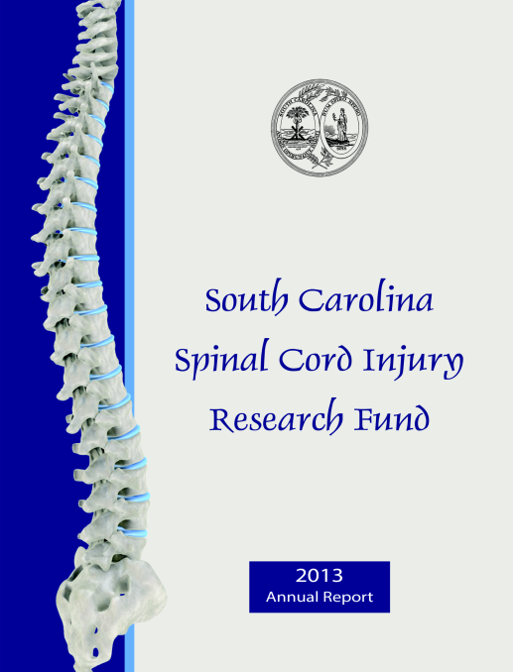collected are used to finance SCI research in South Carolina as well as cover the basic operation costs. The SCIRF is governed by a seven member Board of Directors (BOD) appointed by the Governor upon recommendation of the President of the Medical University of South Carolina (MUSC) and is attached to MUSC for adminstrative purposes.

The long-term goal of the SCIRF is to minimize the risk and incidence of SCI, interrupt or reverse the process of such injuries, and improve the health and quality of life for residents of South Carolina who have an SCI.

The SCIRF BOD is charged with promoting research to develop better understanding of causes and effective treatment strategies for paralysis, sensory loss and other consequences of spinal cord injury and disease with the primary objective of advancing knowledge of SCI repair and regeneration within the South Carolina research community by encouraging physicians and scientists to apply expertise to the SCI field.

The BOD includes 2 medical doctors from MUSC, 2 medical doctors specializing or significantly engaged in the treatment of SCI, 2 people with an SCI or a family member with an SCI and 1 medical doctor at large who is a member of the South Carolina Medical Association. The SCIRF has a full time Executive Director, part time Scientific Director and part time Associate Scientific Director. Board meetings are held at least two times per year in a variety of locations throughout South Carolina.

The SCIRF BOD posted five updated and one new Requests for Proposals (RFPs) in order to solicit proposals from physicians, scientists and researchers throughout the state related to Primary Research, Care/Access/Delivery, Career Development, Pilot Projects, Research Result Dissemination, Student Research Internship, Bridge Funding, Recruitment/Seed and Conference/Education/Training. All RFP details can be found on the website.

The SCIRF made eight awards in FY 2015 with five awardees beginning work in FY 2015 and three starting in FY 2016. Along with the new awards, we continue our support of our Core Administrative

and Research elements. Eight of our grantees concluded their work in FY 2015. As of 6/30/2015 we have 10 active grantees in addition to our Administrative and Research Cores.

The SCIRF supports a variety of research activities that include basic science, clinical, epidemiologic, rehabilitative, and translational studies. Examples of the range of research include: 1) “bench science” to identify injury and recovery mechanisms 2) animal interventions that can be translated into 3) clinical trials in humans. Before clinical trials in humans 4) participant identification must occur as well as 5) a more complete understanding of health care access and health outcomes after SCI.

SCIRF supported activities have increased the number of clinicians and scientists in South Carolina that are focused on SCI research. Surveillance and outcome research projects are currently underway that enhance our understanding of the nature and scope of issues impacting the health of those with SCI. Key findings from studies have been presented at national and international conferences, and have been widely published in scientific journals where they may be used to promote better outcomes. SCIRF funded activities have also seeded federal research grants, bringing in millions of dollars to the state of South Carolina.

The SCIRF income derived from the DUI surcharge is collected on a monthly basis. The total collections for FY 2015 were $753,701.66 with an average monthly collection of $62,808.47. After accounting for committed funds on active grants, Adminstrative and Research Core support through 2018 and set aside amounts in anticipation of up to 4 awards for each RFP, the balance remaining is $1,000,252.50.

We welcomed new Board Chair, Dr. Kevin Kopera and extend our thanks to Dr. Daniel Westerkam for his service in this position during the previous two years.

We look forward to the upcoming year and are pleased to present this FY 2015 Annual Report.

*South Carolina Spinal Cord Injury Research Fund*

*Catherine Leigh Graham, MEBME – Executive Director*

*Phone: 843-614-1756*

*Email:* [*grahacat@musc.edu*](mailto:grahacat@musc.edu)

*Website:* [*www.scscirf.org*](http://www.scscirf.org)**INDEX**

**Page**

Executive Summary 1

Index 3

Letter from Executive Director & Board Chair 4

Letter from Scientific Directors 5

**PART I: Overview 7**

**PART II: New Awards/Extensions 9**

**PART III: Active Awards 11**

**PART IV: Requests for Proposals 12**

**PART V: Awards Closed 13**

**PART VI: Income 15**

**PART VII: Cash Analysis 16**

**PART VIII: Directors 17**

**PART IX: Research Overview 23**

**State of South Carolina**

**Spinal Cord Injury Research Fund Board**

|  |  |  |
| --- | --- | --- |
| **BOARD** | **SC State Seal** | **STAFF** |
| ***Kevin W. Kopera, MD*** | ***Catherine Leigh Graham, MEBME*** |
| *Chair* | *Executive Director* |
| ***Byron N. Bailey, MD***  ***Jeremy S. Chapman***  ***M. Noreen Herring, MD***  ***Sherron M. Jackson, MD***  ***Abhay K. Varma, MD***  ***W. Daniel Westerkam, MD*** | ***James S. Krause, PhD*** |
| *Scientific Director* |
| ***Naren L. Banik, PhD*** |
| *Associate Scientific Director* |

Dear Friends and Supporters:

On behalf of the Board of Directors, Scientific Directors and Executive Director, it is our pleasure to present the FY 2015 Report. This report highlights the progress and accomplishments in implementing the legislative mandate of promoting SCI research throughout South Carolina from July 1, 2014-June 30, 2015.

The SCIRF continued as a source of research funding for any South Carolina entity that responds to the public RFP announcements. In the past year, the SCIRF promoted and supported SCI research through six RFPs including a new RFP for Conferences/Education/Training. Applications were reviewed for both scientific merit, often involving outside scientific reviewers knowledgeable with the topic, and for relevance to the mission of SCIRF.

The SCIRF made eight new grant awards as well as three no cost extensions. Five of these new awardees began their research in FY 2015 while three will begin their research in FY 2016. Eight awardees concluded their research in FY 2015. As of 6/30/2015 the SCIRF has 10 active grantees including support for both the Administrative and Research Cores. The ongoing technical progress reports and final reports for each grantee can be seen on the SCIRF website.

The SCIRF continues to receive DUI collections on a monthly basis. The monthly average and yearly collections for FY 2015 are $62,808 and $753,702, respectively.

I would like to thank Dr. W. Daniel Westerkam who served as the Chair of the Board of Directors from 2013-2015 as well as a founding Board member. We welcomed Dr. Kevin W. Kopera who was elected as the new Chair and began serving in March of 2015.

We are pleased to provide this annual report for FY 2015.

Respectfully submitted,

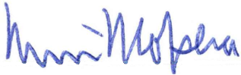

Kevin W. Kopera, MD Catherine Leigh Graham, MEBME

Board Chair Executive Director

**State of South Carolina**

**Spinal Cord Injury Research Fund Board**



|  |  |  |
| --- | --- | --- |
| **BOARD** |  | **STAFF** |
| ***Kevin W. Kopera, MD*** | ***Catherine Leigh Graham, MEBME*** |
| *Chair* | *Executive Director* |
| ***Byron N. Bailey, MD***  ***Jeremy S. Chapman***  ***M. Noreen Herring, MD***  ***Sherron M. Jackson, MD***  ***Abhay K. Varma, MD***  ***W. Daniel Westerkam, MD*** | ***James S. Krause, PhD*** |
| *Scientific Director* |
| ***Naren L. Banik, PhD*** |
| *Associate Scientific Director* |

**Letter from the Scientific Directors**

The SCIRF continues to fund research that is critical to its mission through a number of grant mechanisms that have established the foundation for a wide range of SCI research. This has benefited individuals with SCI in the state of South Carolina by enhancing evidence-based practice, facilitated the development of better clinical practice through research, and heightened awareness of issues faced by people with SCI. The work of the SCIRF goes beyond its statewide impact, as its visibility and impact may also be witnessed at regional, national, and international levels. This in turn has facilitated successful recruitment of key investigators to the state of South Carolina and successful efforts to further support SCI research through extramural funding.

As we look back upon the last year, we take great pride in the accomplishments in both basic and applied sciences. We have seen the development of a foundation for rehabilitative interventions to help improve function, particularly walking ability. The facilitation of this research has brought new technology and viable interventions to the doorstep of those with SCI in South Carolina. These accomplishments are the result of years of seed funding and particularly key recruitments from previous years, which are not restricted to research of rehabilitative function, but also rehabilitative medicine and epidemiology.

Along with recruitments, there has been a corresponding enhancement to research infrastructure, much of which has been seeded by the SCIRF and augmented with other sources of revenue. Funding of research infrastructure through clinic development has in turn facilitated the recruitment of a physician champion in SCI and strengthened clinical service that works hand-in-hand with research. These key recruitments have also led to higher quality and greater number and diversity of students and better training of those individuals who will ultimately will be providing services to those with SCI in the state of South Carolina.

Without question, the degree of collaboration and research has increased throughout the state. In addition to the administration and the research conducted at MUSC, research is being conducted at the University of South Carolina Columbia and Greenville, Clemson University, Furman University and at Roger C Peace in the Greenville Hospital system. The state SCI Association, headquartered in Columbia, has helped to bridge the gap between investigator and stakeholders with SCI. The conduct of a consumer conference has brought together people and ideas, representing a natural forum for the summary of research findings. Of greatest importance, the scientific discoveries in multiple related fields serve as a foundation for improving the lives of people with SCI in South Carolina and beyond.

As we move forward, we maintain our steadfast commitment to the betterment of the lives of people with SCI, we look to further development of infrastructure, recruitment, and the support of research throughout the state of South Carolina. We will continue to evaluate all possible ways of facilitating SCI research within the state of South Carolina, branching into all important fields and qualified investigators. We look forward to enhance understanding of the consequences of SCI to individual’s lives as we look for solutions to limit these consequences to maximize health, quality of life and longevity. We are grateful for the opportunity to participate in this process as we partner with key entities within and outside the state.

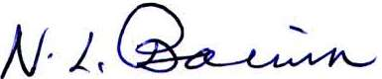

James S. Krause, PhD Naren L. Banik, PhD

Scientific Director Associate Scientific Director

**PART I: OVERVIEW**

# PURPOSE/CHARGE

Promoting research to develop better understanding of causes and effective treatment strategies for paralysis, sensory loss, and other consequences of SCI and disease.

# NEED

SCI is a serious and usually irreversible cause of disability. The consequences of SCI are often severe and include paralysis, loss of sensation, loss of control over movement and bodily functions, chronic pain, metabolic disorders, and complications such as uncontrolled blood pressure and frequent infections. People with SCI may face extraordinary demands due to the costs of medical care and rehabilitation and the absence of environmental support. Family members of people with SCI are also affected. The long-term goal of the SCIRF is to minimize the risk and incidence of SCI, interrupt or reverse the process of such injuries, and improve the health and quality of life for residents of South Carolina who have an SCI.

# LEGISLATIVE BACKGROUND

The South Carolina SCIRF was established by the South Carolina General Assembly in 2000 by amendment (Bill S54 44-38-510) to Section 2, Chapter 38, Title 44 of the 1976 S.C. Code as signed by the Governor on July 20, 2000. The legislation calls for a $100 surcharge to be levied on every South Carolina “Driving Under the Influence” conviction. The proceeds from this surcharge go to the SCIRF and are used to finance SCI research in South Carolina as well as cover basic operation and administrative costs for the SCIRF.

# GOVERNANCE

The SCIRF is governed by a seven member Board of Directors (BOD) appointed by the Governor upon the recommendation of the President of the Medical University of South Carolina (MUSC). It is comprised of two medical doctors from MUSC; two medical doctors specializing or significantly engaged in the treatment of people with SCI in South Carolina; two members who have an SCI or have a family member with an SCI; and one at large medical doctor who is a member of the South Carolina Medical Association.

# ADMINISTRATION/SCIENTIFIC DIRECTORS

The SCIRF is attached to MUSC for administrative purposes. The SCIRF has a full time Executive Director, Catherine Leigh Graham, MEBME, a part time Scientific Director, James S. Krause, PhD, and a part time Associate Scientific Director, Naren L. Banik, PhD.

The Scientific Directors are involved in all aspects of all research development and implementation including setting goals, developing project invitations to meet goals, and making recommendations based on their reviews to the SCIRF BOD of all such projects received.

# PRIMARY OBJECTIVES

Advance knowledge of SCI repair and regeneration within the South Carolina research community by encouraging physicians and scientists to apply expertise to the SCI field.

* Foster collaborative interdisciplinary approaches to SCI research among South Carolina hospitals, rehabilitative centers, research universities, and interested organizations.
* Nurture next generation of SCI researchers throughsupport of young scientists and post-doctoral fellows.
* Improve the well-being and quality of life of individuals with SCI by research programs that prevent or treat the secondary conditions and consequences of SCI.
* Set budgets and administer funds for SCI research as mandated by the South Carolina Legislative Act, and assure highest quality of research and commitment by investigators.

**PART II: NEW AWARDS/EXTENSIONS**

# New awards made and started in FY 2015

* ***#2014 P-01 Geographic Disparities in Access to Outpatient Rehabilitation Services after Spinal Cord Injury***

Nathaniel Bell, PhD – University of South Carolina College of Nursing

Pilot Award

(12/1/2014-11/30/2015 for $28,478)

* ***#2014 I-01 Community-based Virtual Reality Group Exercise Training in Persons with Spinal Cord Injury***

Jennifer Trilk, PhD – University of South Carolina School of Medicine Greenville Biomedical Sciences

Kevin Kopera, MD – Roger C. Peace Rehabilitation Hospital, Greenville Health System

Investigator Initiated Research Award

(12/1/2014-11/30/2016 for $79,954)

* ***#2014 I-02 Neuron-specific Nanotherapeutics for Axonal Regeneration after Spinal Cord Injury***

Jeoung Soo Lee, PhD – Clemson University Department of Bioengineering

Ken Webb, PhD – Clemson University Department of Bioengineering

Investigator Initiated Research Award

(1/1/2015-12/31/2015 for $39,500)

* ***#2014 R-01 Modulation of Stretch Reflexes during Walking in People after Spinal Cord Injury***

Aiko K. Thompson, PhD – Medical University of South Carolina College of Health Professions, Department of Health Sciences and Research

Recruitment/Seed Funding Award

(3/1/2015-2/28/2018 for $117,599)

* ***#2015 S-01 Establishment of cellular model systems to investigate and manipulate the hostile environment produced by thrombin following spinal cord injury***

Victoria L. Turgeon, PhD – Furman University Department of Biology

(Maddison Lewis – Furman University)

Student Award

(6/1/2015-5/30/2016 for $5,000)

# New awards made in FY 2015 but starting in FY 2016

* ***#2015 I-01 Novel combination therapy for neuroprotection in spinal cord injury***

Swapan K. Ray, PhD – University of South Carolina School of Medicine Department of Pathology, Microbiology and Immunology

Investigator Initiated Research Award

(7/1/2015-6/30/2017 for $80,000)

* ***#2015 P-01 Targeting Enolase in spinal cord injury***

Azizul Haque, PhD – Medical University of South Carolina Department of Microbiology and Immunology

Pilot Award

(7/1/2015-6/30/2016 for $30,000)

* ***#2015 I-03 Formoterol, an FDA-approved drug, stimulates mitochondrial biogenesis as a novel therapeutic strategy for spinal cord injury***

Rick G. Schnellmann, PhD – Medical University of South Carolina; RHJ VAMC

Stephen Tomlinson, PhD – Medical University of South Carolina Departmen of Microbiology and Immunology

Investigator Initiated Research Award

(8/1/2015-7/31/2017 for $80,000)

# No Cost Extensions in FY 2015

* ***#09-001 Measuring Outcomes after SCI throughout SC: A System of Tracking, Research and Referral***

Lee L. Saunders, PhD – Medical University of South Carolina Department of Health Sciences and Research

(12/1/2009-11/30/2014 for $975,000; extension 11/30/2016)

* ***#11-005 Developing a Point of Access to SCI Clinical Research at the Center for SCI at Roper Rehabilitation Hospital***

Cathy Therrell, MSN, RN, NEA-BC – Roper Rehabilitation Hospital

(11/1/2011-10/31/2014 for $150,000; extension 1/31/2015)

* ***#11-006 The Application of Medical Sociology to the Study of Health and Mortality after SCI***

Yue Cao, PhD, MSPH – Medical University of South Carolina Department of Health Sciences and Research

(11/1/2011-10/31/2014 for $124,875; extension 10/31/2015)

**PART III: ACTIVE AWARDS (As of 6/30/2015)**

All Technical Progress Report and Final Reports can be found on the website under each respective Grant #.

|  |  |  |  |
| --- | --- | --- | --- |
| **Grant #** | **Title** | **PI** | **Insti-tution** |
| Admin.  Core | Administrative Core Services | N/A | N/A |
| Research  Core | Research Scientific Core Services | N/A | N/A |
| 0908 | SC Traumatic SCI Surveillance & Registry System | Selassie | MUSC COM |
| 09-001 | Measuring Outcomes after SCI throughout SC: A System of Tracking, Research, & Referral | Saunders | MUSC CHP |
| 11-006 | The Application of Medical Sociology to the Study of Health & Mortality after SCI | Cao | MUSC CHP |
| 12-004 | Cooperative Agreement between SCIRF and SCSCIA | Epperly | SCSCIA |
| 2014 P-01 | Geographic Disparities in Access to Outpatient Rehab Services after SCI | Bell | USC Nursing |
| 2014 I-01 | Community-based Virtual Reality Group Exercise Training in Persons with SCI | Trilk/Kopera | USCSOM Gvl, RCP |
| 2014 R-01 | Modulation of Stretch Reflexes during Walking in People after SCI | Thompson | MUSC CHP |
| 2015 S-01 | Establishment of cellular model systems to investigate and manipulate the hostile environment produced by thrombin following SCI | Turgeon | Furman |

**PART IV: REQUESTS FOR PROPOSALS**

The SCIRF has maintained a focus on building research infrastructure, expertise and capacity throughout South Carolina. In order to accomplish this task, the SCIRF BOD has developed and distributed the following RFP’s and/or Requests for Contracts (RFCs) since its inception. The RFP’s listed below were posted in FY 2015 and can be found on the website under [Request for Proposals](http://academicdepartments.musc.edu/scscirf/RFPs.html).

**RFP 2015-P (Pilot)**

Date of Release: December 1, 2014

Date Closed: Open

**RFP 2015-S (Student Research Internship)**

Date of Release: December 1, 2014

Date Closed: Open

**RFP 2015-I (Investigator Initiated Research)**

Date of Release: December 1, 2014

Date Closed: February 1, 2015

**RFP 2015-B (Bridge Funding)**

Date of Release: December 1, 2014

Date Closed: Open

**RFP 2015-R (Recruitment/Seed Funding)**

Date of Release: December 1, 2014

Date Closed: Open

**RFP 2015-CET (Conference/Education/Training)**

Date of Release: December 1, 2014

Date Closed: Open

**PART V: AWARDS CLOSED (In Order of Date Awarded)**

#1105

Title: **A Proposal to Build SCI Research Infrastructure via the Development of a *Center of Interdisciplinary Spinal Cord Injury Research***

Type of Award: Special Request

Award Period/Funding: {2/1/2006-1/31/2009 for $499,309, *extension 1/31/2011, *extension 1/31/2015}

PI:James Krause, PhD, Professor and Associate Dean for Clinical Research, Medical University of South Carolina College of Health Professions

#10-003

Title: **Propulsive Training in Incomplete Spinal cord Injury**

Type of Award: Recruitment/Seed Funding

Award Period/Funding: {12/1/2010-11/30/2013 for $124,943, *extension 11/30/2014}

PI: Mark G. Bowden, PhD, PT – Assistant Professor, Medical University of South Carolina College of Health Professions, Department of Health Sciences and Research

#10-004

Title: **Development of a Rehabilitation Research Program to Study the Biomechanics of Walking Following Incomplete Spinal Cord Injury**

Type of Award: Recruitment/Seed Funding

Award Period/Funding: {12/1/2010-11/30/2013 for $122,848, *extension 11/30/2014}

PI: Chris M. Gregory, PhD – Assistant Professor, Medical University of South Carolina College of Health Professions, Department of Health Sciences and Research

#11-005

Title: **Developing a Point of Access to Spinal Cord Injury Clinical Research at the Center for Spinal Cord Injury at Roper Rehabilitation Hospital**

Type of Award: Primary Grant

Award Period/Funding: {11/1/2011-10/31/2014 for $150,000, *extension 1/31/2015}

PI: Cathy Therrell, MSN, RN, NEA-BC – Director, Roper Rehabilitation Hospital

Co-PI: Susan D. Newman, PhD, RN, CRRN – Assistant Professor, Medical University of South Carolina College of Nursing

#12-001

Title: **Myoprotective Role of Premarin in Spinal Cord Injury**

Type of Award: Pilot

Award Period/Funding: {10/1/2012-9/30/2013 for $30,000, *extension 9/30/2014}

PI: Kenkichi Nozaki, MD, PhD – Assistant Professor, Medical University of South Carolina College of Medicine, Department of Neurosciences

#12-003

Title: **WIND (Wheeling in New Directions) Conference in Spring of 2014**

Type of Award: Conference/Dissemination

Award Period/Funding: {11/1/2012-10/31/2014 for $30,000}

PI: Diane Epperly, Executive Director – South Carolina Spinal Cord Injury Association

#13-002

Title: **Center for Spinal Cord Injury at Roper Rehabilitation Hospital Medical Director Recruitment**

Type of Award: Recruitment/Career Development

Award Period/Funding: {7/1/2013-6/30/2016 for $300,000, ~terminated 1/15/2015 due to departure of recruited MD)

PI: Cathy Therrell, MSN, RN, NEA-BC – Director, Roper Rehabilitation Hospital

#13-003

Title: **Aerobic Exercise to Treat Depression Following Incomplete Spinal Cord Injury**

Type of Award: Pilot

Award Period/Funding: {11/1/2013-10/31/2014 for $14,578}

PI: Stacy Fritz, PhD, PT – Associate Professor, University of South Carolina Department of Exercise Science PT Program

**PART VI: INCOME**

The income to the SCIRF comes exclusively from revenue attributed to a $100 fee levied on every “Driving Under the Influence” (DUI) conviction in South Carolina. MUSC is the legislated administrator of these collected funds and is the state agency responsible for their oversight.

The $100 per DUI surcharges are received monthly throughout each fiscal year. Below is the table of monthly collections for FY 2015. The total collected was $753,701.66 with a monthly average of $62,808.47.

|  |  |
| --- | --- |
| **Month** | **2014-2015** |
| Jul | $ 58,187.28 |
| Aug | $ 57,273.87 |
| Sep | $ 64,644.37 |
| Oct | $ 57,019.67 |
| Nov | $ 73,844.32 |
| Dec | $ 53,092.70 |
| Jan | $ 53,630.28 |
| Feb | $ 58,758.50 |
| Mar | $ 74,109.90 |
| Apr | $ 75,139.46 |
| May | $ 68,696.36 |
| Jun | $ 59,304.95 |
| **FY 2015 TOTAL** | **$ 753,701.66** |
| **Monthly Average** | **$ 62,808.47** |

**PART VII: CASH ANALYSIS**

**March 2001 - June 2015**

|  |  |  |  |
| --- | --- | --- | --- |
|  |  |  | **Running Balance** |
| **Income** | DUI Collections | $ 11,396,672.28 | **$ 11,396,672.28** |
|  |  |  |  |
| **Expenditures** | Active Accounts | $ (1,314,947.13) | **$ 10,081,725.15** |
|  | Inactive Accounts | $ (4,769,415.52) | **$ 5,312,309.63** |
|  | ADMIN Core | $ (725,948.22) | **$ 4,586,361.41** |
|  | RESEARCH Core | $ (529,485.11) | **$ 4,056,876.30** |
|  |  |  |  |
| **Commitments** | Active Grants | $ (732,149.93) | **$ 3,324,726.37** |
|  | ADMIN Core | $ (26,008.78) | **$ 3,298,717.59** |
|  | RESEARCH Core | $ (314,209.89) | **$ 2,984,507.70** |
|  |  |  |  |
| **FY16 CORE's** | FY16 ADMIN Core | $ (133,726.40) | **$ 2,850,781.30** |
|  | FY16 RESEARCH Core | $ (67,692.00) | **$ 2,783,089.30** |
|  |  |  |  |
| **Est CORE FY17-FY18** | FY17 & FY18 ADMIN | $ (267,452.80) | **$ 2,515,636.50** |
|  | FY17 & FY18 RESEARCH | $ (135,384.00) | **$ 2,380,252.50** |
|  |  |  |  |
| **Set Aside (Up to 4/RFP)** | Investigator Initiated | $ (320,000.00) | **$ 2,060,252.50** |
|  | Pilot | $ (120,000.00) | **$ 1,940,252.50** |
|  | Student Research | $ (20,000.00) | **$ 1,920,252.50** |
|  | Bridge | $ (300,000.00) | **$ 1,620,252.50** |
|  | Recruitment/Seed | $ (500,000.00) | **$ 1,120,252.50** |
|  | Conference/Education/Training | $ (120,000.00) | **$ 1,000,252.50** |

**PART VIII: DIRECTORS**

**Board of Directors**

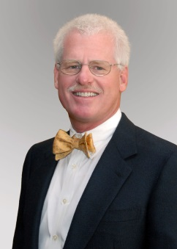**Byron N. Bailey, MD**

Charleston, SC

(Category D)

Board Certified Neurosurgeon at Charleston Neurological Associates, L.L.C.

W: 843-723-8823

**Jeremy S. Chapman**

Pelzer, SC

(Category C)

Agent with New York Life Co.

Email: jroc153@msn.com

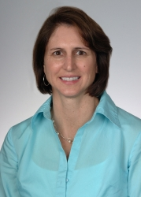**M. Noreen Herring, MD**

Charleston, SC

(Category A)

Specialist in Physical Medicine & Rehabilitation, Assistant Professor at MUSC Neuroscience Department

W: 843-792-3221

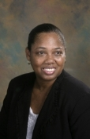**Sherron M. Jackson, MD**

Charleston, SC

(Category C)

Associate Professor of Pediatrics at MUSC

W: 843-792-2406

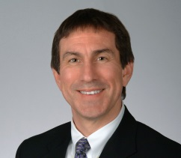**Kevin W. Kopera, MD, MPH - CHAIR**

Greenville, SC

(Category B)

Board Certified in Physical Medicine and Rehabilitation. Medical Director Roger C. Peace Rehabilitation Hospital

W: 864-455-3754

**Abhay K. Varma, MD, MBBS**

Mt. Pleasant, SC

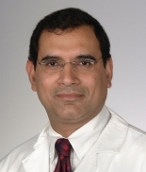(Category A)

Associate Professor of Neurosurgery at MUSC

W: 843-792-1308

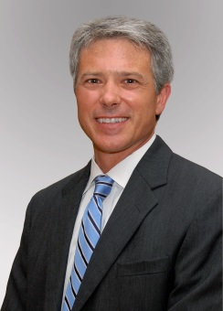**W. Daniel Westerkam, MD**

Columbia, SC

(Category B)

Specialist in PM&R, Dir. of Rehab Services at Palmetto Richland Memorial Hosp. & Associate Med. Dir. at HealthSouth Rehabilitation Hospital

W: 803-401-1369/803-401-1404

**Executive Director**

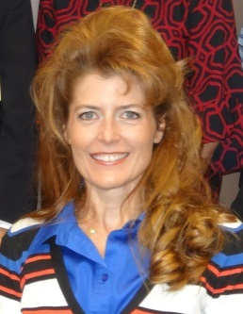**Catherine Leigh Graham, MEBME**

***Executive Director***

W: 843-614-1756

Email: grahacat@musc.edu

**Scientific Directors**

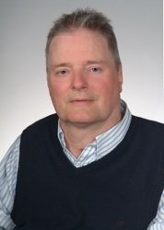**James S. Krause, PhD**

***Scientific Director***

Associate Dean for Clinical Research College of Health Professions, MUSC

W: 843-792-1337

Email: krause@musc.edu

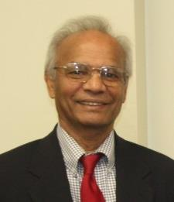**Naren L. Banik, PhD**

***Associate Scientific Director***

Professor, Department of Neurology and Neuroscience, MUSC

W: 843-792-7594

Email: baniknl@musc.edu

**Terms**

The Board is comprised of the following Categories:

1. Two medical doctors from MUSC;
2. Two medical doctors at large specializing or significantly engaged in the treatment of people with an SCI;
3. Two members who have an SCI or have a family member with an SCI; and,
4. One at large medical doctor who is a member of the South Carolina Medical Association.

**Category A.** Two medical doctors from MUSC

**M. Noreen Herring, MD** – first term (2018)

**Abhay K. Varma, MD** – first term (2019)

**Category B.** Two medical doctors at large specializing or significantly engaged in the treatment of people with an SCI

**W. Daniel Westerkam, MD** – second term (2017)

**Kevin W. Kopera, MD, MPH** – first term (2017)

**Category C.** Two members who have an SCI or a family member with an SCI

**Jeremy S. Chapman** – first term (2018)

**Sherron M. Jackson, MD** – first term (2019)

**Category D.** One at large medical doctor who is a member of the SC Medical Association

**Byron N. Bailey, MD** – second term (2016)

**Passing of the Gavel**

The SCIRF BOD would like to thank Dr. W. Daniel Westerkam for serving as the Board Chair from 2013-2015. Dr. Kevin W. Kopera was elected as the new Board Chair at the fall Board meeting in 2014 and began serving in his new role in March of 2015.

**Meetings**

The BOD holds in-person meetings, usually 2-3 per year, to address the organization of the SCIRF as well as directional goals. Meeting dates, locations and select photos are included below. The BOD is responsible for approving all grants awarded as well as budgets for Administrative and Research Core functions.

**October 17, 2014 – Roger C. Peace Rehabilitation Hospital, Greenville**

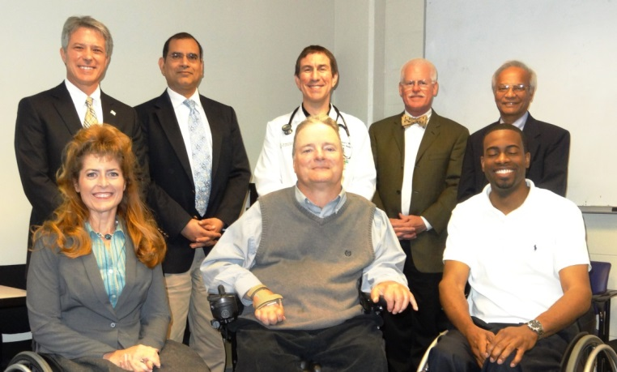

*Back Row: Dr. W. Daniel Westerkam (Chair), Dr. Abhay Varma, Dr. Kevin W. Kopera,*

*Dr. Byron N. Bailey, Dr. Naren L. Banik (Associate Scientific Director)*

*Front Row: Ms. Catherine Leigh Graham (Executive Director), Dr. James S. Krause*

*(Scientific Director), Mr. Jeremy Chapman*

*Via Phone: Dr. M. Noreen Herring, Dr. Sherron M. Jackson*

Three grantees presented their work. Details of each presentation can be found on the website under [Awarded Grants](http://academicdepartments.musc.edu/scscirf/awarded-grants.html).

Head Shot Diane Epperly

#12-003

**WIND Consumer Education Conference**

Ms. Diane Epperly - SC Spinal Cord Injury Association

[WIND Conference](http://www.scspinalcord.org/node/3267) Video



#1105

**Interdisciplinary SCI Research Center**

Dr. James S. Krause - MUSC College of Health Professions

Dr. Naren L. Banik - MUSC Department of Neurosciences

*Head Shot Anbesaw Selassie*

#0908

**SC Traumatic Spinal Cord Injury Registry**

Dr. Anbesaw Selassie - MUSC College of Medicine

**April 17, 2015 – Roper St. Francis, Charleston**

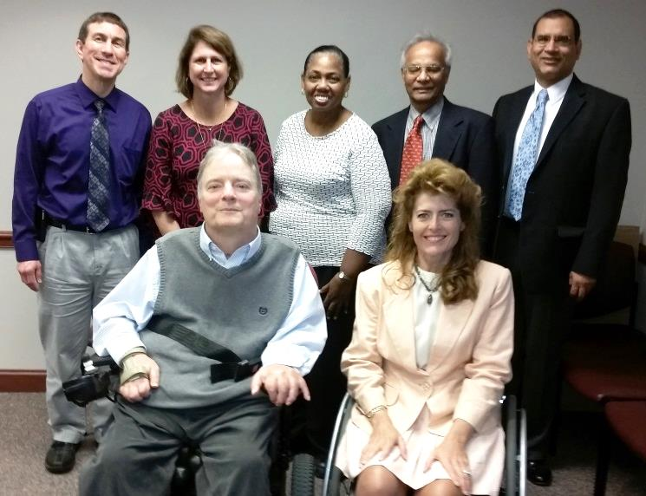

*Back Row: Dr. Kevin W. Kopera, Dr. M. Noreen Herring, Dr. Sherron M. Jackson,*

*Dr. Naren L. Banik (Associate Scientific Director), Dr. Abhay Varma*

*Front Row: Dr. James S. Krause (Scientific Director),*

*Ms. Catherine Leigh Graham (Executive Director),*

*Via Phone: Mr. Jeremy Chapman,*

*Not Present: Dr. W. Daniel Westerkam, Dr. Byron N. Bailey*

Five grantees presented their work. Details of each presentation can be found on the website under [Awarded Grants](http://academicdepartments.musc.edu/scscirf/awarded-grants.html).

Head Shot Stephen Tomlinson#13-001

**Inhibition of the Alternate Complement Pathway to Treat Spinal Cord Injury**

Dr. Stephen Tomlinson - MUSC College of Medicine

Head Shot Cathy Therrell

#11-005

**Point of Access to Research at Roper Rehabilitation Hospital**

Ms. Cathy Therrell - Roper Rehabilitation Hospital

Head Shot Aiko Thompson#2014 R-01

**Modulation of Stretch Reflexes during Walking in People after SCI**

Dr. Aiko Thompson - MUSC Department of Health Sciences and Research

Head Shot Mark Bowden

#10-003

**Propulsive Training in Incomplete SCI**

Dr. Mark Bowden - MUSC College of Health Professions

*Head Shot Chris Gregory* #10-004

**Biomechanics of Waling Following Incomplete SCI**

Dr. Chris Gregory - MUSC College of Health Professions

The Board decided to open up future presentations as a Lunch and Learn opportunity so that colleagues, researchers, stakeholders and students are able to attend and better understand the wide variety of SCIRF awardees as well as their accomplishments on both a state and national level. These will begin at the Fall 2016 Board Meeting in Columbia.

**PART IX: RESEARCH OVERVIEW**

Recently funded projects from the SCIRF have continued to support the areas of research that are central to our understanding of SCI, its complications, consequences, and potential treatments. The research efforts are complemented by an established relationship with the state stakeholder group, the South Carolina Spinal Cord Injury Association, which is essential for taking the information to those with SCI and their families.

Basic science research has continued with the study of complement pathways to treatment. This research moves forward with funding of new, innovative projects aimed at improving the outcome for people with SCI. One of the newly funded proposals will examine the effectiveness of formoterol, an FDA-approved drug in the mitochondrial biogenesis that increases angiogenesis in SCI. Formoterol may help increase cell survival for improvement of motor function. Another study will investigate the combination of miR-96 overexpression and BIT-5 treatment for functional neuroprotection in acute SCI as a new therapy. In addition, a pilot project will investigate whether targeted inhibition of enolase may reduce glial activation and protect neurons in acute SCI leading to functional improvement. A mentor-student initiated study will also investigate axonal regeneration in SCI in a cell culture model may provide valuable information on the mechanisms of axon regeneration in SCI in vivo.

Epidemiologic research has continued to enhance our understanding of health care access and healthcare outcomes within the state of South Carolina, through the identification of all new civilian SCI; comprehensive outcomes assessment related to health care access, health outcomes, quality of life and longevity; and ongoing enrollment of individuals who have been treated within a specialty SCI clinic. As this information continues to grow and improve in terms of quality and amount of follow-up, we will enhance these activities moving forward by assessing common data elements and SCI specialty hospitals, beginning in the upstate.

Rehabilitative interventions reflect the state-of-the-art in improving SCI functional outcomes. Multiple current projects focus on improvement of gait through the enhanced understanding of biomechanics related to SCI, propulsion training, and modulation of stress reflexes. New directions are being undertaken with community-based virtual reality. These studies are aiding in our understanding of SCI interventions and how to maximize function in light of the neurologic deficits associated with SCI.

Taken together, the SCIRF is providing vital support for advancing the science and our understanding of the full scope of issues related to SCI, particularly for those with SCI in South Carolina. We will continue to move forward with innovative research projects, including opportunities for students and postdoctoral candidates. It is only through diligent efforts that we will continue to improve the outcomes of those with SCI, reduce costs, and enhance health and longevity.

***South Carolina Spinal Cord Injury Research Fund***

***Executive Director: Catherine Leigh Graham, MEBME***

***Phone: 843-614-1756***

***Email:*** [***grahacat@musc.edu***](mailto:grahacat@musc.edu)

***Website:*** [***www.scscirf.org***](http://www.scscirf.org)