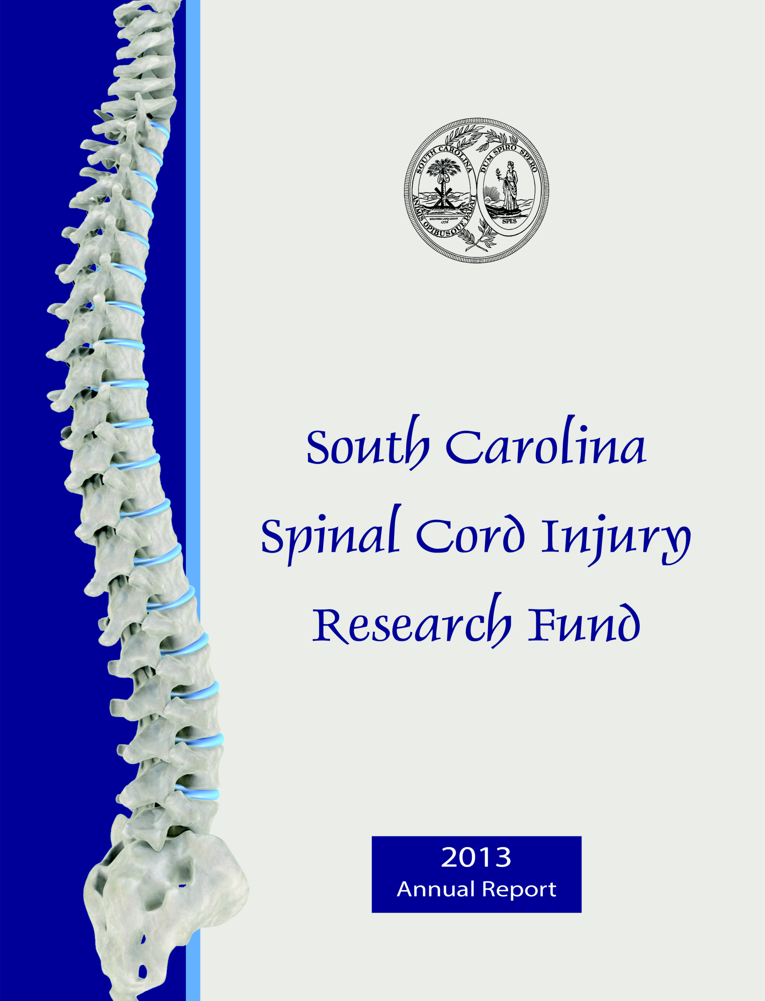

**FY 2010 – FY 2014**

**Report**

**South Carolina Spinal Cord Injury Research Fund**

**FY 2010 – FY 2014 Report**

**Executive Summary**

Spinal cord injury (SCI) is a serious and usually irreversible cause of disability. The consequences of SCI are often severe and include paralysis, loss of sensation, loss of control over movement and bodily functions, chronic pain, metabolic disorders, and complications such as uncontrolled blood pressure and frequent infections. People with SCI may face extraordinary demands due to the costs of medical care and rehabilitation and the absence of environmental support. Family members of people with SCI are also affected.

The South Carolina Spinal Cord Injury Research Fund (SCIRF) was established by Amendment (Bill S54 44-38-510) of the SC Code ratified on July 20, 2000. The SCIRF is provided from a $100 surcharge on each Driving Under the Influence (DUI) conviction throughout the state. The monies

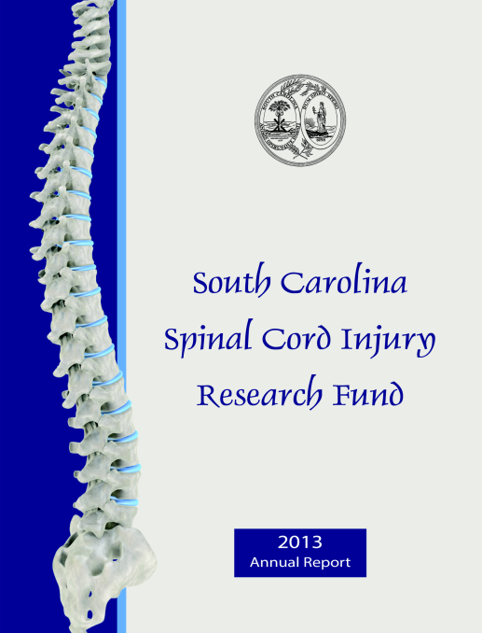collected are used to finance SCI research in South Carolina as well as cover the basic operation costs. The SCIRF is governed by a seven member Board of Directors (BOD) appointed by the Governor upon recommendation of the President of the Medical University of South Carolina (MUSC) and is attached to MUSC for adminstrative purposes.

The long-term goal of the SCIRF is to minimize the risk and incidence of SCI, interrupt or reverse the process of such injuries, and improve the health and quality of life for residents of South Carolina who have an SCI.

The SCIRF BOD is charged with promoting research to develop better understanding of causes and effective treatment strategies for paralysis, sensory loss and other consequences of spinal cord injury and disease with the primary objective of advancing knowledge of SCI repair and regeneration within the South Carolina research community by encouraging physicians and scientists to apply expertise to the SCI field.

The BOD includes 2 medical doctors from MUSC, 2 medical doctors specializing or significantly engaged in the treatment of SCI, 2 people with an SCI or a family member with an SCI and 1 medical doctor at large who is a member of the South Carolina Medical Association. The SCIRF has a full time Executive Director and part time Scientific Director and Associate Scientific Director. Board meetings are held at least two times per year in a variety of locations throughout South Carolina.

The SCIRF BOD has distributed 19 Requests for Proposals (RFPs) in order to solicit proposals from physicians, scientists and researchers throughout the state related to Primary Research, Care/Access/Delivery, Career Development, Pilot Projects, Research Result Dissemination, Student Research Internship, Bridge Funding, and Recruitment/Seed. There have been over 140 proposals submitted since the first RFP. There are currently four RFP’s that are open for proposals and can be found on the website at [www.scscirf.org](http://www.scscirf.org).

The SCIRF has made 67 grant awards, 3 supplemental awards as well as yearly awards for both the Administrative and Research Cores since inception. Out of the 67 grant awards made, 48 were made

through FY 2009 and then 2 in FY 2010, 5 in FY 2011, 6 in FY 2012, 4 in FY 2013 and 2 in FY 2014. There are currently 14 active awards including the Administrative and Research Core awards.

The SCIRF supports a variety of activities and research including: 1) “bench science” to identify injury and recovery mechanisms 2) animal interventions that can be translated into 3) clinical trials in humans. Before clinical trials in humans 4) participant identification must occur as well as 5) a more complete understanding of health and wellness outcomes after SCI.

Education/Dissemination conferences have been supported through funding and held throughout the state. Four *scientific* conferences, showcasing SCIRF funded research, have been held and have included guest speakers on a variety of SCI research topics. Five *consumer* conferences as well as statewide continuing education workshops have been held via grants to the consumer based SC Spinal Cord Injury Association. Two *healthcare provider* conferences have been held in order to increase the provider knowledge regarding SCI in South Carolina.

SCIRF supported activities have increased the number of clinicians and scientists in South Carolina that are focused on SCI research. Multiple surveillance/tracking projects are currently underway that assist the researchers in determining the scope of the issue of SCI as well as the health outcomes impact. There have been over 230 articles published as a result of SCIRF funding which has increased the overall body of work knowledge of SCI. Various researchers and clinicians, through their grants, have given over 170 invited talks and/or presentations. As a result of the work that SCIRF grantees have accomplished, 39 federal and other state research grants have been awarded to researchers in the state of South Carolina.

The SCIRF income derived from the DUI surcharge is collected on a monthly basis with collections beginnning in March of 2001. The SCIRF has expended $6,714,805.50 on both inactive (closed) and active grants. There is an additional commitment of $1,560,918.16 which includes committed funds for active grants as well as Administrative and Research Core support through fiscal year 2015. In order to maintain the core support services through the time period of all of our active grants, an additional $394,000 has been set aside. The SCIRF has several open RFPs with the goal of making multiple awards during the 2014-2015 fiscal year. Funds have been set aside to award up to four proposals for each of the five RFPs in the total amount of $1,260,000. This results in a balance of $713,246.96.

*South Carolina Spinal Cord Injury Research Fund*

*Catherine Leigh Graham, MEBME – Executive Director*

*Phone: 843-614-1756*

*Email:* [*grahacat@musc.edu*](mailto:grahacat@musc.edu)

*Website:* [*www.scscirf.org*](http://www.scscirf.org)

**INDEX**

**FY 2010 – FY 2014 REPORT**

**Page**

Executive Summary i

Report Index 1

Letter from Board Chair 3

Letter from Scientific Directors 4

Letter from Executive Director 5

**PART I: Overview 7**

Purpose/Charge 7

Need 7

Legislative Background 7

Governance 7

Administration/Scientific Directors 7

Primary Objectives 8

**PART II: New Awards FY 2010 - FY 2014 9**

**PART III: Active Awards 12**

**PART IV: Requests for Proposals 13**

**PART V: Closed Awards 15**

**PART VI: Education/Dissemination (Conferences) 24**

Scientific 24

Consumer 30

Provider 33

**PART VII: Income 34**

**PART VIII: Cash Analysis 37**

**PART IX: Board of Directors/Executive & Scientific Directors 38**

Terms 39

Passing of the Gavel 40

Meetings 41

**PART X: Research Overview 49**

Conceptual Overview of SCIRF Activities 49

Overview of SCIRF Funded Activities 50

Importance of Basic Science Research 50

Recent Highlights 51

**PART XI: Appendices 55**

Appendix A. Individual Project Reports 55

Appendix B. Publications 67

Appendix C. Invited Talks and Presentations 79

Appendix D. Federal and Other State Research Grants 89

**State of South Carolina**

**Spinal Cord Injury Research Fund Board**

|  |  |  |
| --- | --- | --- |
| **BOARD** | **SC State Seal** | **STAFF** |
| ***W. Daniel Westerkam, MD*** | ***Catherine Leigh Graham, MEBME*** |
| *Chair* | *Executive Director* |
| ***Byron N. Bailey, MD***  ***Jeremy S. Chapman***  ***M. Noreen Herring, MD***  ***Kevin W. Kopera, MD***  ***Abhay K. Varma, MD*** | ***James S. Krause, PhD*** |
| *Scientific Director* |
| ***Naren L. Banik, PhD*** |
| *Associate Scientific Director* |

**Letter from the Board Chair**

Dear Friends and Supporters:

On behalf of the Board of Directors and staff, it is my pleasure to present the FY 2010 - FY 2014 Report. This report highlights five years of progress and accomplishments in implementing the legislative mandate of promoting spinal cord injury (SCI) research throughout South Carolina.

During this period, we have continued to support SCI research with 19 new grant awards. Over the lifetime of the SCIRF, we have awarded 67 grants, 3 supplements as well as continued funding for our Research and Administrative Cores. Through our grantees, we have attracted millions of research dollars into the state. Over 230 manuscripts have been published in professional journals and over 170 presentations have been made at professional conferences in relation to the work the SCIRF has funded.

The Board of Directors would like to thank Tom Higerd, PhD who stepped in and served as the SCIRF Administrator due to the untimely death of Walker Coleman in 2008. Dr. Higerd resigned as of January 1, 2014 and we wish him well in his future endeavors.

We welcomed Catherine Leigh Graham, MEBME as our new Executive Director. Ms. Graham had been a Board member since 2008 and transitioned into her new role January 6, 2014. We look forward to her valuable contributions to managing and operating the SCIRF. She is a rehabilitation engineer and has extensive research experience.

We would also like to thank the South Carolina Legislature, the Governor, the Medical University of South Carolina, Clemson University and the University of South Carolina for their special interest and support.

Sincerely,

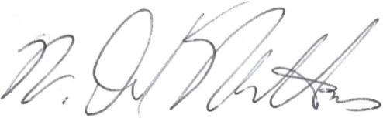

W. Daniel Westerkam, MD

Board Chair

**State of South Carolina**

**Spinal Cord Injury Research Fund Board**



|  |  |  |
| --- | --- | --- |
| **BOARD** |  | **STAFF** |
| ***W. Daniel Westerkam, MD*** | ***Catherine Leigh Graham, MEBME*** |
| *Chair* | *Executive Director* |
| ***Byron N. Bailey, MD***  ***Jeremy S. Chapman***  ***M. Noreen Herring, MD***  ***Kevin W. Kopera, MD***  ***Abhay K. Varma, MD*** | ***James S. Krause, PhD*** |
| *Scientific Director* |
| ***Naren L. Banik, PhD*** |
| *Associate Scientific Director* |

**Letter from the Scientific Directors**

It has been our privilege to serve as scientific directors of the South Carolina Spinal Cord Injury Research Fund (SCIRF) for the past 11 years (Krause, Scientific Director) and six years (Banik, Associate Scientific Director) respectively, using our decades of experience to help develop a vision for the research agenda and establish the research mechanisms for accomplishing the goals of the SCIRF. The research supported through the SCIRF is of regional, national, and international significance to the field of spinal cord injury (SCI) medicine and rehabilitation. Our activities support the research agenda that meets the primary mission of the SCIRF, with the ultimate goal of improving the function, health, quality of life, and longevity of people with SCI within the state of South Carolina.

The past five years have witnessed significant growth in basic and applied sciences. Several key recruitments to the state of South Carolina have strengthened the research infrastructure, particularly for clinical studies. These recruitments have been in the field of SCI specialty medicine, exercise physiology, and epidemiology. The research infrastructure has been strengthened by these recruitments, as well as by research that has helped to identify the particular problems faced by people with SCI in South Carolina and factors related to their outcomes. Key recruitments have been supported with state-of-the-art technologies for improving function after SCI. There has also been an emphasis on basic science studies seeking to identify fundamental mechanisms by which function may be improved and intervention and translational studies directly improving outcomes. For instance, support from the SCIRF has helped take estrogen as an intervening agent into a pilot safety trial in the clinic. We also support the direct dissemination in translation of research findings for stakeholders with SCI and their families within the state.

As we move forward, we look to further development of infrastructure, recruitment, and the support of research throughout the state of South Carolina. We have developed multiple funding mechanisms directly addressing the needs of individuals with SCI within the state and are steadfast in our commitment to continue to better understand the consequences of SCI and develop solutions to improve the lives of people with SCI. We have made significant progress and great strides over the past five years and since the inception of the SCIRF. We look forward to continuing these efforts and to the evolution and advancement of the Spinal Cord Injury Research Fund.



James S. Krause, PhD Naren L. Banik, PhD

Scientific Director Associate Scientific Director

**State of South Carolina**

**Spinal Cord Injury Research Fund Board**



|  |  |  |
| --- | --- | --- |
| **BOARD** |  | **STAFF** |
| ***W. Daniel Westerkam, MD*** | ***Catherine Leigh Graham, MEBME*** |
| *Chair* | *Executive Director* |
| ***Byron N. Bailey, MD***  ***Jeremy S. Chapman***  ***M. Noreen Herring, MD***  ***Kevin W. Kopera, MD***  ***Abhay K. Varma, MD*** | ***James S. Krause, PhD*** |
| *Scientific Director* |
| ***Naren L. Banik, PhD*** |
| *Associate Scientific Director* |

**Letter from the Executive Director**

The South Carolina Spinal Cord Injury Research Fund (SCIRF) has made great progress increasing the number of clinician and scientist researchers throughout the state with spinal cord injury (SCI) expertise as well as increasing the level of SCI research among clinicians and scientists in South Carolina. The SCIRF will continue to strive towards improving the lives of those with SCI and mitigating the impact of functional loss of those who sustain a SCI. These efforts continue to improve the quality of life outcomes as well as decrease the financial impact on those with SCI, their families and the state of South Carolina.

The SCIRF faced a challenge when the founding SCIRF Administrator, Walker Coleman III, passed away unexpectedly July 14, 2008. Kenneth (Gene) Singletary in MUSC’s Office of Grants and Contracts Accounting and Darren McCants in MUSC’s Office of Research and Sponsored Programs were able to provide administrative support and oversight of the approved projects until Tom Higerd, PhD, was hired to fill the part time position in early 2009. Dr. Higerd maintained the administrative functions of the SCIRF until his departure on January 1, 2014.

During 2013, the Board of Directors felt strongly that the SCIRF activities needed a full time Executive Director and searched for candidates towards the latter half of 2013. I transitioned from a Board member to the new Executive Director January 6th, 2014 and am excited to move the SCIRF forward and expand the research impact throughout the entire state of South Carolina.

I would like to thank Dr. Brian Cuddy who served as Chair of the Board of Directors through 2012 and helped to facilitate many of the impactful projects that the SCIRF funded. I would also like to thank Dr. Daniel Westerkam, who began serving as Chair in 2013. He has a wealth of historical knowledge of the SCIRF as well as a great understanding of the needs of those with spinal cord injuries.

I am pleased to provide this collective report with specifics addressing fiscal years 2010 through 2014 as well as comprehensive information regarding the SCIRF.

The SCIRF has made a total of 67 awards, 3 supplemental awards and yearly awards for the Research and Administrative Cores since the SCIRF was established in 2001. The SCIRF made 19 new awards from FY 2010 – FY 2014 (FY10 – 2, FY11 – 5, FY12 – 6, FY13 – 4, FY14 – 2) as well as yearly awards to continue support for both cores. Details on these awards can be seen in PART II: New Awards. There are currently 14 active awards including the two Core awards which can be seen in PART III: Active Awards.

The SCIRF continues to receive DUI collections on a monthly basis. The monthly and yearly average collections are $65,000 and $805,000, respectively. Since the inception of the SCIRF, DUI collections have totaled $10,642,970.62 through June 2014. Details on all collections can be seen in Part VII: Income.

Expenditures to the account through the various grants have totaled $6,714,805.50 from both inactive (closed) and open grants. Committed funds include $1,560,918.16 for active grants as well as FY 2015 Administrative and Research Cores. In order to sustain the Core support, for the remaining years for all committed grants through FY 2017, the SCIRF will expend an additional $394,000. The SCIRF has set aside monies for up to four awards for each of the current Requests for Proposals (RFP) totaling $1,260,000. This results in a remaining balance of $713,246.96.

The SCIRF has distributed 19 RFPs, some with multiple iterations. The SCIRF is a source of research funding for any South Carolina entity that responds to the public RFP announcements. Applications are reviewed for both scientific merit, often involving outside scientific reviewers knowledgeable with the topic, and for relevance to the mission of SCIRF. The following are the entities that have been awarded grants since the beginning of the SCIRF through June 2014.

|  |
| --- |
|  |
| **Awardees** |
| Clemson University, Clemson |
| DisAbility Resource Center, Charleston |
| Furman University, Greenville |
| MUSC Central Administration, Charleston |
| MUSC College of Health Professions, Charleston |
| MUSC College of Medicine, Charleston |
| Roger C. Peace Rehabilitation Hospital, Greenville |
| Roper Rehabilitation Hospital, Charleston |
| SC Spinal Cord Injury Association, Columbia |
| University of South Carolina School of Medicine, Columbia |
| University of South Carolina, Columbia |

Respectfully submitted,

Catherine Leigh Graham, MEBME

Executive Director

**PART I: OVERVIEW**

# PURPOSE/CHARGE

Promoting research to develop better understanding of causes and effective treatment strategies for paralysis, sensory loss, and other consequences of spinal cord injury (SCI) and disease.

# NEED

SCI is a serious and usually irreversible cause of disability. The consequences of SCI are often severe and include paralysis, loss of sensation, loss of control over movement and bodily functions, chronic pain, metabolic disorders, and complications such as uncontrolled blood pressure and frequent infections. People with SCI may face extraordinary demands due to the costs of medical care and rehabilitation and the absence of environmental support. Family members of people with SCI are also affected. The long-term goal of the SCIRF is to minimize the risk and incidence of SCI, interrupt or reverse the process of such injuries, and improve the health and quality of life for residents of South Carolina who have an SCI.

# LEGISLATIVE BACKGROUND

The South Carolina SCIRF was established by the South Carolina General Assembly in 2000 by amendment (Bill S54 44-38-510) to Section 2, Chapter 38, Title 44 of the 1976 S.C. Code as signed by the Governor on July 20, 2000. The legislation calls for a $100 surcharge to be levied on every South Carolina “Driving Under the Influence” conviction. The proceeds from this surcharge go to the SCIRF and are used to finance SCI research in South Carolina as well as cover basic operation and administrative costs for the SCIRF.

# GOVERNANCE

The SCIRF is governed by a seven member Board of Directors (BOD) appointed by the Governor upon the recommendation of the President of the Medical University of South Carolina (MUSC). It is comprised of two medical doctors from MUSC; two medical doctors specializing or significantly engaged in the treatment of people with SCI in South Carolina; two members who have an SCI or have a family member with an SCI; and one at large medical doctor who is a member of the South Carolina Medical Association.

# ADMINISTRATION/SCIENTIFIC DIRECTORS

The SCIRF is attached to MUSC for administrative purposes. Since inception, the SCIRF has had a part time administrator, scientific director and associate scientific director. Beginning in 2014 the SCIRF decided to replace the part time administrator with a full time Executive Director. Catherine Leigh Graham transitioned from the BOD to Executive Director in January 2014. Dr. James Krause was appointed as Scientific Director in 2003 and has served continuously for the past 11 years. Dr. Naren Banik was appointed as Associate Scientific Director in 2008 and has served continuously for the past 6 years. The Scientific Directors are involved in all aspects of all research development and implementation including setting goals, developing project invitations to meet goals, and making recommendations based on their reviews to the SCIRF BOD of all such projects received.

# PRIMARY OBJECTIVES

Advance knowledge of SCI repair and regeneration within the South Carolina research community by encouraging physicians and scientists to apply expertise to the SCI field.

* Foster collaborative interdisciplinary approaches to SCI research among South Carolina hospitals, rehabilitative centers, research universities, and interested organizations.
* Nurture next generation of SCI researchers throughsupport of young scientists and post-doctoral fellows.
* Improve the well-being and quality of life of individuals with SCI by research programs that prevent or treat the secondary conditions and consequences of SCI.
* Set budgets and administer funds for SCI research as mandated by the South Carolina Legislative Act, and assure highest quality of research and commitment by investigators.

**PART II: NEW AWARDS FY 2010 – FY 2014**

# FY 2010

* ***#09-001 Measuring Outcomes after SCI throughout SC: A System of Tracking, Research and Referral***

Dr. Lee L. Saunders – MUSC Department of Health Sciences and Research

(12/1/2009-11/30/2014 for $975,000)

* ***#10-002 One Day Educational Event: WIND (Wheeling in New Directions)***

Ms. Diane Epperly – South Carolina Spinal Cord Injury Association

Conference/Dissemination

(5/1/2010-11/30/2011 for $30,000; *extension 5/1/2012; +supplement $3,463.91)

# FY 2011

* ***#10-003 Propulsive Training in Incomplete SCI***

Dr. Mark G. Bowden – MUSC Department of Health Sciences and Research

Recruitment/Seed Funding

(12/1/2010-11/30/2013 for $124,943; *extension 11/30/2014)

* ***#10-004 Development of a Rehabilitation Research Program to Study the Biomechanics of Walking Following Incomplete SCI***

Dr. Chris M. Gregory – MUSC Department of Health Sciences and Research

Recruitment/Seed Funding

(12/1/2010-11/30/2013 for $122,848; *extension 11/30/2014)

* ***#11-003 Development of Methodology to Investigate PAR-1 Activation and the Establishment of Motor Neuron and Glial Cell Co-cultures***

Dr. Victoria L. Turgeon – Furman University Department of Biology

Pilot

(5/1/2011-4/30/2012 for $27,350)

* ***#11-004 Strategic Planning for the SCIRF***

Dr. Tom Higerd – SCIRF Administrator

Strategic Planning

(2/14/2011-2/13/2012 for $15,000; *extension 8/21/2012, *extension 12/31/2013)

* ***#1004 SC Traumatic SCI Registry***

Dr. Anbesaw Selassie – MUSC Division of Biostatistics and Epidemiology

Surveillance

(7/1/2010-6/30/2011 for $38,500)

# FY 2012

* ***#0908 SC Traumatic SCI Registry***

Dr. Anbesaw Selassie – MUSC Division of Biostatistics and Epidemiology

Surveillance

(7/1/2011-6/30/2016 for $200,000)

* ***#11-001 Effects of Simvastatin on the Bladder Function of Spinal Cord Injured Rats***

Dr. J. Todd Purves – MUSC Department of Urology

Pilot

(7/1/2011-6/30/2012 for $29,896)

* ***#11-002 Estrogen Receptor Antagonist for Treatment of SCI***

Dr. Swapan K. Ray – USC School of Medicine Department of Pathology, Microbiology and Immunology

Primary

(7/1/2011-6/30/2013 for $80,000; *extension 6/30/2014)

* ***#11-005 Developing a Point of Access to SCI Clinical Research at the Center for SCI at Roper***

Ms. Cathy Therrell – Roper Rehabilitation Hospital

Primary

(11/1/2011-10/31/2014 for $150,000)

* ***#11-006 The Application of Medical Sociology to the Study of Health and Mortality after SCI***

Dr. Yue Cao – MUSC Department of Health Sciences and Research

Recruitment/Seed

(11/1/2011-10/31/2014 for $124,875)

* ***#11-007 South Carolina SCI Association*** ***Support Services***

Ms. Diane Epperly – South Carolina Spinal Cord Injury Association

Bridge

(11/1/2011-8/31/2012 for $25,000; *extension 11/30/2012; +supplement $8,334)

# FY 2013

* ***#12-001 Myoprotective Role of Premarin in SCI***

Dr. Kenkichi Nozaki – MUSC Department of Neurosciences

Primary

(10/1/2012-9/30/2013 for $30,000; *extension 9/30/2014)

* ***#12-003 South Carolina SCI Association 2014 WIND Conference***

Ms. Diane Epperly – South Carolina Spinal Cord Injury Association

Conference/Dissemination

(11/1/2012-10/31/2014 for $30,000)

* ***#12-004 Cooperative Agreement between SCIRF and SCSCIA***

Ms. Diane Epperly – South Carolina Spinal Cord Injury Association

Cooperative Agreement

(11/1/2012-10/31/2017 for $193,397)

* ***#13-001 Inhibition of the Alternative Complement Pathways*** ***to Treat SCI***

Dr. Stephen Tomlinson – MUSC Department of Microbiology and Immunology

Pilot

(6/1/2013-5/31/3014 for $30,000)

# FY 2014

* ***#13-002 SCI Center Medical Director Recruitment***

Ms. Cathy Therrell – Roper Rehabilitation Hospital

Recruitment

(7/1/2013-6/30/2016 for $300,000)

* ***#13-003 Aerobic Exercise for Depression***

Dr. Stacy Fritz – USC Department of Exercise Science

Pilot

(11/1/2013-10/31/2014 for $14,578)

**PART III: ACTIVE AWARDS (As of 7/1/2014)**

|  |  |  |  |
| --- | --- | --- | --- |
| **Grant #** | **Title** | **Principal Investigator** | **Institution** |
| Admin.  Core | Administrative Core Services | N/A | N/A |
| Research  Core | Research Scientific Core Services | N/A | N/A |
| #1105 | A Proposal to Build SCI Research Infrastructure via the Development of a Center of Interdisciplinary SCI Research | Krause & Banik | MUSC; CHP |
| #0908 | SC Traumatic SCI Surveillance & Registry System | Selassie | MUSC; COM |
| #09-001 | Measuring Outcomes after SCI throughout SC: A System of Tracking, Research, & Referral | Saunders | MUSC; CHP |
| #10-003 | Propulsive Training in Incomplete SCI | Bowden | MUSC: CHP |
| #10-004 | Development of a Rehabilitation Research Program to Study the Biomechanics of Walking Following Incomplete SCI | Gregory | MUSC; CHP |
| #11-005 | Developing a Point of Access to SCI Clinical Research at the Center for SCI at Roper Rehabilitation Hospital | Therrell | Roper Rehab. Hospital |
| #11-006 | The Application of Medical Sociology to the Study of Health & Mortality after SCI | Cao | MUSC; CHP |
| #12-001 | Myoprotective Role of Premarin in SCI | Nozaki | MUSC; COM |
| #12-003 | WIND; (Wheeling in New Directions) Conference in Spring of 2014 | Epperly | SCSCIA |
| #12-004 | Cooperative Agreement between SCIRF and SCSCIA | Epperly | SCSCIA |
| #13-002 | SCI Center Medical Director Recruitment | Therrell | Roper Rehab. Hospital |
| #13-003 | Aerobic Exercise for Depression | Fritz | USC; Dept. of Exercise Science |

**PART IV: REQUESTS FOR PROPOSALS (RFPs)**

The SCIRF has maintained a focus on building research infrastructure, expertise and capacity throughout South Carolina. In order to accomplish this task, the SCIRF Board of Directors has developed and distributed the following RFP’s and/or Requests for Contracts (RFCs) since its inception. The RFP’s listed below can be found on the website at [www.scscirf.org](http://www.scscirf.org) and are listed by the date of release.

**RFP 01 (Pilot Projects, Collaborative Projects, Research, Recruitment)**

Date of Release: December 15, 2001

(Included in June 30, 2002 Annual Report)

**RFP 02 (Primary Research, Care/Access/Delivery, Career Development, Pilot Grants, Dissemination)**

Date of Release: February 1, 2003

(Included in 2002/2003 Annual Report)

**RFP 02A (Recruitment)**

Date of Release: December 15, 2003

(Included in 2003/2004 Annual Reports)

**RFP 03 (Primary Research, Career Development, Pilot Grants, Dissemination)**

Date of Release: December 15, 2003

(Included in 2003/2004 Annual Report)

**RFP 02B (Rehabilitation Services Feasibility)**

Date of Release: February 1, 2004

(Included in 2003/2004 Annual Report)

**RFP 04 (Primary Research, Career Development, Pilot Grants, Dissemination)**

Date of Release: December 15, 2004 and Mid-year 2005

(Included in 2004/2005 Annual Report)

**RFP 02B rev 2005 (Rehabilitation Services Feasibility)**

Date of Release: December 15, 2005

(Included in 2005/2006 Annual Report)

**RFP 05 (Primary Research, Career Development, Pilot Grants)**

Date of Release: December 15, 2005

(Included in 2005/2006 Annual Report)

**RFC 05A (Bridge Funding)**

Date of Release: May 6, 2006

(Included in 2005/2006 Annual Report)

**RFP 06 (Primary Research, Career Development, Pilot Grants)**

Date of Release: November 15, 2006

(Included in 2006/2007 Annual Report)

**RFP 06A (Endowed Chair)**

Date of Release: August 1, 2006

(Included in 2006/2007 Annual Report)

**RFP 07 (Primary Research, Career Development, Pilot Grants)**

Date of Release: December 15, 2007

**RFP 2010 A (Primary Research, Pilot Grants)**

Date of Release: July 1, 2010

**RFP 2010 B (Recruitment/Seed Funding)**

Date of Release: July 8, 2010

**RFP 2012 – A (Pilot Grants)**

Date of Release: March 29, 2012

**RFP 2014-I (Investigator Initiated Research)**

Date of Release: March 1, 2014

**RFP 2014-P (Pilot Grant)**

Date of Release: March 1, 2014

**RFP 2014-S (Student Research Internship)**

Date of Release: March 1, 2014

**RFP 2014-B (Bridge Funding)**

Date of Release: March 1, 2014

**RFP 2014-R (Recruitment/Seed Funding)**

Date of Release: March 1, 2014

**PART V: CLOSED AWARDS**

**(In Order of Date Awarded)**

* #0302

Statewide Outcome Assessment for Spinal Cord Injury (SOASCI): Assessing the Implementation and Effectiveness of Methylprednisoleone Protocol and Other Outcomes of Spinal Cord Injury In South Carolina

{7/1/2002-6/30/2003 for $123,349; *extension 6/30/2004, *extension 6/30/2005}

**PI:** Anbesaw W. Selassie, DrPH, Assistant Professor, Department of Biometry and Epidemiology, Medical University of South Carolina; Transferred from Stephen J. Haines, MD, Professor and Chair, Department of Neurological Surgery, Medical University of South Carolina

* #1302

Recruitment Assistance for James S. Krause, PhD as Chair of the Department of Rehabilitative Sciences at MUSC and Scientific Director of the SCI Research Fund

{7/1/2002-6/30/2003 for $125,000; multiple extensions through 6/30/2013}

**PI:**James S. Krause, PhD, Associate Dean for Clinical Research; Transferred from Danielle N. Ripich, PhD, Chair, Department of Rehabilitative Sciences, College of Health Professions, Medical University of South Carolina

* #0202

Gene Expression Profiling of CNS Regions Implicated in a Mouse Model of Spinal Cord Injury

{7/1/2002-12/31/2003 for $85,466; *extension 12/31/2004}

**PI:** Jacqueline F. McGinty, PhD, Professor, Physiology and Neuroscience, Medical University of South Carolina

* #0602

Assessment and Treatment of Musculoskeletal Pain in the Shoulder Girdle in SCI Through Surface-Recorded EMG and EMG Biofeedback

{7/1/2002-12/31/2003 for $91,990; *extension 6/30/2004}

**PI:** Susan J. Middaugh, PhD, PT, Professor, Department of Anesthesia and Perioperative Medicine, Medical University of South Carolina

* #0802

Spinal Modulation of the Nociceptive Pressor Reflex

{7/1/2002-12/31/2003 for $87,978; *extension 6/30/2004}

**PI:** L. Britt Wilson, PhD, Associate Professor, Pharmacology and Physiology, University of South Carolina School of Medicine

* #1102

An In Vitro Model of the Reflex Arc as Applied to Spinal Cord Injury

{7/1/2002-12/31/2003 for $100,252; *extension 1/31/2004}

**PI:** James J. Hickman, PhD, Hunter Endowed Chair of Biomaterials, Department of Bioengineering, Clemson University

* #1402

Recruitment Assistance for Mark S. Kindy, PhD as The Admiral Pihl Endowed Chair of Neuroscience at MUSC and Associate Scientific Director of the SCI Research Fund

{7/1/2002-12/31/2004 for $75,000; *extension 6/31/2005, *extension 6/30/2006}

**PI:** Mark S. Kindy, PhD, (transferred from Peter W. Kalivas, PhD), Admiral Pihl Endowed Chair of Neuroscience, Department of Neurosciences, Medical University of South Carolina

* #1202

“Taking Charge of Your Life” Statewide Conference for People With Spinal Cord Injuries

{8/1/2002-7/31/2003 for $29,476}

**PI:** Kermit L. Short, Executive Director, South Carolina Spinal Cord Injury Association

* #0103

“Taking Charge of Your Life” Continuing Education for People With Spinal Cord Injury

{9/1/2003-8/31/2004 for $65,000}

**PI:** Kermit L. Short, Executive Director, South Carolina Spinal Cord Injury Association

* #0903

Therapeutic Use of Minocycline for Spinal Cord Injury

{9/1/2003-8/31/2004 for $24,988; *extension 12/1/2004}

**PI:** Narayan R. Bhat, PhD, Professor, Department of Neurology, Medical University of South Carolina

* #0303/0303S

Development of a Laser Cell Micropatterning System for In Vitro Investigation of Adult Stem Cell Spinal Cord Injury Treatment

{9/1/2003-2/28/2005 for $149,890; *extension 2/28/2006, *extension 6/30/2006; +supplement $22,300}

**PI:** Bruce Z. Gao, PhD, Assistant Professor, Department of Bioengineering, Clemson University

* #0403

In Vitro System to Determine Factors Promote Survival and Regeneration of Principal Neurons of the Spinal Cord

{9/1/2003-2/28/2005 for $74,892}

**PI:** Peter Molnar, PhD, Research Assistant Professor, Department of Bioengineering, Clemson University

* #0503

Determination of Occurrence and Causes of Death Among South Carolina Residents with Traumatic Spinal Cord Injury

{9/1/2003-2/28/2005 for $145,000; *extension 10/31/2006}

**PI:** E. Elisabeth Pickelsimer, DA, Research Assistant Professor, Department of Biometry and Epidemiology/Rehabilitative Sciences, Medical University of South Carolina

* #0603

The Prevalence of Upper Quarter Pain Among Persons with Long-term Spinal Cord Injury

{9/1/2003-2/28/2005 for $75,000; *extension 2/28/2006}

**PI:** David Morrisette, PT, ATC, MTC, PhD, Associate Professor, Physical Therapy Education Program, Department of Rehabilitative Sciences, Medical University of South Carolina

* #0703

Frequency, Severity, and Risk Factors for Falls and Fall-Related Injuries Sustained by Individuals with Incomplete Spinal Cord Injury

{9/1/2003-2/28/2005 for $74,996; *extension 2/28/2006, *extension 6/30/2006}

**PI:** Sandra S. Brotherton, PhD, Assistant Professor, Department of Rehabilitative Sciences, Medical University of South Carolina

* #0803

Estrogen Therapy for Spinal Cord Injury

{9/1/2003-2/28/2005 for $137,592; *extension 2/28/2006, *extension 2/28/2008}

**PI:** Swapan K. Ray, PhD, Assistant Professor, Department of Neurology, Medical University of South Carolina

* #1103

Anti-inflammatory Approaches for Spinal Cord Injury

{11/1/2003-5/30/2005 for $75,000}

**PI:** Ernest Barbosa, MD, Associate Professor, Departments of Neurology and Pediatrics, Medical University of South Carolina

* #0204

2005 Statewide Conference for People with Spinal Cord Injury in South Carolina; And Beyond the Walls—Education Outside of Rehabilitation

{7/1/2004-6/30/2005 for $60,000}

**PI:** Kermit L. Short, Executive Director, South Carolina Spinal Cord Injury Association

* #0604

Patterns of Care for Spinal Cord Injury: South Carolina and the Model Systems

{7/1/2004-6/30/2005 for $61,632; *extension 12/31/2005}

**PI:** David E. Murday, PhD, Assistant Director, Center for Health Services Policy & Research Arnold School of Public Health, University of South Carolina

* #0104

Biomaterial-based Gene Delivery for Spinal Regeneration

{7/1/2004-6/30/2006 for $150,000; *extension 12/31/2006}

**PI:** C.Kenneth Webb, PhD, Assistant Professor, Department of Bioengineering, Clemson University

* #0804

Dissemination of Information Regarding Evidenced-Based Practices to Enhance Independent Lifestyles for People with Spinal Cord Injuries

{7/1/2004-6/30/2006 for $70,000; *extension 6/30/2007}

**PI:** Jill Monger, PT, MHS; Michael Godkin, Executive Director, Disability Resource Center

* #1004

Bridge Funding Support for the SC Statewide Traumatic Spinal Cord Injury Surveillance and Registry System

{7/1/2004-6/30/2006 for $111,965; *extension 6/30/2007}

**PI:** Anbesaw W. Selassie, DrPH, Assistant Professor, Department of Biometry and Epidemiology/Rehabilitation Science, Medical University of South Carolina

* #0304

Home Physical Activity Program for the Promotion of Health and Wellness in Individuals with Spinal Cord Injury

{10/11/2004-10/10/2006 for $150,000; *extension 10/10/2007}

**PI:** Holly H.Wise, PT, PhD, Assistant Professor, Department of Rehabilitative Sciences, Medical University of South Carolina

* #0105A

(SEED REDEVELOPMENT) Repetitive Movement Therapy as an Intervention for Individuals with Incomplete Spinal Cord Injury

{7/1/2005-10/15/2005 for $5,000}

**PI:** Stacy L. Fritz, PhD, PT, Clinical Assistant Professor, Department of Exercise Science, Physical Therapy Program, University of South Carolina

* #0805A

(SEED REDEVELOPMENT) Dynamic Postural Patterns During Task Performance in Individuals with Paraplegia

{7/1/2005-10/15/2005 for $5,000; *extension 3/31/2007}

**PI:** Hon K. Yuen, PhD, OTR, Associate Professor, Department of Rehabilitative Sciences, Medical University of South Carolina

* #0505A

(SEED INITIATION AND REDEVELOPMENT) Engineering Regeneration Through Bridge/Host Distal Interference

{7/1/2005-12/31/2005 for $25,000; *extension 3/31/2006, *extension 6/30/2006}

**PI:** Andrew T. Metters, PhD, Assistant Professor, Department of Chemical and Biomolecular Engineering, Clemson University

* #0205

Modulation of Inflammatory Response and Secondary Injury

{7/1/2005-6/30/2007 for $25,000; *extension 6/30/2007}

**PI:** Stephen Tomlinson PhD, Professor, Department of Microbiology and Immunology, Medical University of South Carolina

* #0705

Assessing Disparities in Patterns of Health Care After Traumatic Spinal Cord Injury

{7/1/2005-6/30/2007 for $119,598; *extension 6/30/2008, *extension 12/31/2008}

**PI:** E.Elisabeth Pickelsimer, DA, Research Assistant Professor, Department of Biometry and Epidemiology/Rehabilitative Sciences, Medical University of South Carolina

* #1005A

(SEED DEVELOPMENT) South Carolina Spinal Cord Injury Association Cooperative Study

{9/1/2005-12/31/2005 for $5,000}

**PI:** RichardF. Bridges, Executive Director, South Carolina Spinal Cord Injury Association

* #0605

Tissue Engineering for Spinal Cord Regeneration

{11/1/2005-10/31/2007 for $100,000; *extension 10/31/2008, *extension 6/30/2009}

**PI:** Xuejun Wen, MD, PhD, Assistant Professor, Clemson University-Medical University of South Carolina Bioengineering Program

* #1005B

South Carolina Spinal Cord Injury Association Cooperative Agreement

{2/1/2006-1/31/2007 for $34,602}

**PI:** Richard F. Bridges, Executive Director, South Carolina Spinal Cord Injury Association

* #0505B

Engineering Regeneration Through Bridge/Host Distal Interference

{2/1/2006-1/31/2008 for $120,000; *extension 12/31/2008}

**PI:** Andrew T. Metters, PhD, Assistant Professor, Department of Chemical and Biomolecular Engineering, Clemson University

* #0105B

Intensive Mobility Training as an Intervention for Individuals with Incomplete Spinal Cord Injury

{3/1/2006-2/31/2008 for $119,829; *extension 2/28/2009}

**PI:** Stacy L. Fritz, PhD, PT, Clinical Assistant Professor, Physical Therapy Program, University of South Carolina

* #1205

Bridge Funding for Role of Proteinase in Spinal Cord Injury

{4/1/2006-3/31/2007 for $49,989; *extension 6/30/2007, *extension 6/30/2008}

**PI:** Naren L. Banik, Professor, Department of Neurosciences, Medical University of South Carolina

* #0102B

The Feasibility of Enhanced Primary Rehabilitation Services in South Carolina

{7/1/2006-6/30/2007 for $99,206}

**PI:** David E. Murday, PhD, Interim Director, Center for Health Services Policy & Research, Arnold School of Public Health, University of South Carolina

* #0206

Nanoscale Biomedical Devices for Treatment of Secondary Spinal Cord Injury

{7/1/2006-6/30/2008 for $100,000; *extension 12/31/2008, *extension 3/31/2009}

**PI:** Alexey Vertegel, PhD, Assistant Professor, Department of Bioengineering, Clemson University

* #0406

Modulation of Astrogliosis by Statins for Spinal Cord Therapy

{7/1/2006-6/30/2008 for $100,000}

**PI:** Mushfiquddin Khan, PhD, Research Assistant Professor, Department of Pediatrics, Medical University of South Carolina

* #0506

Therapeutic Efficacy of Statin in Neuroprotection in Spinal Cord Injury

{7/1/2006-6/30/2008 for $80,000}

**PI:** Shailendra Giri, PhD, Research Assistant Professor, Department of Pediatrics, Medical University of South Carolina

* #0606

Household Composition, Care Giving Intensity and Labor Market Participation of Individuals with Spinal Cord Injury

{7/1/2006-6/30/2008 for $79,955}

**PI:** Clara E. Dismuke, PhD, Assistant Professor, Department of Health Administration and Policy, Medical University of South Carolina

* #1004E

Renewal: Bridge Funding Support for the SC Statewide Traumatic Spinal Cord Injury Surveillance and Registry System

{7/1/2007-12/31/2007 for $38,750; *extension 6/30/2008, +supplement $38,750; *extension 6/30/2009, +supplement $37,500}

**PI:** Anbesaw W. Selassie, DrPH, Associate Professor, Department of Biostatistics, Bioinformatics, and Epidemiology, Medical University of South Carolina

* #0907A

State Spinal Cord Injury Conference: Needs Assessment and Planning Process

{7/1/2007-12/31/2007 for $4,985}

**PI:** Debra Matney, Director of Programs, South Carolina Spinal Cord Injury Association

* #0807

Conference: An Interdisciplinary Approach to Spinal Cord Injury Management

{7/1/2007-6/30/2008 for $25,040}

**PI:** Nancy C. Wolf, Program Manager, Roger C. Peace Rehabilitation Hospital, Greenville Hospital System

* #0307

Biophysical Modeling of Spinal Cord Under Mechanical Loading

{7/1/2007-6/30/2009 for $100,000, *extension 6/30/2010, *extension 12/31/2010, *extension 6/30/2011, *extension 2/29/2012, *extension 8/31/2012}

**PI:** Hai Yao, PhD, Assistant Professor, Clemson University-Medical University of South Carolina Bioengineering Program

* #0607

Melatonin as a Therapy for Spinal Cord Injury

{7/1/2007-6/30/2009 for $79,793; *extension 6/30/2010}

**PI:** Abhay K. Varma, MD, Instructor, Department of Neurosurgery, Medical University of South Carolina

* #0707

Phanor L. Perot, Jr. Endowed Chair in Spinal Cord Injury

{11/1/2007-10/31/2010 for $500,000}

**PI:** Sunil J. Patel, MD, Clinical Chair, Department of Neurosciences, Medical University of South Carolina

* #0108

Myelin Regulation in the Spinal Cord Following PAR-1 Activation

{7/1/2008-6/30/2009 for $26,745}

**PI:** Victoria L Turgeon, PhD, Assistant Professor of Biology, Biology Department, Furman University

* #0808

MRI Evaluation of Altered Inflammatory Response in SCI

{7/1/2008-6/30/2009 for $25,000}

**PI:** Mehmet Bilgen, PhD, Associate Professor, Department of Radiology, Medical University of South Carolina

* #0408A

Biodegradable Scar-Inhibiting Implant for Guided Spinal Cord Regeneration

{7/1/2008-6/30/2010 for $100,000; *extension 6/30/2011}

**PI:** Esmaiel Jabbari, PhD, Associate Professor of Chemical & Biomedical Engineering, Swearingen Engineering Center, University of South Carolina

* #0903

Conference: An Interdisciplinary Approach to Spinal Cord Injury Management

{10/1/2009-5/30/2010 for $25,000}

**PI:** Nancy C. Wolf, Program Manager, Roger C. Peace Rehabilitation Hospital, Greenville Hospital System

* #10-002

One Day Educational Event: WIND (Wheeling in New Directions)

{5/10/2010-11/30/2011 for $30,000; *extension 5/1/2012; +supplement $3463.91}

PI: Diane Epperly, Executive Director, South Carolina Spinal Cord Injury Association

* #11-004

Strategic Planning for the SC Spinal Cord Injury Research Fund

{2/14/2011-2/13/2012 for $15,000; *extension 8/21/2012, *extension 12/31/2013}

PI: Tom Higerd, PhD, SCIRF Administrator

* #11-003

Development of Methodology to Investigate PAR-1 Activation and the Establishment of Motor Neuron and Glial Cell Co-cultures

{5/1/2011-4/30/2012 for $27,350}

**PI:** Victoria L. Turgeon, PhD, Associate Professor, Department of Biology, Furman University

# #11-001

Effects of Simvastatin on the Bladder Function of Spinal Cord-Injured Rats

{7/1/2011-6/30/2012 for $29,896}

**PI:** J. Todd Purves, MD, PhD, Assistant Professor, Department of Urology, Medical University of South Carolina

* #11-002

Estrogen Receptor Antagonist for Treatment of SCI

{7/1/2011-6/30/2013 for $80,000; *extension 6/30/2014}

**PI:** Swapan K. Ray, PhD, Professor, Department of Pathology, Microbiology and Immunology, University of South Carolina School of Medicine

* #11-007

Bridge Funding for the SC Spinal Cord Injury Association Cooperative Agreement

{11/1/2011-8/31/2012 for $25,000; *extension 11/30/2012, +supplement $8,334}

**PI:** Diane Epperly, Executive Director, South Carolina Spinal Cord Injury Association

* #13-001

Inhibition of the Alternative Complement Pathway to Treat SCI

{6/1/2013-5/31/2014 for $30,000}

# PI: Stephen Tomlinson, PhD, Professor, Department of Microbiology and Immunology, Medical University of South Carolina

**PART VI: EDUCATION/DISSEMINATION (CONFERENCES)**

# SCIENTIFIC

The SCIRF Board of Directors selected to host periodic Scientific Conferences to showcase funded research. The Scientific Conferences have included guest speakers on a variety of SCI research topics.

**1st Scientific Conference - May 13, 2005**

(Agenda included in 2004/2005 Annual Report). The first scientific conference was held at the Storm Eye Institute of the Medical University of South Carolina and was attended by over 100 scientists and clinicians from throughout South Carolina. There were three nationally known keynote speakers and 10 presentations by SCIRF funded project investigators. Mr. James Shepherd, Jr., chairman of the Board of Directors of the Shepherd Center in Atlanta, GA described how his own SCI led to the development of the Shepherd Center. Dr. Barth Green of the Miami project discussed the history and current status of research to enhance function after SCI. Dr. Scott Whittemore, Director of the Kentucky SCI Research Center at the University of Louisville highlighted the status of his research on restoring function after SCI.

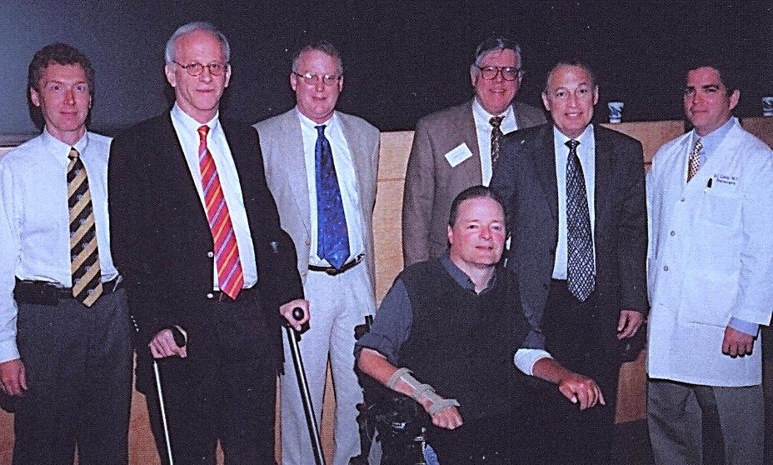

*Back Row: Dr. Mark Kindy (Associate Scientific Director), Mr. James A Shepherd, Jr. (Shepherd Center), Dr. Scott Whittemore (Kentucky SCI Research Center), Mr. Walker Coleman (Administrator), Dr. Barth A. Green (The Miami Project),*

*Dr. Brian G. Cuddy (Chair)*

*Front Row: Dr. James S. Krause (Scientific Director)*

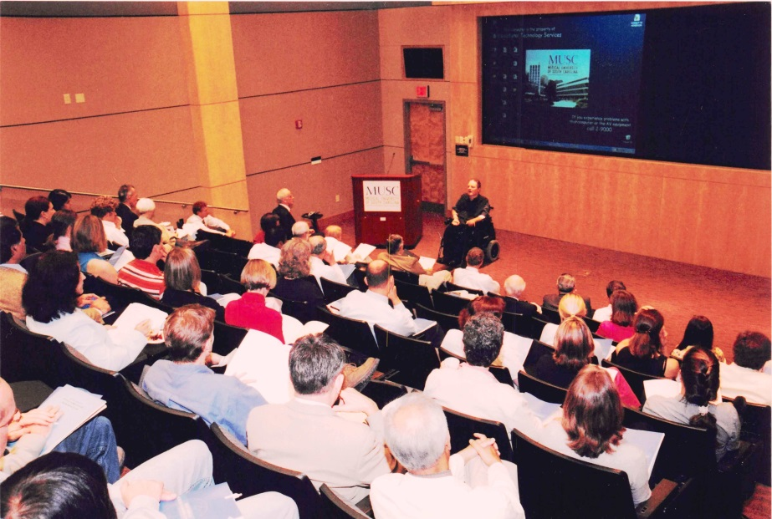

*Dr. James S. Krause (Scientific Director),*

*providing an overview of the SCIRF to attendees*

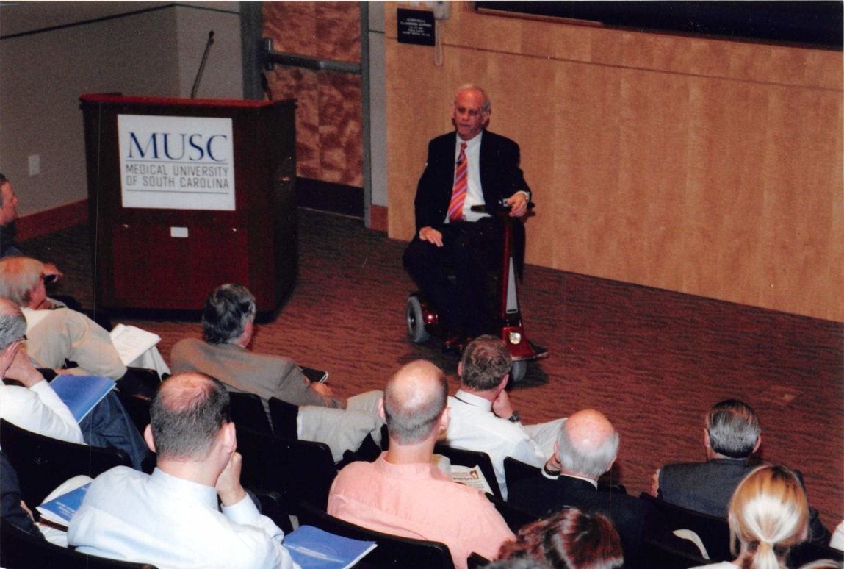

*Mr. James A. Shepherd, Jr.*

**2nd Scientific Conference - May 30, 2008**

(Summary included in 2007/2009 Annual Report). The second scientific conference was held at the Storm Eye Institute of the Medical University of South Carolina and was attended by over 60 physicians, researchers and advocates from across South Carolina.

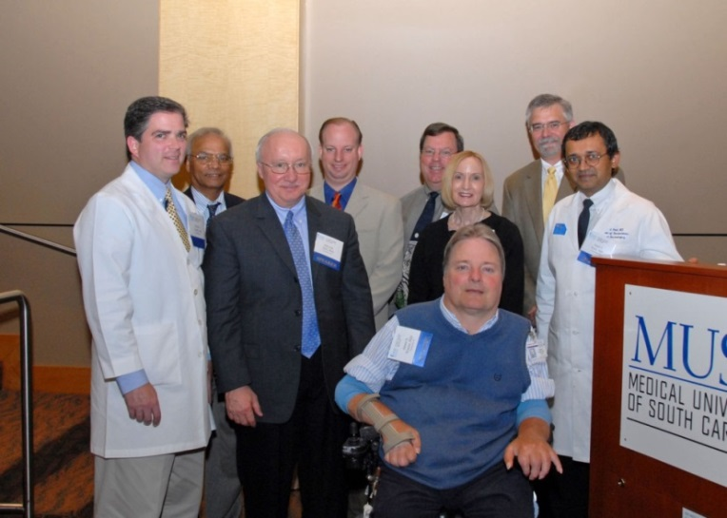

*Back Row: Dr. Brian G. Cuddy (Chair), Dr. Naren L. Banik (Associate Scientific Director), Dr. Edward D. Hall (Director – Spinal Cord and Brain Injury Research Center in Kentucky), Dr. Kenneth Webb (Clemson University), Dr. David Murday, Dr. Linda Veldheer (Director – Head and Spinal Cord Injury Division-SCDDSN), un-identified, Dr. Sunil Patel (MUSC)*

*Front Row: Dr. James S. Krause (Scientific Director)*

**3rd Scientific Conference** - **July 8, 2010**

The third scientific conference was held at the Storm Eye Institute of the Medical University of South Carolina with invited guest speaker, Dr. Allan D. Levi from the Miami Project to Cure Paralysis.

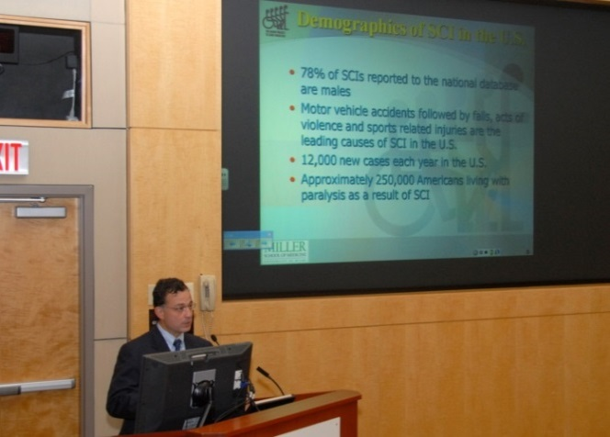

*Dr. Allan D. Levi*

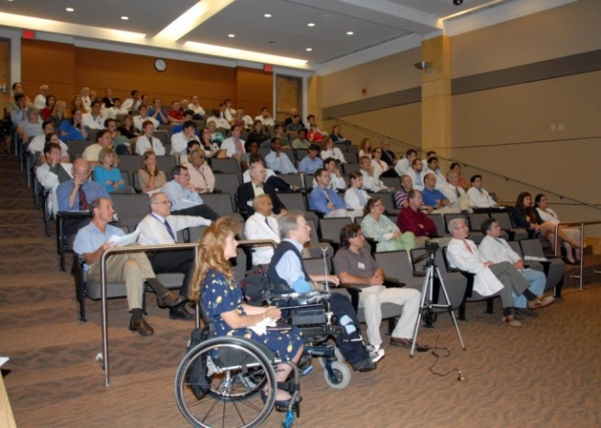

*Audience at presentation by Dr. Allan D. Levi*

**4th Scientific Conference** – **March 22, 2013**

The fourth scientific conference was held at the Bioengineering Building auditorium at the Medical University of South Carolina. The agenda below included updates from SCIRF grant recipients as well as other researchers.

9:00 – 9:10 Opening Remarks

W. Daniel Westerkam, MD, Board Chair, SCIRF

James S. Krause, PhD, Scientific Director, SCIRF

9:10 – 9:25 Current Status of the Epidemiology of Spinal Cord Injury in South Carolina – Incidence and Prevalence, 1998 - 2011

Anbesaw W. Selassie, DrPH, Professor, Dept. of Public Health Sciences, College of Medicine, Medical University of South Carolina

9:25 – 9:40 Health Outcomes Among Persons with Spinal Cord Injury in South Carolina

Lee L. Saunders, PhD, Assistant Professor, Dept. of Health Sciences and Research, College of Health Professions, Medical University of South Carolina

9:40 – 9:55 The Center for Spinal Cord Injury – A Gateway to Spinal Cord Injury Clinical Care and Research

Cathy Therrell, MSN, RN, NEA-BC, Director, Physical Rehabilitation Services, Roper Rehabilitation Hospital

Susan D. Newman, PhD, RN, CCRN, Associate Professor, College of Nursing, Medical University of South Carolina

9:55 – 10:20 Plenary Speaker

Testosterone Deficiency and Replacement: Implications after Spinal Cord Injury

Jeffrey T. Tubbs, MD, Fellow, Spinal Cord Injury Medicine, Dept. of Physical Medicine and Rehabilitation, Hunter Holmes McGuire VA Medical Center/ Virginia Commonwealth University, Richmond, VA. Recruited to Roper Rehabilitation Hospital, Charleston SC, as Medical Director of the Center for Spinal Cord Injury (July 1, 2013)

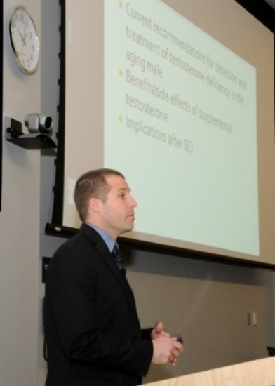 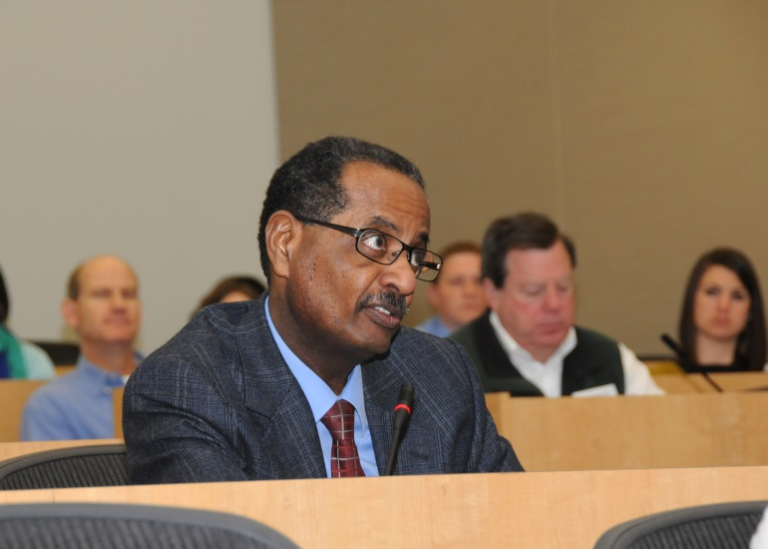

*Jeff Tubbs, MD Audience member, Dr. Anbesaw Selassie*

10:20 – 10:30 Break

10:30 – 10:45 Risk of Death after Hospital Discharge with Traumatic Spinal Cord Injury in South Carolina, 1998 - 2009

Yue Cao, PhD, Research Associate, Dept. of Health Sciences and Research, College of Health Professions, Medical University of South Carolina

10:45 – 11:00 Physiological Predictors of Locomotor Function in Persons Following Motor Incomplete Spinal Cord Injury

Chris M. Gregory, PhD, Assistant Professor, Dept. of Health Sciences and Research, College of Health Professions, Medical University of South Carolina

11:00 – 11:15 Center of Mass Acceleration as a Surrogate for Force Production After Spinal Cord Injury – Effects of Inclined Treadmill Walking

Mark G. Bowden, PhD, Assistant Professor, Dept. of Health Sciences and Research, College of Health Professions, Medical University of South Carolina

11:15 – 11:30 Therapeutic Modulation of the Complement System

Stephen Tomlinson, PhD, Professor, Dept. of Microbiology and Immunology, College of Medicine, Medical University of South Carolina

11:30 – 11:45 The Telomere and Telomerase as a Potential Target in Spinal Cord Injury Therapy

Sooyoung Park, PhD, Postdoctoral Fellow, Dept. of Neurosciences, College of Medicine, Medical University of South Carolina

11:45 – 12:00 Estrogen Receptor Agonist for Treatment of Spinal Cord Injury

Swapan K. Ray, PhD, Professor, Dept. of Pathology, Microbiology and Immunology, School of Medicine, University of South Carolina

12:00 – 12:15 Muscle Atrophy in Spinal Cord Injury

Kenkishi Nozaki, MD, PhD, Assistant Professor, Dept. of Neurosciences, College of Medicine, Medical University of South Carolina

12:15 – 12:20 Closing Remarks

James S. Krause, PhD, Scientific Director, SCIRF

**Distinguished Service Award**

Immediately following the 2013 Scientific Conference, the SCIRF presented Representative Chip Limehouse with the Distinguished Service Award for his tireless effort in the establishment of the SCIRF.

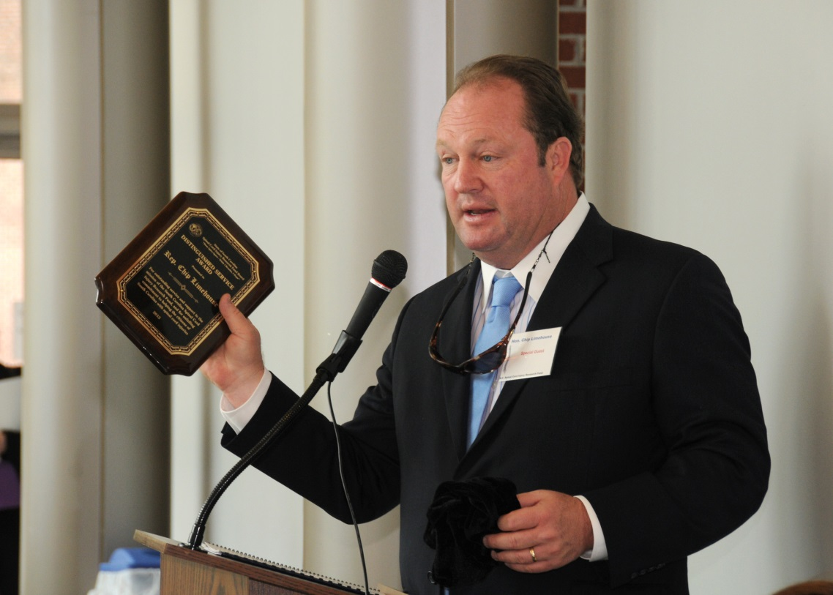

*Rep. Chip Limehouse*

# CONSUMER

The SCIRF has maintained an ongoing relationship with the South Carolina Spinal Cord Injury Association (SCIA) in order to reach those with spinal cord injury living in South Carolina. The SCIA maintains a very informative website ([www.scspinalcord.org](http://www.scspinalcord.org)) that includes resource information and methods to participate in SCIRF research studies. The SCIA has held several consumer educational conferences and education workshops over the years with support from the SCIRF.

**1st Consumer Conference - May 1, 2003**

The first statewide conference “Taking Charge of Your Life” was held, with SCIRF support (Grant #1202), at the Sheridan Convention Center in Columbia, SC. (Details included in the 2004/2005 Annual Report). There were 160 participants with 15 exhibitors and representatives from agencies and providers of SCI services.

**Statewide Continuing Education Workshops - 2004**

The “SCI Healthy Habits Workshop” was held, with SCIRF support (Grant #0103), between February and May of 2004 in Columbia, North Charleston, Florence, and Greenville. A part-time nurse educator organized and developed the curriculum and conducted the workshops for over 160 people.

**2nd Consumer Conference - May 12, 2005**

The second statewide conference “Experience the Power: Living Well after Spinal Cord Injury” was held, with SCIRF support (Grant #0204), at the Columbia Hotel and Conference Center in Columbia, SC. (Agenda and details included in the 2004/2005 Annual Report). There were 279 registrants with 29 vendors and exhibitors. Multiple presentations included:

* + - Optimism in SCI Research: Progress of New Treatments
    - Nuts and Bolts of Wheelchair Selection and Seating
    - Getting What You Need Through Effective Advocacy
    - News You Can Use: Update on Preventive Medical and Management of Common Complications After SCI
    - Ask the Experts Panel Session
    - SCIRF Abstract Presentations

**3rd Consumer Conference - October 15, 2011**

The third statewide conference “Wheeling in New Directions” was held, with SCIRF support (Grant #10-002), at Saluda Shoals in Columbia, SC. There were 98 attendees, 27 vendors, nine breakout session and two general sessions.

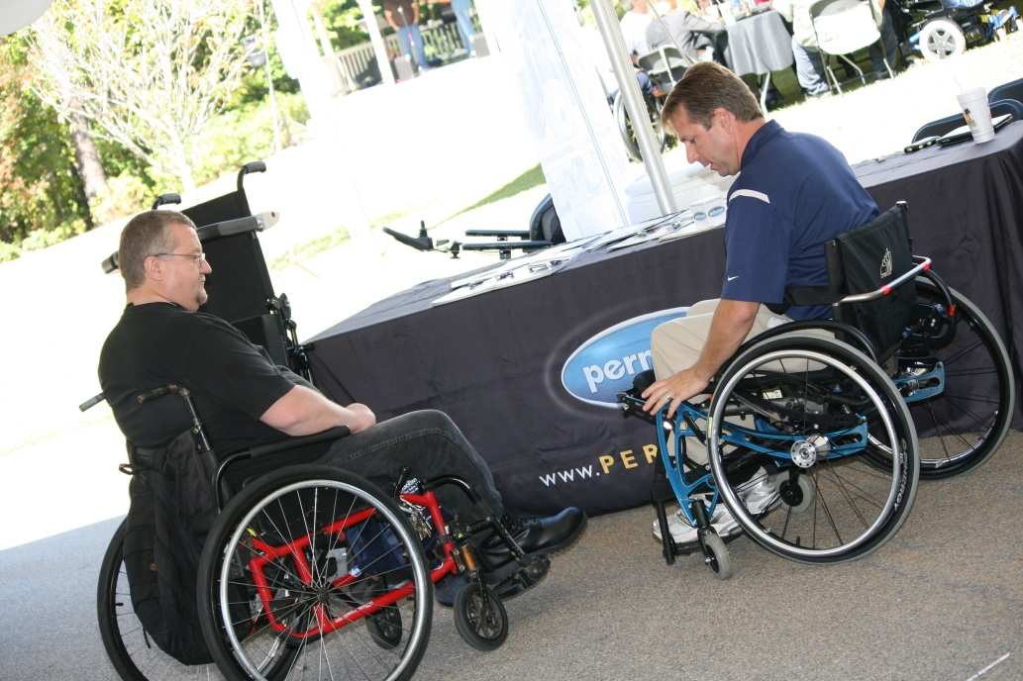

*Exhibitor demonstrating wheelchair adaptation to attendee*

**4th Consumer Conference - May 10, 2014**

The fourth statewide conference “Wheeling in New Directions” was held, with SCIRF support (Grant #12-003), at the Columbia Conference Center in Columbia, SC. There were 103 attendees, 32 exhibitors, 12 breakout sessions and two general sessions. A short video about the conference can be seen at [www.scspinalcord.org/node/3267](http://www.scspinalcord.org/node/3267).

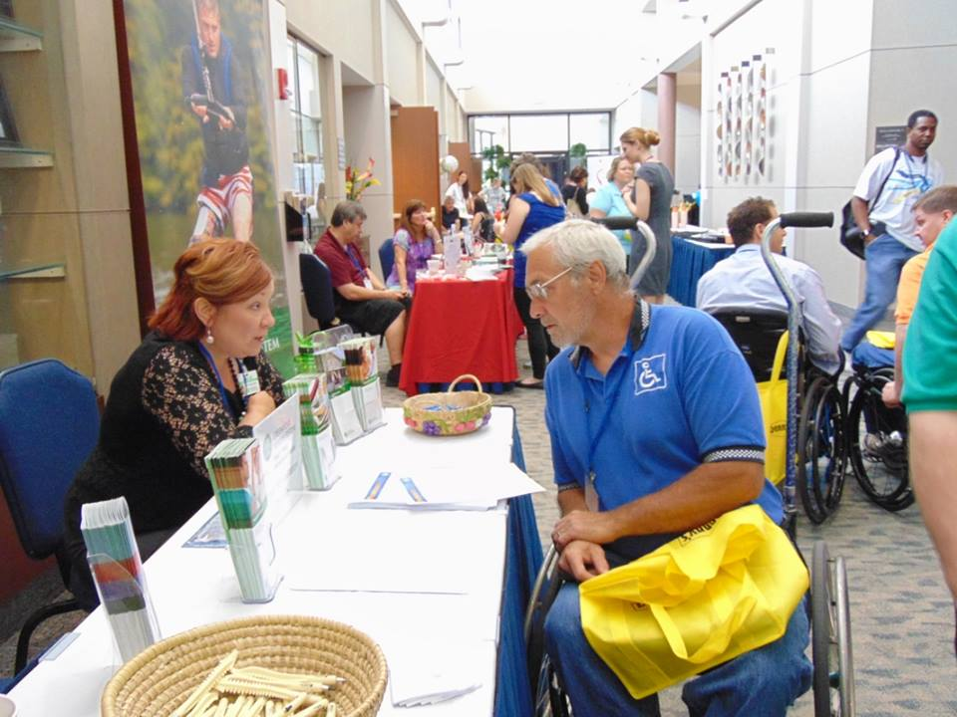

*Attendees visiting exhibitor tables in main hallway*

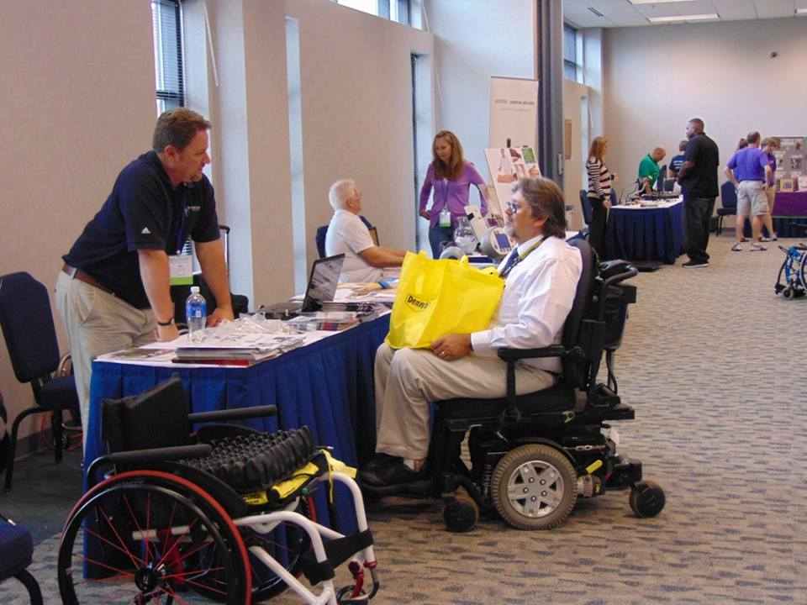

*Attendee visiting exhibitor table in exhibitor room*

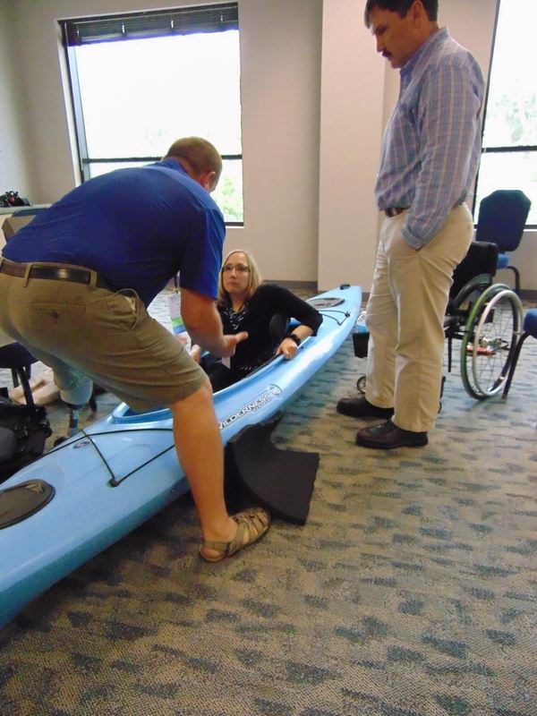

*Attendee learning about adaptive kayaking in breakout session*

# PROVIDER

The SCIRF understands that there is a need to increase healthcare provider knowledge regarding spinal cord injury management and rehabilitation throughout the state of South Carolina. We have encouraged proposals for provider conferences in order to accomplish this.

**1st Provider Conference – November 3-4, 2007**

Through a grant from the SCIRF (Grant #0807), Roger C. Peace Rehabilitation Hospital, planned and held a provider conference “An Interdisciplinary Approach to SCI Management” in Greenville, SC. The audience included over 125 physicians, case managers, nurses, occupational therapists, physical therapists, psychologists, recreational therapists, respiratory therapists, speech pathologists and other healthcare professionals concerned with the care and treatment of those with spinal cord injuries.

**2nd Provider Conference – April 17-18, 2010**

Through a grant from the SCIRF (Grant #0903), Roger C. Peace Rehabilitation Hospital, planned and held a provider conference “Management of the Traumatic and Non-Traumatic Spinal Cord Injury” at the Hyatt Regency Hotel in Greenville, SC. The audience included over 150 attendees with a substantial portion of nurses. Continuing education units were provided to occupational and physical therapists as well as nurses.

Day one topics included:

* + - “Exploring Traumatic and Non-Traumatic SCI” keynote presentation from Anthony Chiodo, MD (Director of Adult Spasticity Clinic – University of Michigan Health System)
    - ASIA classification
    - medical complications
    - functional outcomes
    - basic skin and nutrition
    - basic bowel and bladder function
    - medical and non-medical comorbidities

Day two topics included:

* research updates
* respiratory complications and assessments
* sexuality and SCI
* role of speech language pathologist in SCI treatment
* management of medical complications
* upper extremity function
* advance bowel and bladder management
* mobility progression and transfers
* advanced respiratory care
* basic seating and positioning
* advanced skin and nutrition
* treatment in the critical care unit
* service dogs

**PART VII: INCOME**

# AMOUNT COLLECTED

The income to the SCIRF comes exclusively from revenue attributed to a $100 fee levied on every “Driving Under the Influence” (DUI) conviction in South Carolina. MUSC is the legislated administrator of these collected funds and is the state agency responsible for their oversight.

The $100 per DUI surcharges are received monthly throughout each fiscal year. SCIRF began collecting funds in March of 2001 and collected $6,234,704.82 from FY 2001-FY 2009 with a running monthly average of $60,986.54. SCIRF collected an additional $4,408,265.80 from FY 2010-FY 2014 with a total collected of $10,642,970.62. The running monthly average rose to $65,445.31.

Detailed monthly collections since the inception of the SCIRF are included on the following 2 pages.

**Overall Income**

|  |  |  |  |  |  |  |  |
| --- | --- | --- | --- | --- | --- | --- | --- |
| **Month** | **2000-2001** | **2001-2002** | **2002-2003** | **2003-2004** | **2004-2005** | **2005-2006** | **2006-2007** |
| Jul |  | 54,159.28 | 58,312.09 | 49,138.21 | 55,373.62 | 55,200.43 | 52,944.66 |
| Aug |  | 62,635.31 | 76,064.34 | 70,190.90 | 61,492.46 | 52,186.44 | 54,331.33 |
| Sep |  | 61,642.97 | 60,925.72 | 62,249.13 | 47,197.81 | 48,844.66 | 55,875.47 |
| Oct |  | 60,039.88 | 67,764.04 | 52,129.53 | 70,469.83 | 65,694.81 | 64,546.13 |
| Nov |  | 63,716.54 | 69,631.96 | 55,817.92 | 51,773.76 | 55,735.32 | 51,117.05 |
| Dec |  | 53,845.08 | 65,987.31 | 49,267.84 | 54,640.47 | 41,315.54 | 46,386.08 |
| Jan |  | 43,035.45 | 56,063.61 | 63,663.52 | 53,425.96 | 44,937.24 | 44,707.64 |
| Feb |  | 67,213.13 | 79,548.82 | 57,270.58 | 57,445.32 | 69,201.91 | 73,209.95 |
| Mar | 41,630.22 | 110,797.84 | 75,621.55 | 59,148.68 | 59,519.99 | 65,222.55 | 76,915.55 |
| Apr | 41,513.91 | 68,851.79 | 67,871.19 | 57,654.32 | 65,713.64 | 58,319.24 | 58,314.69 |
| May | 42,606.41 | 73,028.36 | 69,933.84 | 68,408.00 | 71,195.33 | 76,984.57 | 60,762.94 |
| Jun | 50,170.12 | 82,816.15 | 78,235.51 | 54,125.04 | 59,263.03 | 61,198.58 | 61,040.84 |
| **FY Total** | **175,920.66** | **801,781.78** | **825,959.98** | **699,063.67** | **707,511.22** | **694,841.29** | **700,152.33** |
| *Running Total* | *175,920.66* | *977,702.44* | *1,803,662.42* | *2,502,726.09* | *3,210,237.31* | *3,905,078.60* | *4,605,230.93* |
| *Running Monthly Avg* | *43,980.17* | *55,397.66* | *59,875.10* | *59,470.15* | *59,367.98* | *59,123.89* | *59,012.76* |

**Overall Income**

|  |  |  |  |  |  |  |  |
| --- | --- | --- | --- | --- | --- | --- | --- |
| **Month** | **2007-2008** | **2008-2009** | **2009-2010** | **2010-2011** | **2011-2012** | **2012-2013** | **2013-2014** |
| Jul | 65,188.54 | 63,295.64 | 68,925.72 | 78,117.38 | 92,702.44 | 62,278.79 | 65,930.03 |
| Aug | 67,482.75 | 73,283.15 | 80,363.88 | 81,616.00 | 87,643.50 | 85,707.41 | 71,821.97 |
| Sep | 61,205.30 | 62,688.45 | 63,866.12 | 60,919.25 | 80,632.32 | 64,550.12 | 83,532.83 |
| Oct | 58,630.09 | 67,089.26 | 67,798.75 | 79,353.39 | 74,347.28 | 60,544.15 | 51,995.76 |
| Nov | 58,898.92 | 58,490.47 | 71,156.95 | 83,937.35 | 76,534.98 | 91,926.62 | 89,457.41 |
| Dec | 55,068.52 | 67,219.41 | 81,153.11 | 29,279.51 | 62,860.57 | 58,984.27 | 67,818.34 |
| Jan | 62,996.88 | 53,732.19 | 64,017.56 | 58,056.23 | 49,162.13 | 52,654.22 | 46,695.07 |
| Feb | 68,439.74 | 74,118.95 | 76,886.22 | 85,200.24 | 74,521.10 | 63,222.76 | 64,894.09 |
| Mar | 70,910.02 | 92,928.07 | 84,037.26 | 32,075.97 | 98,974.51 | 82,683.92 | 83,040.77 |
| Apr | 79,977.58 | 74,324.53 | 88,118.43 | 96,983.72 | 73,041.07 | 89,729.93 | 92,337.53 |
| May | 75,040.33 | 71,711.55 | 70,467.32 | 81,955.64 | 86,829.15 | 74,408.09 | 64,968.25 |
| Jun | 74,607.40 | 72,146.15 | 83,679.78 | 83,627.06 | 75,057.43 | 78,398.26 | 76,785.89 |
| **FY Total** | **798,446.07** | **831,027.82** | **900,471.10** | **851,121.74** | **932,306.48** | **865,088.54** | **859,277.94** |
| *Running Total* | *5,403,677.00* | *6,234,704.82* | *7,135,175.92* | *7,986,297.66* | *8,918,604.14* | *9,783,692.68* | *10,642,970.62* |
| *Running Monthly Avg* | *59,953.32* | *60,986.54* | *62,391.81* | *63,167.72* | *64,378.09* | *64,971.37* | *65,445.31* |

**PART VIII: CASH ANALYSIS**

|  |  |  |  |  |  |
| --- | --- | --- | --- | --- | --- |
|  |  |  |  | **Sub Totals** | **Running Totals** |
| **Income** |  |  |  |  |  |
|  | (DUI Collections 3/2001-6/2014) |  | 10,642,970.62 |  |  |
|  |  |  |  | 10,642,970.62 | **10,642,970.62** |
| **Expenditures** |  |  |  |  |  |
|  | Active Grant Accounts |  | (3,192,977.90) |  |  |
|  | Inactive (closed) Grant Accounts |  | (3,521,827.60) |  |  |
|  |  |  |  | (6,714,805.50) | **3,928,165.12** |
| **Commitments** |  |  |  |  |  |
|  | Active Grant Accounts |  | (1,327,333.16) |  |  |
|  | FY15 ADMIN Core |  | (163,400.00) |  |  |
|  | FY15 RESEARCH Core |  | (70,185.00) |  |  |
|  |  |  |  | (1,560,918.16) | **2,367,246.96** |
| **Core Support through FY17** | |  |  |  |  |
|  | FY16 & FY17 ADMIN Core |  | (250,000.00) |  |  |
|  | FY16 & FY17 RESEARCH Core |  | (144,000.00) |  |  |
|  |  |  |  | (394,000.00) | **1,973,246.96** |
| **Set Aside (Up to 4/each RFP)** | |  |  |  |  |
|  | Investigator Initiated (80,000/each) |  | (320,000.00) |  |  |
|  | Pilot (30,000/each) |  | (120,000.00) |  |  |
|  | Student Research (5,000/each) |  | (20,000.00) |  |  |
|  | Bridge (75,000/each) |  | (300,000.00) |  |  |
|  | Recruitment/Seed (125,000/each) |  | (500,000.00) |  |  |
|  |  |  |  | (1,260,000.00) | **713,246.96** |

**PART IX: BOARD OF DIRECTORS/**

**EXECUTIVE & SCIENTIFIC DIRECTORS**

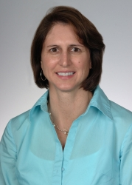**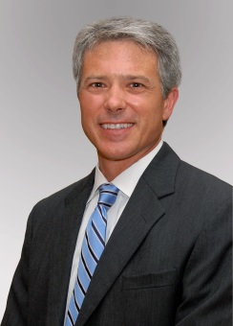Chair: W. Daniel Westerkam, MD** Columbia, SC

(Category B)

Specialist in PM&R, Dir. of Rehab Services at Palmetto Richland Memorial Hosp. & Associate Medical Dir. at HealthSouth Rehabilitation Hospital

W: 803-401-1369/803-401-1404

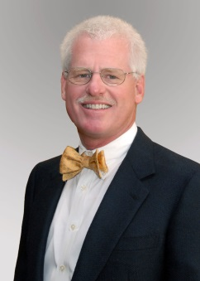

**Byron N. Bailey, MD**

Charleston, SC

(Category D)

Board Certified Neurosurgeon in private practice at Charleston Neurological Associates, L.L.C.

W: 843-723-8823

**Jeremy S. Chapman**

Pelzer, SC

(Category C – Person or family member with SCI)

Email: jroc153@msn.com

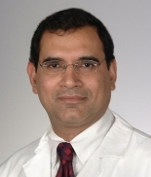

**Abhay K. Varma, MD, MBBS**

Mt. Pleasant, SC

(Category A)

Associate Professor of Neurosurgery at MUSC

W: 843-792-1308

**Nomination submitted**

(Category C)

**M. Noreen Herring, MD**

Charleston, SC

(Category A)

Specialist in Physical Medicine and Rehabilitation and Assistant Professor at MUSC Neuroscience Department

W: 843-792-3221

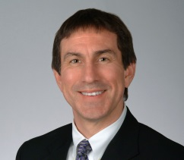**Kevin W. Kopera, MD, MPH**

Greenville, SC

(Category B)

Board Certified in Physical Medicine and Rehabilitation. Medical Director Roger C. Peace Rehabilitation Hospital

W: 864-455-3754

**STAFF**

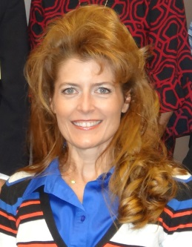

**Catherine Leigh Graham, MEBME**

***Executive Director***

W: 843-614-1756

Email: grahacat@musc.edu

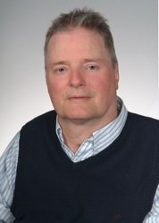

**James S. Krause, PhD**

***Scientific Director***

Associate Dean for Clinical Research College of Health Professions, MUSC

W: 843-792-1337

Email: krause@musc.edu

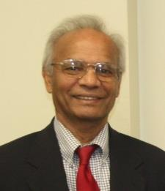

**Naren L. Banik, PhD**

***Associate Scientific Director***

Professor, Department of Neurology and Neuroscience, MUSC

W: 843-792-7594

Email: baniknl@musc.edu

**Terms**

The Board is comprised of the following Categories:

1. Two medical doctors from MUSC;
2. Two medical doctors at large specializing or significantly engaged in the treatment of people with an SCI;
3. Two members who have an SCI or have a family member with an SCI; and,
4. One at large medical doctor who is a member of the South Carolina Medical Association.

**Category A.** Two medical doctors from MUSC

**M. Noreen Herring, MD –** initial term (2014)

**Abhay K. Varma, MD** – first term (2018)

**Category B.** Two medical doctors at large specializing or significantly engaged in the treatment of people with an SCI

**W. Daniel Westerkam, MD –** second term (2015)

**Kevin W. Kopera, MD, MPH –** first term (2017)

**Category C.** Two members who have an SCI or a family member with an SCI

**Jeremy S. Chapman** – first term (2018)

Nomination Submitted

**Category D.** One at large medical doctor who is a member of the SC Medical Association

**Byron N. Bailey, MD –** second term (2015)

**Passing of the Gavel**

The SCIRF Board of Directors would like to express a heartfelt thank you to Dr. Brian G. Cuddy who served as the Board Chair from 2002-2013. Dr. W. Daniel Westerkam, incoming Board Chair, presented the Chairman’s Award to Dr. Cuddy after the Scientific Conference in March of 2013.

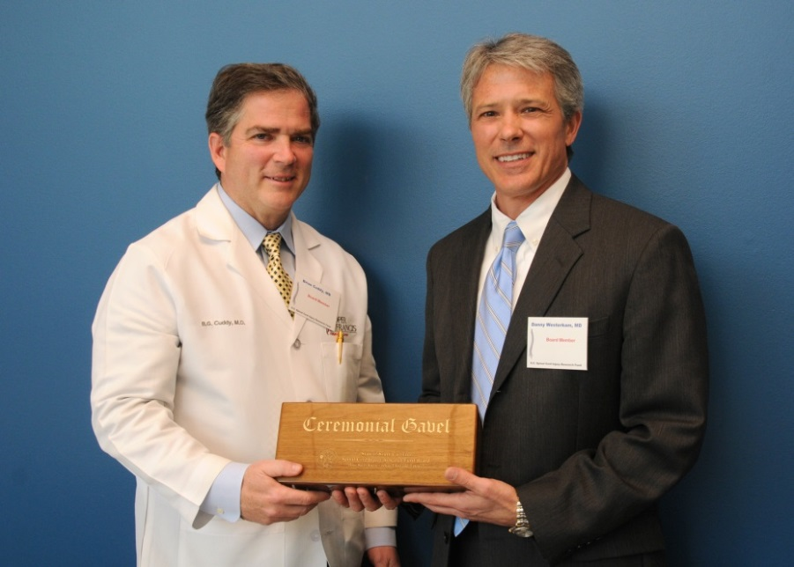

*Dr. Brian G. Cuddy (left) accepting the Chairman’s Award from*

*Dr. W. Daniel Westerkam*

The SCIRF Board of Directors welcomed Dr. W. Daniel Westerkam as the new Board Chair in 2013 after the Scientific Conference. Dr. Brian G. Cuddy presented Dr. Westerkam with the Ceremonial Gavel.

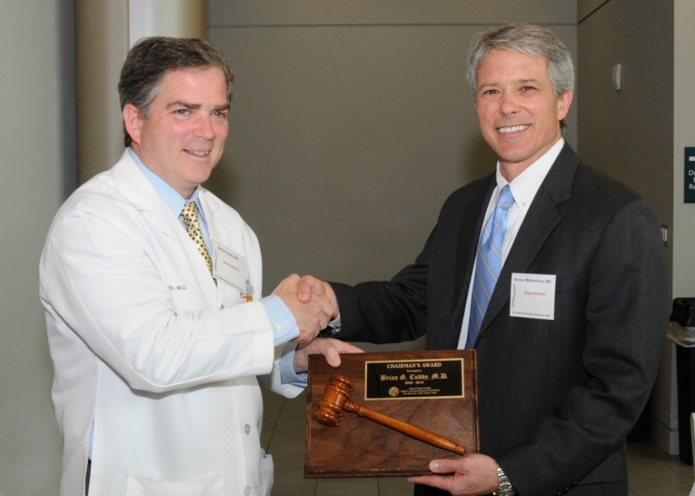

*Dr. W. Daniel Westerkam (right) accepting the ceremonial gavel from*

*Dr. Brian G. Cuddy*

**Meetings**

The Board of Directors holds in-person meetings, usually 2-3 per year, to address the organization of the SCIRF as well as directional goals. Meeting dates, locations and select photos are included below. The Board of Directors is responsible for approving all grants awarded as well as budgets for Administrative and Research Core functions.

**2001**

**June 8** – Board Room, Medical University of South Carolina, Charleston (Agenda included in June 30, 2002 Annual Report)

**August 24** – Board Room, Medical University of South Carolina, Charleston (Agenda included in June 30, 2002 Annual Report)

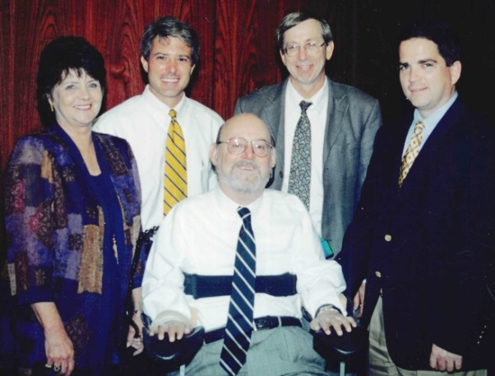

*Back Row: Ms. Terry Peacock, Dr. W. Daniel Westerkam, Dr. David Shallcross,*

*Dr. Brian G. Cuddy (Chair)*

*Front Row: Judge Charles Allen*

**2002**

**March 22** – Board Room, Medical University of South Carolina, Charleston (Agenda included in June 30, 2002 Annual Report)

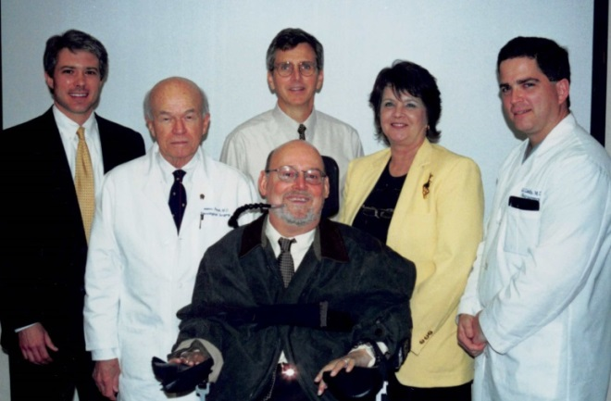

*Back Row: Dr. W. Daniel Westerkam, Dr. Phanor Perot, Dr. David Greisemer,*

*Ms. Terry Peacock, Dr. Brian G. Cuddy (Chair)*

*Front Row: Judge Charles Allen*

**May 31** – Board Room, Medical University of South Carolina, Charleston (Agenda included in June 30, 2002 Annual Report)

**December 6** – University Board Room, 2nd Floor Administration/Library Building, Medical University of South Carolina, Charleston (Agenda included in 2002/2003 Annual Report)

**2003**

**July 11** – Charleston (Agenda included in 2002/2003 Annual Report)

**December 5** – Embassy Suites Hotel/Airport Convention Center, 5055 International Blvd, North Charleston (Agenda included in 2003/2004 Annual Report)

**2004**

**June 25** – SC Department of Health and Environmental Control Board Room, 2600 Bull Street, Columbia (Agenda included in 2003/2004 Annual Report)

**December 3** – Corporate Offices of the Medical Society of South Carolina, 69-B Barre Street, Charleston (Agenda and participant list included in 2004/2005 Annual Report)

**2005**

**July 1** – Corporate Offices of the Medical Society of South Carolina, 69-B Barre Street, Charleston (Agenda included in 2004/2005 Annual Report)

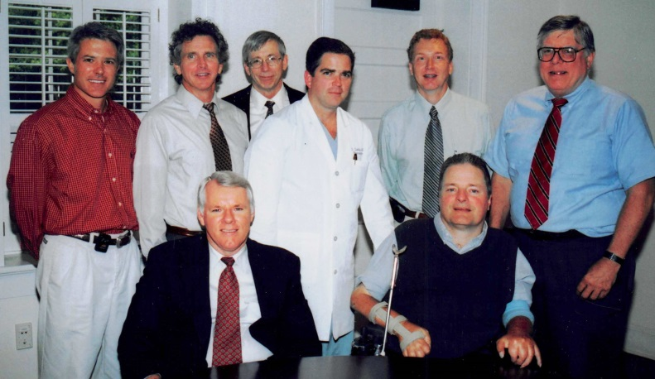

*Back Row: Dr. W. Daniel Westerkam, Dr. David Griesemer, Dr. David Shallcross,*

*Dr. Brian G. Cuddy (Chair), Dr. Mark Kindy (Associate Scientific Director),*

*Mr. Walker Coleman (Administrator)*

*Front Row: Mr. John Stevens, Dr. James S. Krause (Scientific Director)*

*Not Pictured: Ms. Terry Peacock and Dr. Phanor Perot*

**2006**

**January 27** – Corporate Offices of the Medical Society of South Carolina, 69-B Barre Street, Charleston (Agenda in 2005/2006 Annual Report)

**June 9** – Corporate Offices of the Medical Society of South Carolina, 69-B Barre Street, Charleston (Agenda in 2005/2006 Annual Report)

**2007**

**January 26** – Corporate Offices of the Medical Society of South Carolina, 69-B Barre Street, Charleston (Agenda in 2006/2007 Annual Report)

**June 22** – 2nd Floor Conference Room, Colcock Hall, Medical University of South Carolina, Charleston (Agenda in 2006/2007 Annual Report)

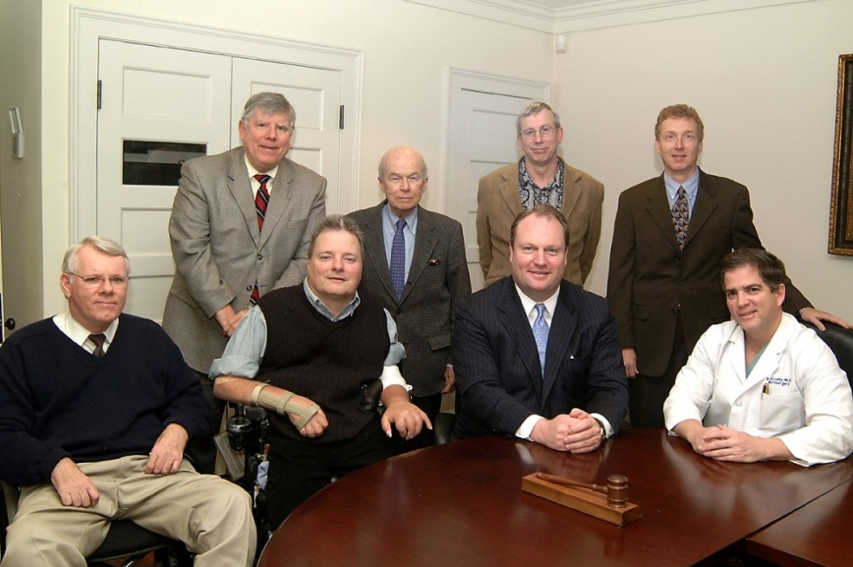

*Back Row: Mr. Walker Coleman (Administrator), Dr. Phanor Perot,*

*Dr. David Shallcross, Dr. Mark Kindy (Associate Scientific Director)*

*Front Row: Mr. John Stevens, Dr. James S. Krause (Scientific Director),*

*Rep. Chip Limehouse, Dr. Brian G. Cuddy (Chair)*

**2008**

**January 23** – Capitol City Club, Salon C, Columbia

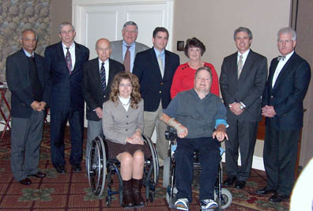

*Back Row: Dr. Naren L. Banik (Associate Scientific Director), Dr. David Shallcross,*

*Dr. Phanor Perot, Mr. Walker Coleman (Administrator), Dr. Brian G. Cuddy (Chair),*

*Ms. Terry Peacock, Dr. W. Daniel Westerkam, Dr. Byron N. Bailey*

*Front Row: Ms. Catherine Leigh Graham, Dr. James S. Krause (Scientific Director)*

**May 30 –** Medical University of South Carolina,Charleston

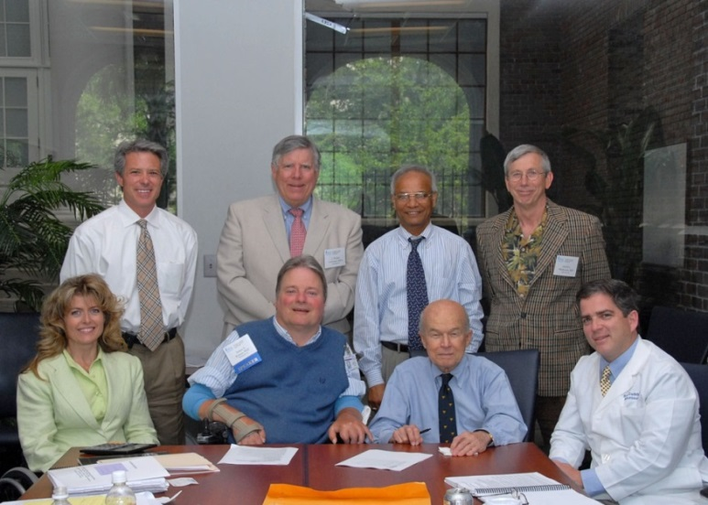

*Back Row: Dr. W. Daniel Westerkam, Mr. Walker Coleman (Administrator),*

*Dr. Naren L. Banik (Associate Scientific Director), Dr. David Shallcross*

*Front Row: Ms. Catherine Leigh Graham, Dr. James S. Krause (Scientific Director),*

*Dr. Phanor Perot, Dr. Brian G. Cuddy (Chair)*

**2009**

**February 27 –** Room 102, College of Health Professions A Building, 151 Rutledge Avenue, Charleston

**December 11 –** 3209 Colonial Drive, USC School of Medicine Family Practice, Columbia

**2010**

**July 8 –** Colcock Hall, Charleston

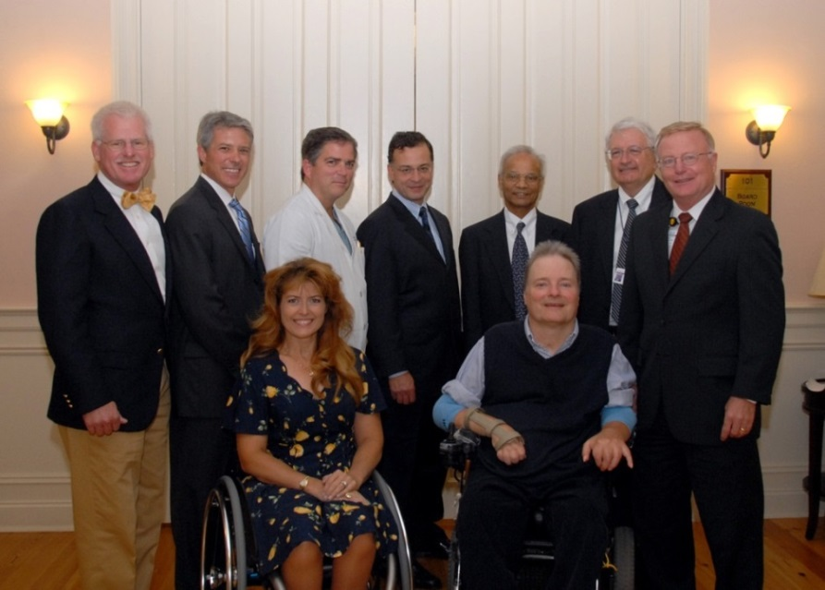

*Back Row: Dr. Byron N. Bailey, Dr. W. Daniel Westerkam, Dr. Brian G. Cuddy (Chair),*

*Dr. Allan D. Levi (The Miami Project), Dr. Naren L. Banik (Associate Scientific Director),*

*Dr. Tom Higerd (Administrator), Dr. Mark Sothmann (MUSC Interim President)*

*Front Row: Ms. Catherine Leigh Graham, Dr. James S. Krause (Scientific Director)*

**2011**

**February 11** – Capital City Club, 1201 Main Street, Columbia

**October 21** – Room 909 Harborview Tower, Medical University of South Carolina, Charleston

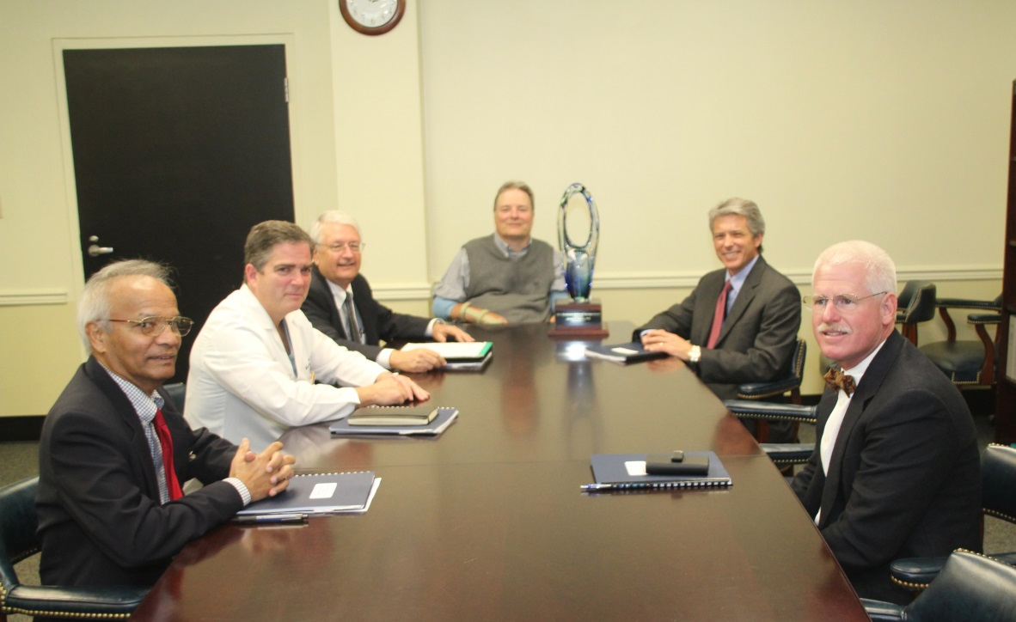

*Left to Right: Dr. Naren L. Banik (Associate Scientific Director), Dr. Brian G. Cuddy (Chair), Dr. Tom Higerd (Administrator), Dr. James S. Krause - winner of the 2011 Medtronic National Courage Award (Scientific Director), Dr. W. Daniel Westerkam, Dr. Byron N. Bailey*

**2012**

**March 23** – Room 102, Bioengineering Building, Medical University of South Carolina, Charleston

**August 17** – Ground Floor Conference Room, Roger C. Peace Rehabilitation Hospital, Greenville

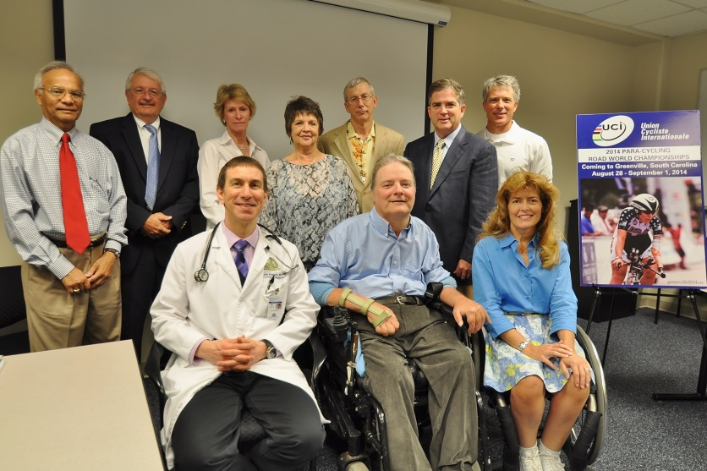

*Back Row: Dr. Naren L. Banik (Associate Scientific Director), Dr. Tom Higerd*

*(Administrator), Ms. Joanne Cole, Ms. Terry Peacock, Dr. David Shallcross,*

*Dr. Brian G. Cuddy (Chair), Dr. W. Daniel Westerkam*

*Front Row: Dr. Kevin W. Kopera, Dr. James S. Krause (Scientific Director),*

*Ms. Catherine Leigh Graham*

**Tour of the facilities at Roger C. Peace Rehabilitation Hospital by Dr. Kevin W. Kopera**

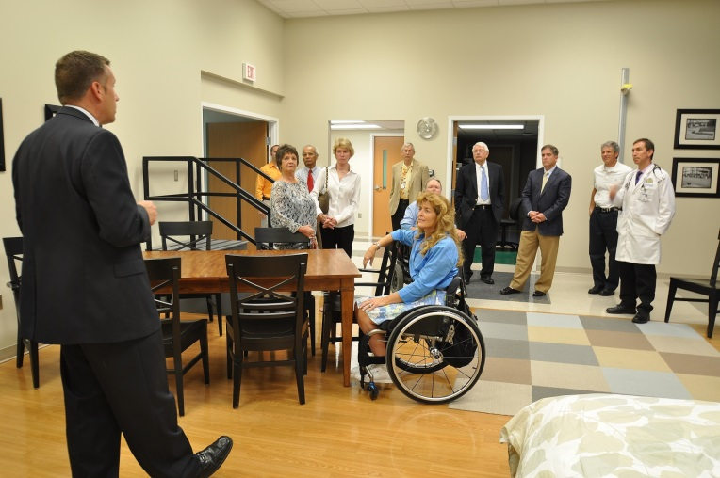

*Dr. Kevin W. Kopera (left) explains the function*

*of the home set up for trial by patients*

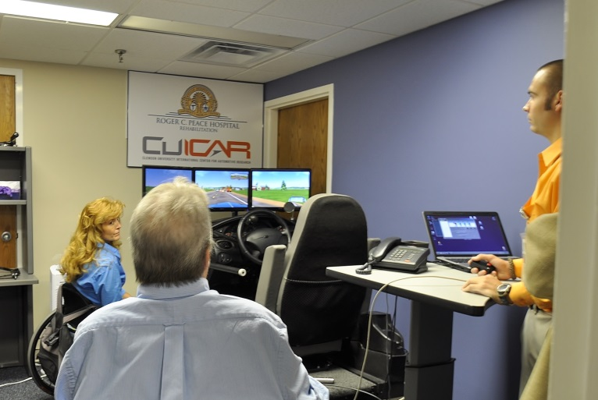

*Ms. Catherine Leigh Graham and Dr. James S.*

*Krause view the driving simulator*

**“Years of Service” Presentations to two out-going Board of Directors**

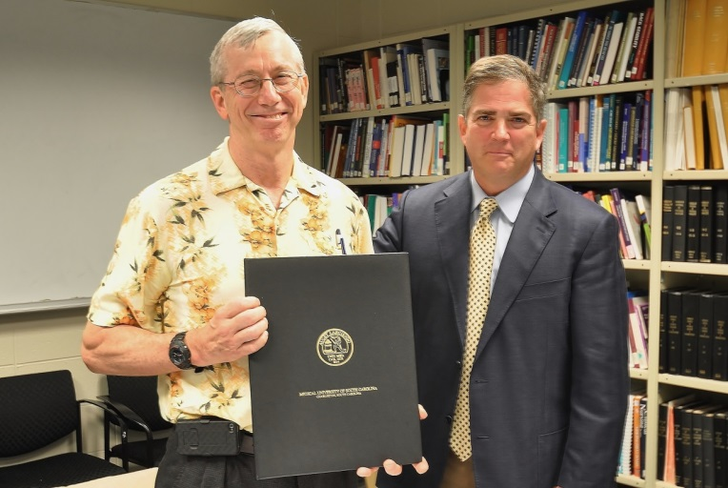

*Dr. Brian G. Cuddy (right) presents recognition to Dr. David Shallcross*

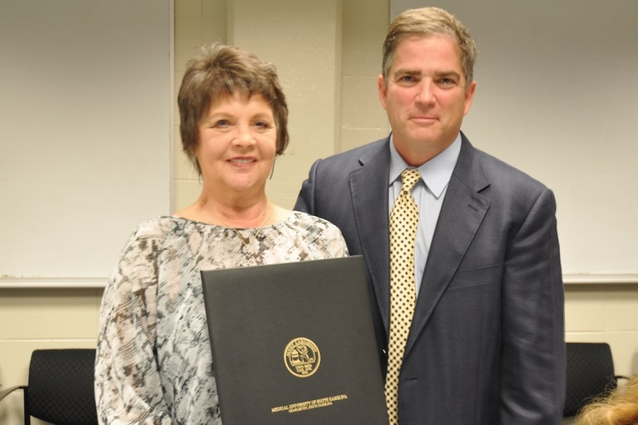

*Dr. Brian G. Cuddy (right) presents recognition to Ms. Terry Peacock*

**2013**

**January 25** – Palmetto Club of Columbia, 1231 Sumter Street, Columbia

**March 22** – Drug Discovery Building, Room 111, Medical University of South Carolina, Charleston

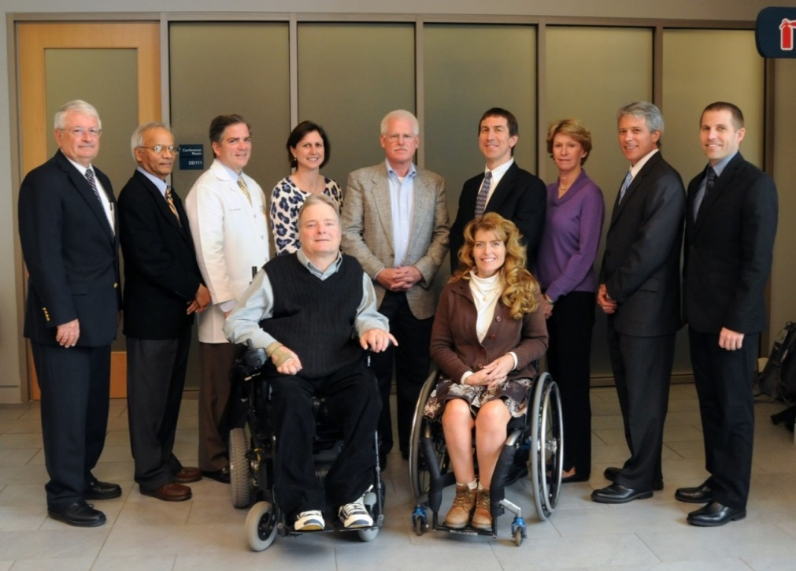

*Back Row: Dr. Tom Higerd (Administrator), Dr. Naren L. Banik (Associate Scientific Director),*

*Dr. Brian G. Cuddy (Outgoing Chair), Dr. M. Noreen Herring, Dr. Byron N. Bailey, Dr. Kevin W. Kopera, Ms. Joanne Cole, Dr. W. Daniel Westerkam (Incoming Chair), Dr. Jeff Tubbs (Incoming Medical Director – Roper Rehabilitation Hospital)*

*Front Row: Dr. James S. Krause (Scientific Director), Ms. Catherine Leigh Graham*

**November 8** – Board Room, Colcock Hall, Medical University of South Carolina, Charleston

**2014**

**May 2** – 2935 Colonial Drive, Healthsouth, Columbia

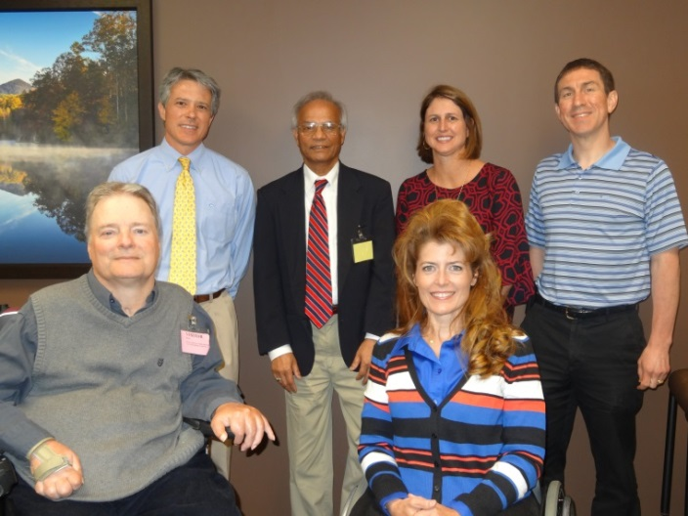

*Back Row: Dr. W. Daniel Westerkam (Chair), Dr. Naren L. Banik (Associate*

*Scientific Director), Dr. M. Noreen Herring, Dr. Kevin W. Kopera*

*Front Row: Dr. James S. Krause (Scientific Director),*

*Ms. Catherine Leigh Graham (Executive Director)*

*Not Pictured: Dr. Byron N. Bailey*

**PART X: RESEARCH OVERVIEW**

We are proud to summarize research accomplishments in animal and human research, development of infrastructure, and the conduct of knowledge translation conferences for both professionals and consumers. The scope of work reflects a combination of activities designed to have short-term, intermediate, and long-term effects. The knowledge translation activities disseminated directly to stakeholders with spinal cord injury (SCI) in the state of South Carolina, in collaboration with the South Carolina SCI Association, are intended to have direct effects. Studies directed at immediate health concerns and outcomes have direct effects as well as more indirect intermediate effects in that they train healthcare professionals to facilitate better outcomes. Studies in basic science and translational science, as well as infrastructure development, are geared toward intermediate and long-term outcomes, including the restoration of function after SCI.

**Conceptual Overview of Spinal Cord Injury Research Fund Activities**

The South Carolina SCI Research Fund (SCIRF) supports diverse activities necessary to meet the overall mission. Figure 1 represents a flowchart of the combination of animal and human studies, as well as their interactions, that are needed to maximize recovery, functional, and clinical outcomes after SCI. The contents of this report are organized around this figure, including the essential elements of basic animal research leading to the development of interventions, which then can be translated into intervention strategies to improve functional, health, and quality of life outcomes.

Bench science is needed to reveal the fundamental mechanisms by which recovery may take place (A). Identification of the mechanisms in animal research allows for the development of interventions (B) that may address the fundamental aspects of injury that may then be tested on animals. These studies may then be translated into interventions and clinical trials at a human level (E). However, before interventions may be implemented at a human translational level, there must be the availability or identification of participants for human research (C) and a more complete understanding of the nature of clinical outcomes after SCI (D). The net sum of these activities is the promotion of maximal recovery, function, and enhanced clinical outcomes (F), that occur at multiple time points from inpatient rehabilitation through the life cycle after SCI.

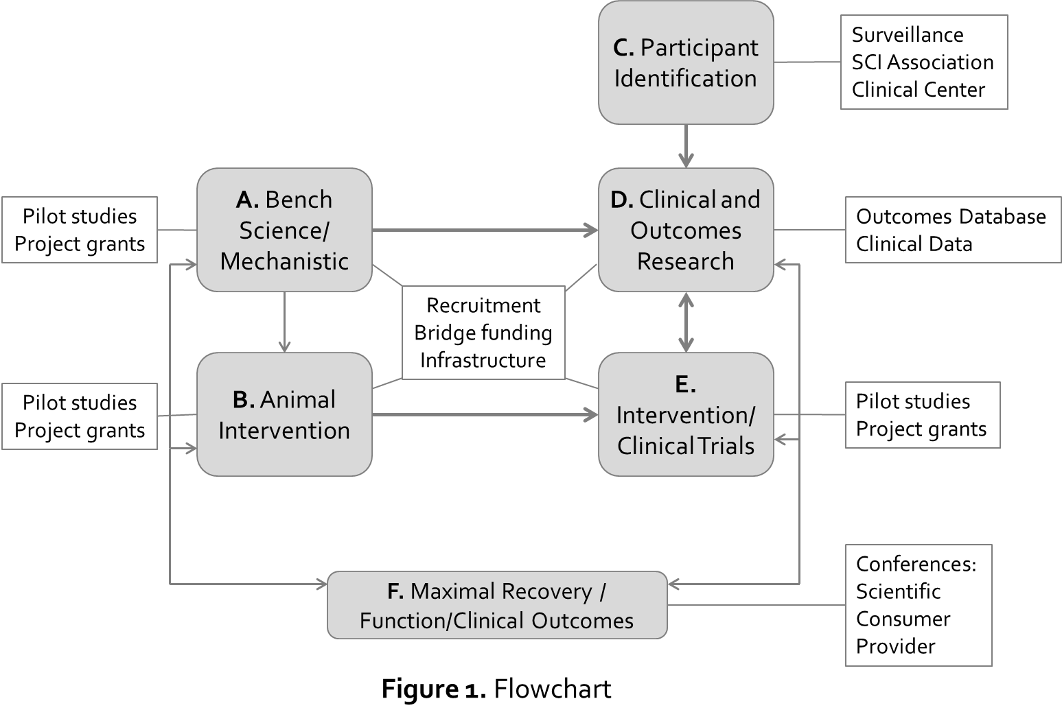

**Overview of SCIRF Funded Activities**

A number of different activities are supported to meet the overall goals of the SCIRF, with each pertaining to at least one of the major components within the flow of research and translational activities. In Figure 1 (in rectangles starting from left to right), we highlight the mechanisms addressing each of the components. Not every type of granting mechanism is used each year, but all have been used over the lifetime of the SCIRF.

*Pilot study grants* have been used to support bench science and animal interventions (A, B), as have project grants which are larger. *Recruitment grants* have been used to bring key personnel with specific SCI training or research experience to South Carolina. Most recently, a recruitment grant was made to Roper Hospital to bring in Dr. Jeffrey Tubbs, a board-certified physiatrist in SCI medicine, establishing a clinical foundation for the development of a research site. Previous recruitments include the Scientific Director, Dr. James Krause (2002), with an established history of federally funded research in SCI. Subsequent recruitments include Dr. Mark Bowden and Dr. Chris Gregory, both of whom are experts in gait studies of SCI, directly promoting enhanced functional outcomes, and Dr. Yue Cao, a medical sociologist and MPH, who came from the national data center at the University of Alabama – Birmingham. *Bridge funding* has been used to successfully maintain the lines of research initiated by Dr. Phanor Perot and continued by Dr. Naren Banik. *Infrastructure grants* have gone hand-in-hand with recruitment.

Roper Rehabilitation Hospital received an infrastructure grant to establish data collection on clinical outcomes that may serve as a foundation for research and was able to purchase an exoskeleton under the recruitment grant for Dr. Jeffrey Tubbs. Previous infrastructure support through the recruitment of Dr. James Krause and the interdisciplinary center grant was used to help establish a comprehensive biomechanics laboratory, including motion analysis, that served as the foundation for the eventual recruitment of Dr. Mark Bowden and Dr. Chris Gregory, as well as innovative research and basic and translational science including telomere changes related to SCI.

Several mechanisms have been used to establish the identification of participants for research (C), including SCI surveillance of all injuries treated acutely within the state of South Carolina, self-report registry of volunteers through the SCI Association, and identification of participants through the Roper Clinic. A statewide database, using surveillance cases with detailed follow-up, has been used to identify clinical outcomes within the state and create the opportunity for manuscript development and identification of cases for research with specific outcomes (D). Pilot and program studies evaluate functional recovery interventions (E), and a number of conferences have been held for knowledge translation including those directed at stakeholders with SCI, providers, and research professionals.

**Importance of Basic Science Research**

Basic science research is essential to understand the underlying mechanisms involved in SCI dysfunction so that target(s) may be identified for development of drugs which may lead to intervention and subsequently improve function. The precise goal of the bench research started many years ago at MUSC with National Institutes of Health (NIH) support led by Dr. Phanor Perot was just that and significantly advanced the field of SCI research. More recently, projects with NIH funding and pilot funding from the SCIRF (Banik; MUSC) have found that estrogen (17β-estradiol) is a powerful intervening agent for the treatment of animals following SCI. Because of the detrimental side effects of estrogen, very low doses of estrogen were subsequently investigated and found to be as effective as high doses for ameliorating dysfunction in SCI. The efficacy of low dose estrogen was confirmed in animals with SCI with Premarin, a conjugated estrogen which is FDA approved and used by menopausal women. This study demonstrated excellent efficacy in animals treated with the low amount of estrogen present in Premarin administered by different routes at different times following injury. Results from this bench study were taken into clinic with support from funding from an MUSC-Clinical and Translational Science Award (CTSA) grant (Banik, Varma) for an Investigational New Drug (IND)-approved safety trial in five individuals with SCI at MUSC. No adverse effect was found in these individuals and all survived. Delivery of Premarin with nano-particle is now being tested in the laboratory in an experimental animal model of SCI (supported by Neurosurgery, MUSC, Varma). Further studies are required before it can be taken into clinic.

Since muscle atrophy is a major problem after SCI, recent studies on understanding the mechanisms involved have been supported by an SCIRF pilot grant to Dr. Kenkichi Nozaki. The preliminary studies have shown some beneficial effect in preserving muscle fibers in animals with SCI. Recent investigation on protection of spinal cord motoneurons from inflammatory insult and oxidative damage demonstrated pivotal interactions between insulin growth factor receptors (IGF-1) and estrogen receptors ERα and ERβ (Park, Banik, Krause; SCIRF). The possibility of using estrogen receptor agonists in the treatment of animals with SCI has now been tested with an SCIRF grant to Dr. Swapan Ray (USC). These studies demonstrated the agonists are 3X more sensitive than estrogen itself, indicating that agonists at 1/3 concentration levels of estrogen may be used for averting the side effects caused by estrogen. This is a very important finding that has potential as a therapy for SCI.

Other studies supported by NIH (Banik) and SCIRF (Varma) helped develop a study on using combination therapy in animals following SCI. The triple treatment is found to be more beneficial than treatment with each drug alone (e.g. methylprednisolone, melatonin, and calpain inhibitor). This treatment paradigm also has potential to be taken to clinic.

The latest basic research has been directed to examine the status and length of telomeres, which need to be maintained for longevity of cells, in individuals with SCI as well as in animals with and without SCI. Interesting and correlative preliminary data are seen with the extent of injury as well as in animals treated with estrogen showing protection and preservation of cells correlating with maintaining the telomere length (Park, Banik, Krause; SCIRF).

The results generated from these areas of bench research described pharmacological interventions in SCI that have the utmost potential use for treatment of SCI in clinic. Therefore, funding from basic research is pivotal for ameliorating dysfunction and treatment of individuals with SCI.

**Recent Highlights**

There have been multiple recent accomplishments related to basic, human, and translational science, including infrastructure development: (1) identification of new cases of SCI within the state through ongoing surveillance, (2) identification of the key outcomes among those with SCI in South Carolina including health and quality of life outcomes, (3) ongoing rehabilitation research to promote walking after SCI, (4) recruitment of an SCI board-certified physiatrist to help build infrastructure for clinical research studies on SCI, (5) innovative research on oxidized stress and telomeres, using both animal and human models, (6) identification of available participants for SCI clinical trials through formal affiliation with the state SCI Association, comprised of people with SCI and other stakeholders, (7) a scientific conference summarizing key findings from SCIRF related grants, and (8) ongoing activity that has grown out of funding from the SCIRF and has now developed into self-sustaining research activities.

***The South Carolina SCI Surveillance and Registry Report***

Dr. Anbesaw Selassie (MUSC) conducts statewide surveillance of SCI by identifying new instances of SCI occurring within the state and to receive acute treatment for SCI within the state. Conducting surveillance is an essential function of the SCIRF, because it allows for identification of all cases of SCI and therefore provides a basis for identifying potential participants in research, as well as those who might potentially benefit from innovative treatments for SCI. It is also essential for tracking patterns of SCI, including the unfortunate trend for an increased incidence of SCI in South Carolina over the past few years. Surveillance activities are part of a core activity that is funded for five year intervals. The surveillance in the state of South Carolina is the *most well-established and best* *surveillance system in the country* due to the funding from the SCIRF, as federal support through the Centers for Disease Control has been highly limited during the past decade, and the information from South Carolina not only helps address the needs of those with SCI within the state but also serves as a basis for understanding SCI throughout the United States.

***Measuring Outcomes after SCI throughout South Carolina: A System of Tracking, Research, and Statewide Outcomes Database***

Building upon the basic information abstracted from hospital records to conduct surveillance, Dr. Lee Saunders (MUSC) has been collecting outcomes data on people within the state to identify key outcomes. A more complete summary of these findings is in the appendices. Since the initiation of the project in 2009, a total of 904 participants completed a large self-report measure designed to identify their outcomes and factors that may lead to more or less favorable outcomes. These factors may be used to develop programs to prevent health complications among those with SCI, as well as to identify individuals with particular characteristics or outcomes that may make them appropriate for any newly developed rehabilitative, medical, or other intervention. In addition to the one-time enrollment of participants into the statewide outcomes database, annual follow-ups are conducted with a subset of participants who are either within the first five years post-injury or reach milestones based on five year intervals (i.e., 5 years, 10 years, 15 years post-injury). This information is being used as a basis for publications. Preliminary meetings have occurred between Dr. Saunders, Dr. David Murday, and Dr. Linda Veldheer – Department of Disabilities and Special Needs. Dr. Murday is contributing to efforts to link the data with other state data (from the Office of Research and Statistics) and to fully de-identify the data so it may be used by a number of investigators around the state, with a distinct funding mechanism proposed to use this data during the upcoming year.

***Development of a Rehabilitation Research Program to Study the Biomechanics of Walking following Incomplete Spinal Cord Injury***

Rehabilitative interventions serve as a key means for promoting better outcomes among those with SCI, particularly enhancing fitness and recovery. Through the recruitment of two key faculty members, Dr. Chris Gregory and Dr. Mark Bowden, MUSC has established research activities in SCI using intensive training to promote walking after SCI. Rehabilitation interventions are essential when there is an absence of medical interventions, as they utilize neural plasticity to improve the functioning of individuals with SCI. Although in the early developmental stages, this line of research is highly promising for promoting better outcomes and the ultimate goal of the majority of people with SCI – to return to the highest level of possible functioning, including walking. Over the past three years, 32 individuals have been enrolled.

***Roper Rehabilitation Hospital Spinal Cord Injury Infrastructure Grant***

The primary aim of this study is to establish a long term, prospective, patient database to collect and store comprehensive clinical, laboratory, and psychosocial data from patients with SCI who receive care at the Roper Rehabilitation Hospital SCI Clinic. The secondary aim is to develop a well-characterized pool of participants with SCI who are interested in participating in future SCI research and who have provided consent to be contacted regarding research participation.

***Recruitment of SCI Board-certified Physiatrist***

One of the key accomplishments during the past year and the culmination of several years of work was the funding of the recruitment grant for Dr. Jeffrey Tubbs at Roper Hospital. Dr. Tubbs is board-certified in clinical care in SCI. This recruitment builds upon the development of the SCI Clinic at Roper Rehabilitation Hospital which brings specialized services to the low country and serves as a basis for both identification of clinical cases for research and the collection of research data from clinical participants. This also establishes the clinical outlet with expertise to become part of the research infrastructure for the development and delivery of interventions to reduce or eliminate complications in SCI. Dr. Tubbs comes from the well-established training program at Virginia Commonwealth University and brings a wealth of new knowledge to the state of South Carolina that will not only be directly beneficial in the low country but will allow for collaboration statewide.

***Research on Oxidative Stress and Telomeres using Animal and Human Models***

One of the primary goals of the SCIRF is the conduct of novel research that may be translated from animal to human models. Under the leadership of Dr. Naren Banik, the Associate Scientific Director of the SCIRF, we conducted primary research on the relationship between telomere length and telomerase activity as related to acute and chronic SCI. The preliminary results have been published (Park, Nozaki, Smith, Krause & Banik, 2014), as has a conceptual paper on allostatic load (Krause et al., 2014), a physiologic-based theory of stress. This line of research uses data collected through an existing mechanism within the SCIRF, the Interdisciplinary Center, to continue the line of groundbreaking studies.

***Identification of Participants through the South Carolina SCI Association***

The South Carolina SCI Association represents the consumer based organization that interfaces with people with SCI throughout the state of South Carolina, largely through centralized activity in Columbia, an outreach website, and support groups throughout the state. With the support of the SCIRF, the SCI Association has been able to conduct conferences on special issues for people with SCI, including summaries of SCIRF funded activities where the research findings have implications for improving the quality of life of individuals with SCI in South Carolina. The SCI Association has also established a database that is growing in terms of identifying individuals who are willing to serve as participants in the various research projects funded by the SCIRF.

***Scientific Conference***

On March 22, 2013, we conducted a scientific conference at the Medical University of South Carolina that consisted of a full day of presentations, followed by special acknowledgments to Rep. Chip Limehouse and to the outgoing SCIRF Chair, Dr. Brian Cuddy. Dr. Jeffrey Tubbs, the newly hired board-certified specialist in SCI at Roper Rehabilitation Hospital, delivered the keynote address. Supportive presentations were conducted by the Scientific Directors, Dr. James Krause, and Dr. Naren Banik, along with their colleagues. The topics included diverse projects from the SCIRF activities, including surveillance of SCI (Selassie; MUSC), collection of data through a statewide follow-up system.

***Additional Benchmarks***

One measuring stick of the success of the SCIRF is the total number of SCI related grants, publications and presentations generated within the state. The specific grants, publications, and presentations are listed in the appendices. These accomplishments relate directly or indirectly from the activities of the SCIRF.

In addition to the many direct outcomes produced by the funding during the course of the research, there are many additional accomplishments that occur based on the foundation laid by SCIRF grants. Infrastructure has been developed that may improve clinical outcomes either as part of the infrastructure development (e.g., the SCI Clinic at Roper Rehabilitation Hospital), or through the activities that directly are part of the research process (e.g., the gait training that is performed at MUSC). Other projects have led to quarterly in-services on SCI that have educated a wide array of professionals in the low country and provided individual training opportunities for undergraduate, graduate, and medical students from around the state and adjoining states. Additionally, expertise of nationally recognized individuals and institutions has been used to train practitioners around the state of South Carolina, including training designed to prevent secondary health conditions prior to the inpatient rehabilitation (Shepherd Center in Atlanta, GA, a component of the Rehabilitation Research and Training Center on Secondary Conditions in Individuals with SCI). Key individuals have been involved from initiatives such as the Miami Project (Alan Levy, Mark Nash).

**References**

Park, S., Nozaki, K., Smith, J. A., Krause, J. S., & Banik, N. L. (2014). Cross-talk between IGF-1 and estrogen receptors attenuate intracellular changes in ventral spinal cord motoneuron cells due to interferon-gamma exposure. *Journal of Neurochemistry*, *128*(6), 904-918.

Krause, J. S., DiPiro, N. D., Saunders, L. L., Newman, S., Banik, N. L., & Park, S. (2014). Allostatic load and spinal cord injury: Review of existing research and preliminary feasibility data. *Topics in Spinal Cord Injury Rehabilitation, 20*(2), 137-146.

**PART XI: APPENDICES**

**Appendix A - Individual Project Reports**

**#0908 - The South Carolina SCI Surveillance and Registry Report – Dr. Anbesaw Selassie**

**I. Project Summary**

Bridge funding for the South Carolina SCI Surveillance and Registry (SCISR) has been in effect for the past four years. Over the course of the funding, the project made significant progress to accomplish the following primary objectives that are aligned with the mandate of the SCIRF.

* Updated the SCI registry with hospital discharge and emergency department encounters due to Traumatic Spinal Cord Injury (TSCI) in South Carolina on a semi-annual basis to establish timely enumeration South Carolina residents with TSCI.
* Enhanced and validated hospital and Emergency Department encounter data on a random sample of persons with TSCI.
* Provided mail contact information to researchers regarding persons discharged alive with TSCI who consented to be included for future studies.
* Acquired mortality information annually by identifying persons who died after acquiring TSCI including the underlying and contributing causes of death. This is accomplished by matching the registry data with the statewide multiple causes of death data (MCDD).
* Analyzed the registry data regarding risk characteristics and the trend of TSCI to inform public policy, the scientific community, advocacy organizations, and the general public. In this regard, SCISR developed eight manuscripts in major scientific journals since 2009.
* Provided customized data and summary statistics to academic institutions, hospitals, and other clinical consortia throughout the state to support grant applications.
* Participated in grant applications.

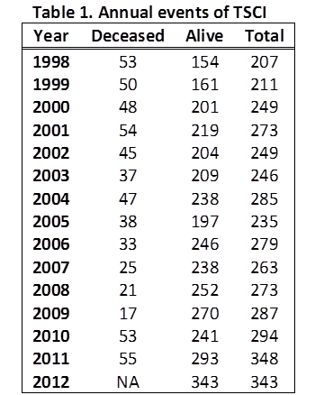The successful partnership forged among MUSC, the Department of Disabilities and Special Needs (DDSN), the Department of Health and Environmental Control (DHEC), the SC Budget and Control Board Division of Research and Statistics remains instrumental in accomplishing the goals and objectives of SCISR. Identifiable data are available to us by legal authority (Amendment of Ch. 38, title 44, 1976) granted to the South Carolina Head and Spinal Cord Injury Information System, which currently is housed in DDSN, a major partner in this project.

**II. Project Performance**

* Updating the SCISR on a regular basis is the quintessential function of a good surveillance system. The main reason behind this action is to identify incident cases of TSCI for service linkage activities and monitor the trend of TSCI. The project has been identifying deceased persons to separately analyze causes of death among state residents. As shown in Table 1, the number of discharges has been increasing steadily and this is also true when the discharges are accounted as rates. Of note, mortality data was not available for 2012 when this analysis was performed. The pattern of mortality, however, has been irregular with some years showing very low counts and some other years much higher counts. Most persons who died after TSCI are the elderly and persons with high cervical injuries who required ventilator assistance.
* Enhancing and updating discharge data imply medical record review to acquire variables that are not routinely available in the administrative datasets. This activity also refers to applying several iterative procedures in the datasets to extract critical information such as severity of injury by mapping the discharge diagnosis on a computerized algorithm, translating the 14 secondary diagnoses codes into the specific diagnosis and listing the various comorbid conditions and concomitant injuries. The South Carolina TSCI data is perhaps the most enhanced data to provide useful information for research activities.
* Since 2009, we expanded our registry activities by directly contacting the persons with TSCI to acquire their consent to be contacted for additional research to better understand their healthcare and social needs or participate in clinical trials. Although this request is generic in content, the participants have the ability to decline their participation should they find it unacceptable. The primary purpose of this endeavor is to accelerate the response time and piggyback the initial phase of contacting under the existing project IRB legal provisions. The main problem of this endeavor is the change of patients’ address from the one included in the discharge database, especially with more years elapsing from date of hospital discharge. To date three additional studies have benefitted from this activity.
* Acquiring the death files in South Carolina DHEC is an integral part of the SCISR. Death is an event that occurs at a higher rate among persons with TSCI than in the general population. This process involves identifying persons with established TSCI from the registry and annually linking their files with the death files. The process is labor and time intensive enabling us to acquire all of the data elements in the death certificates and the listing of causes of death ranked by a computerized algorithm called ACME (Automated Classification of Medical Entities). This system is critical to identify the underlying and contributing causes of death. South Carolina complies with National Center of Health Statistics (NCHS) by listing one underlying cause and 20 contributing causes of death. The joint availability of causes of death and pre-existing health conditions one every person in the SCISR database offered unparalleled opportunity to better understand the association of TSCI, its complications, and long-term outcomes. The availability of information on the acute trauma, comorbid conditions recorded in the health encounter files, trauma to other body regions noted during the initial episode of TSCI, and causes of death for persons who died since acquiring TSCI is the unique strength of the SCISR made possible through grant support of SCIRF.
* Analysis of data to provide up-to-date information to stakeholders, researchers, and the scientific community is among the most useful activities of the project. We have continuously brought the challenges of living with SCI to the general public and the scientific community, including state agencies that need to know the problems facing persons with SCI. We have also provided summary statistics to the South Carolina SCI Association (contacts: Mrs. Diane Epperly and Ms. Angela Jacildone), the Health South Consortia, Grand Strand Hospital, Roper St. Francis Hospitals, and MUSC.
* Providing summary and case level data remains one of the essential activities of the SCISR. There were five requests for anonymous case level data and eight requests for consent-driven case level data provided. Two of the summary data provided (DDSN and South Carolina SCI Association) needed periodic update for service delivery and advocacy activities. Additionally, two summer undergraduate research students (SURP) (Leah Snipe from Wofford College and Elisabeth (Chandler) Church from MUSC) completed summer rotations which culminated in two manuscripts. Additionally data have been used to support masters and doctoral thesis.
* Participation in grant application has been a priority area of support to maximize the usefulness of the data and attain sustainable funding to continue the activities. The main data support provided since 2009 are as follows in Table 2.

Table 2. Data support provided since 2009

|  |  |  |
| --- | --- | --- |
| Researcher (PI) | Purpose | Funding Agency |
| Mark George | Veteran Health application | Dept. of Defense |
| Jim Krause/Lee Saunders | Rehab Research and Training | NIDRR |
| Sarah Protho | Social Support and Advocacy | HRSA, HHS |
| Hon Yuen | Remote Dental care support | NIH |
| Susan Newman | K12/R21applications | NIH |
| Mark Riffle | Nutrition survey | Private donor in Columbia |
| Abhay Varma | Assessment DVT in TSCI | SCIRF/GCRC |
| Elizabeth Pickelsimer | Unmet service needs | NIDRR |

**#09-001 - Measuring Outcomes after SCI throughout South Carolina: A System of Tracking, Research, and Statewide Outcomes Database – Dr. Lee Saunders**

The statewide outcomes database has continued to progress through the collection of detailed data on outcomes among those with SCI living in the community. Individuals with SCI are contacted via mail after being identified through the surveillance system. Three types of data are collected: (1) enrollment of existing cases at the time of the start of data collection, (2) enrollment of new cases identified annually from the surveillance system, and (3) follow-up data collection on subsequent years for those within the first five years post injury and that five year intervals thereafter (i.e., 10 years, 15 years). Data are entered twice to ensure the accuracy of the final data set.

Substantial progress has been made with each type of data collection. To date (June 2014), 904 cases have been enrolled, including the combination of those who were in the surveillance system at the initiation of the study (n = 704) and those who were added during subsequent years (n = 200). Additionally, 338 follow-up assessments have been completed. Altogether, 1,242 data forms have been collected. This information builds on the basic information from the surveillance system obtained through hospital records and addresses health, psychological, vocational, and quality of life outcomes. It also measures predictors of these outcomes including several sets of variables such as biographic and injury related characteristics, psychological status, socio-environmental factors, and behavioral factors.

Examples of data analyses highlight the characteristic outcomes observed among those with SCI who were injured in the state of South Carolina.

Education
58% had high school or lower
27% had beyond high school
15% had Bachelors or higherHousehold Income
29% had below 10,000
26% had 10,000-20,000
27% had 20,000-50,000
8% had 50,000-75,000
10% had over 75,000

Number of Hospitalizations in Past Year
60% none
29% 1-2
11% 3-10Number of ER visits in Past Year
52% none
27% 1-2
21% 3-10

Ever Missed Medical Care Due to Inadequate Insurance
71% no
29% yesEver Missed Medical Care Due to Inadequate Assistance
78% no
22% yes

Over the past year, the project has made great progress. While we continue to enroll new persons with SCI, as well as conduct follow-ups of persons who are already in the study, we have recently finalized a cleaned dataset. Preliminary results regarding health outcomes were presented at both the SCI Fund Conference in March 2013 as well as at the SCSCIA Breeze conference leader meeting (March 2014). Additionally, the first research brief for stakeholders has been posted on the SCSCIA website (September 2013; <http://www.scspinalcord.org//health-care-and-research/south-carolina-spinal-cord-injury-research-fund/research-brief-south>). Data collection will continue this year as we will enroll persons who sustained an SCI in 2013, and we will perform follow-up on eligible participants in July 2014.

With Dr. Dave Murday, we have started the process of assessing health care utilization, including emergency department visits and hospitalizations, among persons with SCI in South Carolina. Additionally, a researcher at the University of South Carolina will be submitting a pilot project that will use the data to assess access to rehabilitation services among persons with SCI in South Carolina using spatial analysis.

**Publications**

Saunders, L.L., Selassie, A., Cao, Y., Zebracki, K., & Vogel, L. (under review). Epidemiology of pediatric traumatic spinal cord injury in a population-based cohort, 1998-2012. *Topics in Spinal Cord Injury Rehabilitation*.

**Presentations**

Saunders, L. L. Measuring outcomes after spinal cord injury in South Carolina. Oral presentation at the Breeze Leader Conference, Columbia, South Carolina: March 2014.

Saunders, L.L.Health outcomes among persons with spinal cord injury in South Carolina. Oral presentation at the South Carolina Spinal Cord Injury Research Fund Scientific Conference, Charleston, South Carolina: March 2013.

**#10-004 - Development of a Rehabilitation Research Program to Study the Biomechanics of Walking following Incomplete Spinal Cord Injury – Dr. Chris Gregory**

**I. Progress relative to Aims:**

* ***Establish a network for recruitment of subjects:*** We have made substantial progress on recruitment efforts over the past three years. We have established means through which to recruit subjects throughout the Charleston area through the various medical centers (MUSC, Roper and VA) as well as special interest and support groups. We make regular trips throughout the state to speak to support groups and hospital rehabilitation teams on SCI research and our on-going studies. We also give regular tours of our laboratories so as to emphasize our research focus on individuals following SCI.
* ***Develop database describing the biomechanics of walking:*** To date we have enrolled 32 subjects with incomplete SCI (ASIA C or D) into our database for studies of walking recovery. All of these subjects have been enrolled and completed data collections for quantitative biomechanical analyses of their walking at various speeds and during different adaptive conditions.
* ***Determine predictors of impaired walking:*** Data collected to date emphasize the importance of physiological capacity (strength and metabolic capacity) on walking performance (gait speed). The data collected during the funding period have resulted in grant proposals targeting each of these impairments (see below). In addition, a manuscript is in preparation describing the role of lower extremity muscle strength in predicting gait speed following incomplete SCI (preliminary abstract below)

**Lower extremity strength is associated with locomotor function**: We examined the importance of lower extremity muscle strength in predicting locomotor ability in twenty two individuals with chronic motor incomplete SCI (C4-T10; ASIA C/D). Values for maximum voluntary isometric contraction (MVIC) and rate of torque development (RTD) as well as voluntary activation deficits in the plantar flexor (PF) and knee extensor (KE) muscle groups were determined. In addition, self-selected gait speed as well as spatio-temporal characteristics of gait were measured. MVIC (i.e. strength) in the KE, but not the PF, muscle groups correlated significantly with gait speed. RTD (analogous to muscle power), correlated significantly with gait speed in the KE and PF muscle groups, the latter showing the strongest correlation with gait speed (r = 0.87; Figure 1). Step length on the more- and less-involved side as well as single support time in the more-involved limb were strongly correlated with gait speed (r=0.67-0.85). Spatio-temporal characteristics also correlated with contralateral muscle function, with RTD more strongly associated with these measures than MVIC. These data suggest the importance of lower extremity power in predicting locomotor ability. In addition, more-affected PF function as a potential limiting factor to gait speed is highlighted.

Correlations between maximum gait speed and plantar flexor rate of torque development:
The x-axis is plantar flexor RTD
The y-axis is self selected walking speed

* ***Perform pilot studies on adaptations to interventions, in persons following incomplete SCI:*** These data collections are in collaboration with Dr. Mark Bowden. We have collected data on subjects during both incline and decline walking to examine the potential influence on level ground walking (abstract presented at Society for Neuroscience conference in 2011). In addition, we have begun preliminary investigations into the effects of split-belt walking as well as speed-based training on short-term adaptations in walking function. Our goal is to examine the predictive ability of subject adaptations toward response to long-term training.

**Figure 1:** Correlations between maximum gait speed and plantar flexor rate of torque development in persons following incomplete SCI.

**#10-003 - Propulsive Training in Incomplete Spinal Cord Injury – Dr. Mark Bowden**

To date, we have enrolled approximately 21 individuals who participated in this protocol. The data were used as pilot data in a VA Rehabilitation Research and Development Career Development-2 grant which was funded with a priority score of 140. This grant funding initiated on April 1, 2013 and will run through March 31, 2018.

This project resulted in an abstract presented at the 2012 Society for Neuroscience meeting in New Orleans, LA in October 2012. Data from this project were also presented at the SCI Scientific Conference, held at MUSC on Friday, March 22, 2013, the SCIRF Board meeting in Columbia, SC in June 2013, and at the Rock Hill SCI support group on August 13, 2013. Most recently, a presentation from this project was given at the Columbia, South Carolina SCI Support Group on October 29, 2013. Two manuscripts are currently in preparation related to this project.

**#11-006 - Recruitment Assistance – Dr. Yue Cao**

Dr. Yue Cao has been using the dedicated time from his recruitment grant to develop his SCI career activities. He is successfully building upon his history of work with SCI databases, which first began at the University of Alabama Birmingham, working with the National SCI Statistical Center, as part of the SCI Model Systems. Specific activities conducted by Dr. Cao include:

1. Collaborating with Dr. Anbesaw Selassie to study the SCI incidence change from 1998 to 2012 in South Carolina by using South Carolina SCI surveillance data, identifying a disturbing trend with an increased incidence of SCI during the 14 years period;
2. Identifying the risk factors for mortality after SCI by using South Carolina SCI surveillance data, resulting in a manuscript “Risk of Death after Hospital Discharge with Traumatic Spinal Cord Injury: A Population-Based Analysis, 1998-2009”, which was published by Archives of Physical Medicine and Rehabilitation in 2013;
3. Developing studies with the intent to bridge the gap between the research done in South Carolina and that being done nationally through the SCI Model Systems, leading the development and publication of a manuscript on “Risk Factors for Mortality after Spinal Cord Injury in the USA” (published by *Spinal Cord* in 2013) and a second publication “Suicide Mortality after Spinal Cord Injury in the United States: Injury Cohorts Analysis,” accepted by the *Archives of Physical Medicine and Rehabilitation* in 2013; and
4. Working with three additional manuscripts using other databases available from research stimulated by the recruitment grant of Dr. James Krause, including first authorship on a manuscript entitled “Household Income and Subjective Well-being after Spinal Cord Injury: A Longitudinal Study,” which was accepted by *Topics in Spinal Cord Injury Rehabilitation* in 2013.

**#1105 - Interdisciplinary Center – Dr. Naren Banik & Dr. James Krause**

SCI projects, partially supported at some time by the SCIRF, have continued for a number of years and helped develop two very innovative therapeutic strategies for the treatment of individuals with SCI as well as enabled us to secure extramural funding from both NIH and VA Research Programs. Substantial progress has been made on both projects since 2009 and generated a pilot clinical safety trial using low dose estrogen (Premarin) in individuals with SCI at MUSC (in collaboration with Dr. Abhay Varma, MD, a neurosurgeon and SCI researcher). This trial was made possible with the help of a Clinical and Translational Science Award (CTSA) grant from MUSC and support from the Neurosurgery section of Neurosciences. A combination treatment strategy using melatonin, methylprednisolone (MP), and calpain inhibitor SNJ1945 has been developed and tested in animals with SCI. Research on both fronts has been supported by extramural funds from NIH. Both projects generated numerous peer-reviewed publications, reviews, book chapters, and a book over this period (2009 to present) as well as invited seminars, presentations at national and international meetings.

1. Estrogen efficacy in SCI: The only current therapy recommended for SCI is high dose methylprednisolone (MP), which has limited efficacy and numerous side effects. Therefore, we have developed a new therapeutic strategy using the neurohormone estrogen, a multi-active agent that can attenuate different destructive pathways involved in tissue degeneration. Estrogen has been used in our laboratory to block the degenerative process in rats with SCI. Our previous studies, both in vitro (cell culture) and in vivo (acute injury in a rat model) have demonstrated attenuation of cell death, oxidative damage, and calpain activity and promoted preservation of tissue. This work continued utilizing very low dose estrogen (Premarin, 1-10µg/kg body weight) to minimize the side effects of high dose estrogen administration, including feminizing effects, in animals with SCI. The high dose estrogen treatment of acute and chronic SCI animals not only demonstrated reduction of inflammation, protection of cells, and preservation of axons and myelin, but also showed improvement in locomotor function. These very encouraging findings led us to examine the effects of low dose estrogen in both acute and chronic SCI, which also showed reduction of inflammation, protection of cells, and improvement of function at 5-10µg doses of Premarin. The efficacy of this very low dose estrogen treatment has only been demonstrated in our laboratory.
2. Safety Trial with Estrogen in Clinic: Further studies on low dose estrogen in animals prompted us to take this basic bench research into the clinic, with IRB/IND approval, for a safety trial. This trial permitted use of five individuals with SCI; fortunately, following treatment, all these individuals survived. Whether estrogen had caused deep vein thrombosis (DVT) was not clear since individuals with severe SCI normally develop DVT. To continue this study, we are developing estrogen delivery via nanoparticle. Estrogen may be applied topically even at a lower dose directly to the injury site. Our preliminary studies, in collaboration with the Clemson University Bioengineering Department, are very promising and seem to demonstrate the feasibility of this new delivery system. We are excited about the prospect of estrogen therapy and believe that in the very near future delivery of estrogen via nanoparticle will be taken to the clinic for trial. To do such a clinical trial, we will apply to NIH for funding resources.
3. Combination Therapy for SCI: Over the years, our long-standing NIH funded grant has generated the data on the feasibility of using melatonin, MP, and calpain inhibitor for pharmacological intervention. We have provided evidence for the involvement of calpain in the degeneration of tissue and cells in SCI. Since melatonin, a pineal hormone, demonstrates multi-active properties such as attenuation of oxidative damage, reduction of calcium influx, promotion of angiogenesis, and protection of cells, we have examined its efficacy not only in vitro (cell culture) but also in vivo (rat SCI). Our results demonstrated melatonin blocked all of the above mentioned pathways that are detrimental to cell survival and improved functionality of cells. Based on this data and because several destructive pathways are involved in injury, treatment with one agent may not be beneficial; therefore, treatment with a combination of several agents maybe imperative to see stronger efficacy in spinal cord following injury. Thus, our combination of triple treatment using melatonin, MP, and calpain inhibitor in rat SCI has demonstrated much better improvement in locomotor function. These preliminary data are the basis for generating intra- and extramural resources for continuation of this very promising research. Because both melatonin and MP are FDA approved, and approval of calpain inhibitor is pending, this therapeutic approach has the potential for use to treat individuals with SCI. We are excited about our findings. Again, this novel therapeutic strategy must be thoroughly investigated to fulfill the goal of finding a cure and/or ameliorating dysfunction in SCI. Resources have to be generated to achieve this goal.
4. Protective mechanisms of estrogen and melatonin: Other important work is in progress in our laboratory to dissect the mechanisms by which estrogen and melatonin protect cells, attenuate cell death and inflammation, and improve function following treatment of SCI animals. These pathways will be studied both in vitro and in vivo using different estrogen and melatonin receptor agonists. These agonists could also be potential alternative therapeutic agents for treatment of SCI. Because agonists are three times more sensitive than estrogen or melatonin, the use of receptor agonists will reduce the side effects of treatment.
5. Telomere: Another project we have embarked on in collaboration with Dr. James Krause investigates the status (change) of telomere length and telomerase activity in human SCI blood samples as well as in blood from rats following SCI. Telomere is the time keeper in cells. The goal is to establish if there is any relationship between telomere length and severity of injury and extent of dysfunction/disability. In animal SCI models, telomere length may be correlated with extent of severity and time following injury as well as cell death and other detrimental parameters. Whether treatment with estrogen or melatonin can reverse this relationship and maintain the telomere length is being investigated. Since telomere shortening leads to cell death, maintaining telomerase activation, which extends the life span of a cell, is important. Activation of telomerase can improve the longevity of cells as well as the quality of life not only in individuals with SCI but also in the general population.

Studies listed and described received partial support from the SCIRF for Drs. Nozaki, Ray, and Varma and contributed significantly to the advancement of our understanding of the mechanisms involved in degeneration and protection of the spinal cord following injury.

**#11-005 - Developing a Point of Access for SCI Research at Roper – Ms. Cathy Therrell**

In November 2011, the SCIRF awarded Roper Rehabilitation Hospital a three-year $150,000 grant to develop a Point of Access to Spinal Cord Injury (SCI) Clinical Research.

**Project Goals and Aims:** The stated goals of the SCIRF11-005 funded project are 1) to develop a research infrastructure within the Roper Rehabilitation Hospital Center for Spinal Cord Injury clinical setting and 2) to utilize the infrastructure to enroll participants into a clinical research database that will interface with existing surveillance and database programs within the SCIRF and state SCI research community.

Aim 1: Establish a long term, prospective, patient database to collect and store comprehensive clinical, laboratory, and psychosocial data from patients with SCI who come to the Center for Spinal Cord Injury.

Aim 2: Develop a well-characterized pool of persons with SCI who are interested in participating in future research on SCI, and who have consented to be contacted regarding research participation.

Primary Activities include hiring a project coordinator, creating an infrastructure, and establishing a patient-consented database of clinical, laboratory, and psychosocial data.

**Report Overview:** This project report provides an overview of outcomes data, project related milestones, completion status of stated objectives and activities and a narrative summary of project accomplishments to date.

**Summary Patient Outcome Report as of 4/15/2014:**

|  |  |  |  |  |  |
| --- | --- | --- | --- | --- | --- |
| Unduplicated Patients | Patient Consents | Consents Insured | Consents for Peers | Consents  for Counselor | Deaths |
| 76 | 56 | 32 | 74 | 37 | 1 |

**Objectives Checklist and Timeframe for Completion:**

Objective 1: Develop research capacity and infrastructure during initial 6 months.

|  |  |
| --- | --- |
| **Activity** | **Status** |
| Hire and train Project Coordinator | Complete |
| Gain regulatory approval from Roper and MUSC IRBs for research database protocols | Complete |
| Collaborate with SCI researchers to identify priority information to be included in database | Complete |
| Create a CSCI research participant and patient outcome tracking database infrastructure | Complete |
| Develop a protocol for systematic data collection | Complete |
| Create capacity for implementing research protocols from collaborators | Ongoing |

Objective 2: Implement the Center for Spinal Cord Injury database

|  |  |
| --- | --- |
| **Activity** | **Status** |
| Collect clinical, laboratory, and psychosocial data from CSCI patients | Ongoing |
| Monitor “benchmarks” of research “point of access” success (i.e. number of patients enrolled into database and recruited into other SCI studies, investigator satisfaction, etc.), | Ongoing |
| Systematically review data relevant to patient needs in order to tailor clinical services to meet priority needs effectively. | Ongoing |

**Patient Recruitment and Consent:** Once IRB approval was obtained, nearly 100% of patients approached regarding database participation have consented to participate. A data collection form was developed, based on the nursing assessment form, to allow for easier collection and retrieval of SCI-specific clinical information from the medical record for inclusion in the database. Although clinic staff was involved in the development of the form, in practice, the form proved to be more complicated than anticipated and not feasible for patient and nurse to complete during the clinic visit. The form is currently under revision. In the interim targeted clinical data is located throughout the medical record and is being extracted and entered into the research database REDCap. Until the database contains sufficient numbers of persons to review patient needs and tailor clinical services to meet priority needs effectively, a patient satisfaction survey tool was implemented to collect data on perceived needs of the persons served. Currently, 56 patients have consented to database participation.

**#12-001 - Myoprotective Role of Premarin in Spinal Cord Injury – Dr. Kenkichi Nozaki**

* Our first goal is to see whether any molecular changes occur in the sublesional skeletal muscle after SCI in its acute phase.  We first induced moderately severe SCI (40g cm) at the T10 level of the spinal cord (injury group), or laminectomy only (sham group) in adult male Sprague-Dawley rats (weight 250-300g). We sacrificed the animals 48 hrs after the induction and separated medial gastrocnemius muscles. We saw visibly red and white parts in each muscle sample.  To see whether there was any difference between them, we obtained protein samples from each part and measured expression levels of myofibrillar proteins (myosin heavy chain-1, and -2b).  Both proteins were expressed higher in red compared to white part.  The data suggest higher muscle protein content in red part, and thus we carried following studies using muscle samples obtained from visibly red part.
* We examined the expression levels of various proteins and compared between injury and sham groups. Expression levels of Akt and phospho-Akt (protein synthesis markers) were decreased in the injury group compared to the sham group. Expression levels of MuRF-1 and MAFbx (protein degradation markers), and Cox-2 and TNF-α (inflammatory markers) were increased in the injury group compared to the sham.  These data indicate that decreased protein synthesis, increased protein degradation, and inflammation occur in sublesional muscles after spinal cord injury in its acute phase.  These findings are important since they occur earlier than previously reported, and in the stage when significant muscle atrophy is usually not seen. Our data also suggest that inflammatory changes may trigger other molecular changes.
* Our next goal is to see whether other molecular changes occur in the subacute phase.  We will induce injury and sham, sacrifice animals in 2wk, and compare protein expression levels of proteases and mitochondrial related proteins between the two groups.  Based on these data, we will determine appropriate timing and dosage of estrogen, and see its myoprotective role in SCI.

**#13-001 - Inhibition of the Alternative Complement Pathway to Treat Spinal Cord Injury – Dr. Steve Tomlinson**

The overall aim of the project is to characterize and compare the effect of two types of targeted complement inhibitor on complement activation, inflammation and injury in a mouse model of SCI. The two inhibitors are CR2-fH and B4scFv-fH, both of which inhibit the alternative pathway of complement, but contain different targeting vehicles: CR2, that targets the C3d complement activation product, and B4scFv, a single chain antibody that targets epitopes that become exposed in the injured spinal cord. The epitopes that become exposed are recognized by natural pathogenic IgM and trigger complement activation.

Thus far, we have been focused on characterizing our new B4scFv targeting vehicle (the CR2-fH construct is better characterized, and has been therapeutically applied in other models of injury). We have demonstrated that the B4 targeting vehicle recognizes both mouse and human hypoxic, but not normoxic healthy endothelial cells, and that B4scFv linked to complement inhibitors block the binding of pathogenic IgM and inhibit complement activation. Furthermore, B4scFv-mediated targeting of complement inhibition significantly improves locomotor activity and reduces tissue injury after SCI, and also reduces injury and improves outcome after ischemic stroke, another model involving CNS injury. We have also demonstrated an important role for B1 cells in SCI by mouse depletion studies. B1 cells produce natural pathogenic antibodies that recognize the same epitope that is targeted by our scFv construct.

**#13-002 - Roper Rehabilitation Hospital Center for Spinal Cord Injury (CSCI) Medical Director Recruitment – Ms. Cathy Therrell**

**Objective 1**: Recruit board-certified physiatrist Jeffrey T. Tubbs, Jr, MD, as Medical Director of the new Center for Spinal Cord Injury at Roper Rehabilitation Hospital and support establishing a related start-up research infrastructure.

Jeffrey Tubbs, MD, joined the Center for Spinal Cord Injury as Medical Director on July 29, 2013. He is board certified in Physical Medicine & Rehabilitation, with a subspecialty board certification in Spinal Cord Injury Medicine.

**Objective 2**: Purchase state-of-the-art robotic exoskeleton equipment for use by Dr. Tubbs and CSCI collaborative partners in research designed to support the core goal of rehabilitation medicine to restore and maintain function in patients with mobility disorders.

In the fall of 2013, Dr. Tubbs worked with the SCIRF Board and scientific directors to determine an exoskeleton unit to purchase for the Charleston area. The ReWalk unit was chosen with the goal to use this system for clinical research. Therapists have been instructed on its use. Twenty seven patients met the physical and functional criteria to use the ReWalk robotic exoskeleton. We will build on the research infrastructure on the CSCI to create research protocols to use with all consenting patients in the CSCI research database and specifically to use with the ReWalk system as a clinical research project.

**Objective 3**: Integrate the infrastructure of a new CSCI-specific research program into a multi-discipline, non-academic clinical setting working collaboratively with the SCIRF scientific directors, executive director, and board of directors.

The Medical Director will work with the Spinal Cord Injury Research Fund executive director and scientific directors to create a SCI-specific clinical translational research model that enhances the adoption of best practices while focused on cost-effectiveness and optimal treatment strategies for the SCI community in South Carolina.

**APPENDIX B – Publications**

1. Bakken, D., Burg, K., Narasimhan, S., & Gao, B. Z. (2005). Microspheres into neuronal-glial co-culture for the study of axonal regeneration. *Macromolecular Symposia, 227*, 335-344.
2. Banik, N. L. (2010). Estrogen: a promising agent for treatment of spinal cord injuries. *J S C Med Assoc, 106*(1), 10-12.
3. Banik, N. L., & Ray, S. K. (2009). *Handbook of Neurochemistry and Molecular Biology: Brain and Spinal Cord Trauma* (3rd ed.). New York, NY: Springer.
4. Bombardier, C. H., Richards, J. S., Krause, J. S., Tulsky, D., & Tate, D. G. (2004). Symptoms of major depression in people with spinal cord injury: implications for screening. *Archives of Physical Medicine and Rehabilitation, 85*(11), 1749-1756.
5. Broderick, L. E., & Krause, J. S. (2003). Breast and gynecologic health-screening behaviors among 191 women with spinal cord injuries. *Journal of Spinal Cord Medicine, 26*(2), 145-149.
6. Brotherton, S., Krause, J. S., & Nietert, P. (2007). Falls in individuals with incomplete spinal cord injury. *Spinal Cord, 45*, 37-40.
7. Brotherton, S., Krause, J. S., & Nietert, P. (2007). A pilot study of factors associated with falls in individuals with incomplete spinal cord injury. *Journal of Spinal Cord Medicine, 30*(3), 243-250.
8. Brotherton, S. S., Saunders, L. L., Krause, J. S., & Morrisette, D. C. (2012). Association between reliance on devices and people for walking and ability to walk community distances among persons with spinal cord injury. *Journal of Spinal Cord Medicine, 35*(3), 156-161.
9. Brown, S. A., Saunders, L. L., & Krause, J. S. (2012). Racial disparities in depression and life satisfaction after spinal cord injury: A mediational model. *Topics in Spinal Cord Injury Rehabilitation, 18*(3), 232-240.
10. Cao, Y., Krause, J. S., & Dipiro, N. (2013). Risk factors for mortality after spinal cord injury in the USA. *Spinal Cord, 51*(5), 413-418.
11. Cao, Y., Krause, J. S., & DiPiro, N. D. (in press). Unmet expectations of adjustment and depressive symptoms among people with traumatic spinal cord injury. *Rehabilitation Psychology*.
12. Cao, Y., Krause, J. S., Saunders, L. L., & Bingham, W. (2014). Household income and subjective well-being after spinal cord injury: A longitudinal study. *Topics in Spinal Cord Injury Rehabilitation, 20(1)*, 40-47.
13. Cao, Y., Massaro, J., Krause, J. S., Chen, Y., & DeVivo, M. (2014). Suicide mortality after spinal cord injury in the United States: Injury cohorts analysis. *Archives of Physical and Medical Rehabilitation, 95,* 230-235.
14. Cao, Y., Selassie, A. W., & Krause, J. S. (2013). Risk of death after hospital discharge with traumatic spinal cord injury: a population-based analysis, 1998-2009. *Archives of Physical Medicine and Rehabilitation, 94*(6), 1054-1061.
15. Chakrabarti, M., Banik, N. L., & Ray, S. K. (2014). miR7-1 potentiated estrogen receptor agonists for neuroprotection in VSC4.1 mononeurons. *Journal of Neuroscience Research*, 256, 322-333.
16. Chi, L. Y., Yu, J., Zhu, H., Li, X. G., Zhu, S. G., & Kindy, M. S. (2008). The dual role of tumor necrosis factor-alpha in the pathophysiology of spinal cord injury. *Neurosci Lett, 438*(2), 174-179.
17. Chou, P. C., Shunmugavel, A., El Sayed, H., Desouki, M. M., Nguyen, S. A., Khan, M., Singh, I., & Bilgen, M. (2011). Preclinical use of longitudinal MRI for screening the efficacy of S-nitrosoglutathione in treating spinal cord injury. *J Magn Reson Imaging, 33*(6), 1301-1311.
18. Das, A., Belagodu, A., Reiter, R. J., Ray, S. K., & Banik, N. L. (2008). Cytoprotective effects of melatonin on C6 astroglial cells exposed to glutamate excitotoxicity and oxidative stress. *J Pineal Res, 45*(2), 117-124.
19. Das, A., Guyton, M. K., Matzelle, D. D., Ray, S. K., & Banik, N. L. (2008). Time-dependent increases in protease activities for neuronal apoptosis in spinal cords of Lewis rats during development of acute experimental autoimmune encephalomyelitis. *Journal of Neuroscience Research, 86*(13), 2992-3001.
20. Das, A., McDowell, M., Pava, M. J., Smith, J. A., Reiter, R. J., Woodward, J. J., Varma, A. K., Ray, S. K., & Banik, N. L. (2010). The inhibition of apoptosis by melatonin in VSC4.1 motoneurons exposed to oxidative stress, glutamate excitotoxicity, or TNF-alpha toxicity involves membrane melatonin receptors. *J Pineal Res, 48*(2), 157-169.
21. Das, A., Smith, J. A., Gibson, C., Varma, A. K., Ray, S. K., & Banik, N. L. (2011). Estrogen receptor agonists and estrogen attenuate TNF-alpha-induced apoptosis in VSC4.1 motoneurons. *J Endocrinol, 208*(2), 171-182.
22. Das, A., Sribnick, E. A., Wingrave, J. M., Del Re, A. M., Woodward, J. J., Appel, S. H., Banik, N. L., & Ray, S. K. (2005). Calpain activation in apoptosis of ventral spinal cord 4.1 (VSC4.1) motoneurons exposed to glutamate: calpain inhibition provides functional neuroprotection. *Journal of Neuroscience Research, 81*(4), 551-562.
23. Das, A., Wallace, G. T., Reiter, R. J., Varma, A. K., Ray, S. K., & Banik, N. L. (2012). Overexpression of melatonin membrane receptors increases calcium-binding proteins and protects VSC4.1 motoneurons from glutamate toxicity through multiple mechanisms. *J Pineal Res*.
24. Das, M., Bhargava, N., Gregory, C., Riedel, L., Molnar, P., & Hickman, J. J. (2005). Adult rat spinal cord culture on an organosilane surface in a novel serum-free medium. *In Vitro Cell Dev Biol Anim, 41*(10), 343-348.
25. Das, M., Molnar, P., Devaraj, H., Poeta, M., & Hickman, J. J. (2003). Electrophysiological and morphological characterization of rat embryonic motoneurons in a defined system. *Biotechnol Prog, 19*(6), 1756-1761.
26. Das, M., Rumsey, J. W., Bhargava, N., Stancescu, M., & Hickman, J. J. (2010). A defined long-term in vitro tissue engineered model of neuromuscular junctions. *Biomaterials, 31*(18), 4880-4888.
27. Das, M., Rumsey, J. W., Gregory, C. A., Bhargava, N., Kang, J. F., Molnar, P., Riedel, L., Guo, X., & Hickman, J. J. (2007). Embryonic motoneuron-skeletal muscle co-culture in a defined system. *Neuroscience, 146*(2), 481-488.
28. Davis, H., Guo, X., Lambert, S., Stancescu, M., & Hickman, J. J. (2012). Small molecule induction of human umbilical stem cells into myelin basic protein positive oligodendrocytes in a defined three-dimensional environment. *ACS Chem Neurosci, 3*(1), 31-39.
29. Deng, L. X., Hu, J., Liu, N., Wang, X., Smith, G. M., Wen, X., & Xu, X. M. (2011). GDNF modifies reactive astrogliosis allowing robust axonal regeneration through Schwann cell-seeded guidance channels after spinal cord injury. *Exp Neurol, 229*(2), 238-250.
30. DiPiro, D., Bowden, M. G., Embry, A., Perry, L. A., & Gregory, C. M. (under review). Intensity matters: A multimodal exercise program improves strength and gait speed after incomplete SCI. *Spinal Cord Medicine*.
31. DiPiro, N. D., Krause, J. S., Saunders, L. L., Brotherton, S., & Kraft, S. (2014). Pain and fatigue as mediators of the relationship between mobility aid usage and depressive symptomatology in ambulatory individuals with SCI. *Spinal Cord, 52*(4), 316-321.
32. Dismuke, C. E., Krause, J. S., & Terza, J. V. (2011). Racial disparities in poverty status among families of individuals with spinal cord injury. *Poverty and Public Policy, 3*(1), article 9.
33. Dubal, D. B., Rau, S. W., Shughrue, P. J., Zhu, H., Yu, J., Cashion, A. B., Suzuki, S., Gerhold, L. M., Bottner, M. B., Dubal, S. B., Merchanthaler, I., Kindy, M. S., & Wise, P. M. (2006). Differential modulation of estrogen receptors (ERs) in ischemic brain injury: a role for ERalpha in estradiol-mediated protection against delayed cell death. *Endocrinology, 147*(6), 3076-3084.
34. Edwards, D., Das, M., Molnar, P., & Hickman, J. J. (2010). Addition of glutamate to serum-free culture promotes recovery of electrical activity in adult hippocampal neurons in vitro. *J Neurosci Methods, 190*(2), 155-163.
35. Fritz, S., Merlo-Rains, A., Rivers, E., Brandenburg, B., Sweet, J., Donley, J., Mathews, H., deBode, S., & McClenaghan, B. A. (2011). Feasibility of intensive mobility training to improve gait, balance, and mobility in persons with chronic neurological conditions: a case series. *J Neurol Phys Ther, 35*(3), 141-147.
36. Fritz, S. L., Merlo-Rains, A. M., Rivers, E. D., Peters, D. M., Goodman, A., Watson, E. T., Carmichael, B. M., & McClenaghan, B. A. (2011). An intensive intervention for improving gait, balance, and mobility in individuals with chronic incomplete spinal cord injury: a pilot study of activity tolerance and benefits. *Archives of Physical Medicine and Rehabilitation, 92*(11), 1776-1784.
37. Groah, S. L., Charlifue, S., Tate, D., Jensen, M. P., Molton, I. R., Forchheimer, M., Krause, J. S., Lammertse, D. P., & Campbell, M. (2012). Spinal cord injury and aging: Challenges and recommendations for future research. *American Journal of Physical Medicine and Rehabilitation, 91*(1), 80-93.
38. Guo, G., & Bhat, N. R. (2004). Glutamate release and hypoxia induced motor neuron cell death. *Journal of Neurochemistry, 90*(suppl 1), 14.
39. Guo, G., & Bhat, N. R. (2007). p38alpha MAP kinase mediates hypoxia-induced motor neuron cell death: a potential target of minocycline's neuroprotective action. *Neurochem Res, 32*(12), 2160-2166.
40. Guo, X., Ayala, J. E., Gonzalez, M., Stancescu, M., Lambert, S., & Hickman, J. J. (2012). Tissue engineering the monosynaptic circuit of the stretch reflex arc with co-culture of embryonic motoneurons and proprioceptive sensory neurons. *Biomaterials, 33*(23), 5723-5731.
41. Guo, X., Das, M., Rumsey, J., Gonzalez, M., Stancescu, M., & Hickman, J. (2010). Neuromuscular junction formation between human stem-cell-derived motoneurons and rat skeletal muscle in a defined system. *Tissue Eng Part C Methods, 16*(6), 1347-1355.
42. Guo, X., Gonzalez, M., Stancescu, M., Vandenburgh, H. H., & Hickman, J. J. (2011). Neuromuscular junction formation between human stem cell-derived motoneurons and human skeletal muscle in a defined system. *Biomaterials, 32*(36), 9602-9611.
43. Guo, X., Johe, K., Molnar, P., Davis, H., & Hickman, J. (2010). Characterization of a human fetal spinal cord stem cell line, NSI-566RSC, and its induction to functional motoneurons. *J Tissue Eng Regen Med, 4*(3), 181-193.
44. Guo, X., Spradling, S., Stancescu, M., Lambert, S., & Hickman, J. J. (2013). Derivation of sensory neurons and neural crest stem cells from human neural progenitor hNP1. *Biomaterials, 34*(18), 4418-4427.
45. Guyton, M. K., Wingrave, J. M., Yallapragada, A. V., Wilford, G. G., Sribnick, E. A., Matzelle, D. D., Tyor, W. R., Ray, S. K., & Banik, N. L. (2005). Upregulation of calpain correlates with increased neurodegeneration in acute experimental auto-immune encephalomyelitis. *Journal of Neuroscience Research, 81*(1), 53-61.
46. Hoffman, J. M., Bombardier, C. H., Graves, D. E., Kalpakjian, C. Z., & Krause, J. S. (2011). A longitudinal study of depression from one to five years after spinal cord injury. *Archives of Physical Medicine & Rehabilitation, 92*, 411-418.
47. Kalpakjian, C. Z., Toussaint, L. L., Albright, K. J., Bombardier, C. H., Krause, J. K., & Tate, D. G. (2009). Patient Health Questionnaire-9 in spinal cord injury: An examination of factor structure as related to gender. *Journal of Spinal Cord Medicine, 32*(2), 147-156.
48. Karakostas, T., Hsiang, S. M., Sarantopoulos, C., & Krause, J. S. (2007). Dynamic loading performance of fasciocutaneous flaps and implications for gait. *Clinical Biomechanics, 22*(4), 478-485.
49. Karakostas, T., Hsiang, S., Boger, H., Middaugh, L., & Granholm, A. (2013). Three-dimensional rodent motion analysis and neurodegenerative disorders. *Journal of Neuroscience Methods, 231*, 31-37*.*
50. Kemp, B. J., Kahan, J. S., Krause, J. S., Adkins, R. H., & Nava, G. (2004). Treatment of major depression in individuals with spinal cord injury. *Journal of Spinal Cord Medicine, 27*, 22-28.
51. Khang, D., Lu, J., Yao, C., Haberstroh, K. M., & Webster, T. J. (2008). The role of nanometer and sub-micron surface features on vascular and bone cell adhesion on titanium. *Biomaterials, 29*(8), 970-983.
52. Kohout, R. K., Saunders, L. L., & Krause, J. S. (2011). The relationship between prescription medication use and ability to ambulate distances after spinal cord injury. *Archives of Physical Medicine and Rehabilitation, 92*(8), 1246-1249.
53. Krause, J. S. (2003). Years to employment after spinal cord injury. *Archives of Physical Medicine and Rehabilitation, 84*(9), 1282-1289.
54. Krause, J. S. (2004). Factors associated with risk for subsequent injuries after the onset of traumatic spinal cord injury. *Archives of Physical Medicine and Rehabilitation, 85*, 1503-1508.
55. Krause, J. S. (2007). Self-reported problems after spinal cord injury: Implications for rehabilitation practice. *Topics in Spinal Cord Injury Rehabilitation, 12*(3), 35-44.
56. Krause, J. S. (2010). Aging, life satisfaction, and self-reported problems among participants with spinal cord injury. *Topics in Spinal Cord Injury Rehabilitation, 15*, 34-40.
57. Krause, J. S. (2010). Is the ability to ambulate associated with better employment outcomes in participants with traumatic spinal cord injury? *Rehabilitation Counseling Bulletin, 53*, 117-119.
58. Krause, J. S. (2010). Risk for subsequent injuries after spinal cord injury: a 10-year longitudinal analysis. *Archives of Physical Medicine and Rehabilitation, 91*(11), 1741-1746.
59. Krause, J. S., & Adkins, R. A. (2004). Research and methodological issues in the study of aging with a disability. In B. J. Kemp & L. Mosqueda (Eds.), *Aging with a disability*. Baltimore, MD: Johns Hopkins University Press.
60. Krause, J. S., Bombardier, C. H., & Carter, R. E. (2008). Assessment of depressive symptoms during inpatient rehabilitation for spinal cord injury: Is there an underlying somatic factor when using the PHQ? *Rehabilitation Psychology, 53*(4), 513-520.
61. Krause, J. S., & Bozard, J. L. (2012). Natural course of life changes after spinal cord injury: A 35-year longitudinal study. *Spinal Cord, 50*(3), 227-231.
62. Krause, J. S., & Broderick, L. (2004). Outcomes after spinal cord injury: Comparisons as a function of gender and race and ethnicity. *Archives of Physical Medicine and Rehabilitation, 85*(3), 355-362.
63. Krause, J. S., & Broderick, L. (2004). Patterns of recurrent pressure ulcers after spinal cord injury: Identification of risk and protective factors 5 or more years after onset. *Archives of Physical Medicine & Rehabilitation, 85*, 1257-1264.
64. Krause, J. S., & Broderick, L. (2005). A 25-year longitudinal study of the natural course of aging after spinal cord injury. *Spinal Cord*, 1-8.
65. Krause, J. S., & Broderick, L. (2006). Relationship of personality and locus of control with employment outcomes among participants with spinal cord injury. *Rehabilitation Counseling Bulletin, 49*(2), 111-114.
66. Krause, J. S., Broderick, L. E., & Broyles, J. (2004). Subjective well-being among African-Americans with spinal cord injury: An exploratory study between men and women. *NeuroRehabilitation, 19*(2), 81-89.
67. Krause, J. S., Broderick, L. E., Saladin, L. K., & Broyles, J. (2006). Racial disparities in health outcomes after spinal injury: Mediating effects of education and income. *Journal of Spinal Cord Medicine, 29*, 17-25.
68. Krause, J. S., Brotherton, S., Morrisette, D., Newman, S., & Karakostas, T. (2007). Does pain interference mediate the relationship of independence in ambulation with depressive symptoms after spinal cord injury? *Rehabilitation Psychology, 52*(2), 162-169.
69. Krause, J. S., Cao, Y., & Bozard, J. L. (2013). Changes in hospitalization, physician visits, and self-reported fitness after spinal cord injury: a cross-sequential analysis of age, years since injury, and age at injury onset. *Archives of Physical Medicine and Rehabilitation, 94*(1), 32-37.
70. Krause, J. S., Carter, R., Zhai, Y., & Reed, K. (2009). Psychologic factors and risk of mortality after spinal cord injury. *Archives of Physical Medicine and Rehabilitation, 90*(4), 628-633.
71. Krause, J. S., & Carter, R. E. (2009). Risk of mortality after spinal cord injury: relationship with social support, education, and income. *Spinal Cord, 47*(8), 592-596.
72. Krause, J. S., Carter, R. E., & Brotherton, S. (2009). Association of mode of locomotion and independence in locomotion with long-term outcomes after spinal cord injury. *Journal of Spinal Cord Medicine, 32*, 237-248.
73. Krause, J. S., Carter, R. E., & Pickelsimer, E. (2009). Behavioral risk factors of mortality after spinal cord injury. *Archives of Physical Medicine and Rehabilitation, 90*(1), 95-101.
74. Krause, J. S., Carter, R. E., Pickelsimer, E., & Wilson, D. (2008). A prospective study of health and risk of mortality after spinal cord injury. *Archives of Physical Medicine & Rehabilitation, 89*(8), 1482-1491.
75. Krause, J. S., & Clark, J. M. (in press). Stability of vocational interests after recent spinal cord injury. *Rehabilitation Psychology*.
76. Krause, J. S., & Coker, J. L. (2006). Aging after spinal cord injury: A 30-year longitudinal study. *Journal of Spinal Cord Medicine, 29*(4), 371-376.
77. Krause, J. S., DeVivo, M., Saunders, L. L., Reed, K. S., & Johnson, E. (2010). Risk factors for mortality after spinal cord injury. *Future Neurology, 5*(5), 757-764.
78. Krause, J. S., DeVivo, M. J., & Jackson, A. B. (2004). Health status, community integration, and economic risk factors for mortality after spinal cord injury. *Archives of Physical Medicine and Rehabilitation, 85*(11), 1764-1773.
79. Krause, J. S., DiPiro, N. D., Saunders, L. L., Newman, S., Banik, N. L., & Park, S. (2014). Allostatic load and spinal cord injury: Review of existing research and preliminary feasibility data. *Topics in Spinal Cord Injury Rehabilitation, 20*(2), 137-146.
80. Krause, J. S., Dismuke, C. E., Acuna, J., Sligh-Conway, C., Washington, K., & Reed, K. S. (2014). Race-ethnicity and poverty after spinal cord injury. *Spinal Cord, 52*(2), 133-138.
81. Krause, J. S., & Edles, P. (2014). Injury perceptions, hope for recovery, and psychological status after spinal cord injury. *Rehabilitation Psychology, 59,* 176-182.
82. Krause, J. S., Edles, P., & Charlifue, S. (2011). Changes in employment status and earnings after spinal cord injury: A pilot comparison from pre to post injury. *Topics in Spinal Cord Injury Rehabilitation, 16*(4), 74-79.
83. Krause, J. S., Focht, K. L., Bozard, J. L., & Saunders, L. L. (under revision). Pain interference, pain severity, and depressive symptoms after spinal cord injury. *Journal of Spinal Cord Medicine*.
84. Krause, J. S., McArdle, J. J., Pickelsimer, E., & Reed, K. S. (2009). A latent variable structural path model of health behaviors after spinal cord injury. *Journal of Spinal Cord Medicine, 32*, 162-174.
85. Krause, J. S., Morrisette, D., Brotherton, S., Karakostas, T., & Apple, D. (2007). Pain interference in ambulatory spinal cord injury. *Topics in Spinal Cord Injury Rehabilitation, 12*(3), 91-96.
86. Krause, J. S., & Newman, S. (2009). Clinical outcomes after spinal cord injury. In A. Lajtha (Ed.), *Handbook of Neurochemistry and Molecular Neurobiology: Central Nervous System Injuries and Disorders* (3 ed., Vol. 24, pp. 615-632). New York: Springer.
87. Krause, J. S., Newman, S., & Brotherton, S. (2009). Clinical considerations in translational research with chronic spinal cord injury: Intervention readiness and intervention impact. In A. Lajtha (Ed.), *Handbook of Neurochemistry and Molecular Neurobiology: Central Nervous System Injuries and Disorders* (3 ed., Vol. 24, pp. 563-580). New York: Springer.
88. Krause, J. S., & Pickelsimer, E. (2008). Relationship of perceived barriers to employment and return to work five years later: A pilot study among 343 participants with spinal cord injury. *Rehabilitation Counseling Bulletin, 51*(2), 118-121.
89. Krause, J. S., & Reed, K. S. (2009). Life satisfaction and self-reported problems after spinal cord injury: Measurement of underlying dimensions. *Rehabilitation Psychology, 54*(3), 343-350.
90. Krause, J. S., & Reed, K. S. (2009). Obtaining employment after spinal cord injury: Relationship with pre- and post-injury education. *Rehabilitation Counseling Bulletin, 53*, 27-33.
91. Krause, J. S., & Reed, K. S. (2011). Barriers and facilitators to employment after spinal cord injury: underlying dimensions and their relationship to labor force participation. *Spinal Cord, 49*(2), 285-291.
92. Krause, J. S., Reed, K. S., & McArdle, J. J. (2010). Factor structure and predictive validity of somatic and nonsomatic symptoms from the Patient Health Questionnaire-9: A longitudinal study after spinal cord injury. *Archives of Physical Medicine and Rehabilitation, 91*, 1218-1224.
93. Krause, J. S., Reed, K. S., & McArdle, J. J. (2010). Prediction of somatic and non-somatic depressive symptoms between inpatient rehabilitation and follow-up. *Spinal Cord, 48*, 239-244.
94. Krause, J. S., Reed, K. S., & McArdle, J. J. (2010). A structural analysis of health outcomes after spinal cord injury. *Journal of Spinal Cord Medicine, 33*(1), 22-32.
95. Krause, J. S., & Ricks, J. M. (2012). Stability of vocational interests after recent spinal cord injury: Comparisons related to sex and race. *Archives of Physical Medicine and Rehabilitation, 93*(4), 588-596.
96. Krause, J. S., Saladin, L. K., & Adkins, R. H. (2009). Disparities in subjective well-being, participation, and health after spinal cord injury: A 6-year longitudinal study. *NeuroRehabilitation, 24*(1), 47-56.
97. Krause, J. S., & Saunders, L. L. (2009). Risk of hospitalizations after spinal cord injury: relationship with biographical, injury, educational, and behavioral factors. *Spinal Cord, 47*, 692-697.
98. Krause, J. S., & Saunders, L. L. (2010). Life expectancy estimates in the life care plan: Accounting for economic factors. *Journal of Life Care Planning, 9*(2), 15-28.
99. Krause, J. S., & Saunders, L. L. (2010). Risk and protective factors for secondary conditions: A 15-year longitudinal study. *Topics in Spinal Cord Injury Rehabilitation, 16*(2), 22-29.
100. Krause, J. S., & Saunders, L. L. (2010). Risk of mortality and life expectancy after spinal cord injury: The role of health behaviors and participation. *Topics in Spinal Cord Injury Rehabilitation, 16*(2), 53-60.
101. Krause, J. S., & Saunders, L. L. (2011). Health, secondary conditions, and life expectancy after spinal cord injury. *Archives of Physical Medicine and Rehabilitation, 92*(11), 1770-1775.
102. Krause, J. S., & Saunders, L. L. (2012). Do risk factors for mortality after spinal cord injury parallel those from the general USA population?, expanded abstract. *Topics in Spinal Cord Injury Rehabilitation, 18*(2), 113-117.
103. Krause, J. S., & Saunders, L. L. (2012). Socioeconomic and behavioral risk factors for mortality: do risk factors observed after spinal cord injury parallel those from the general USA population? *Spinal Cord, 50*(8), 609-613.
104. Krause, J. S., Saunders, L. L., & Acuna, J. (2012). Gainful employment and risk of mortality after spinal cord injury: effects beyond that of demographic, injury and socioeconomic factors. *Spinal Cord, 50*, 784-788.
105. Krause, J. S., Saunders, L. L., Adkins, R., & Selassie, A. W. (2010). Coordinated program of research: Theoretical risk model, literature, and shared methodology. *Topics in Spinal Cord Injury Rehabilitation, 16*(2), 10-21.
106. Krause, J. S., Saunders, L. L., Bombardier, C., & Kalpakjian, C. (2011). Confirmatory factor analysis of the Patient Health Questionnaire-9: A study of the participants from the Spinal Cord Injury Model Systems. *PM&R, 3*(6), 533-540.
107. Krause, J. S., Saunders, L. L., & DeVivo, M. J. (2011). Income and risk of mortality after spinal cord injury. *Archives of Physical Medicine and Rehabilitation, 92*(3), 339-345.
108. Krause, J. S., Saunders, L. L., DiPiro, N. D., & Reed, K. S. (2013). Theoretical risk and prevention model for secondary health conditions and mortality: 15 years of research. *Topics in Spinal Cord Injury Rehabilitation, 19*(1), 15-24.
109. Krause, J. S., Saunders, L. L., & Newman, S. (2010). Posttraumatic stress disorder and spinal cord injury. *Archives of Physical Medicine & Rehabilitation, 91*, 1182-1187.
110. Krause, J. S., Saunders, L. L., Reed, K. S., Coker, J., Zhai, Y., & Johnson, E. (2009). Comparison of the Patient Health Questionnaire and the Older Adult Health and Mood Questionnaire for self-reported depressive symptoms after spinal cord injury. *Rehabilitation Psychology, 54*, 440-448.
111. Krause, J. S., Saunders, L. L., & Staten, D. (2010). Race-ethnicity, education, and employment after spinal cord injury. *Rehabilitation Counseling Bulletin, 53*, 78-86.
112. Krause, J. S., Saunders, L. L., Staten, D., & Rohe, D. E. (2011). Vocational interests after recent spinal cord injury: comparisons related to sex and race. *Archives of Physical Medicine and Rehabilitation, 92*(4), 626-631.
113. Krause, J. S., Saunders, L. L., Wise, H. H., & Backus, D. (2010). Center for the prevention of secondary conditions after spinal cord injury: Background and overview of coordinated activities. *Topics in Spinal Cord Injury Rehabilitation, 16*(2), 1-9.
114. Krause, J. S., Saunders, L. L., & Zhai, Y. (2012). Stability of predictors of mortality after spinal cord injury. *Spinal Cord, 50*(4), 281-284.
115. Krause, J. S., & Terza, J. V. (2006). Injury and demographic factors predictive of disparities in earnings after spinal cord injury. *Archives of Physical and Medical Rehabilitation, 87*(10), 1318-1326.
116. Krause, J. S., Terza, J. V., & Dismuke, C. (2008). Earnings among people with spinal cord injury. *Archives of Physical Medicine and Rehabilitation, 89*(8), 1474-1481.
117. Krause, J. S., Terza, J. V., & Dismuke, C. (2010). Factors associated with labor force participation after spinal cord injury. *Journal of Vocational Rehabilitation, 33*(2), 89-99.
118. Krause, J. S., Terza, J. V., Erten, M., Focht, K. L., & Dismuke, C. E. (2012). Prediction of postinjury employment and percentage of time worked after spinal cord injury. *Archives of Physical Medicine and Rehabilitation, 93*(2), 373-375.
119. Krause, J. S., Terza, J. V., Saunders, L. L., & Dismuke, C. E. (2010). Delayed entry into employment after spinal cord injury: factors related to time to first job. *Spinal Cord, 48*(6), 487-491.
120. Krause, J. S., Vogel, L. C., & Reed, K. S. (in press). Life care planning. In K. Zebracki (Ed.), *The Child with a Spinal Cord Injury* (2 ed.). London: Mac Keith Press.
121. Krause, J. S., Zhai, Y., Saunders, L. L., & Carter, R. E. (2009). Risk of mortality after spinal cord injury: an 8-year prospective study. *Archives of Physical Medicine and Rehabilitation, 90*(10), 1708-1715.
122. Krishna, V., Andrews, H., Jin, X., Yu, J., Varma, A., Wen, X., & Kindy, M. (2013). A contusion model of severe spinal cord injury in rats. *J Vis Exp*(78).
123. Krishna, V., Andrews, H. K., Varma, A., Mintzer, J., Kindy, M. S., & Guest, J. (2014). Spinal cord injury: How can we improve the classification and quantification of its severity and prognosis? *Journal of Neurotrauma, 31*(3), 215-227.
124. Krishna, V., Konakondla, S., Nicholas, J., Varma, A., Kindy, M., & Wen, X. (2013). Biomaterial-based interventions for neuronal regeneration and functional recovery in rodent model of spinal cord injury: a systematic review. *Journal of Spinal Cord Medicine, 36*(3), 174-190.
125. Kutty, J. K., Cho, E., Soo Lee, J., Vyavahare, N. R., & Webb, K. (2007). The effect of hyaluronic acid incorporation on fibroblast spreading and proliferation within PEG-diacrylate based semi-interpenetrating networks. *Biomaterials, 28*(33), 4928-4938.
126. Liu, J., Rumsey, J. W., Das, M., Molnar, P., Gregory, C., Riedel, L., & Hickman, J. J. (2008). Electrophysiological and immunocytochemical characterization of DRG neurons on an organosilane surface in serum-free medium. *In Vitro Cell Dev Biol Anim, 44*(5-6), 162-168.
127. McCutcheon, E. P., Selassie, A. W., Gu, J. K., & Pickelsimer, E. E. (2004). Acute traumatic spinal cord injury, 1993-2000A population-based assessment of methylprednisolone administration and hospitalization. *Journal of Trauma, 56*(5), 1076-1083.
128. McDowell, M. L., Das, A., Smith, J. A., Varma, A. K., Ray, S. K., & Banik, N. L. (2011). Neuroprotective effects of genistein in VSC4.1 motoneurons exposed to activated microglial cytokines. *Neurochem Int, 59*(2), 175-184.
129. Meade, M. A., Forchheimer, M., Krause, J. S., & Charlifue, S. (2011). The influence of secondary conditions on job acquisition and retention in adults with spinal cord injury. *Archives of Physical Medicine & Rehabilitation, 92*, 425-432.
130. Middaugh, S. J., Thomas, K. J., Klingmueller, J., Smith, A. R., McFall, T. L., Gilber, S. P., & Bailey, J. A. (2004). Treatment of musculoskeletal pain in the neck and shoulder in manual wheelchair users with spinal cord injury. *Applied Psychophysiology and Biofeedback, 29*(4), 294.
131. Middaugh, S. J., Thomas, K. J., Smith, A. R., McFall, T. L., & Klingmueller, J. (2013). EMG biofeedback and exercise for treatment of cervical and shoulder pain in individuals with a spinal cord injury: A pilot study. *Topics in Spinal Cord Injury Rehabilitation, 19*(4), 311-323.
132. Molnar, P., Wang, W., Natarajan, A., Rumsey, J. W., & Hickman, J. J. (2007). Photolithographic patterning of C2C12 myotubes using vitronectin as growth substrate in serum-free medium. *Biotechnol Prog, 23*(1), 265-268.
133. Nicholas, J. S., Selassie, A. W., Lineberry, L. A., Pickelsimer, E. E., & Haines, S. J. (2009). Use and determinants of the methylprednisolone protocol for traumatic spinal cord injury in South Carolina acute care hospitals. *Journal of Trauma, 66*(5), 1446-1450; discussion 1450.
134. Nozaki, K., Das, A., Ray, S. K., & Banik, N. L. (2010). Calpain inhibition attenuates intracellular changes in muscle cells in response to extracellular inflammatory stimulation. *Exp Neurol, 225*(2), 430-435.
135. Nozaki, K., Das, A., Ray, S. K., & Banik, N. L. (2011). Calpeptin attenuated apoptosis and intracellular inflammatory changes in muscle cells. *Journal of Neuroscience Research, 89*(4), 536-543.
136. Olivares-Navarrete, R., Raz, P., Zhao, G., Chen, J., Wieland, M., Cochran, D. L., Chaudhri, R. A., Ornoy, A., Boyan, B. D., & Schwartz, Z. (2008). Integrin alpha2beta1 plays a critical role in osteoblast response to micron-scale surface structure and surface energy of titanium substrates. *Proc Natl Acad Sci U S A, 105*(41), 15767-15772.
137. Pannu, R., Barbosa, E., Singh, A. K., & Singh, I. (2005). Attenuation of acute inflammatory response by atorvastatin after spinal cord injury in rats. *Journal of Neuroscience Research, 79*(3), 340-350.
138. Park, S., Nozaki, K., Guyton, M. K., Smith, J. A., Ray, S. K., & Banik, N. L. (2012). Calpain inhibition attenuated morphological and molecular changes in skeletal muscle of experimental allergic encephalomyelitis rats. *Journal of Neuroscience Research, 90*(11), 2134-2145.
139. Park, S., Nozaki, K., Smith, J. A., Krause, J. S., & Banik, N. L. (2014). Cross-talk between IGF-1 and estrogen receptors attenuate intracellular changes in ventral spinal cord motoneuron cells due to interferon-gamma exposure. *Journal of Neurochemistry*, 128(6), 904-918.
140. Pettigrew, L. C., Kindy, M. S., Scheff, S., Springer, J. E., Kryscio, R. J., Li, Y., & Grass, D. S. (2008). Focal cerebral ischemia in the TNFalpha-transgenic rat. *J Neuroinflammation, 5*, 47.
141. Pickelsimer, E., Shiroma, E. J., & Wilson, D. A. (2010). Statewide investigation of medically attended adverse health conditions of persons with spinal cord injury. *Journal of Spinal Cord Medicine, 33*(3), 221-231.
142. Qiao, F., Atkinson, C., Kindy, M. S., Shunmugavel, A., Morgan, B. P., Song, H., & Tomlinson, S. (2010). The alternative and terminal pathways of complement mediate post-traumatic spinal cord inflammation and injury. *Am J Pathol, 177*(6), 3061-3070.
143. Qiao, F., Atkinson, C., Song, H., Pannu, R., Singh, I., & Tomlinson, S. (2006). Complement plays an important role in spinal cord injury and represents a therapeutic target for improving recovery following trauma. *Am J Pathol, 169*(3), 1039-1047.
144. Ray, S. K. (2006). Currently evaluated calpain and caspase inhibitors for neuroprotection in experimental brain ischemia. *Curr Med Chem, 13*(28), 3425-3440.
145. Ray, S. K., & Banik, N. L. (2003). Calpain and its involvement in the pathophysiology of CNS injuries and diseases: therapeutic potential of calpain inhibitors for prevention of neurodegeneration. *Curr Drug Targets CNS Neurol Disord, 2*(3), 173-189.
146. Ray, S. K., Guyton, M. K., Sribnick, E. A., & Banik, N. L. (2006). Calpain as a target for prevention of neuronal death in CNS injuries and diseases. In A. Lajtha & N. L. Banik (Eds.), *Handbook of Neurochemistry and Molecular Neurobiology – Neural Protein Metabolism and Function* (Vol. 7, pp. 1-23). New York, NY: Springer.
147. Ray, S. K., Hogan, E. L., & Banik, N. L. (2003). Calpain in the pathophysiology of spinal cord injury: neuroprotection with calpain inhibitors. *Brain Res Rev, 42*(2), 169-185.
148. Ray, S. K., Karmakar, S., Nowak, M. W., & Banik, N. L. (2006). Inhibition of calpain and caspase-3 prevented apoptosis and preserved electrophysiological properties of voltage-gated and ligand-gated ion channels in rat primary cortical neurons exposed to glutamate. *Neuroscience, 139*(2), 577-595.
149. Ray, S. K., Matzelle, D. D., Sribnick, E. A., Guyton, M. K., Wingrave, J. M., & Banik, N. L. (2003). Calpain inhibitor prevented apoptosis and maintained transcription of proteolipid protein and myelin basic protein genes in rat spinal cord injury. *J Chem Neuroanat, 26*(2), 119-124.
150. Ray, S. K., Samantaray, S., Smith, J. A., Matzelle, D. D., Das, A., & Banik, N. L. (2011). Inhibition of cysteine proteases in acute and chronic spinal cord injury. *Neurotherapeutics, 8*(2), 180-186.
151. Rosenbalm, T. N., Owens, S., Bakken, D., & Gao, B. (2006). Cell viability test after laser guidance. *Optical Interactions with Tissue and Cells XVII*.
152. Saladin, L. S., Krause, J. S., & Adkins, R. H. (2009). Pressure ulcer prevalence and barriers to treatment after spinal cord injury: Comparisons of 4 groups based on race-ethnicity. *NeuroRehabilitation, 24*(1), 57-66.
153. Samantaray, S., Butler, J. T., Ray, S. K., & Banik, N. L. (2008). Extranigral neurodegeneration in Parkinson's disease. *Ann N Y Acad Sci, 1139*, 331-336.
154. Samantaray, S., Das, A., Thakore, N. P., Matzelle, D. D., Reiter, R. J., Ray, S. K., & Banik, N. L. (2009). Therapeutic potential of melatonin in traumatic central nervous system injury. *J Pineal Res, 47*(2), 134-142.
155. Samantaray, S., Knaryan, V. H., Butler, J. T., Ray, S. K., & Banik, N. L. (2008). Spinal cord degeneration in C57BL/6N mice following induction of experimental parkinsonism with MPTP. *J Neurochem, 104*(5), 1309-1320.
156. Samantaray, S., Knaryan, V. H., Guyton, M. K., Matzelle, D. D., Ray, S. K., & Banik, N. L. (2007). The parkinsonian neurotoxin rotenone activates calpain and caspase-3 leading to motoneuron degeneration in spinal cord of Lewis rats. *Neuroscience, 146*(2), 741-755.
157. Samantaray, S., Knaryan, V. H., Le Gal, C., Ray, S. K., & Banik, N. L. (2011). Calpain inhibition protected spinal cord motoneurons against 1-methyl-4-phenylpyridinium ion and rotenone. *Neuroscience, 192*, 263-274.
158. Samantaray, S., Knaryan, V. H., Shields, D. C., & Banik, N. L. (2013). Critical role of calpain in spinal cord degeneration in Parkinson's disease. *J Neurochemistry*, *127*(6), 880-890.
159. Samantaray, S., Matzelle, D. D., Ray, S. K., & Banik, N. L. (2010). Physiological low dose of estrogen-protected neurons in experimental spinal cord injury. *Ann N Y Acad Sci, 1199*, 86-89.
160. Samantaray, S., Ray, S. K., Ali, S. F., & Banik, N. L. (2006). Calpain activation in apoptosis of motoneurons in cell culture models of experimental parkinsonism. *Ann N Y Acad Sci, 1074*, 349-356.
161. Samantaray, S., Ray, S. K., & Banik, N. L. (2008). Calpain as a potential therapeutic target in Parkinson's disease. *CNS Neurol Disord Drug Targets, 7*(3), 305-312.
162. Samantaray, S., Smith, J. A., Das, A., Matzelle, D. D., Varma, A. K., Ray, S. K., & Banik, N. L. (2011). Low dose estrogen prevents neuronal degeneration and microglial reactivity in an acute model of spinal cord injury: effect of dosing, route of administration, and therapy delay. *Neurochem Res, 36*(10), 1809-1816.
163. Samantaray, S., Sribnick, E. A., Das, A., Knaryan, V. H., Matzelle, D. D., Yallapragada, A. V., Reiter, R. J., Ray, S. K., & Banik, N. L. (2008). Melatonin attenuates calpain upregulation, axonal damage and neuronal death in spinal cord injury in rats. *J Pineal Res, 44*(4), 348-357.
164. Samantaray, S., Sribnick, E. A., Das, A., Thakore, N. P., Matzelle, D., Yu, S. P., Ray, S. K., Wei, L., & Banik, N. L. (2010). Neuroprotective efficacy of estrogen in experimental spinal cord injury in rats. *Ann N Y Acad Sci, 1199*, 90-94.
165. Samantaray, S. T., N.P., Matzelle, D. D., Varma, A., Ray, S. K., & Banik, N. L. (2010). Neuroprotective drugs in traumatic CNS injury. *Open Drug Discovery Journal, 2* (spec. iss. 3), 174-180.
166. Saunders, L. L., DiPiro, N. D., Krause, J. S., Brotherton, S., & Kraft, S. (2013). Risk of fall related injuries among ambulatory participants with spinal cord injury. *Topics in Spinal Cord Injury Rehabilitation, 19*(4), 259-266.
167. Saunders, L. L., Ekoja, E., Whitlock, C. S., Dipiro, N. D., Gregory-Bass, R., & Krause, J. S. (2013). A comparison of health behaviors between African Americans with spinal cord injury and those in the general population. *NeuroRehabilitation, 33*(3), 449-456.
168. Saunders, L. L., Gregory-Bass, R., & Krause, J. S. (2013). Gender, race, pain, and subjective well-being of adults with spinal cord injury. *Journal of Health Care for the Poor and Underserved, 24*(3), 1257-1265.
169. Saunders, L. L., & Krause, J. S. (2010). Personality and behavioral predictors of pressure ulcer history. *Topics in Spinal Cord Injury Rehabilitation, 16*(2), 61-71.
170. Saunders, L. L., & Krause, J. S. (2011). Psychological factors affecting alcohol use after spinal cord injury. *Spinal Cord, 49*, 637-642.
171. Saunders, L. L., & Krause, J. S. (2012). Behavioral factors related to fatigue among persons with spinal cord injury. *Archives of Physical Medicine and Rehabilitation, 93*(2), 313-318.
172. Saunders, L. L., Krause, J. S., & Acuna, J. (2012). Association of race, socioeconomic status, and health care access with pressure ulcers after spinal cord injury. *Archives of Physical Medicine and Rehabilitation, 93*(6), 972-977.
173. Saunders, L. L., Krause, J. S., Carpenter, M., & Saladin, M. (2014). Risk behaviors related to cigarette smoking among persons with spinal cord injury. *Nicotine & Tobacco Research*, *16*, 224-230.
174. Saunders, L. L., Krause, J. S., Dipiro, N. D., Kraft, S., & Brotherton, S. (2013). Ambulation and complications related to assistive devices after spinal cord injury. *Journal of Spinal Cord Medicine*, *36*(6), 652-659.
175. Saunders, L. L., Krause, J. S., & Focht, K. L. (2012). A longitudinal study of depression in survivors of spinal cord injury. *Spinal Cord, 50*(1), 72-77.
176. Saunders, L. L., Krause, J. S., Peters, B. A., & Reed, K. S. (2010). The relationship of pressure ulcers, race, and socioeconomic conditions after spinal cord injury. *Journal of Spinal Cord Medicine, 33*(4), 387-395.
177. Saunders, L. L., Krause, J. S., & Selassie, A. W. (2010). Association of health services with secondary conditions: Use of a population-based cohort of persons with SCI in South Carolina. *Topics in Spinal Cord Injury Rehabilitation, 16*(2), 30-39.
178. Saunders, L. L., Selassie, A. W., Hill, E. G., Nicholas, J. S., Varma, A. K., Lackland, D. T., & Patel, S. J. (2009). Traumatic spinal cord injury mortality, 1981-1998. *Journal of Trauma, 66*(1), 184-190.
179. Saunders, L. L., Voss, K., & Krause, J. S. (under revision). Chronic disease in long-term health outcomes in African Americans after spinal cord injury or traumatic brain injury compared to the general population. *Archives of Physical and Medical Rehabilitation*.
180. Schwartz, Z., Zhao, G., Raz, P., Barak, Y., Tauber, M., Yao, H., & Boyan, B. D. (2008). Micron scale roughness on the surface of ti6al4v pedicle screws enhances osteoblast differentiation in vitro and osteointegration in sheep spine in vivo. *Journal of Bone and Joint Surgery, 90*, 2485-2498.
181. Selassie, A., Snipe, L., Focht, K. L., & Welldaregay, W. (2013). Baseline prevalence of heart diseases, hypertension, diabetes, and obesity in persons with acute traumatic spinal cord injury: potential threats in the recovery trajectory. *Top Spinal Cord Inj Rehabil, 19*(3), 172-182.
182. Selassie, A. W., Varma, A., & Saunders, L. L. (2011). Current trends in venous thromboembolism among persons hospitalized with acute traumatic spinal cord injury: does early access to rehabilitation matter? *Archives of Physical Medicine and Rehabilitation, 92*(10), 1534-1541.
183. Selassie, A. W., Varma, A., Saunders, L. L., & Welldaregay, W. (2013). Determinants of in-hospital death after acute spinal cord injury: a population-based study. *Spinal Cord, 51*(1), 48-54.
184. Shunmugavel, A., Khan, M., Chou, P. C., & Singh, I. (2012). Spinal cord injury induced arrest in estrous cycle of rats is ameliorated by S-nitrosoglutathione: novel therapeutic agent to treat amenorrhea. *J Sex Med, 9*(1), 148-158.
185. Shunmugavel, A., Khan, M., Te Chou, P. C., Dhindsa, R. K., Martin, M. M., Copay, A. G., Subach, B. R., Schuler, T. C., Bilgen, M., Orak, J. K., & Singh, I. (2010). Simvastatin protects bladder and renal functions following spinal cord injury in rats. *J Inflamm (Lond), 7*, 17.
186. Silverman, S. R., Schertz, L. A., Yuen, H. K., Lowman, J. D., & Bickel, C. S. (2012). Systematic review of the methodological quality and outcome measures utilized in exercise interventions for adults with spinal cord injury. *Spinal Cord, 50*(10), 718-727.
187. Smith, J. A., Das, A., Butler, J. T., Ray, S. K., & Banik, N. L. (2011). Estrogen or estrogen receptor agonist inhibits lipopolysaccharide induced microglial activation and death. *Neurochem Res, 36*(9), 1587-1593.
188. Smith, J. A., Das, A., Ray, S. K., & Banik, N. L. (2012). Role of pro-inflammatory cytokines released from microglia in neurodegenerative diseases. *Brain Res Bull, 87*(1), 10-20.
189. Smith, J. A., Park, S., Krause, J. S., & Banik, N. L. (2013). Oxidative stress, DNA damage, and the telomeric complex as therapeutic targets in acute neurodegeneration. *Neurochem Int, 62*(5), 764-775.
190. Smith, J. A., Zhang, R., Varma, A. K., Das, A., Ray, S. K., & Banik, N. L. (2009). Estrogen partially down-regulates PTEN to prevent apoptosis in VSC4.1 motoneurons following exposure to IFN-gamma. *Brain Res, 1301*, 163-170.
191. Sribnick, E. A., Del Re, A. M., Ray, S. K., Woodward, J. J., & Banik, N. L. (2009). Estrogen attenuates glutamate-induced cell death by inhibiting Ca2+ influx through L-type voltage-gated Ca2+ channels. *Brain Res, 1276*, 159-170.
192. Sribnick, E. A., Matzelle, D. D., Ray, S. K., & Banik, N. L. (2006). Estrogen treatment of spinal cord injury attenuates calpain activation and apoptosis. *Journal of Neuroscience Research, 84*(5), 1064-1075.
193. Sribnick, E. A., Matzelle, D. D., Ray, S. K., & Banik, N. L. (2008). Estrogen is a promising multi-active agent for the treatment of spinal cord injury. In N. L. Banik & S. K. Ray (Eds.), *Handbook of Neurochemistry and Molecular Biology: Brain and Spinal Cord Trauma* (3 ed., Vol. 24, pp. 581-597). New York, NY: Springer.
194. Sribnick, E. A., Ray, S. K., & Banik, N. L. (2004). Estrogen as a multi-active neuroprotective agent in traumatic injuries. *Neurochem Res, 29*(11), 2007-2014.
195. Sribnick, E. A., Ray, S. K., & Banik, N. L. (2006). Estrogen prevents glutamate-induced apoptosis in C6 glioma cells by a receptor-mediated mechanism. *Neuroscience, 137*(1), 197-209.
196. Sribnick, E. A., Ray, S. K., Nowak, M. W., Li, L., & Banik, N. L. (2004). 17beta-estradiol attenuates glutamate-induced apoptosis and preserves electrophysiologic function in primary cortical neurons. *Journal of Neuroscience Research, 76*(5), 688-696.
197. Sribnick, E. A., Samantaray, S., Das, A., Smith, J., Matzelle, D. D., Ray, S. K., & Banik, N. L. (2010). Postinjury estrogen treatment of chronic spinal cord injury improves locomotor function in rats. *Journal of Neuroscience Research, 88*(8), 1738-1750.
198. Sribnick, E. A., Wingrave, J. M., Matzelle, D. D., Ray, S. K., & Banik, N. L. (2003). Estrogen as a neuroprotective agent in the treatment of spinal cord injury. *Ann N Y Acad Sci, 993*, 125-133; discussion 159-160.
199. Sribnick, E. A., Wingrave, J. M., Matzelle, D. D., Wilford, G. G., Ray, S. K., & Banik, N. L. (2005). Estrogen attenuated markers of inflammation and decreased lesion volume in acute spinal cord injury in rats. *Journal of Neuroscience Research, 82*(2), 283-293.
200. Sur, P., Sribnick, E. A., Wingrave, J. M., Nowak, M. W., Ray, S. K., & Banik, N. L. (2003). Estrogen attenuates oxidative stress-induced apoptosis in C6 glial cells. *Brain Res, 971*(2), 178-188.
201. Tatar, I., Chou, P. C., Desouki, M. M., El Sayed, H., & Bilgen, M. (2009). Evaluating regional blood spinal cord barrier dysfunction following spinal cord injury using longitudinal dynamic contrast-enhanced MRI. *BMC Med Imaging, 9*, 10.
202. Tate, D. G., Forchheimer, M., Krause, J. S., Meade, M. A., & Bombardier, C. H. (2004). Patterns of alcohol and substance use and abuse in persons with spinal cord injury risk factors and correlates. *Archives of Physical Medicine & Rehabilitation, 85*, 1837-1847.
203. Thigpen, M. T., Cauraugh, J., Creel, G., Day, K., Flynn, S., Fritz, S., Frost, S., Respess, R., Gardner-Smith, P., Brack, M., & Behrman, A. (2009). Adaptation of postural responses during different standing perturbation conditions in individuals with incomplete spinal cord injury. *Gait Posture, 29*(1), 113-118.
204. Thomas, K. J., Wise, H. H., Nietert, P., Brown, D. D., Sword, D. O., & Diehl, N. S. (2011). Interaction with a health care professional influences change in physical activity behaviors among individuals with a spinal cord injury. *Topics in Spinal Cord Injury Rehabilitation, 17*(1), 94-106.
205. Trager, N., Haque, A., Ray, S. K., & Banik, N. L. (2013). Role of calpain in immunobiology of demyelinative and neurodegenerative diseases. In S. Chakrabarti & N. Dhalla (Eds.), *Proteases*. New York: Springer Publisher, pp. 3-15.
206. Varghese, K., Das, M., Bhargava, N., Stancescu, M., Molnar, P., Kindy, M. S., & Hickman, J. J. (2009). Regeneration and characterization of adult mouse hippocampal neurons in a defined in vitro system. *J Neurosci Methods, 177*(1), 51-59.
207. Varma, A., Hill, E. G., Nicholas, J., & Selassie, A. (2010). Predictors of early mortality after traumatic spinal cord injury: a population-based study. *Spine (Phila Pa 1976), 35*(7), 778-783.
208. Varma, A. K., Das, A., Wallace, G. t., Barry, J., Vertegel, A. A., Ray, S. K., & Banik, N. L. (2013). Spinal cord injury: a review of current therapy, future treatments, and basic science frontiers. *Neurochem Res, 38*(5), 895-905.
209. Wang, Y., Meng, A., Lang, H., Brown, S. A., Konopa, J. L., Kindy, M. S., Schmiedt, R. A., Thompson, J. S., & Zhou, D. (2004). Activation of nuclear factor kappaB In vivo selectively protects the murine small intestine against ionizing radiation-induced damage. *Cancer Res, 64*(17), 6240-6246.
210. Wei, J. F., Wei, L., Zhou, X., Lu, Z. Y., Francis, K., Hu, X. Y., Liu, Y., Xiong, W. C., Zhang, X., Banik, N. L., Zheng, S. S., & Yu, S. P. (2008). Formation of Kv2.1-FAK complex as a mechanism of FAK activation, cell polarization and enhanced motility. *J Cell Physiol, 217*(2), 544-557.
211. Westerkam, D., Saunders, L. L., & Krause, J. S. (2011). Association of spasticity and life satisfaction after spinal cord injury. *Spinal Cord, 49*(9), 990-994.
212. Whiteneck, G., Forchheimer, M., & Krause, J. S. (2007). Quality of life and health in the last years after spinal cord injury. *Topics in Spinal Cord Injury Rehabilitation, 12*(3), 77-90.
213. Wilson, K., Molnar, P., & Hickman, J. (2007). Integration of functional myotubes with a Bio-MEMS device for non-invasive interrogation. *Lab Chip, 7*(7), 920-922.
214. Wingrave, J. M., Schaecher, K. E., Sribnick, E. A., Wilford, G. G., Ray, S. K., Hazen-Martin, D. J., Hogan, E. L., & Banik, N. L. (2003). Early induction of secondary injury factors causing activation of calpain and mitochondria-mediated neuronal apoptosis following spinal cord injury in rats. *Journal of Neuroscience Research, 73*(1), 95-104.
215. Wingrave, J. M., Sribnick, E. A., Wilford, G. G., Matzelle, D. D., Mou, J. A., Ray, S. K., Hogan, E. L., & Banik, N. L. (2004). Higher calpastatin levels correlate with resistance to calpain-mediated proteolysis and neuronal apoptosis in juvenile rats after spinal cord injury. *J Neurotrauma, 21*(9), 1240-1254.
216. Wingrave, J. M., Sribnick, E. A., Wilford, G. G., Matzelle, D. D., Mou, J. A., Ray, S. K., Hogan, E. L., & Banik, N. L. (2004). Relatively low levels of calpain expression in juvenile rat correlate with less neuronal apoptosis after spinal cord injury. *Exp Neurol, 187*(2), 529-532.
217. Wise, H. H., Brotherton, S. S., Thomas, J. K., & Krause, J. S. (2004). Employment outcomes: Health factors and role of the physical therapist. *Topics in Spinal Cord Injury Rehabilitation, 9*(4), 11-18.
218. Wise, H. H., Thomas, K. J., Nietert, P., Brown, D. D., Sword, D. O., & Diehl, N. S. (2009). Home physical activity programs for the promotion of health and wellness in individuals with spinal cord injury. *Topics in Spinal Cord Injury Rehabilitation, 14*(4), 122-132.
219. Wu, J., Zhu, B. B., Yu, J., Zhu, H., Qiu, L., Kindy, M. S., Gu, L., Seidel, A., & Li, G. M. (2003). In vitro and in vivo modulations of benzo[c]phenanthrene-DNA adducts by DNA mismatch repair system. *Nucleic Acids Res, 31*(22), 6428-6434.
220. Xu, T., Molnar, P., Gregory, C., Das, M., Boland, T., & Hickman, J. J. (2009). Electrophysiological characterization of embryonic hippocampal neurons cultured in a 3D collagen hydrogel. *Biomaterials, 30*(26), 4377-4383.
221. Xu, T., Zhang, N., Nichols, H., Shi, D., & Wen, X. (2007). Modification of nanostructured materials for biomedical applications. *Materials Science and Engineering: C, 27*(3), 579-594.
222. Yao, H., & Gu, W. Y. (2007). Convection and diffusion in charged hydrated soft tissues: a mixture theory approach. *Biomech Model Mechanobiol, 6*(1-2), 63-72.
223. Yao, H., & Gu, W. Y. (2007). Three-dimensional inhomogeneous triphasic finite-element analysis of physical signals and solute transport in human intervertebral disc under axial compression. *J Biomech, 40*(9), 2071-2077.
224. Yarrow, J. F., Conover, C. F., Beggs, L. A., Beck, D., Otzel, D., Baelez, A., Combs, S. M., Miller, J. R., Aguirre, I., Neuville, K. G., Gregory, C. M., Wronski, T. J., Bose, P. K., & Borst, S. E. (2014). Testosterone dose-dependently prevents bone and muscle loss following SCI. *Journal of Neurotrauma*. May 1:31(9):834-45.
225. Yu, J., Kindy, M. S., Ellis, B. C., Baatz, J. E., Peden-Adams, M., Ellingham, T. J., Wolff, D. J., Fair, P. A., & Gattoni-Celli, S. (2005). Establishment of epidermal cell lines derived from the skin of the Atlantic bottlenose dolphin (Tursiops truncatus). *Anat Rec A Discov Mol Cell Evol Biol, 287*(2), 1246-1255.
226. Yuen, H. K., Azuero, A., & London, S. (2011). Association between seeking oral health information online and knowledge in adults with spinal cord injury: a pilot study. *Journal of Spinal Cord Medicine, 34*(4), 423-431.
227. Yuen, H. K., Burik, J. K., & Krause, J. S. (2004). Physical and psychological well-being among adults with spinal cord injury: the role of volunteer activities. *Topics in Spinal Cord Injury Rehabilitation, 9*(4), 19-25.
228. Yuen, H. K., & Pope, C. (2009). Oral home telecare for adults with tetraplegia: a feasibility study. *Spec Care Dentist, 29*(5), 204-209.
229. Yuen, H. K., Shotwell, M. S., Magruder, K. M., Slate, E. H., & Salinas, C. F. (2009). Factors associated with oral problems among adults with spinal cord injury. *Journal of Spinal Cord Medicine, 32*(4), 408-415.
230. Yuen, H. K., Wolf, B. J., Bandyopadhyay, D., Magruder, K. M., Selassie, A. W., & Salinas, C. F. (2010). Factors that limit access to dental care for adults with spinal cord injury. *Spec Care Dentist, 30*(4), 151-156.
231. Zhang, L., Ma, Z., Smith, G. M., Wen, X., Pressman, Y., Wood, P. M., & Xu, X. M. (2009). GDNF-enhanced axonal regeneration and myelination following spinal cord injury is mediated by primary effects on neurons. *Glia, 57*(11), 1178-1191.
232. Zhang, L., Yu, J., & Kindy, M. S. (2005). Does knockout of JNK3 gene provide a protective action in spinal cord injury of mice? *Journal of Emergency and Critical Care Medicine, 2*, 497-503.
233. Zhang, N., Zhang, C., & Wen, X. (2005). Fabrication of semipermeable hollow fiber membranes with highly aligned texture for nerve guidance. *J Biomed Mater Res A, 75*(4), 941-949.

**APPENDIX C - Invited Talks and Presentations**

1. Banik, N.L., Wei, L., Samantaray, S., Das, A., Sribnick, E.A., Matzelle, D.D., Ray, S.K., Yu, S.P. (2008, June/July). *Neuroprotective efficacy of estrogen in acute and chronic spinal cord injury in rats*. Poster Number: P2-03-07 presented at the 3rd International Society for Neurochemistry (ISN) Special Neurochemistry Conference, Beijing, China.
2. Banik, N.L., Wei, L., Samantaray, S., Das, A., Sribnick, E.A., Matzelle, D.D., Ray, S.K., Yu, S.P. (2008, September). *Estrogen is neuroprotective in acute and chronic spinal cord injury (SCI) in rats*. Presented at the 9th International Conference on Neuroprotective Agents, Woods Hole, MA.
3. Barbosa, E. (2004, August). *Attenuation of Acute Inflammatory Response by Atorvastatin after Spinal Cord Injury*. Presented at the annual meeting of the American Society of Neurochemistry.
4. Barbosa, E. (2005, November). *HMG-CoA Reductase Inhibitor protects against Endothelial Dysfunction and Inflammatory Disease in a Rat Model of Spinal Cord Injury.* Presented at the annual meeting of the Society for Neuroscience.
5. Beachley, V., Wen, X. (2007, X). *Three Dimensional Aligned Individual Nano-fibers For Neural Tissue Engineering*. Society for Biomaterials 33rd Annual Meeting, Chicago, IL.
6. Bowden, M., Gregory, C., Kautz, S. (2012, October). *Center of mass acceleration as a surrogate for force production after neurological Injury: Effects of inclined treadmill walking*. Society for Neuroscience Annual Meeting, New Orleans, LA.
7. Brotherton, S.S., Nietert, P.J. (2005, May). *Falls among individuals with incomplete spinal cord injury*. Platform presentation at the South Carolina Spinal Cord Injury Research Fund Scientific Conference, Charleston, SC.
8. Brotherton, S.S., Krause, J.S., Nietert, P.J. (2006, February). *Risk factors for falls among individuals with incomplete spinal cord injury*. Presented at the APTA Combined Sections Meeting, San Diego, CA.
9. Brotherton, S.S., Krause, J.S., Nietert, P.J. (2006, February). *Falls among individuals with incomplete spinal cord injury*. Presented at the APTA Combined Sections Meeting. San Diego, CA.
10. Brotherton, S.S., Krause, J.S., Nietert, P.J. (2007, June). *Falls in individuals with incomplete spinal cord injury.* Poster presentation at APTA Scientific Meeting and Exposition, Denver, CO.
11. Brotherton, S., Saunders, L.L., Krause, J.S. (2011, June). *Assistance on devices and people for walking and ability to walk distance among individuals with spinal cord injury*. Poster presentation at the annual conference of the American Physical Therapy Association, National Harbor, MD.
12. Brotherton, S. (2013, June). *Ambulation and Complications Related to Devices after Spinal Cord Injury*. Poster presentation at APTA Conference and Exposition.
13. Cao, Y., Krause, J.S. (2012, August). *Unmet expectations of adjustment and life satisfaction among people with SCI.* Oral presentation at the annual conference of the Paralyzed Veterans of America, Las Vegas, NV.
14. Cao, Y., Krause, J.S. (2012, September). *Unmet expectation and depression among people with spinal cord injury.* Oral presentation at the annual conference of the Academy of Spinal Cord Injury Professionals, Las Vegas, NV.
15. Cao, Y. (2013, May). *Secondary Conditions and Mortality after TSCI—Longitudinal Analyses*. Presented at 2013 ASIA State of Science Pre Conference, Chicago, IL.
16. Cao, Y. (2013, March). *Risk of Death after Hospital Discharge with Traumatic Spinal Cord Injury in South Carolina, 1998 – 2009*. Presented at the 2013 South Carolina Spinal Cord Injury Research Fund Scientific Conference, Charleston, SC.
17. Bickel, C.S., Lein, D., Gregory, C.M. (2011, October). *Impact of Electrical Stimulation Parameters on Muscle Torque and Fatigue in People with SCI.* American Congress of Rehabilitation Medicine Annual Conference, Atlanta, GA.
18. Das, A., Pava, M.J., Reiter, R.J., Woodward, J.J., Ray, S.K., Banik, N.L. (2009, March). *Protective effects of melatonin in organotypic slice cultures of rat spinal cord during glutamate excitotoxicity*. 40th Annual Meeting of the American Society of Neurochemistry, Charleston, SC.
19. Datar, K., Lee, J.S., Vyavahare, N.R., Webb, K. (2005, April). *Controlled release hydrogel coatings on deep groove polymer fibers for spinal cord regeneration.* Society for Biomaterials, Memphis, TN.
20. DeVivo, M.J., Chen, Y., Krause, J.S., Saunders, L.L. (2010, May). *Causes of death following spinal cord injury.* Presentation at the annual conference of the American Spinal Injury Association, Nashville, TN.
21. Dismuke, C.E., Bradford, W.D., Krause, J.S. (2007, June). *Labor Market Participation of the Spinal Cord Injured: Effects of Disability Payments, Spousal Labor-Market Supply and Care-Giving Intensity*. Presented at the 6th International Health Economics Association Meetings, Copenhagen, Denmark.
22. Dismuke, C.E., Bradford, W.D., Krause, J.S. (2008, June). Income *Below the Poverty Level: The Reality of SCI Households*. Poster Presented at the 2nd Annual Spinal Cord Injury Fund Association Conference, Charleston, SC.
23. Dismuke, C.E., Krause, J.S., Terza, J.P. (2008, June). *Why Do So Many Families Affected By Spinal Cord Injury Live in Poverty?* Presented at the 2nd Biennial Conference of the American Society of Health Economists, Durham, NC.
24. Dismuke, C.E., Jones, W., Krause, J.S. (2008, October). *The Effect of Education Acquisition on Employment and Income of Individuals Affected by Spinal Cord Injury*. Poster presentation at the American Public Health Association Meeting, San Diego, CA.
25. Dismuke, C.E. (2008, December). *Economic Consequences of Spinal Cord Injury in OEF/OIF Veterans*. Presented at the REAP VA Seminar Series, Charleston, SC.
26. Duncan, B., River, E.D., Merlo, A., Fritz, S.L. (2008, April). *The Effect of Intensive Mobility Training Booster Session in an Individual with Chronic Spinal Cord Injury*. Platform presentation at the University of South Carolina Graduate Student Day, SC.
27. Fritz, SL. (2007, May). *Intensive Mobility Training, an Intervention for Individuals with Neurologic Impairments and Disabilities*. SCAPTA Midlands District Meeting, Columbia, SC.
28. Fritz, SL. (2007, October). *Constraint-Induced Movement Therapy and Locomotor Training, from plasticity to function*. Department of Neuroscience-Universiteit Utrecht, Utrecht, Holland.
29. Fritz, SL. (2008, March). *Intensive Training: Application to Speech Therapy*. University of South Carolina, Neurogenics Graduate Program in Speech-Language Pathology, SC.
30. Fritz, SL. (2008, March). *Intensive Mobility Training: a Hybrid of CIMT and LT*. Chatham University, Pittsburg, PA.
31. Fritz, S.L., Merlo, A.R., Rivers, E.D. (2008, May). *Intensive Mobility Training for an Individual with Incomplete Spinal Cord Injury: A Case Study*. Poster presentation at the Second Scientific Conference of the South Carolina Spinal Cord Injury Research Fund, Charleston, SC.
32. Fritz, SL. (2008, May). *Neuroplasticity*. HealthSouth Rehabilitation Hospital: Rehabilitation Approaches for the 21st Century, SC.
33. Fritz, S.L., Merlo, A.R., Rivers, E.D., Watson, E. (2008, June). *Intensive Mobility Training as an Intervention for Individuals with Incomplete Spinal Cord Injury: A Pilot Study*. Platform presentation at Physical Therapy 2008: Annual Conference & Exposition of the American Physical Therapy Association, San Antonio, TX.
34. Fritz, S.L. (2008, July). *Intensive Mobility Training: Pilot Results from Intensive Therapy*. Dorn VA Medical Center, Grand Rounds, Columbia, SC.
35. Fritz, S.L., Merlo, A.R., Rivers, E.D., Brandenburg, B., Sweet, J.K., Galloway, D., deBode, S. (2009, February). *Intensive Mobility Training in Individuals with Chronic Neurological Injuries: A Case Series.* Poster presentation at Combined Sections Meeting, Las Vegas, NV.
36. Gao, B.Z. (2004, March). *Laser Cell Guidance of Embryonic Chick Forebrain Neuronal Cell for Study of Spinal Cord Microenvironments*. Presented at the Fifth Frontiers in Neuroscience Research Day, Charleston, SC.
37. Gao, B.Z. (2005, March). *Release of Nerve Growth Factor from Polylactide-co-glycolide Microspheres for use in Laser Micropatterning.* Presented at the 6th Annual Frontiers in Neuroscience Research Day – Neuromics: From Genomics to Metabolomics, Charleston, SC.
38. Gregory-Bass, R., Saunders, L.L., Krause, J.S. (2013, April). *Gender, race, pain, and subjective well-being of adults with spinal cord injury*. Poster presentation at Health Disparities Research at the Intersection of Race, Ethnicity, and Disability: A National Conference, Washington, DC.
39. Guyton, M.K., Das, A., Pahan, K., Ray, S.K., Banik, N.L. (2008, March). *Calpain inhibition attenuates immunological and neurodegenerative pathologies of EAE*. Presented at the 39th annual meeting of the American Society for Neurochemistry (ASN), San Antonio, TX.
40. Guyton, M.K., Das, A., Inoue, J., Azuma, M., Ray, S.K., Brammachari, S., Pahan, K., Banik, N.L. (2009, March). *Calpain inhibition of MBP-specific T cells before adoptive transfer ameliorates relapsing-remitting EAE in SJL/J mice.* 40th Annual Meeting of the American Society of Neurochemistry, Charleston, SC.
41. Harrison-Felix, C., Brown, A., Pickelsimer, E.E., DeVivo, M., Whiteneck, G., Hammond, F.M. (2006, September). *Rehabilitation Practice Implications of Research on Life Expectancy After Spinal Cord Injury and Traumatic Brain Injury*. 2-hour course presented at the American Congress of Rehabilitation Medicine Annual Conference, Boston, MA.
42. Krause, J.S., Broderick, L.E. (2003, September). *Vocational interests of persons with recent spinal cord injuries*. Presented at the annual conference of the American Association of Spinal Cord Injury Psychologists and Social Workers, Las Vegas, NV.
43. Krause, J.S. (2003, October). *Pressure ulcer history and spinal cord injury*. Presented at the annual conference of the American Congress of Rehabilitation Medicine, Tucson, AZ.
44. Krause, J.S. (2004, May). *The use of longitudinal design in spinal cord injury research*. Pre- conference course presentation at the annual conference of the American Spinal Injury Association, Denver, CO.
45. Krause, J.S., DeVivo, M.J., Jackson, A. (2004, May). *Risk Factors for Mortality After SCI*. Presented at the annual conference of the American Spinal Injury Association, Denver, CO.
46. Tate, D.G., Forchheimer, M., Meade, M., Bombardier, C., Krause, J.S. (2004, May). *Patterns of alcohol and substance use/abuse with SCI: Risk factors and correlates.* Presented at the annual conference of the American Spinal Injury Association, Denver, CO.
47. Bombardier, C.H., Richard, J.S., Tulsky, D., Tate, D.G., Krause, J.S. (2004, May). *The frequency, phenomenology and correlates of probable major depression one year after spinal cord injury.* Presented at the annual conference of the American Spinal Injury Association, Denver, CO.
48. Coker, J., Broderick, L., Krause, J.S. (2004, September). *Maintenance of healthy affect and avoidance of depression after spinal cord injury.* Presented at the annual conference of the American Association of Spinal Cord Injury Psychologists and Social Workers, Las Vegas, NV.
49. Coker, J., Broderick, L., Krause, J.S. (2004, September). *Pre-injury Alcohol Use, Intoxication at Injury, and Personality Among Persons With SCI*. Presented at the annual conference of the American Association of Spinal Cord Injury Psychologists and Social Workers, Las Vegas, NV.
50. Coker, J., Broderick, L., Krause, J.S. (2004, September). *Spiritual Coping: Differences between Caucasians and African Americans with spinal cord injuries*. Presented at the annual conference of the American Association of Spinal Cord Injury Psychologists and Social Workers, Las Vegas, NV.
51. Coker, J., Broderick, L., Krause, J.S. (2004, September). *Factors associated with earnings from gainful employment after spinal cord injury*. Presented at the annual conference of the American Association of Spinal Cord Injury Psychologists and Social Workers, Las Vegas, NV.
52. Pickelsimer, E., DeVivo, M., Jackson, A., Broderick, L., Krause, J.S. (2004, September). *Risk factors for mortality after spinal cord injury.* Presented at the annual conference of the American Congress of Rehabilitation Medicine, Ponte Vedre Beach, FL.
53. DeVivo, M.J., Jackson, A., Krause, J.S. (2004, September). *Health Status, community integration and economic risk factors for mortality after spinal cord injury*. Presented at the annual conference of the International Spinal Cord Society, Athens, Greece.
54. Broderick, L., Krause, J.S. (2004, November). *Spiritual coping: Differences between Caucasians and African Americans with SCI*. Presented at the annual conference of the American Public Health Association, Washington, DC.
55. Broderick, L., Kemp, B., Coker, J., Krause, J.S. (2004, November). *Maintenance of healthy affect and avoidance of depression after spinal cord injury.* Presented at the annual conference of the American Public Health Association, Washington, DC.
56. Broderick, L., Krause, J.S. (2005, May). *Spiritual coping: Differences between Caucasians and African Americans with SCI*. Presented at the annual conference of the American Spinal Injury Association, Dallas, TX.
57. Broderick, L., Krause, J.S. (2005, August). *Vocational Interests among participants with spinal cord injury*. Presented at the annual conference of the American Psychological Association, Washington, DC.
58. Krause, J.S. (2005, October). *A 30-year longitudinal study of outcomes after spinal cord injury*. Presented at the annual conference of the American Congress of Rehabilitation Medicine, Chicago, IL.
59. Krause, J.S. (2005, September/October). *Depressive symptoms during inpatient rehabilitation for spinal cord injury*. Presented at the annual conference of the American Congress of Rehabilitation Medicine, Chicago, IL.
60. Krause, J.S., Broderick, L. (2005, November). *A 30-year longitudinal study of outcomes after spinal cord injury*. Presented at the annual conference of the American Public Health Association; New Orleans, LA, November 5-9, 2005.
61. Krause, J.S., Broderick, L. (2005, November). *Depressive symptoms during inpatient rehabilitation for spinal cord injury*. Presentation at the annual conference of the American Public Health Association, New Orleans, LA.
62. Krause, J.S., Karakostas, T., Berme, N., Hsiang, S.M. (2006). *An EMG-driven model to investigate co-contraction of lower extremity muscles during gait*. Presented at the 5th World Congress of Biomechanics, Munich, Germany.
63. Krause, J.S., Broderick, L., Brotherton, S., Morrisette, D., Karakostas, T. (2006, July). *Pain Interference and Ambulatory Spinal Cord Injury*. Presented at the annual conference of the International Spinal Cord Society and American Spinal Injury Association, Boston, MA.
64. Krause, J.S., Broderick, L., Terza, J. (2006, July). *Earnings from gainful employment after spinal cord injury: Disparities attributable to sex, race, age, injury severity, and education*. Presented at the annual conference of the International Spinal Cord Society and American Spinal Injury Association, Boston, MA.
65. Krause, J.S., Newman, S., Brotherton, S., Morrisette, D., Karakostas, T. (2006, September). *Pain Interference, Depression, and Ambulatory Spinal Cord Injury.* Presented at the annual conference of the American Association of Spinal Cord Injury Psychologists and Social Workers, Las Vegas, NV.
66. Krause, J.S., Brotherton, S. (2007, June). *Health, Participation, and Subjective Well-being after SCI: Relationship as a Function of Ambulatory and Mobility Status*. Presented at the annual conference of the American Spinal Injury Association, Tampa, FL.
67. Krause, J.S., Terza, J., Dismuke, C. (2007, June). *Earnings From Gainful Employment After Spinal Cord Injury: Disparities Attributable To Biographic, Injury, Educational, And Work Factors*. Presented at the annual conference of the American Spinal Injury Association, Tampa, FL.
68. Krause, J.S. (2008, March). *Health, participation, and subjective well-being after spinal cord injury: Relationship as a function of ambulatory and mobility status*. Accepted for presentation at the 5th annual Aging Research Day, Clemson, SC.
69. Krause, J.S. (2008, April). *Depressive symptoms during inpatient rehabilitation for spinal cord injury*. Presented at the annual conference of the American Board of Rehabilitation Psychologist, APA Div 22, Tucson, AZ.
70. Krause, J.S. (2008, June). *Relationship of provision of job accommodations with job retention after spinal cord injury*. Presented at the annual conference of the American Spinal Injury Association, San Diego, CA.
71. Krause, J.S. (2008, June). *A prospective study of health and risk of mortality after spinal cord injury*. Presented at the annual conference of the American Spinal Injury Association, San Diego, CA.
72. Krause, J.S. (2008, June). *A latent variable structural path model of health behaviors after spinal cord injury*. Presented at the annual conference of the American Spinal Injury Association, San Diego, CA.
73. Krause, J.S. (2008, June). *The natural history of major depression after spinal cord injury*. Presented at the annual conference of the American Spinal Injury Association, San Diego, CA.
74. Krause, J.S. (2008, June). *Examination of clinical utility indices of PHQ-9 items for two scoring schemes in men and women with spinal cord injury*. Presented at the annual conference of the American Spinal Injury Association, San Diego, CA.
75. Krause, J.S. (2008, September). *Applying scientific data in the life care plan: Examples with spinal cord injury*. Invited talk at the annual conference of the International Symposium on Life Care Planning, Scottsdale, AZ.
76. Krause, J.S. (2008, October). *A latent variable structural path model of health behaviors after spinal cord injury*. Poster presented at the annual conference of the American Congress of Rehabilitation Medicine, Toronto, Ontario.
77. Krause, J.S. (2008, October). *Behavioral risk factors for mortality after spinal cord injury*. Poster presented at the annual conference of the American Congress of Rehabilitation Medicine, Toronto, Ontario.
78. Krause, J.S. (2008, October). *Changes in somatic and non-somatic depressive symptoms between inpatient rehabilitation and follow-up*. Poster presented at the annual conference of the American Congress of Rehabilitation Medicine, Toronto, Ontario.
79. Krause, J.S., Jones, M., Edgerton, R., Nash, M., Backus, D. (2008, October). *Activity-based therapy in spinal cord injury: What are the known and presumed effects on neurological recovery, health, fitness, and quality of life?* Symposium presented at the American Congress of Rehabilitation Medicine, Toronto, Ontario.
80. Krause, J.S. (2008, October). *A latent variable structural path model of health behaviors after spinal cord injury*. Presented at the annual conference of the American Public Health Association, San Diego, CA.
81. Krause, J.S. (2008, October). *Changes in somatic and non-somatic depressive symptoms between inpatient rehabilitation and follow-up*. Presented at the annual conference of the American Public Health Association, San Diego, CA.
82. Krause, J.S. (2008, November). *Change in labor force participation after neurologic injury*. Presented at the annual conference of the International Association of Rehabilitation Professionals Forensic Conference, Ft. Lauderdale, FL.
83. Krause, J.S., McArdle, J.J., Reed, K.S. (2009, February). *Changes in somatic and non-somatic depressive symptoms between inpatient rehabilitation and follow-up*. Presented at the annual conference of the American Board of Rehabilitation Psychology, Division of Health Psychology (APA Div 38), Jacksonville, FL.
84. Krause, J.S., Saunders, L.L., Dismuke, C.E. (2009, September). *Delayed entry into employment after spinal cord injury: Factors related to time to work*. Presented at the Congress on Spinal Cord Medicine and Rehabilitation, the combined annual conferences of the American Spinal Injury Association and the United Spinal Association, Dallas, TX.
85. Krause, J.S., Saunders, L.L., Reed, K.S., Coker, J.L., Zhai, Y. (2009, September). *Self-report measurement of depressive disorders after spinal cord injury: Comparison of the Patient Health Questionnaire and the Older Adult Health and Mood Questionnaire*. Presented at the Congress on Spinal Cord Medicine and Rehabilitation, the combined annual conferences of the American Spinal Injury Association and the United Spinal Association, Dallas, TX.
86. Krause, J.S., Apple, D., Saunders, L.L. (2009, May). *Changes in somatic and non-somatic depressive symptoms between inpatient rehabilitation and follow-up*. Presented at the annual conference of the National Association of Rehabilitation Research Training Centers, Arlington, VA.
87. Krause, J.S., Saunders, L.L. (2009, September). *Enhanced formulas for life expectancy after spinal cord injury*. Oral presentation at the International Symposium of Life Care Planning, Chicago, IL.
88. Krause, J.S., Saunders, L.L., Reed, K.S. (2009, September). *Quantifying labor force participation after traumatic disability*. Poster presentation at the International Symposium of Life Care Planning, Chicago, IL.
89. Krause, J.S. (2009, September). *Long-term healthcare issues for individuals with spinal cord injury*. Oral presentation at the Rural Spinal Cord Injury Rehabilitation Conference, Lexington, KY.
90. Krause, J.S., Saunders, L.S. (2009, November). *Disparities in health outcomes in underserved populations with neurologic injuries*. Oral presentation at the MUSC/VA Health Services Grand Rounds Series, Charleston, SC.
91. Krause, J.S. (2010, January). *Secondary conditions: Individuals with spinal cord injury*. Oral presentation at MUSC Grand Rounds, Charleston, SC.
92. Krause, J.S., Saunders, L.L. (2010, May). *Vocational interests after recent spinal cord injury: Comparisons related to gender and race.* Poster presentation at the annual conference of the National Association of Rehabilitation Research Training Centers, Alexandria, VA.
93. Krause, J.S., Saunders, L.L., DeVivo, M.D. (2010, May). *Economic factors and risk of mortality after spinal cord injury*. Oral presentation at the annual conference of the American Spinal Injury Association, Nashville, TN.
94. Krause, J.S. (2010, July). *Secondary conditions: Spinal cord injury*. Oral presentation to OT/PT students, RRTC training, Charleston, SC.
95. Krause, J.S., Reed, K.S., McArdle, J.J. (2010, September). *Natural course of depressive symptoms after spinal cord injury*. Oral presentation at the annual conference of the Academy of Spinal Cord Injury Professionals, Las Vegas, NV.
96. Krause, J.S., Saunders, L.L., Newman, S. (2010, September). *Posttraumatic stress disorder after spinal cord injury*. Oral presentation at the annual conference of the Academy of Spinal Cord Injury Professionals, Las Vegas, NV.
97. Krause, J.S. (2010, October). *Funded research of studies relevant to disability: funding opportunities through the department of education.* Brown bag lecture to South Carolina State University faculty, Orangeburg, SC.
98. Krause, J.S., Focht, K.L., Bozard, J.L., Saunders, L.L. (2011, April). *Does pain interference mediate the relationships between pain severity and total pain symptoms with depressive symptoms after spinal cord injury*. Oral presentation at the annual conference of the National Association of Rehabilitation Research Training Centers, Bethesda, MD.
99. Krause, J.S., Saunders, L.L. (2011, June). *Do risk factors for mortality after SCI parallel those from the general USA population?* Invited oral presentation to the Awards Session of the American Spinal Injury Association/International Spinal Cord Society annual conference, Washington, DC.
100. Krause, J.S., Saunders, L.L. (2011, June). *Health, secondary conditions, and life expectancy after spinal cord injury*. Oral presentation at the American Spinal Injury Association/International Spinal Cord Society annual conference, Washington, DC.
101. Krause, J.S., Saunders, L.L., Sligh-Conway, C. (2011, September). *Race-ethnicity, health behaviors, and secondary conditions in SCI*. Oral presentation at the annual conference of the Paralyzed Veterans of America, Orlando, FL.
102. Krause, J.S. (2011, September). *Considerations in applying for NIDRR grants*. Oral presentation at the South Carolina State University Research Forum, Orangeburg, SC.
103. Krause, J.S., Saunders, L., DeVivo, M., Staten, D., Cao, Y, Reed, K.S. (2011, October). *Disparities in health outcomes after TBI and SCI*. Symposium presented at the annual conference of the American Congress of Rehabilitation Medicine, Atlanta, GA.
104. Krause, J.S., Bozard, J.L., Reed, K.S. (2011, October). *Natural course of life changes after spinal cord injury: A 35-year longitudinal study*. Poster presentation at the annual conference of the American Congress of Rehabilitation Medicine, Atlanta, GA.
105. Krause, J.S., Saunders, L.L. (2012, March). *Developing a fundable program of research focused on underserved populations*. Invited oral presentation at Race, Ethnicities, and Disabilities: State of the Science Conference, Arlington, VA.
106. Krause, J.S., Acuna, J. (2012, March). *Vocational outcomes among underserved populations with SCI: a systematic program of research.* Invited oral presentation at Race, Ethnicities, and Disabilities: State of the Science Conference, Arlington, VA.
107. Krause, J.S., Saunders, L.L. (2012, April). *Socioeconomic factors and mortality after spinal cord injury*. Oral presentation at the annual conference of the American Spinal Injury Association, Denver, CO.
108. Krause, J.S., Saunders, L.L., Acuna, J. (2012, September). *Gainful employment and risk of mortality after SCI: Effects beyond that of demographic, injury, and socioeconomic factors*. Poster presentation at the annual conference of the International Spinal Cord Society, London, England.
109. Krause, J.S., Cao, Y., Harrison-Felix, C., Saunders, L.L., Whiteneck, G. (2012, September). *Mortality and life expectancy after traumatic brain injury: The influence of demographic, etiology, discharge disability, and socio-environmental factors.* Poster presentation at the 10th annual conference of the North American Brain Injury Society, Miami, FL.
110. Krause, J.S., Hudson, L.M. (2012, November). *A longitudinal study of gainful employment 10 years after SCI onset: Comparisons of those who do and do not return to the pre-injury employer*. Oral presentation at Shepherd Research Day, Atlanta, GA.
111. Krause, J.S. (2012, November). *A longitudinal study of gainful employment 10 years after SCI onset: Comparisons of those who do and do not return to the pre-injury employer*. Poster presentation at Shepherd Research Day, Atlanta, GA.
112. Krause, J.S. (2012, November). *The Longevity after Injury Project*. Oral presentation at Shepherd Research Day, Atlanta, GA.
113. Krause, J.S., Dismuke, C.E., Acuna, J., Sligh-Conway, C., Washington, K., Reed, K.S. (2013, April). *Race-ethnicity and poverty after spinal cord injury.* Oral presentation at the annual conference of NARRTC, Alexandria, VA.
114. Krause, J.S., Dismuke, C.E., Acuna, J., Sligh-Conway, C., Washington, K., Reed, K.S. (2013, May). *Race-ethnicity and poverty after spinal cord injury*. Poster presentation at the annual conference of the American Spinal Injury Association, Chicago, IL.
115. Lineberry, L., Selassie, A.W., Pickelsimer, E.E., Nicholas, J.S. (2005, May). *Population-based outcome of traumatic spinal cord injury in South Carolina*. NCIPC Injury Conference, Denver, CO.
116. Mertz, T.L. (2010, April). *Adjustment to SCI. Oral presentation at Management of the Traumatic and Non-Traumatic Spinal Cord Injury*. Healthcare provider conference presented by Roger C. Peace Rehabilitation Hospital, Greenville, SC.
117. McGinty, J.F. (2005, May). *Gene Expression Profiling of CNS Regions Implicated in a Mouse Model of Spinal Cord Injury-Induced Pain*. Presented at the South Carolina Spinal Cord Injury Research Fund Scientific Conference, Charleston, SC.
118. Middaugh, S.J., Thomas, K.J., Klingmueller, J., Smith, A.R., McFall, T.L., Gilbert, S.P., Bailey, J.A. (2005, May). *Assessment and treatment of musculoskeletal pain in the neck and shoulder in manual wheelchair users with spinal cord injury*. Platform presentation at the first Annual South Carolina Spinal Cord Injury Research Conference, Charleston, SC.
119. Middaugh, S.J., Thomas, K.J., Klingmueller, J., Smith, A.R., McFall, T.L., Gilbert, S.P., Bailey, J.A. (2005, May). *Treatment of musculoskeletal pain in the neck and shoulder in manual wheelchair users with spinal cord injury*. Poster presentation at the Association for Applied Psychophysiology and Biofeedback 35th Annual Meeting, Colorado Springs, CO.
120. Middaugh, S.J. (2005, May). *Prevalence of Upper Quarter Pain in Individuals with Chronic SCI*. Presented at the annual meeting of the South Carolina Spinal Cord Injury Research Fund, Charleston, SC.
121. Morrisette, D., Saunders, L.L., Krause, J.S. (2010, June). *Prevalence of upper quarter pain by location in individuals with spinal cord injury: A pilot study*. Poster presentation at the annual conference of the American Physical Therapy Association, Boston, MA.
122. DiPiro, N.D., Bowden, M.G., Embry, A.E., Perry, L.A., Gregory, C.M. (2013). *Intensity Matters: A Multimodal Exercise Program Improves Strength and Gait Speed After Incomplete SCI.* American College of Sports Medicine Annual Meeting, Indianapolis, IN.
123. Newman, S.D., Therrell, C. (2013, March). *The Center for Spinal Cord Injury: A gateway to SCI clinical care and research.* South Carolina Spinal Cord Injury Research Fund Scientific Conference, Charleston, SC.
124. Park, S., Nozaki, K., Das, A., Krause, J.S., Rohrer, B., Banik, N.L. (2011, November). *Insulin like growth factor-1 attenuates intracellular changes in ventral spinal cord 4.1 motoneuron cells damaged by interferon-gamma*. Society for Neuroscience Meeting, Washington, DC.
125. Park, S., Nozaki, K., Guyton, M.K., Krause, J.S., Ray, S.K., Banik, N.L. (2012, March). *Calpeptin attenuated morphological and molecular changes in skeletal muscle in experimental allergic encephalomyelitis rats*. 43rd Annual American Society for Neurochemistry, Baltimore, MD.
126. Park, S., Nozaki, K., Smith, J.A., Krause, J.S., Banik, N.L. (2013, April). *Cross-talk between IGF-1 and estrogen receptors attenuates intracellular changes in ventral spinal cord 4.1 motoneuron cells due to interferon-gamma exposure.* Joint ISN/ASN meeting, Cancun, Mexico.
127. Pickelsimer, E.E., Gabella, B.A., Wilson, D.A., Selassie, A.W., DeVivo, M.J. (2005, September/October). *Determination of occurrence and causes of death within five years of injury among South Carolina and Colorado residents with traumatic spinal cord injury*. American Congress of Rehabilitation Medicine Annual Conference, Chicago, IL.
128. Pickelsimer, E.E. (2005, May). *Occurrence and causes of death of persons with traumatic spinal cord injury*. South Carolina Spinal Cord Injury Annual Conference, Columbia, SC.
129. Pickelsimer, E.E., Wilson, D.A. (2005, May). *Occurrence and causes of death of persons with traumatic spinal cord injury*. South Carolina Spinal Cord Injury Research Fund Scientific Meeting, Charleston, SC.
130. Pickelsimer, E.E., Gabella, B.A., Wilson, D.A., Selassie, A.W., DeVivo, M.J. (2005, September/October). *Death within seven years of traumatic spinal cord injury*. American Congress of Rehabilitation Medicine Annual Conference, Chicago, IL.
131. Pickelsimer, E.E., Gabella, B.A., Wilson, D.A., Selassie, A.W., DeVivo, M.J. (2006, April). *Occurrence, causes of death, and probability of dying within five years of injury among South Carolina residents with traumatic spinal cord injury*. 8th World Conference on Injury Prevention and Safety Promotion, Durban, South Africa.
132. Pickelsimer, E.E. (2008, May). *Disparity of patterns in health insurance status of persons with traumatic spinal cord injury.* South Carolina Spinal Cord Injury Research Fund Conference, Charleston, SC.
133. Pickelsimer, E.E., Wilson, D. (2008, October). *Disparity of patterns in health insurance status of persons with traumatic spinal cord injury.* American Academy of Rehabilitation Annual Conference, Toronto, Canada.
134. Pickelsimer, E.E. (2008, November). *Prevalence and incidence of medically attended health conditions after traumatic spinal cord injury.* MUSC Student Research Day, Charleston, SC.
135. Ray, S.K. (2005, May). *Therapeutic Effects of Estrogen in Spinal Cord Injury*. SC Spinal Cord Injury Research Foundation (SCIRF) Conference, Charleston, SC.
136. Reukov, V., Olbrich, J.M., Satishkumar, R., Vertegel, A. (2007, November). *Protein-Nanoparticle Conjugates as a Potential Therapeutic Agents For Treatment of Secondary Spinal Cord Injury.* Materials Research Society 2007 Fall Meeting, Boston, MA.
137. Reukov, V., Satishkumar, R., Vertegel, A. (2008, September). *Nanodevices For Treatment of Secondary Spinal Cord Injury.* Society for Biomaterials 2008 Annual Meeting,Atlanta, GA.
138. Samantaray, S., Das, A., Matzelle, D., Reiter, R.J., Ray, S.K., Banik, N.L. (2008, March). *Melatonin prevented neuronal death and axonal damage in spinal cord injury in rats.* Presented at the 39th annual meeting of the American Society for Neurochemistry (ASN), San Antonio, TX.
139. Samantaray, S., Ray, S.K., Banik, N.L. (2008, March/April). *Production of MPP+ in the spinal cord caused spinal cord degeneration in C57BL/6N mice following MPTP-induced experimental parkinsonism*. Presented at the South Carolina Aging Research Conference: Movement and Mobility, Clemson, SC.
140. Samantaray, S., Das, A., Matzelle, D., Reiter, R.J., Ray, S.K., Banik, N.L. (2008, July). *Melatonin prevented inflammation, axonal damage, and neuronal death in spinal cord injury in rats*. Presented in the 26th annual meeting of the National Neurotrauma Society (NNS), Orlando, FL.
141. Samantaray, S., Das, A., Sribnick, E.A., Matzelle, D.D., Yu, S.P., Ray, S.K., Wei, L., Banik, N.L. (2009, March). *Neuroprotective efficacy of estrogen in acute and chronic spinal cord injury in rats*. 40th Annual Meeting of the American Society of Neurochemistry, Charleston, SC.
142. Samantaray, S., Patel, K., Knaryan, V.H., Thakore, N.P., Roudabush, S., Heissenbuttle, J.H., Banik, N.L. (2013, April). *Ethanol Exposure-induced Alterations in Ventral Spinal Cord Motor Neurons*. Joint ISN/ASN meeting, Cancun, Mexico.
143. Satishkumar, R., Reukov, V., Vertegel, A. (2008, March). *Treatment of Secondary Spinal Cord Injury using Covalently Conjugated Superoxide dismutase and Anti Glutamate Receptor on poly (butyl) Cyanoacrylate Nanoparticles*. Institute of Biological Engineering 2008 Annual Meeting, Chapel Hill, NC.
144. Saunders, L.L., Krause, J.S. (2010, May). *Psychological factors affecting alcohol use after spinal cord injury*. Oral presentation at the annual conference of the National Association of Rehabilitation Research Training Centers, Alexandria, VA.
145. Saunders, L.L., Krause, J.S., Peters, B., Reed, K.S. (2010, May). *The relationship of pressure ulcers, race, and socioeconomic conditions after spinal cord injury*. Poster at the annual conference of the American Spinal Injury Association, Nashville, TN.
146. Saunders, L.L., Krause, J.S., Brotherton, S., Morrisette, D. (2010, September). *Walking distance and spinal cord injury.* Poster presented at the annual conference of the Academy of Spinal Cord Injury Professionals, Las Vegas, NV.
147. Saunders, L.L., Krause, J.S., Peters, B., Reed, K.S. (2010, November*). The relationship of pressure ulcers, race, and socioeconomic conditions after spinal cord injury*. Poster presented at the annual conference of the American Public Health Association, Denver, CO.
148. Saunders, L.L., Krause, J.S. (2010, November). *Psychological factors affecting alcohol use after spinal cord injury*. Poster presented at the annual conference of the American Public Health Association, Denver, CO.
149. Saunders, L.L., Krause, J.S., Focht, K.L. (2011, June). *A longitudinal study of depression after spinal cord injury*. Oral presentation at the American Spinal Injury Association/International Spinal Cord Society annual conference, Washington, DC.
150. Saunders, L.L., Krause, J.S. (2011, June). *Health behaviors and chronic health conditions among blacks with TBI and SCI compared to the general population.* Poster presentation at the 3rd Federal Interagency Conference on TBI, Washington, DC.
151. Saunders, L.L., Krause, J.S. (2012, February). *Health outcomes research and capacity building for underserved populations with spinal cord injury and traumatic brain injury*. Invited presentation at Spelman College, Atlanta, GA.
152. Saunders, L.L., Krause, J.S. (2012, April). *Behavioral factors related to fatigue among persons with spinal cord injury*. Oral presentation at the annual conference of the American Spinal Injury Association, Denver, CO.
153. Saunders, L.L., Krause, J.S., Acuna, J. (2012, April). *The association of race, socioeconomic status, and health care access with pressure ulcers after spinal cord injury*. Oral presentation at the annual conference of the American Spinal Injury Association, Denver, CO.
154. Saunders, L.L., Krause, J.S., Selassie, A. (April, 2012). *Health behaviors among blacks with spinal cord injury: A comparison with the general population*. Poster presentation at the annual conference of the American Spinal Injury Association, Denver, CO.
155. Saunders, L.L., Krause, J.S., Selassie, A., Cao, Y. (2012, April). *Healthcare access after SCI and TBI: A comparison with the general population.* Oral presentation at the annual conference of NARRTC, Alexandria, VA.
156. Saunders, L.L., Krause, J.S., Acuna, J., Cao, Y. (2012, April). *Association of race, socioeconomic status, and health care access with pressure ulcers after SCI*. Oral presentation at the annual conference of NARRTC, Alexandria, VA.
157. Saunders, L.L., Krause, J.S. (2012, September). *Unintentional injuries occurring after spinal cord injury.* Oral presentation at the annual conference of the International Spinal Cord Society, London, England.
158. Saunders, L.L., Krause, J.S., Acuna, J. (2012, September). *Healthcare access and socioeconomic status among African-Americans with traumatic brain injury compared with the general population*. Poster presentation at the 10th annual conference of the North American Brain Injury Society, Miami, FL.
159. Saunders, L.L., Krause, J.S., Saladin, M.E., Carpenter, M.J. (2013, April). *Cigarette smoking in adults with spinal cord injury*. Oral presentation at the annual conference of NARRTC, Alexandria, VA.
160. Saunders, L.L., Krause, J.S. (2013, May). *Secondary conditions after spinal cord injury in a population-based cohort.* Oral presentation at The Science of Prevention: Managing Secondary Health Conditions in People with Spinal Cord Injury, the pre-course to the annual conference of the American Spinal Injury Association, Chicago, IL.
161. Saunders, L.L., Krause, J.S. (2013, May). *Rehabilitation research and training center on secondary conditions in individuals with spinal cord injury.* Oral presentation at The Science of Prevention: Managing Secondary Health Conditions in People with Spinal Cord Injury, the pre-course to the annual conference of the American Spinal Injury Association, Chicago, IL.
162. Saunders, L.L., Krause, J.S., Saladin, M.E., Carpenter, M.J. (2013, May). *Cigarette smoking in adults with spinal cord injury.* Poster presentation at the annual conference of the American Spinal Injury Association, Chicago, IL.
163. Saunders, L.L. (2013, March). *Health outcomes among persons with spinal cord injury in South Carolina*. Oral presentation at the South Carolina Spinal Cord Injury Research Fund Scientific Conference, Charleston, SC.
164. Saunders, L.L., Krause, J.S., DiPiro, N., Brotherton, S., Kraft, S.V. (2013, June). *Ambulation and complications related to devices after spinal cord injury*. Poster presentation at the annual conference of the American Physical Therapy Association, Salt Lake City, UT.
165. Smith, A.W., Guyton, M.K., Das, A., Ray, S.K., Banik, N.L. (2008, March*) Induction of calpain and caspase cascades in spinal cord tissues of Lewis rats with the onset of acute EAE*. Presented at the 39th annual meeting of the American Society for Neurochemistry (ASN), San Antonio, TX.
166. Smith, J.A., Das, A., Wallace, G.C., Ray, S.K., Banik, N.L. (2012, March). *Estrogen receptor agonists protect against glutamate excitotoxicity in rat spinal cord slices*. 43rd Annual American Society for Neurochemistry, Baltimore, MD.
167. Tate, D., Charlifue, S., Groah, S., Forchheimer, M., Molton, I., Jensen, M., Chiodo, A., Krause, J. (2012, October). *Aging with spinal cord injury/disease: Recommendations for future research*. Poster presentation at the annual conference of the American Congress of Rehabilitation Medicine, Vancouver, British Columbia, Canada.
168. Thomas, K.J., Wise, H.H., Nietert, P.J., Brown, D.D., Sword, D.O., Diehl, N.S. (2010, June). *Interaction with a Health Care Professional Influences Change in Physical Activity Behaviors among Individuals with a Spinal Cord Injury*. Poster presentation at the annual Conference and Exposition of the American Physical Therapy Association, Boston, MA.
169. Wilson, D.A., Pickelsimer, E.E., Selassie, A.W. (2005, September). *Mortality within seven years after traumatic spinal cord injury*. American College of Epidemiology, New Orleans, LA. (Note: This presentation was cancelled due to Hurricane Katrina’s destruction in New Orleans.)
170. Wise, H.H., Thomas, J.K., Sword, D.S., Diehl, N.S., Brown, D.D., Nietert, P. (2006, September). *Home physical activity programs for individuals with a spinal cord injury*. Poster presentation at the CDC’s 2006 Annual Health Promotion Conference: Innovations in Health Promotion: New Avenues for Collaboration, Atlanta, GA.
171. Wise, H.H., Thomas, J.K., Diehl, N., Sword, D.O., Brown, D.D. (2007, June). *Home programs of physical activity for the promotion of health and wellness in individuals with spinal cord injury.* Poster presentation at the Annual Conference and Exposition of the American Physical Therapy Association, Denver, CO.
172. Zhang, N., Tresco, P.A., Wen, X. (2006). *A Tissue Engineered Multifilament Entubulation Bridging Device for Spinal Cord Repair,* Annual Meeting of the Biomedical Engineering Society, Chicago, IL.

**APPENDIX D - Federal and Other State Research Grants**

1. **Banik, N.L. (*Principal Investigator*), Ray, S.K. (*Co-Principal Investigator*)** The role of proteinase in spinal cord injury (RO1, NS-31622), NIH/NINDS, $1,152,025; 2001-2006.
2. **Banik, N.L. (*Principal Investigator*)** Estrogen Efficacy in SCI (RO1-NS45967-06), NIH/NINDS, $1,327,500; 2003-2010.
3. **Banik, N.L. (*Principal Investigator*), Ray, S.K. (*Co-Principal Investigator)*** Involvement of spinal cord in MPTP_induced parkinsonism, National Institutes of Health, 2005-2007.
4. **Banik, N.L. (*Principal Investigator*), Ray, S.K. (*Co-Principal Investigator*)** Attenuation of axonal damage and neuronal death in EAE (RO1, NS-56176-04), NIH/NINDS, $1,825,000; 2006-2012.
5. **Banik, N.L.** ***(Principal Investigator)*** Hormonal intervention protects axon-myelin and promotes recovery of function in rat SCI (1IOBX001262-01), VA Administration, $1,434,290; 2012-2016.
6. **Bhat, N. (*Principal Investigator*), Kindy, M.S. (*Co-Principal Investigator*)** Neuroinflammation in cholesterol-induced AD pathogenesis, 1 RO1 NS-01, $1,125,000; 7/1/2006-11/30/2011.
7. **Brotherton, S.S *(Co-Investigator)*** Ambulation and Secondary Complications: Participants with Chronic Spinal Cord Injury. Field Initiated Research Grant, National Institute on Disability and Rehabilitation Research, Department of Education, $599,937; 10/2010-12/2013.
8. **Dipiro, N.M. *(Principal Investigator)*** Aerobic Exercise for Locomotor Recovery after Incomplete SCI, TL1 pre-doctoral award, South Carolina Clinical & Translational Research Institute, $21,180; 2013-2014.
9. **Hickman, J. (*Principal Investigator),* Kindy, M.S. (*Co-Principal Investigator*)** An In Vitro Model of Stem Cell Innervation of Myotubes, NIH, 1 R01 NS050452-01A1, $499,580 ($2,000,000 total); 8/15/2005-8/14/2010.
10. **Hickman, J. (*Principal Investigator),* Kindy, M.S. (*Co-Principal Investigator*)** In Vitro Model of the Reflex Arc for Spinal Disorders, NIH, $3,750,000; 8/15/2005-8/14/2010.
11. **Kindy, M.S.** (***Principal Investigator)*** Oxidized Lipoproteins in Neurodegeneration, NIH 1.152 M (Total); 8/15/2001-8/31/2007.
12. **Kindy, M.S. (*Principal Investigator*)** South Carolina Commission on Education – Center of Economic Excellence in Neuroscience Research, $6,000,000 Total; 7/1/2003-6/30/2007.
13. **Kindy, M.S. *(Principal Investigator)*** Therapeutic Intervention in Cervical Spinal Cord Injury, Department of Veteran’s Affairs, $125,000/yr.; 10/1/2007-9/30/2011.
14. **Kindy, M.S. (*Principal Investigator)*** EPSCoR Phenomics Center for Neuroscience Research, NSF, $1,200,000; 6/1/2005-5/31/2008.
15. **Krause, J.S.** (***Principal Investigator*)** A 6-Year Longitudinal Study of Community Integration, Subjective Well-Being, and Health after Spinal Cord Injury: Relationship with Gender, Race/Ethnicity, and Environmental Factors, National Institute on Disability and Rehabilitation Research, Department of Education, $449,515; 9/1/2002-8/31/2006.
16. **Krause, J.S. (*Principal Investigator*)** Mortality Rates and Causes of Death in the First Decade After Spinal Cord Injury Onset: A Comparative Study of Veterans and Non-Veterans, Veteran’s Administration (VISN-7), $116,000; 7/2003-7/2005.
17. **Krause, J.S.** (***Principal Investigator)*** Stability of Vocational Interests Two Years after Spinal Cord Injury: Relationship with Employment, Participation, and Subjective Well-Being, National Institute on Disability and Rehabilitation Research, Department of Education, $444,209; 10/1/2003-9/30/2006.
18. **Krause, J.S.** (***Principal* Investigator)** Risk for Early Mortality After Spinal Cord Injury, National Institute on Disability and Rehabilitation Research, Department of Education, $449,944; 10/1/2003-9/30/2006.
19. **Krause, J.S.** (***Principal Investigator*)** Risk for Adverse Outcomes after SCI: A Longitudinal Study, R01, National Institutes of Health, $2,098,101; 1/1/2006-12/31/2011.
20. **Krause, J.S.** (***Principal* Investigator)** Risk for Adverse Health Events after SCI: A Longitudinal Study of 1,391 participants, National Institute on Disability and Rehabilitation Research, Department of Education, $449,990; 12/1/2005-11/30/2008.
21. **Krause, J.S. *(Principal Investigator)*** A Longitudinal Study of Risk for Hospitalizations, Pressure Ulcers, and Subsequent Injuries after Spinal Cord Injury. Field Initiated Research Grant, National Institute on Disability and Rehabilitation Research, Department of Education, $449,990; 12/1/2005-11/30/2008.
22. **Krause, J.S. *(Principal Investigator)*** Participation, Subjective Well Being, Health, and Spinal Cord Injury: A 35-Year Longitudinal Study, Field Initiated Research Grant, National Institute on Disability and Rehabilitation Research, Department of Education, $449,887; 12/1/2006-11/30/2009.
23. **Krause, J.S. (*Project Director/Principal Investigator*), Saunders, L. *(Principal Investigator*)** Center on Health Outcomes Research and Capacity Building for Underserved Populations with SCI and TBI: Race‐ethnicity and risk of adverse health outcomes after spinal cord injury: A multisite collaborative study, Disability Rehabilitation Research Project, National Institute on Disability and Rehabilitation Research, Department of Education, $1,766,667; 10/1/2008-9/30/2013.
24. **Krause, J.S. *(Principal Investigator)*** Ambulation and secondary complications: Participants with chronic spinal cord injury, Field Initiated Research Grant, National Institute on Disability and Rehabilitation Research, Department of Education, $599,937; 10/1/2009-9/30/2012.
25. **Krause, J.S. *(Principal Investigator)*** Participation, Subjective Well Being, Health, and Spinal Cord Injury: a 40-Year Longitudinal Study, Field Initiated Research Grant, National Institute on Disability and Rehabilitation Research, Department of Education, $599,992; 10/1/2011-9/30/2014.
26. **Krause, J.S. *(Principal Investigator)*** Rehabilitation Research and Training Center on Secondary Conditions in Individuals with SCI, National Institute on Disability and Rehabilitation Research, Department of Education, $3,964,320; 10/1/2009-9/30/2014.
27. **Krause, J.S. *(Principal Investigator)*** Successful Employment and Quality Work Life after Severe Disability Due to SCI. Disability Rehabilitation Research Project, National Institute on Disability and Rehabilitation Research, Department of Education, $2,471,827; 10/1/2012-9/30/2017.
28. **Krause, J.S. *(Principal Investigator, Research Study 2)*** Successful employment and quality work life after severe disability: Comparison of predictive models with multiple sclerosis and spinal cord injury. Rehabilitation Research and Training Center on Employment of Individuals with Physical Disabilities, National Institute on Disability and Rehabilitation Research, Department of Education, $1,500,000; 10/1/2013-9/30/2018.
29. **Molnar, P. (*Principal Investigator*)** Engineered Neuronal Networks for Drug Screening, (K01 career development grant), NIH/NIBIB, 2004-2009.
30. **Ray, S.K. (*Principal Investigator*)** Differentiation and apoptosis in malignant neuroblastoma (RO1, NS-57811), NIH/NINDS, $1,460,000; 2006-2010.
31. **Tomlinson, S. (*Principal Investigator*), Kindy, M.S. (*Co-Principal Investigator*)** Controlling complement in cerebral ischemic injury, 1 R01 HL082485-01, $225,000; 12/1/2005-11/30/2010.
32. **Tomlinson, S. *(Principal Investigator)*** Therapeutic intervention in cervical spinal cord injury, VA Research Grant, $450,000; 5/1/2008-9/30/2011.
33. **Tomlinson, S. *(Principal Investigator)*** The complement system and spinal cord injury, Dept. of Veteran’s Affairs, 11/15/2011-11/14/2015.
34. **Varma, A. *(Principal Investigator)*** DuraSealTM Exact Spine Sealant System Post-Approval Study.
35. **Varma, A. *(Principal Investigator)*** A Double-Blind, Placebo-Controlled Study of AC105 in Patients with Acute Traumatic Spinal Cord Injury.
36. **Varma, A. *(Principal Investigator)*** A Prospective, Post-Market Assessment of Nanoss Bioactive 3D in the Posterolateral Spine.
37. **Wen, X. (*Principal Investigator*)** A Tissue-Engineered Multifilament Entubulation Bridging Device For The Treatment Of Spinal Cord Injury, Wallace H. Coulter Foundation, Early Career Translational Research Award in Biomedical Engineering, 2005-2008.
38. **Wen, X. (*Principal Investigator*)** Tissue engineering in spinal cord regeneration. NIH/NINDS, 2007-2012.
39. **Yuen, H.** ***(Principal Investigator)*** Oral Home Telecare for Tetraplegics, National Institutes of Dental and Craniofacial Research (NIDCR), $417,915; 7/1/2009 – 6/30/2011.

The totals for grants, publications, and presentations are from multiple sources and are approximate. Grant dollars are projected based on total grant years. This list may not be comprehensive, as the accomplishments of some investigators may have occurred after they had left the state. Conversely, other accomplishments that could be credited may not have been identified. Additionally, we excluded accomplishments related to populations other than SCI although they may be extensions of research supported by the SCIRF.

***South Carolina Spinal Cord Injury Research Fund***

***Executive Director: Catherine Leigh Graham, MEBME***

***Phone: 843-614-1756***

***Email:*** [***grahacat@musc.edu***](mailto:grahacat@musc.edu)

***Website:*** [***www.scscirf.org***](http://www.scscirf.org)