The 2018 Revised Common Rule:
Breaking down the exempt categories 2 and 4 (45 CFR 46.104)

Exempt Research Category 2
(Educational tests, surveys, interviews, observation of public behavior)
The 2018 changes to the Common Rule provide additional flexibility with regard to the kind of information that can be collected in survey/questionnaire research under exempt review.
NOTE: The only research activities involving children that may fall under this exemption are those involving educational tests or observation of public behavior where the Principal Investigators do not participate in the activity being observed.
The regulation:
Research that only includes interactions involving educational tests (cognitive, diagnostic, aptitude, achievement), survey procedures, interview procedures, or observation of public behavior (including visual or auditory recording) if at least one of the following criteria is met:
i. The information obtained is recorded by the investigator in such a manner that the identity of the human subjects cannot readily be ascertained, directly or through identifiers linked to the subjects;
ii. Any disclosure of the human subjects' responses outside the research would not reasonably place the subjects at risk of criminal or civil liability or be damaging to the subjects' financial standing, employability, educational advancement, or reputation; or
If this sub-category applies and health information is to be collected, application should include a request for a HIPAA waiver of authorization.

iii. The information obtained is recorded by the investigator in such a manner that the identity of the human subjects can readily be ascertained, directly or through identifiers linked to the subjects, and an IRB conducts a limited IRB review to make the determination required by §46.111(a)(7).
The eIRB application:
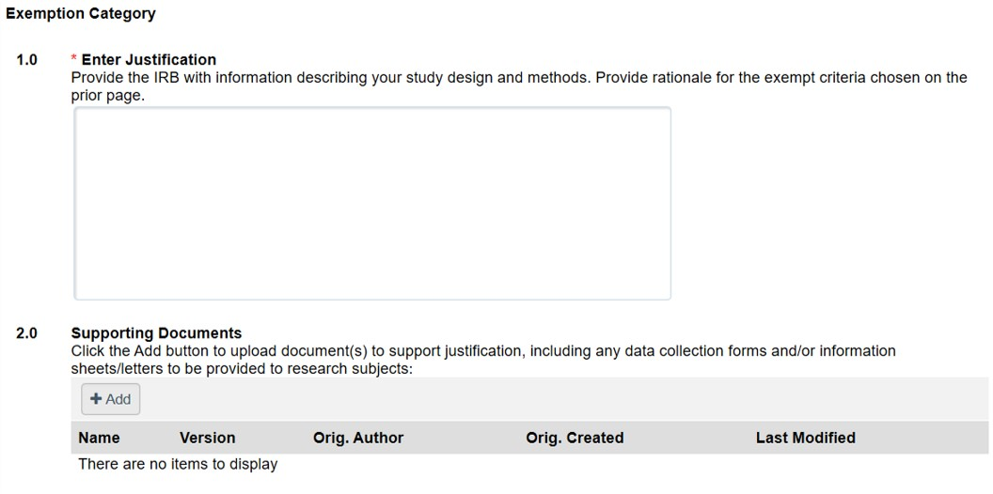
- - Provide the IRB with the following information to justify the exemption:
- Include information about the study population, the study setting, how participants will be identified and recruited; if you plan to use cold contact to recruit participants, see MUSC guidance at Cold Contact Recruitment Policy .
- If MUSC students and/or employees will be recruited, please address the measures that will be put in place to minimize coercion/undue influence.
- List the study procedure(s) in chronological order and include any remuneration that will be given for participation (if applicable).
- Describe any linkages to subjects (if applicable) and indicate who will have access to subject identities. Keep in mind that by definition, if the data is code-linked, it is not de-identified. De-identified means that there are no codes or identifiers; no way at all of linking the data to the subject.
- For research studies that involve interviews/focus groups, please specify if the interviews/focus groups will be audio recorded. If they are being recorded, will they be transcribed?
- If applicable, list any collaborating sites where human subjects research will be performed, and describe the role of those sites in performing the proposed research. Describe how data will be transferred and whether the data will contain identifiers.

- – Supporting Documents:
- Upload an information paragraph that will be distributed to the participants prior to the completion of the survey, interview and/or focus group. The document should include the eIRB watermark. The information paragraph may include the following information:
  - Potential participants are being asked to participate in research study and that participation in research is voluntary
  - The purpose of the research who is conducting the research and why the participant is being asked to participate.
  - Include a statement on what (if any) identifying information will be stored. If any interview/focus group will be audio recorded.
  - Instructions on how to return any completed surveys (if applicable), the duration of the study, how long each survey and/or focus group will take.
  - Brief description of any risks (e.g. loss of confidentiality)
  - Information about participant remuneration (if applicable).
  - Information about who to contact if there are any questions.
Suggest beginning the paragraph with the following sentence: “You are being asked to participate in this research study because you are [have] . . .”
** Note –recruitment materials should not be uploaded as supporting documents. These materials should be uploaded on the advertising/recruitment smartform. Recruitment materials should include an eIRB watermark.

Exempt Research Category 4
(Secondary research)
Perhaps the most impactful procedural change as a result of the Revised Rule relates to secondary research, i.e. retrospective chart review studies. Many of these were previously reviewed as expedited and may now be eligible for exempt review under Category 4.
Two things now allowable under exempt review which were not included previously:
- Recording of HIPAA identifiers or links to identifiers for information collection studies
- Use of not yet existing or not currently “on the shelf” data
Note that secondary use of identifiable biospecimens in which the researcher would like to document/retain a link between the identifiers and the specimen is still not allowed under Category 4 –those must still be reviewed via expedited review.
The regulation:
Secondary research for which consent is not required: Secondary research uses of identifiable private information or identifiable biospecimens, if at least one of the following criteria is met:
Secondary research under this sub-category must be recorded in a non-identifiable manner.
i. The identifiable private information or identifiable biospecimens are publicly available;
ii. Information, which may include information about biospecimens, is recorded by the investigator in such a manner that the identity of the human subjects cannot readily be ascertained directly or through identifiers linked to the subjects, the investigator does not contact the subjects, and the investigator will not re-identify subjects;
This sub-category allows secondary research use of identifiable health information. IRB application should include a HIPAA waiver of authorization request when this sub-category applies. Note that category 4 iii specifies “only information collection”. Research involving storage of identifiable biospecimens must still be submitted for expedited review.

iii. The research involves only information collection and analysis involving the investigator’s use of identifiable health information when that use is regulated under 45 CFR parts 160 and 164, subparts A and E, for the purposes of “health care operations” or “research” as those terms are defined at 45 CFR 164.501 or for “public health activities and purposes” as described under 45 CFR 164.512(b); or
iv. The research is conducted by, or on behalf of, a Federal department or agency using government-generated or government-collected information obtained for nonresearch activities, if the research generates identifiable private information that is or will be maintained on information technology that is subject to and in compliance with section 208(b) of the E-Government Act of 2002, 44 U.S.C. 3501 note, if all of the identifiable private information collected, used, or generated as part of the activity will be maintained in systems of records subject to the Privacy Act of 1974, 5 U.S.C. 552a, and, if applicable, the information used in the research was collected subject to the Paperwork Reduction Act of 1995, 44 U.S.C. 3501 et seq.

The eIRB application:
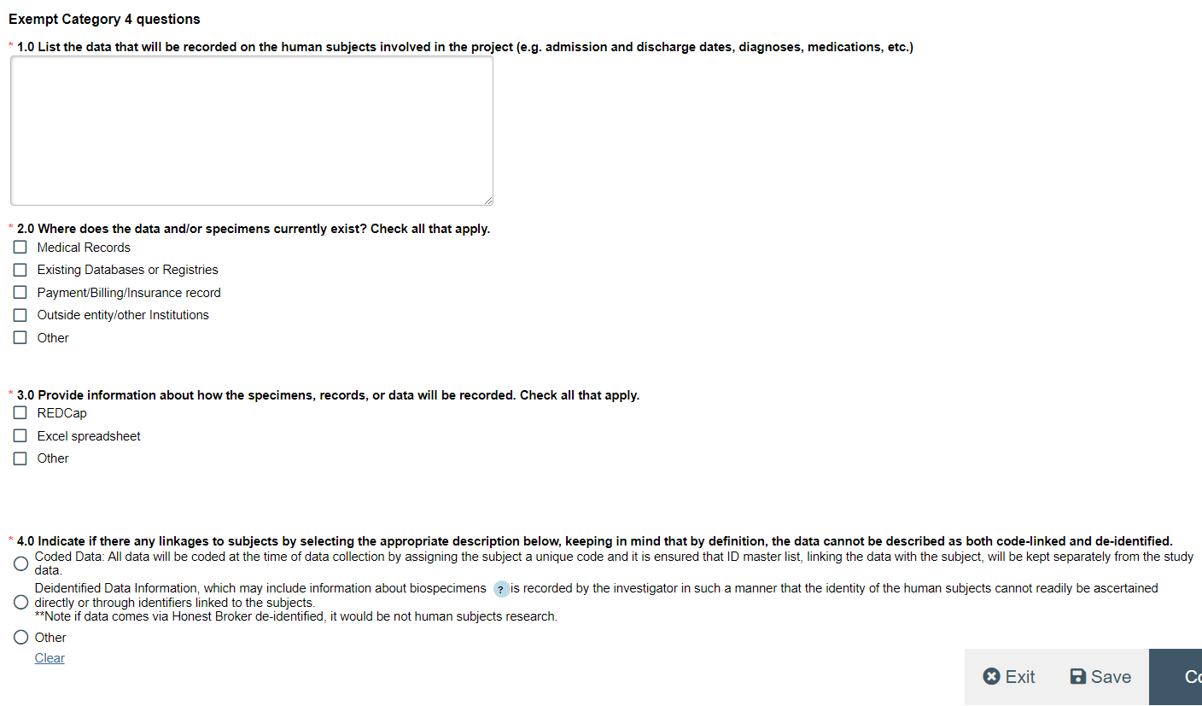
1.0 - Provide the IRB with the following information to justify the exemption:
- List the data that will be recorded on the human subjects involved in the project (e.g., admission and discharge dates, diagnoses, medications, etc. (Also include any PHI elements needed to conduct the study: MRN, names, zip codes, etc.
2.0 - Where does the data and/or specimens currently exist? In the eIRB application, you will have the option to make the following selections. You will select all that apply:
o- medical records
o- existing databases or registries
o- Payment/Billing/Insurance Records
o- Outside entity/other Institutions
- If applicable, list any outside sites where MUSC involved human subjects research will be performed, and describe the role of those sites in performing the proposed research. If data will be sent or received outside of MUSC, describe how data will be transferred and whether the data will contain identifiers.
o- other (explain)

3.0 - Provide information about how the specimens, records, or data will be recorded
o- REDCap
o-Excel spreadsheet
o-other (please explain)

4.0 - Indicate if there any linkages to subjects by selecting the appropriate description below keeping in mind that, by definition, the data cannot be described as both code-linked and de-identified.
o- Coded Data: All data will be coded at the time of data collection by assigning the subject a unique code and it is ensured that ID master list, linking the data with the subject, will be kept separately from the study data. Identifiable subject data should be replaced with research identification codes. The research identification code will serve as the designated identifiers for the collected health data. Once coded, this information should be stored in separate files. These measures will create the necessary separation of identifiable subject data from health data.

OR
o-Deidentified Data Information, which may include information about biospecimens, is recorded by the investigator in such a manner that the identity of the human subjects cannot readily be ascertained directly or through identifiers linked to the subjects.
o- Note if data comes via Honest Broker de-identified, it would be not human subjects research.
o-other (please explain)

